Brief description |  | Participants use their cultural profiles as a basis to negotiate an appropriate e-culture.

Goals |  | - Participants negotiate processes and structures of an e-culture.  - Participants identify and evaluate best practices for their own teams.
Time |  | 90 min. (of which approx. 20 min. for the creation of an own cultural profile)
Method |  | Culturally unspecific;  distributive/instructive
Material |  | - Worksheet cultural profile  - Worksheet e-culture negotiation
Implementation |  | Participants first work through the worksheet on their own cultural profile. Alternatively, this step can also be done in advance in preparation for the exercise. The trainer divides the participants into small groups of three to four people.  Using the "Negotiating an e-Culture" worksheet, the groups discuss their profiles and possible differences that could lead to conflict. With the help of the graphic on the negotiation process of an e-culture, they work out influencing factors and elements of possible teamwork. The groups then present their group profile. These results are evaluated and reflected upon in a plenary session.
Notes |  | If necessary, the activity can also be divided into several exercise sessions.
Source |  | Annika Schmidt

Task

Worksheet Cultural Profile
Imagine you have been invited to the kick-off workshop of a new project, where you will have the opportunity to get to know your team members. To help the other team members get to know you better, please fill out the four different quadrants of your cultural profile:
- Who am I?
- What can I contribute?
- What have I experienced?
- What is important to me when working with others?
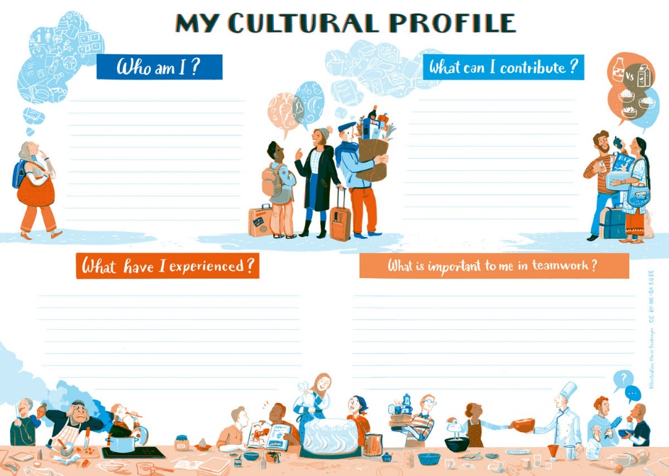
Who am I? The answers should provide the other team members with personal information (that you are willing to share) in order to help them get to know you better in a work context.
- What is my educational and professional background?
- What is my age?
- What are the main collectives to which I belong? (e. g., occupation, leisure)
- What collectives still have a strong influence on me when I work with others?
(e.g., your university, your family, your sports team).
What can I contribute? This quadrant contains information about experiences and skills you possess that could be helpful in collaborative project work. The following questions might help you identify these:
- What languages do I speak and at what level?
- What competencies and skills can I contribute? These could include previous experience abroad, openness, interest in other countries and cultures, willingness to listen, or exploring and dealing with the unknown.

What have I experienced? This quadrant is about evaluating past experiences in an intercultural setting.
- What motivates me when I encounter others?
- What irritates me when I interact with others?
- What drives me crazy?
- What are my trigger points?
- What groups of people do I find easy to relate to?

What is important to me when working with others?
- What are my expectations?
- How do I want others to behave when they work with me?
Source: Edubox Intercultural Communication on Glocal Campus,
URL: https://glocal-campus.org/mod/page/view.php?id=1623

Task

Worksheet e-Culture Negotiation
After developing your own cultural profile, compare your profiles in the group and create a group profile:
- What do we have in common?
- Where do we see differences?
- How might these differences show up in behaviour?
Based on your group profile and the insights you now have about your team members, the next step is to develop an e-culture using the diagram provided below as a guide. For example, you may have noticed differing preferences within the group regarding communication. To prevent misunderstandings, it is important to consider how communication should be approached based on these differences. Additionally, think about how these differences can complement each other synergistically and shape future collaborations. Here are key points to consider:
- Recognising and valuing differences as well as commonalities
- Developing an understanding of the areas to be negotiated
- Discussing and identifying contextual factors
- Developing a shared meaning of issues and goals
- Negotiating and trying to find common ground
- Identifying the elements of the culture of negotiation
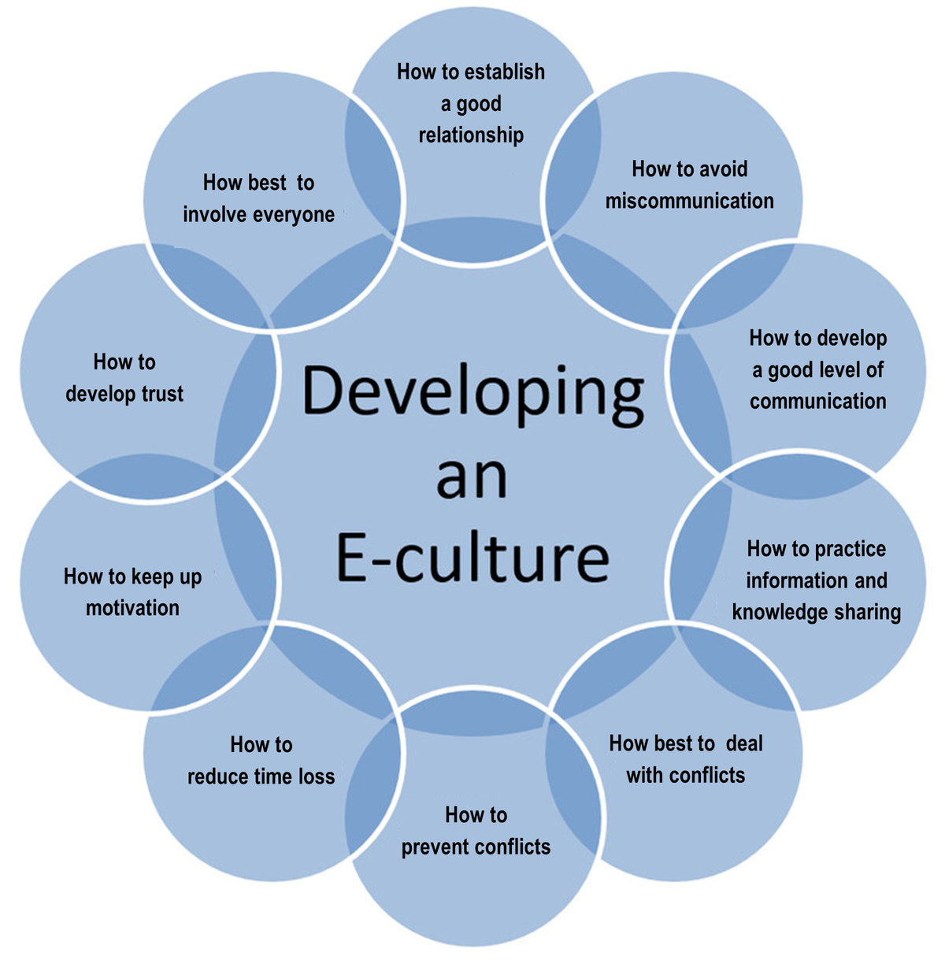

Source: Edubox Virtual Intercultural Teams on Glocal Campus,
URL: https://glocal-campus.org/mod/page/view.php?id=1561

