



**Your name:**

|  |
| --- |
|  |

**Virtual intercultural teams**

**Session 5:**

**Creating mutuality  
in intercultural and interdisciplinary virtual teams**

**Learning journal**



Except where otherwise noted, the content contained in this document is licensed under a   
[Creative Commons Attribution-ShareAlike License v 4.0](https://creativecommons.org/licenses/by-sa/4.0/).

The work is attributable to:   
Project Team „Edubox Virtual intercultural teams“ / HOOU

## Content / Tasks

5.1 Prelude

Which teams perform best?

5.2 Introduction

5.3 The MBI approach in a virtual environment

My diversity wheel

Hierarchical versus status orientation

Opening hours

Getting to know myself and my cultural orientation

De-centering

The meaning of ‘team meeting’

5.4 Creating mutuality and negotiating culture in a virtual team

5.5 Using cultural profiles as a basis for mapping and negotiating culture

My cultural profile

Commonalities and differences among team members

Reconciling differences

5.6 Summary

5.7 Learning review

Learnings from this session

5.8 Sources, further reading and web links

## ► 5.1 Prelude

### Which teams perform best?

Which teams do you believe are able to perform better, those which are diverse or those which are homogenous?

Take three minutes to note down your answer here.

|  |
| --- |
|  |

## ► 5.3 The MBI approach in a virtual environment

### My diversity wheel

Imagine you work in an intercultural and interdisciplinary team. Use the diversity wheel as an orientation to note down a few things you think you should share with your team members in order for them to get to know you well.

|  |
| --- |
|  |

### Hierarchical versus status orientation

Read the following quote from an internship report and answer the question as to how this may influence the teamwork.

*"I perceived the work environment as very positive and the team work went quite smoothly. However, after some time I realized one thing that I was not used to and that is that the team structure is very hierarchical. Actually, everything works via titles. It is not just in the team itself. Throughout the company there is a strict way of upward mobility. Once you have finished a traineeship the first position or title is analyst. Next step would be associate, then senior associate followed by director."*

|  |
| --- |
|  |

### Opening hours

Look at the photograph below and note down your thoughts about when the shop is going to reopen and what somebody who is used to clearly defined opening hours would think about the shop owner.

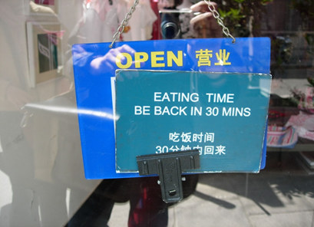

|  |
| --- |
|  |

### Getting to know myself and my cultural orientation

Knowing yourself is an important stepping stone when wanting to work well in an intercultural virtual team, and the dimensions discussed are helpful in doing so.

Using the scales below, position yourself on a scale of one to five considering a work context by crossing the respective checkbox. (If you print out this sheet, you can then connect the crossed checkboxes to get a visual representation of your profile as a zig-zag line.)

|  |  |  |
| --- | --- | --- |
|  | **1 2 3 4 5** |  |
| **Strongly task oriented** |  | **Strongly relationship oriented** |
| **Independent** |  | **Interdependent** |
| **Egalitarian oriented** |  | **Status oriented** |
| **Preference for direct communication** |  | **Preference for indirect communication** |
| **Risk** |  | **Certainty** |
| **Monochrone** |  | **Polychrone** |

### De-centering

A manager tells his Chinese employee: *“I know that as a Chinese it's hard for you to disagree openly with your boss, but I want you to know it's okay to do that with me. I don't mind when you disagree with me, in fact I expect you to.”*

Considering an open definition of culture, why can this not be considered de-centering?

|  |
| --- |
|  |

|  |  |
| --- | --- |
|  | **The meaning of ‘team meeting’** |

Note down your thoughts about what team meetings mean to you and how different meanings can influence your teamwork.

|  |
| --- |
|  |

## ► 5.5 Using cultural profiles as a basis for mapping and negotiating culture

|  |  |
| --- | --- |
|  | **My cultural profile** |

Imagine you are expected to work in an intercultural and interdisciplinary virtual team of three. Your boss is planning to invite you for a first get together call and is asking you to develop a profile which helps other team members to get to know you. He wants to distribute these profiles to all team members so that you can use them to identify commonalities and differences. Because you know that the project is not only going to be challenging with regard to the task but also likely due to the diversity of the team members. You want to bring in your previous experiences and in particular want to achieve a high level of cooperation and mutuality.

As a first task, develop your cultural profile. Your identity profile has four squares and covers issues such as:

* Who am I?
* What can I contribute?
* What have I experienced?
* What is important to me when working in a team?

In a first step you are asked to fill out the four different quadrants of the cultural profile in your learning journal. In doing so, you can refer to the questions below as a general guide from which you may choose relevant questions depending on time, the project itself and other factors. However, for the purpose of this exercise you only need to answer the questions which are *highlighted*.

**Who am I?**

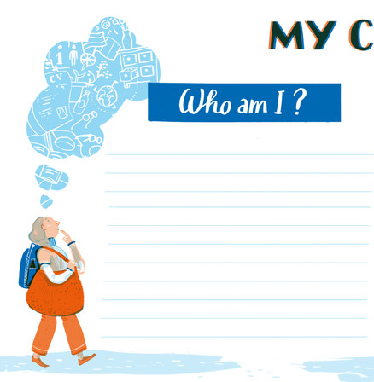

The answers should provide other team members with personal information you are ready to share and which would help them to get to know you better considering the work context.

* What are central issues of your life path?
* *What is your educational and professional background?*
* How old are you?
* What is your marital status?
* What is your parental status?
* What are central collectives you are a member of?

(e.g. professional, leisure time)

* *Which collectives had a big impact on you during your upbringing? (e.g. your family, sports club)*

For example, you may have been or are still a member of a sports club which influenced you because of the team spirit and friendships you developed and is still important to you because occasionally you are still joining them for important matches.

* Which collectives are still very influential and powerful when working with others? (e.g. your university, your family, sports club)

For example, the rituals and traditions in your family may still be very influential and you may e.g. be requested to be with your family on specific occasions which influences your work calendar.

* Which contextual factors had a large influence on you and with regard to what? (e.g. the local church)
* *Which contextual issues are still influential when working with others? (e.g. behaviour I learned at grammar school)*

|  |
| --- |
|  |

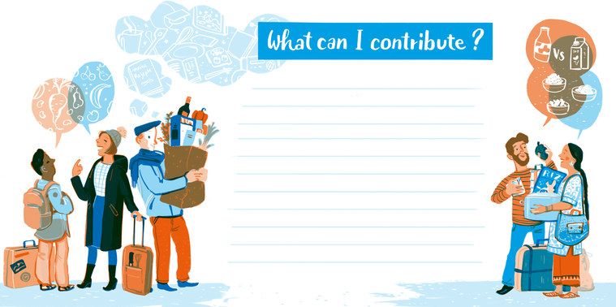**What can I contribute?**

This quadrant includes information about experiences and competencies you have and which could be beneficial to achieving the team’s goals and support team satisfaction. Questions which may support identifying these are the following:

* *Which languages do you speak and at what level?*
* *What competencies are you able to bring along considering: media skills and knowledge,   
  self-management and efficacy, intercultural competence, team related competencies?*

|  |
| --- |
|  |

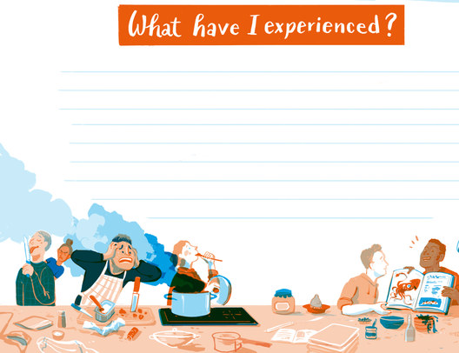**What have I experienced?**

This quadrant refers to experiences you have with regard to teamwork and virtual teamwork in particular and the following questions may guide you in this.

* *What motivates you when working with others?*
* *What irritates you when working with others?*
* What drives you up the roof?
* What are your trigger points?
* Where did you feel excluded?
* With which groups of people can I easily establish a relationship?

|  |
| --- |
|  |

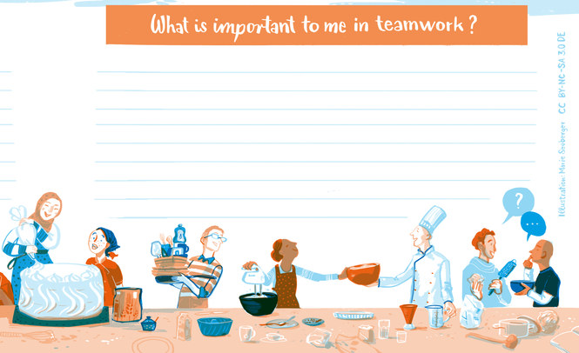**What is important to me when working in a team?**

* What are your expectations?
* *How would you like others to behave when in a team with you? Consider dimensions such as "independence versus interdependence", "task versus relationship", "egalitarian versus status", "direct versus indirect", "risk versus certainty" and "monchronicity vesus polychronicty"?*
* How is your self-image with regard to these dimensions?

|  |
| --- |
|  |

### Commonalities and differences among team members

Comparing your own profile with the profiles of Natalia and Hoang, use the common triangle (figure below) and highlight commonalities as well as differences.

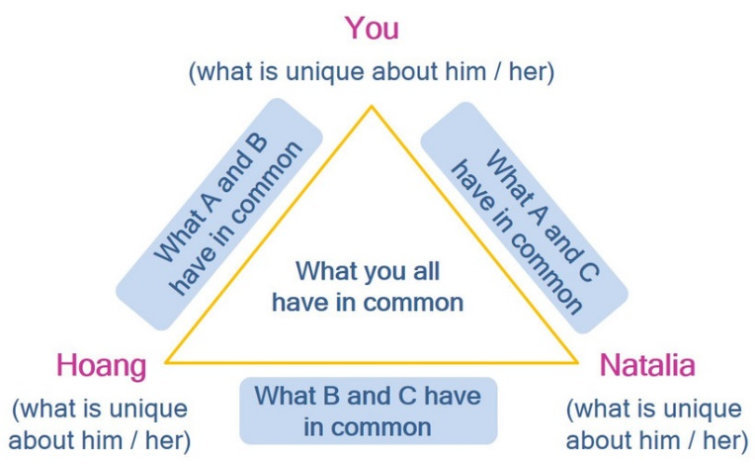

|  |
| --- |
|  |

### Reconciling differences

How would you go on about dealing with differences following the MBI-approach? Choose two examples and go through the MBI process considering differences and commonalities between the three of you.

|  |
| --- |
|  |

## ► 5.8 Learning review

### Learnings from this session

Look back at the results of your cultural profile and the process of creating mutuality in virtual teams and note down three major learnings.

|  |
| --- |
|  |