



Your name:

Intercultural communication
Session 9:
The journey continues
Learning journal



Except where otherwise noted, the content contained in this document is licensed under a
Creative Commons Attribution-ShareAlike License v 4.0.
The work is attributable to:
Project Team „ Edubox Intercultural communication “ / HOOU

Content / Tasks

9.1 Prelude
9.2 Introduction
9.3 Developing intercultural competence
9.4 Key areas of intercultural competence and my personal achievements
 | Dealing with opposing views  (► Openness: New thinking)
Mastering an unknown situation
(► Openness: Welcoming attitude)
O | Case “Not telling the truth”  (► Openness: Acceptance)
Case “How to tackle a difficult topic in a constructive way”
(► Communication: Exposing positive intentions)
Interpreting non- and paraverbal behaviour
(► Communication: Being receptive to communication styles)
The world upside down
(► Culture-reflexive knowledge: Reflecting perspectives)
Privileges and disadvantages
(► Culture-reflexive knowledge: Awareness of global positioning)
9.5 ... and the journey continues
9.6 Sources, further reading and web links

► 9.4 Key areas of intercultural competence and my personal achievements

✶ Openness: New thinking
 | Dealing with opposing views
Open a newspaper or a website that you usually would not read because the views displayed here do not depict your own. Pick an article, maybe a commentary, which you reckon to be quite different from what you believe and what your common understanding is. When you read the article, ask yourself how you can deal with opposing views or behaviour. Is there anything in the reading that enriches your worldview?
Choose two aspects from the article or commentary, describe them briefly and note down the new thinking which developed from your reflection.

✶ Openness: Welcoming attitude
Mastering an unknown situation
Remember a situation where you mastered an unknown situation well, for example when you got into contact with a former unfamiliar person or faced a behaviour you do not cherish at all. Do you also remember your inner hurdles and hestitations? What helped you to foster a welcoming attitude and embrace the moment?
Note down the story together with a short commentary as to what was helpful in dealing with the situation well. The strategy you used is a valuable resource to remember and to be used again. It follows the motto: "If you are not my friend, you are my coach”.

✶ Openness: Acceptance
Case “Not telling the truth”
Having read the case description, please answer the following questions.
On a scale from 1 (= nearly no acceptance) to 10 (= full acceptance), how would you assess your ability to accept that behaviour? Note down a number.
Imagine you wrote down 3 (or 5 or 8). Explain why your level of acceptance is not lower than this number. What would help you to accept Nina's behaviour?

✶ Communication: Exposing positive intentions
Case “How to tackle a difficult topic in a constructive way”
Write down the conversation between Zamil and his colleague (Zamil's part) in your learning journal. What could Zamil have said (quote!) to express his positive intentions? Note down the beginning of the conversation, and how he cultivates the relationship. Also write down how he approaches the touchy topic by showing his positive intentions.

✶ Communication: Being receptive to communication styles
Interpreting non- and paraverbal behaviour
Have another look at the video from session 6 about the interaction between a Chinese supervisor and his employee. Please pay particular attention to the non- and para-verbal communication of the employee. If you were the supervisor, how would you react to accommodate the needs of your staff? How would you interpret his non- and para-verbal signs and show your understanding of the underlying needs here?

✶ Culture-reflexive knowledge: Reflecting perspectives
The world upside down
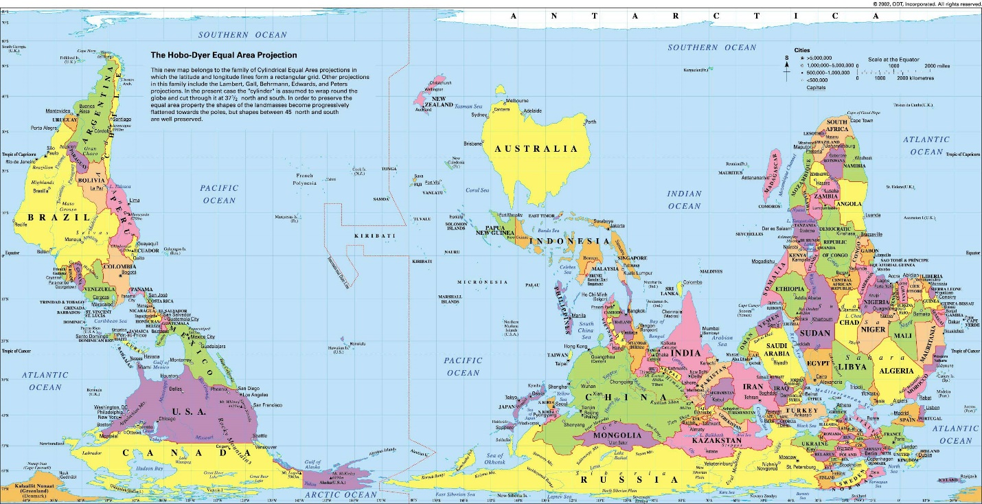
Have a look at the map above. Search for the country you were born in. Was this more difficult for you than usual? Why is that? Describe the perspective that you see.

What could you do to acquaint yourself with the unfamiliar view and make it a more familiar perspective? Note down three such strategies.

✶ Culture-reflexive knowledge: Awareness of global positioning
Privileges and disadvantages
Have a look at the following checklist that lists over 130 privileges: https://sites.google.com/a/u.boisestate.edu/social-justice-training/about-us/our-training/privilege-checklist
After copying the list into an editable document or printing it out, choose three categories and mark or check off each sentence that you can confirm.
Then answer the following questions:
How many privileges do you have? How does it make you feel?
Name one disadvantage you face yourself. How do you handle it? Give an example.
How do you handle disadvantages of others? Give 2 specific examples.

