



Your name:

Intercultural communication
Session 4:
Culture and social behaviour
Learning journal



Except where otherwise noted, the content contained in this document is licensed under a
Creative Commons Attribution-ShareAlike License v 4.0.
The work is attributable to:
Project Team „ Edubox Intercultural communication “ / HOOU

Content / Tasks

4.1 Prelude
4.2 Introduction
4.3 The link between culture and social behaviour
 | At the doctor
 | The missing information
4.4 How do we want to engage with others?
My fellow researchers
Getting to know each other
Working together?
Hierarchical versus egalitarian orientation
What you think and what you say
A team presentation
Business deal
Differences in time orientation
Getting to know myself and my cultural orientation
4.5 My cultural identity profile
My cultural profile
4.6 Bridging cultural differences
Comparing profiles
Bridging cultural differences
4.7 Summary
4.8 Learning review
Case “To cut a long story short...”
4.9 Sources, further reading and web links

► 4.3 The link between culture and social behaviour
 | At the doctor
Imagine you need to go to the doctor and are being asked to wait in the waiting room to be called upon. In the waiting room, there are lots of chairs and there is only one other patient. Where would you choose to sit? Referring to the list of available options below, tick the one or the ones you consider to be relevant and note down why you are choosing this particular seat.
1 | You choose to leave at least three chairs in between you and the other patient in order to avoid any infections | ☐
2 | You want to sit far enough so that the likelihood that the other patient talks to you is minimized | ☐
3 | You want to sit close to the window and are not concerned about the other patient | ☐
4 | Having a quick look at the other patient makes you feel as if she is a very empathic person and you choose sitting in ‘talking distance’ | ☐
5 | You don’t want to sit at the other end of the room because the other patient may feel intimidated if you choose being furthest away from her | ☐
6 | You want to sit next to the door so that you can quickly get up when called upon | ☐
7 | You want to sit very close to the other patient so that you can console her and have a good chat | ☐
8 | Other: | ☐
Why are you choosing this option (or these options)?

The missing information
You are working on a project with four others and were tasked to prepare a presentation of your work results. The deadline is tight and when you realise that you need information from your colleague Huan, one of the team members, you are not too sure what to do because Huan is gone for the afternoon and cannot be reached. However, you know that the file with the information must be on his desk. What do you do? In your learning journal, tick one of the three options.
1 | You know that the documents must be either on Huan's desk or in his filing cabinet, so you walk over to his desk and search for the information you need. | ☐
2 | You walk over to Huan's desk and see whether the file with the information is visible, but feel reluctant to actively search for it. | ☐
3 | You leave a note on Huan's answering machine and wait for his return to the office. | ☐
No matter which choice you make, you cannot be sure of Huan's reaction. Read through the different possibilities, think about explanations for any of his possible reactions and note some down below:
1 | „I can’t believe that my colleague actually went through my file and documents. I truly feel that my privacy has been invaded.“
2 | „I feel sorry that I couldn’t be reached and am glad, my colleague took the liberty to search for the missing information. I don’t mind my team members to do so, we are in this together.“
3 | „Well, I guess that my colleague was under pressure and didn’t really know what to do. But going through my filing cabinet and documents leaves an unpleasant feeling of ‚invading my private sphere‘.“

► 4.4 How do we want to engage with others?
My fellow researchers
Read the case study and find indicators which may suggest that Vadim is more relationship oriented than his fellow post-graduates. What could be other reasons as to why Vadim’s colleagues are adamant to talk about private issues? When answering this question think about the context as well as personal issues. Where is Vadim making assumptions?

Getting to know each other
Read the case study and answer the following questions.
Which topics does Karen consider to be inappropriate?
What could be reasons why Thao is asking these questions?
What would be topics you consider as inappropriate in such a context?

Working together?
Read through the case study and indicate why Mihai and his fellow student may have different understandings of ‘carrying out a team task’.

Hierarchical versus egalitarian orientation
Bowing in Japan is part of a long-standing cultural tradition. Use the internet to search for the reasons why people bow, how people bow and when they do so. Note down those aspects which relate to status and hierarchical orientations.

What you think and what you say
Imagine you are in a foreign country and are being offered some food which to you really looks disgusting and you surely want to decline from the offer. What would you do or say? Choose an option from the list below.
1 | “This food really looks different and I am sorry, but I cannot eat it.” | ☐
2 | “Thank you very much for your offer, I very much appreciate it. But I am very sorry to say that I won’t be able to stay.” | ☐
3 | “This food looks disgusting, no way I can eat it.” | ☐
4 | “This is very kind of you, but I am afraid that I am not feeling well.” | ☐
5 | “This food looks very interesting and I wished I would be able to join, but I am afraid I have a stomach disorder.” | ☐
6 | Other: | ☐
Why would you choose this option?

A team presentation
Read the case study and note down how Alice could explain to Ajul why she finds it difficult to follow his way of approaching the team task.

Business deal
After reading through the case study, note down how the concept of monochronicity and polychroncity can help us to understand Mr. Balto’s and Mr. Bau’s behavioural expectations.

Differences in time orientation
Having read through the case which illustrates different time orientations, note down two positive aspects about acknowledging clock time and two positive aspects about acknowledging flow time.

Getting to know myself and my cultural orientation
Knowing yourself is an important stepping stone when wanting to work well in an intercultural setting, and the dimensions discussed are helpful in doing so.
Using the scales below, position yourself on a scale of one to five considering a work context by crossing the respective checkbox. (If you print out this sheet, you can then connect the crossed checkboxes to get a visual representation of your profile as a zig-zag line.)
 | 1 2 3 4 5
Strongly task oriented | ☐ ☐ ☐ ☐ ☐ | Strongly relationship oriented
Independent | ☐ ☐ ☐ ☐ ☐ | Interdependent
Egalitarian oriented | ☐ ☐ ☐ ☐ ☐ | Status oriented
Preference for direct communication | ☐ ☐ ☐ ☐ ☐ | Preference for indirect communication
Risk | ☐ ☐ ☐ ☐ ☐ | Certainty
Monochrone | ☐ ☐ ☐ ☐ ☐ | Polychrone

► 4.5 My cultural identity profile
My cultural profile
Imagine you are invited to join a workshop preparing you to work abroad. You are expecting to meet new and very different people who are all interested in preparing themselves well for working outside of your home country. In the invitation, you were asked to develop a cultural profile and bring it along to the workshop.
In order to help you doing so, you received a template with a couple of questions you may want to answer, but of course you are free to add any information you think may help seminar participants to get to know you well. Please fill out your cultural identity profile, which has four squares and covers issues such as:
- Who am I?
- What can I contribute?
- What have I experienced?
- What is important to me when working with others?
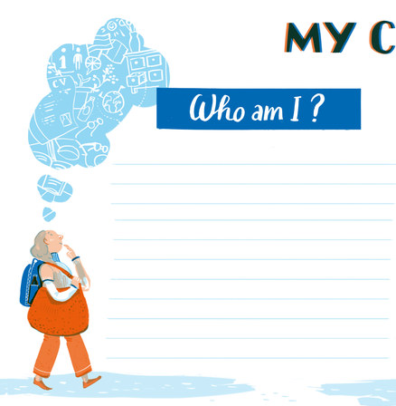
Who am I?
The answers should provide other workshop participants with personal information you are ready to share and which would help them to get to know you better considering the work context.
- What is your educational and professional background?
- How old are you?
- What are central collectives you are a member of?
(e.g. professional, leisure time)
- Which collectives are still very influential and powerful when working with others?
(e.g. your university, your family, sports club)
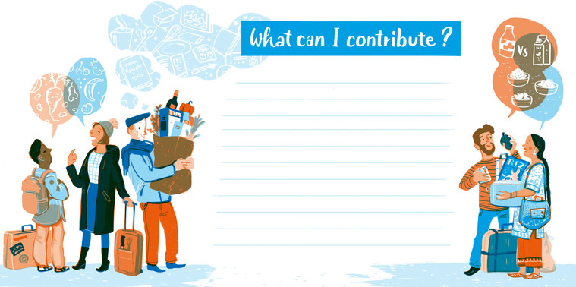
What can I contribute?
This quadrant includes information about experiences and competencies you have and which could be helpful when going abroad. Questions which may support identifying these are the following:
- Which languages do you speak and at what level?
- What competencies and skills are you able to bring along? These could for example relate to previous experiences abroad, openness and interest in other countries and cultures, readiness to listen and explore and deal with the unknown.
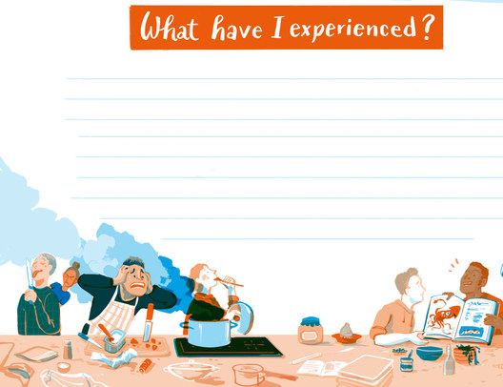
What have I experienced?
This quadrant refers to evaluating past experiences in intercultural settings.
- What motivates you when working with others?
- What irritates you when working with others?
- What drives you up the roof?
- What are your trigger points?
- With which groups of people can I easily establish a relationship?
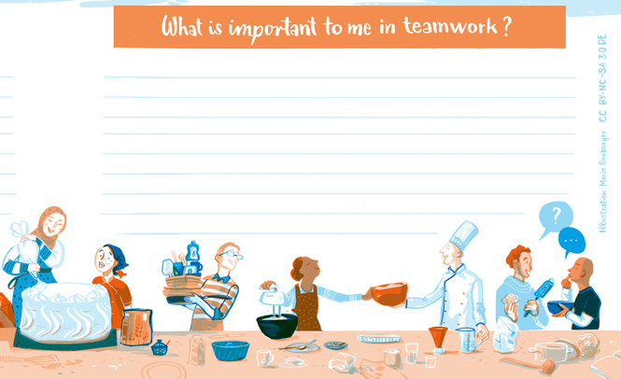
What is important to me when working with others?
- What are your expectations?
- How would you like others to behave when working with you? When answering this question consider the cultural dimensions you dealt with earlier on: independence versus interdependence, task versus relationship, egalitarian versus status, direct versus indirect, risk versus certainty and monochronicity versus polychroncity.
- How is your self-image with regard to these dimensions?

► 4.6 Bridging cultural differences
Comparing profiles
Compare your profile with Natalia’s profile and, considering that you want to work together with her, identify differences and commonalities which you consider to be important. Note these down here.

Bridging cultural differences
Comparing your cultural profile and that of Natalia, choose two areas where, cyou detect differences. Using the PCC-model, carry out a situation analysis as is and based on this make suggestions how the differences could possibly be bridged. Note down the results of your analysis and your suggestions.

► 4.8 Learning review
Case “To cut a long story short...”
After reading the case study, note down the answers to the following questions:
What are obvious differences you detect?
Why do you think could be reasons for them to adopt such different styles? Consider culture, person and situation. What might this say about the way they see hierarchy and status?
We may conclude that Miguel probably takes a bit longer in his tasks because he worries about formalities. Or do we? They both delivered their files within a few hours. - Do you think this allows for an evaluation of his efficiency, given the task they had to execute?
Do you think his formality necessarily makes Miguel less productive? Can you imagine situations where his formality may be an advantage in a professional context?
Mike would rather that Miguel wasn’t so formal; not because he is too slow, but because Mike wants him to feel at ease. He considers that it doesn’t matter if Miguel takes a bit longer now and then. What does the fact that he wants to speak to Miguel say about Mike and his cultural orientation? How does Mike interpret formality and informality in terms of efficiency and productivity, and in terms of work ambience? What does Mike consider to be the most desirably work method and why?
In your own work context, what people and factors influence and determine the way of doing things?
Who depicts your own cultural orientation best: Mike, Miguel or Jeremy?

