Virtual Intercultural Teams

Welcome to our online self-learning course version 1.0. It is a self-learning course which will continue to grow, develop and change. We may, for example, include other case studies and material. This is why we understand our work as a 'work in progress'.
For those, who want to use the material or part of it in their teaching and training sessions and are looking for didactical information and additional tasks and case studies, we have developed a Trainer Manual which can be accessed here: https://glocal-campus.org/course/view.php
?id=25)
The ability to work effectively in intercultural teams has been a key competence for a considerable time. Now, the increasing necessity (and opportunity) to work in these teams in a virtual environment has made these competences even more crucial. Expanding your experience and enhancing your expertise in virtual intercultural teams (VITeams) has therefore become indispensable in diverse professional, social and work contexts. Additionally, competence in VITeams will assist you in both in your search for and subsequently development of a satisfying career.
With this in mind, we would like to welcome you to our online course ‘Virtual intercultural teams’. This course will help you identify and analyse key challenges of working in VITeams and develop professional as well as social competencies to support and enable a high level of performance and work satisfaction. In a nutshell, the objective of this course aims is to enhance your virtual and intercultural competencies so that you can work successfully in diverse virtual team settings.
The following video will highlight the key elements of the course.
Video introduction: virtual intercultural teams, https://www.podcampus.de/nodes/wEOzq

Copyrights
We are committed to providing higher vocational education based on scientific evidence free of charge. It is our strong belief that contributing to providing equal opportunities of education will help us all to grow and learn to interact as global citizens.
Therefore the content of this online course is, unless stated otherwise, licensed under a Creative Commons Attribution-ShareAlike 4.0 International license (CC BY-SA), which means that it is freely available for anyone to use, adapt and share as long as the author collective is being credited and any derivative works are shared under the same terms.
Please credit the author collective as follows:
Iken, Adelheid / Nazarkiewicz, Kirsten / Voigt, Andrea / Witchalls, Peter / Yildirim-Krannig, Yeliz (2024): EduBox – Virtual Intercultural Teams – Online Modules (Version 1.0. Hamburg Open Online University HOOU), Glocal Campus Jena. https://glocal-campus.org
Copyright information on images / graphics / videos can be found directly with the images or videos.

Content

1. Virtual teamwork in my work environment 1
1.1 Prelude 2
1.2 Virtual teamwork, an introduction 2
Task: Changes in work environments 2
Task: Virtuality – what are we talking about? 4
1.3 Virtuality, what are we talking about? 4
1.4 Different types of virtual teams 8
Task: Teams and their level of virtuality 9
1.5 Virtual team competencies – a general introduction 9
Task: Competencies an virtual teams 13
1.6 Summary 14
1.7 Learning review 14
Task: Case "IT problems" 14
Task: Case "Designing a new office chair" 17
1.8 Sources, further reading and web links 20
2. Culture and interculturality, a plea for an open and dynamic approach 22
2.1 Prelude 23
2.2 Introduction 23
Task: Culture and virtual teams 23
2.3 A narrow and an expanded concept of culture 24
2.4 An open versus closed concept of culture 24
Task: Switzerland from a closed culture perspective 25
Task: Find your own example 28
Task: 'Zooming' – a new perspective on culture 31
2.5 Interculturality 32
2.6 Common cultural misconceptions and the potential of zooming for developing a collaborative team culture 34
Task: Cultural misconceptions and zooming in intercultural communication 34
2.7 Summary 35
2.8 Learning review 36
Task: Working in an intercultural team – some practical questions 36
2.9 Sources, further reading and web links 38

3. Developing from a group into a virtual team 40
3.1 Prelude 41
3.2 Introduction 41
Task: Differences between a group and a team 41
3.3 The life cycle of virtual teams 42
Task: Developing into a team 45
Task: Central characteristics of team development stages 47
3.4 Features of team development 50
Task: A framework for supporting team development 56
3.5 Summary 59
3.6 Learning review 59
Task: Case "Development of a project team" 59
3.7 Sources, further reading and web links 65
4. Roles and role expectations 66
4.1 Introduction 67
Task: Diversity factors 67
4.2 Introducing roles as a factor for diversity 68
Task: A variety of roles 69
4.3 The function of team roles in work teams 70
Task: Team diversity – a risk or an asset? 70
Task: Team roles test 71
4.4 Understanding team roles 72
Task: Three areas of team roles 72
Task: Case "Creative ideas – not appreciated" 73
4.5 Applying the team roles for our self-awareness 74
Task: Strengths and allowable weaknesses in your team roles 74
Task: Your own experiences with strengths and weaknesses in teamwork 75
4.6 Applying team roles in work teams 75
Task: Essential team roles 76
Task: Case "Two job advertisements" 77
4.7 Summary 78
4.8 Learning review 78
Task: Case "A team assignment" 78
4.9 Sources, further reading and web links 80

5. Creating mutuality in intercultural and interdisciplinary virtual teams 81
5.1 Prelude 82
Task: Which teams perform best? 82
5.2 introduction 83
5.3 The MBI approach in a virtual environment 83
Task: My diversity wheel 86
Task: The meaning of work 86
Task: Task vs relationship orientation 87
Task: Different expectations 88
Task: Hierarchical versus status orientation 88
Task: Opening hours 91
Task: Getting to know myself and my cultural orientation 92
Task: De-centering 95
Task: The meaning of 'team meeting' 95
5.4 Creating mutuality and negotiating culture in a virtual team 96
Task: A common path 97
5.5 Using cultural profiles as a basis for mapping and negotiating culture 98
Task: My cultural profile 98
Task: Commonalities and differences among team members 102
Task: Reconciling differences 103
5.6 Summary 104
5.7 Learning review 104
Task: Learnings from this session 104
5.8 Sources, further reading and web links 104
6. Key challenges of virtual intercultural teams 106
6.1 Prelude 107
6.2 Introduction 107
Task: Challenges in virtual teamwork 107
6.3 Team performance and team satisfaction 107
6.4 Key challenges of virtual intercultural teams 108
Task: Identifying challenges 110
Task: What makes me trust my team? 115
Task: Drafting an email 119
Task: Changing perspective 119
Task: A team identity 121
Task: A liberated work place 123
6.5 Summary 124
6.6 Learning review 125
Task: Case "Designing a new office chair" (Reprise) 125
Task: Case "The relocation" 125
6.7 Sources, further reading and web links 126

7. Negotiating an E-culture for virtual teams 127
7.1 Prelude 128
7.2 Introduction 128
Task: Benefits of virtual teamwork 128
7.3 Culture, interculturality and cultural negotiations, a quick review 129
7.4 Cultural leverage in teams or negotiating an E-culture 130
7.5 An E-culture, best practices 133
7.6 Approaches for finding best practices 135
Task: My dune model 136
7.7 Summary 140
7.8 Learning review 141
Task: Case "An Austrian-US-American teamwork" (Part 1) 141
Task: Case "An Austrian-US-American teamwork" (Part 2) 147
7.9 Sources, further reading and web links 148
8. My competences for working in a virtual intercultural team 149
8.1 Prelude 150
8.2 Introduction 150
8.3 Developing competences for working in VITeams 150
8.4 Key areas of virtual intercultural competence and my personal achievements 152
Activity: Changing your work routines 154
Activity: Joining a team (1) 156
Activity: Dealing with irritating behaviour 157
Activity: Joining a team (2) 159
Activity: Dealing with a touchy topic 160
Activity: The interaction between the team lead and the employees 162
Activity: Contextual issues 164
Activity: Changing perspectives 166
Activity: Privileges 168
Activity: Reflecting on positive and negative experiences 170
Activity: Developing the communication flow within the team 171
Activity: Synergies through differences 173
8.5 ...and the journey continues 173
Task: Benefits of virtual teamwork 173
8.6 Sources, further reading and web links 174

1. Virtual teamwork in my work environment

Topics
1.1 Prelude 2
1.2 Virtual teamwork, an introduction 2
Task: Changes in work environments 2
Task: Virtuality – what are we talking about? 4
1.3 Virtuality, what are we talking about? 4
1.4 Different types of virtual teams 8
Task: Teams and their level of virtuality 9
1.5 Virtual team competencies – a general introduction 9
Task: Competencies an virtual teams 13
1.6 Summary 14
1.7 Learning review 14
Task: Case "IT problems" 14
Task: Case "Designing a new office chair" 17
1.8 Sources, further reading and web links 20

Learning outcome
In this session you will reflect on the relevance of virtual teams in the context of a changing work environment and identify typical characteristics of virtual teams as well as basic skills and competencies needed when working in a virtual environment
Objectives
At the end of the session, you will be able to
- explain the meaning of virtuality
- discuss the relevance of virtual teamwork in the context of a changing work environment
- distinguish different types of virtual teamwork
- identify and name required competencies in virtual work places

1.1 Prelude
Working in teams has become commonplace in both academic as well as in business contexts. With advancements in information and communication technologies as well as the increasing affordability of technological innovations, more and more of these teams now work in a virtual environment. This 'virtual' environment ranges from the simple use of electronic mail systems or instant messaging to working from home and meeting colleagues through web conferences, and linking up with team members in different locations around the world.
This is an introductory session in which we will discuss the relevance of virtual teams and examine the factors that actually make a team virtual. Since we can all improve our skills in this area, we will be discussing the basic skills and competences needed when working in a virtual environment.

Download: Learning journal for session 1
Learning journal (.docx) Learning journal (.odt) Learning journal (.rtf)

1.2 Virtual teamwork, an introduction
Today working in a virtual environment is ubiquitous, and for this reason many researchers have proposed moving away from the dichotomy of virtual as opposed to face-to-face teamwork, preferring to consider the level of virtuality involved, as well as the specific nature of teams and the challenges to be overcome. With this in mind, the aim of this session is to analyse and classify the central characteristics of virtual teams as well as outline the associated challenges and the impact they have on teamwork.
Before we get started, let's listen to a few voices explaining what has changed for them in their work environments and why it is beneficial and necessary to work in virtual teams.

Task: Changes in work environments
Watch the short video and in brief, note down in your learning journal what Sayah Berjandi, James Kirwan and Natalia Bialobrzewska have to say about the changes in their work environment. Then think about what has changed in your work environment in the context of virtuality and teamwork.
At first glance, working in teams appears to be quite a straightforward activity: A group of people get together and are responsible for tackling a specific task. This could be creating a product, accruing knowledge or providing a support function. When the team does this predominantly by using the internet as a support system, they are a virtual team. However, on closer inspection it is a little more complex.
This complexity relates to the team itself, which can take various forms. So, for example, what ties the team together? Also, with regard to virtuality, how virtual does a virtual team need to be in order to be considered virtual? Answering these questions and outlining the associated challenges is the objective of this session.
Every time you open a business magazine, you are likely to read about a new tool for video conferencing or managing virtual teams. Although the worldwide corona pandemic accelerated the trend towards virtual teamwork, it had already been gaining momentum long before that. According to a survey carried out among more than a 1000 executives in 80 countries
in 2016, 85% were working in at least one virtual team (Trends in Global Virtual Teams (PDF document))
But what exactly is a virtual team? Let us start by exploring some of the general characteristics of a work team. According to Köppel (2007, p.10), a work team is:
A small collective of individuals who
- work on the same task
- feel somehow connected as a social entity
- are interdependent due to their common tasks
- are embedded in one or more larger social systems
- share a common goal
- should aim to develop specific team practices and routines in order to work well together
A collective of individuals can be as small as two persons (which is a very special type of team), and as large as 25 or more. What is important in this context is that the size of the group will have an influence on the potential and possibility for interaction. The larger the group, the more likely it is that sub-groups will emerge within the team. Also, specific group dynamics will be relevant depending on the number of members. So a five-member team, for example, will experience quite different communicative dynamics than a three-member team.
There are in fact many reasons for forming a team and teams may be short lived or relatively permanent. Whereas work teams tend to endure over a longer period of time, project or ad hoc teams are created for a specific purpose and are disbanded when the work has been completed. Reasons for establishing a team may include for example solving a problem collaboratively, generating innovative new ways of working, implementing services and managing organisational entities.
Having a common purpose supports the 'we-feeling' and each member's identification with the team as a social entity. This mini social system thus supports the development of a feeling of cohesion, while creating a boundary to the outside world. The team is acknowledged as such by outsiders, while the permeability of the boundaries depends on various factors.
The extent to which members of a team feel interdependent and influence each other depends on factors such as the task to be accomplished, the size and location of the team as well as the personalities involved.
Work teams are embedded in one or more social systems. This means that they are usually part of a larger system such as an organisational unit and/or company. However, members of different organisational units can form a team which is then embedded in further systems. A work team in a university context is embedded in a course structure and this course is embedded in the university structure, for example. Considering that teams are part of larger social systems helps us understand the possible constraints as well as opportunities the team might face, such as the availability of resources.
Recent advances in information and communication technologies including their affordability have changed the way teams work, while supercharging the development of virtual teams. Generally speaking, these can be understood as teams in which members are geographically dispersed and interact using technology-mediated communication in order to achieve their goals. Because virtual working ranges from writing emails with colleagues next door to working from home or communicating across national borders, the line between a face-to-face-team and a virtual team is blurred. Virtuality should hence rather be seen as a continuum, whereby a higher degree of geographic dispersion and dependency on technology-mediated communication correlates with a higher degree of virtuality. In this context it is therefore important to unpack the characteristics of ‘virtuality’ in more detail in order to understand the challenges linked to virtual teamwork.

Task: Virtuality – what are we talking about?
In your learning journal, note down what comes into your mind when you think about 'virtuality' or 'virtualness'.

Sample answer
Some associations of other participants with 'virtuality'
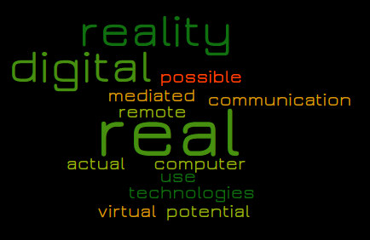
- not real, remote
- virtual reality
- digital technologies
- digital reality
- real but not actual
- possible, potential and real
- use of computer mediated
- communication

An etymological definition of virtuality
According to the online etymological dictionary the word virtual appeared in the late 14th century and draws its meaning from the medieval Latin word virtualis and the Latin virtus meaning "excellence, potency, efficacy". But by late 1950s, it started taking up a new meaning of "not physically existing but made to appear by software". Today the common meaning of virtuality and working virtual refers to people meeting and communicating using electronic devices and the internet, in other words, being online.
Source: https://www.etymonline.com/word/virtual

1.3 Virtuality, what are we talking about?
According to Gibson and Gibbs (2006) and Köppel (2007), a number of different criteria are used to characterise virtual teamwork, although most authors agree on the aspects of geographical dispersion and communication that is dependent on electronic devices. These are also the most prominent characteristics commonly studied by scholars. However, as Gibson and Gibbs (2006) argue, the variables dynamic structure, diversity as well as communicative climate need to be added if we want to understand the challenges thrown up by virtuality. This is because they are likely to have unique effects on the performance and satisfaction experienced within the team. Let us look at them in more detail:
- geographic dispersion
- electronic dependence
- dynamic structure
- diversity
- communicative climate
As geographic dispersion of team members can mean both communicating with colleagues from our home office as well as communicating with business partners located in another country, it therefore makes sense to consider geographical dispersion as a continuum, rather than a binary either/or proposition. Thus we can speak of 'the degree' of virtuality or physical dispersion, and this degree is likely to influence the flow of communication into the team and within the team. One of the reasons for this is that team members who are highly dispersed are likely to be embedded in different external contexts and therefore have less shared contextual knowledge, and a far greater understanding of their own specific context. For example, team members who are situated in the same city are likely to anticipate common knowledge related to their environment and may take this knowledge for granted and therefore not feel the need to articulate its relevance to team members from other locations. Co-location is hence likely to facilitate interaction and the development of a common ground of understanding, which in turn supports information sharing. It becomes even more complex when some of the team members have a low level of virtuality and can meet in person, whereas the other members of the team are limited in their interaction due to their geographical location. Physical proximity also influences the possibilities for synchronicity in the team members' virtual interactions. And as the following quote shows, geographical dispersion also means being able to work independently of location and/or time:
"It's awesome that you can communicate with each other regardless of TIME, regardless of location. This means that I don't have to be in a room with two people to discuss some topic, I just write a message in a group chat at eleven o'clock on Thursday evening and get an answer on Friday morning from someone somewhere in [China]."
Given the fact that geographical dispersion has an influence on possible time windows for synchronous meetings, the degree of geographical dispersion is also likely to have an influence on the logistical administration required for gathering and coordinating resources. Making sure that team members are appreciated and not left out of decision processes because they are not physically present is one important factor here. In summary, geographical dispersion poses challenges when dealing with reduced contextual knowledge among team members as well as extra costs for coordinating resources.
Because some teams rely more on technology-mediated communication than others, electronic dependence should also be considered as a continuum along which teams can be located. A team which communicates entirely through e-mails, text exchange and video conferences, for example, is much more electronically dependent than teams which have the opportunity to meet face-to-face at least occasionally. According to research results, reliance on technology-mediated communication influences factors such as monitoring, opportunities for informal feedback, and the ability to interpret information correctly. A crucial side effect of communicating virtually is that it encourages the use of a more direct style of communication with fewer social cues. In text communication, for example, non-verbal cues such as the tone of voice are extremely important in conveying how you wish a message to be understood. Also, opportunities for informal feedback are fewer, and therefore the social framing of messages is less distinct. Difficulties in interpretation not only lead to misunderstandings but also to wrong conclusions and often judgments and assumptions about other team members. In sum, it can be said that the level of electronic dependence may influence the understanding of messages and thus the quality of teamwork.
However, exposure to new technologies and the developing the knowledge and skills related to them is certainly a distinct advantage:
"And ALSO dealing with new technologies. In other companies, which don’t practice working in virtual teams, the technical mindset of employees is developed accordingly."
The next factor, dynamic structure (Gibson & Gibbs, 2006) refers to the frequency with which team membership changes, roles are rearranged and relationships among team members shift. We are therefore talking about the nature and the dynamics of the team structure and its relationships. On the one hand some people might partner with others through informal, temporary and relatively unstructured arrangements, whereas on the other, some teams might be characterised by relative stability, long term duration and established role sharing. The structural dynamics of a team influences the development of trust, the level of uncertainty and perceived risk, and the potential for establishing routines and thus a collective virtual culture. The level of uncertainty felt when working in a team in turn influences the willingness and openness to share information. A high turnover of team members influences the propensity to develop relationships and establish an organisational memory, thereby strengthening social ties and relationships among team members. The strength of these ties guides the amount of interactions, the emotional intensity and the level of reciprocity between team members.
Another feature which requires consideration is diversity. Because technological advancements provide the opportunity to work across national boundaries, in the early literature on virtual teams, scholars such as Gibson and Gibbs (2006) focused their attention on national diversity and thus ‘passport identity’. However, given the fact that team diversity exists along many different dimensions, this is a narrow perspective assuming a high level of homogeneity within countries and nationality as a superordinate determinant of identity. It therefore makes sense that more recently Gibbs et al (2017) started to turn their attention to cultural and functional diversity. Functional diversity is understood to be the degree to which different areas of expertise are present in a team. One of the specific challenges in such teams relates to knowledge integration, since team members from different professional backgrounds may use specific jargon and face conflicting priorities due to their specific function and roles.
Diversity in its broad sense encompasses aspects such as age, gender, educational and work background, socio economic status, parental situation or caring responsibilities. These might be strong sources of identity and influence the teamwork to varying degrees. As the following quote indicates, appreciating and managing diversity has become an important part of most companies' culture:
"At Henkel, we promote a holistic Diversity & Inclusion approach. The diversity of our employees, their backgrounds, experiences, talents, knowledge, creativity, and the appreciation of all their individual differences are the foundation for our competitive advantage. As a multinational corporation, Henkel employs people from 120 nations in almost 80 countries. About 85 percent of our employees work outside of Germany, with more than half of them in emerging markets. We believe that a company culture focused on diversity and inclusion is the key driver of creativity, innovation, and invention."
Source: https://www.henkel.com/company/diversity-and-inclusion (accessed on 30.10.2020, used with permission)

The challenge for virtual teams is thus to identify diversity domains which have a strong influence on teamwork and subsequently clarify the differences in work behaviour which may be linked to these. The team's task is use this diversity as a means to work productively, while viewing differences as an opportunity, and the basis for developing a shared overall work culture and vision.
Cultural diversity encompasses a range of differences in organisational, national and individual cultural affiliations. Despite the fact that national diversity is a rather broad and generalising categorisation, Gibbs et al (2017) argue that it is particularly salient because perceived national cultural differences may be a source of stereotyping, communication barriers and interpersonal conflicts which may hamper team communication, cohesion and shared understanding. They maintain that teams working across national boundaries need to pay particular attention to be aware of and tackle these challenges and communication obstacles.
If we understand cultural diversity based on an open definition of culture, then this means acknowledging membership of a variety of obvious but also less obvious collectives. A collective in this context is a group of people for whom it makes sense to come together for any number of reasons, ranging from a rowing club to a corporate organisation or nation state. This refers to a lifeworld, or living environment understanding of culture, which emphasises the heterogeneity present within the confines of a nation or an organisation, and allows for multiple layers of cultural affiliation and involvement which may overlap or even contradict each other. Team members can thus be considered to be multi-collective. The challenge, when working together, is thus to identify individual membership of collectives which have the potential to support the group's orientation around commonalities and therefore encourage team cohesion and the creation of normality. Overall it is crucial to identify hitherto unknown differences but also commonalities relevant in the context of the teamwork.
The last feature to be considered relates to the communicative climate. This can be understood as the atmosphere, or the social tone in which a communication takes place or the overall feeling or emotional mood between team members. It focuses on a broad set of communication behaviour and the way team members interact with each other. According to Gibson and Gibbs (2006), a psychologically safe communication climate is one in which team members trust each other and therefore are ready to assume that the behaviour and actions of the other team members will be of benefit to the overall team goals. As a consequence, they are also willing to accept reflective or friction-causing actions such as being vulnerable, admitting mistakes, questioning routines and searching for feedback in order to deal with problems. It is also characterised by mutual support and respect, openness and readiness to take risks. As such, the level of perceived communication climate plays a critical role in supporting team learning and sharing among team members. A positive communication climate supports people's propensity to engage in spontaneous and informal communication, provide unsolicited information, suspend judgement of other team members, raise differences in discussion, remain open to other ideas and perspectives, and engage in active listening. A safe psychological climate also has the potential to bridge any differences which may occur due to the diversity of team members and support people's readiness to use differences as an opportunity rather than a threat or disturbance. In this way the team can develop a shared, positive framing of the concept of difference and thus build a productive virtual team culture. By developing a psychologically safe communication climate, many of the challenges posed by virtuality can be mitigated and even transformed into an opportunity, thus supporting team satisfaction and task performance.

In conclusion, it can be said that virtual teams are teams whose members use a variety of information and communication technologies, are geographically dispersed, are diverse and pursue a common purpose. The degree to which these features are relevant vary, and they may be complemented by other features such as temporary dispersion. The virtuality of a team should thus be considered as a continuum ranging from low to high virtuality. A team with the highest degree of virtuality would be one in which members are located in opposite time zones, are heavily dependent on technologically mediated tools, whose members never get to know each other in persona, and display a high level of cultural and functional diversity.

1.4 Different types of virtual teams
If we consider key characteristics related to teams such as geographical dispersion, team members' objectives and roles, the flexibility of structural arrangements, the level of diversity and finally the team's electronic dependence, then we can distinguish some emergent team types:
Project or product development teams
These can be considered to be the most traditional virtual teams, which started to come into existence in the 1990s. They consist of experts on a subject matter, sometimes from different places across the globe, who get together to work on a very specific task, for example a new product. Such teams are often characterised by a high level of professional homogeneity but also a high level of cultural heterogeneity. An example of such teams are software development teams. However, they can also include a high level of functional diversity, for example when a team is tasked with finding a technical business solution, which may include expertise in engineering, user experience design and graphic design, for example.
Work, production or functional teams
These are teams which tend to have a high level of structural embeddedness in an organisation. Team members typically have clearly defined roles and tasks, enabling them to work independently. However, they are members of teams that need to combine their work in order to produce an end result. Hence they come together to exchange views on the development of their work, streamline work processes and coordinate tasks.
Action teams
Action teams are teams that get together on an ad hoc basis, for example because there is an urgent issue to be tackled. They are often asked to offer an immediate response to a problem, whereby the minute the problem has been solved, they also disperse. These teams are strictly task oriented and therefore other characteristics are subordinated.
Agile teams
These are self-organised and self-dependent teams which are able to handle complex tasks in a very productive, flexible and creative manner. They are cross-functional teams, so every team member has a broad set of social and professional skills, which are required to fulfil the project. As self-responsibility is one of the main characteristics, hierarchy levels are flat. Agile teams act autonomously and are generally not dependent on other teams. They are therefore responsible for risks and delays, since they often do not depend on other teams.
Management teams
Management teams are formed by managers of an organisation, who may come from different countries and cities around the world. They operate and coordinate at the higher levels of an organisation and may or may not be geographically dispersed.

Task: Teams and their level of virtuality
When looking at virtual teamwork from a perceptual perspective we can consider its discontinuities. Considering a team you have been working with or intend to work with, note down in your learning journal how you would assess its level of virtuality. In order to do this, refer to the five factors that were discussed and, for each one of them, rate your team’s level of virtuality from 1 (low) to 2 (medium) to 3 (high):
- Geographical dispersion
- Electronic dependence
- Level of diversity of team members
- Flexibility of structural arrangements
- Safety of communication climate

1.5 Virtual team competencies – a general introduction
In the previous section we outlined the different types of virtual team and their characteristics. On this basis we can now start to consider which general and specific competencies might support virtual teamwork. What follows therefore, is a discussion of the challenges of virtual teamwork and the competencies needed for good team performance and satisfaction among team members.
A competence can generally be understood as a cluster of related knowledge, skills and attitudes (KSAs) that influence and guide performance and team satisfaction, which can be enhanced through training. In this context, it can be understood as the ability to establish ‘routines’ and a sense of 'normality' in teamwork, which facilitate the desired outcome successfully. In the context of working remotely, Wang and Haggerty (2009) define virtual competence “…as the extent of an individual’s KSAs to work and communicate in virtual environments for the purpose of completing collaborative virtual work projects” (p.578). We can say in general that when acquiring competencies, the ability to apply self-reflection and critical thinking in order to assimilate and analyse new knowledge and skills is critical. This in turn requires an openness, curiosity and respect towards others and the ability to empathise with team members while considering their perspectives. Competencies thus need to be seen as complex multi-dimensional constructs.
In the context of the multi-faceted nature of virtual teams, competencies are required in order to tackle challenges linked to technology and geographical dispersion as well as cultural diversity and team related challenges. Schulze and Krumm (2017) mention that research on required competencies for effective and satisfying virtual teamwork is still scarce. The approach taken here is to discuss the specific competencies which might positively influence team effectiveness and team satisfaction.

Technology-related competencies
Having the skills and proficiency to apply available communication technologies such as email, instant messaging, telephone or video conferencing is a basic requirement for teamwork. In fact it is the enabler of virtual teamwork. Digital media skills go beyond the mere technical expertise of simply operating the respective tools. It also involves exploiting their potentials appropriately, in order to facilitate collaborative activities in a virtual setting. At times this is also referred to as digital fluency, understood as the ability to select and use the technology that is most suitable to achieve a particular outcome in a particular context.
One important choice to be made is, for example, between synchronous and asynchronous media. Whereas synchronous media such as video conferencing enable teams to move together at the same time, asynchronous media allow team members to access information when time and circumstances allow. Generally speaking, therefore, a synchronous medium such as video is a better choice for goals such as the development of mutual understanding, collective sense making and defining goals, whereas asynchronous media is more appropriate for disseminating and processing large amounts of information.
Media skills are performative and a lack of proficiency influences the entire communication flow and coordination. For example, although it can be assumed that the functionalities of emails are widely known, when and how best to use them in a virtual team setting requires consideration and expertise. This means that the competency level refers to the ability to use information and communication technologies for the benefit of the team's objectives.
A competency closely linked to technology use is remote self-efficacy, which relates to an individual’s belief and judgment about his or her ability to use and orchestrate an expanding IT toolkit. In addition, each member's confidence in their ability to work well with others in a remote setting is key. This is of particular relevance because working remotely in different contexts is, for many, still an uncommon way of working and the lack of face-to-face contact can have profound effects on how the team works.
Individuals with a high level of self-efficacy in virtual environments tend to be persistent in their search for mechanisms that will overcome obstacles. These individuals are motivated to mobilise efforts when dealing with non-technical issues in the absence of face-to-face interaction. With the confidence to deal with both technical and non-technical issues, they are able to develop effective communication strategies and thus improve knowledge transfer. Self-efficacy in the virtual environment is thus a key concept in enabling team members to cope and persist through difficulties in their work context.
Whereas virtual media competency is linked to concrete capabilities and skills in the use of the technologies available to them, emphasising the 'how', virtual self-efficacy focuses more on the ‘knowing what’ which is belief and attitude oriented. Both are vital to ensure team performance.
Media skills are an important stepping stone for the development of common ground as they can support relationship building, cohesion and ensure effective and trustworthy communication within a team.

Geographical dispersion related competencies
Geographical dispersion also brings about specific challenges, which need to be addressed. A key issue here is that the further away team members are, the more likely they are to span different time zones. This can easily lead to communication and emotional disconnects. When only one or a few team members work from further afield, their geographical dispersion may result in low visibility and a feeling of being isolated and not included. Such a working environment will undoubtedly require keen coordination skills on the part of the team leader or leaders and the team members themselves. It will also require the willingness to deal with time issues, make an extra effort to ensure the accessibility of information and readiness among team members to extend their working hours beyond the norm.
Temporal dispersion means that working hours do not necessarily overlap, and vacation times also may not coincide. On a micro-level, it also requires understanding among team members that considerable time might elapse before receiving a response to an email, for example. This understanding will avoid frustration and feelings of rejection or accusations of incompetence.
Geographical dispersion may mean less interaction and a greater degree of work autonomy, which requires enhanced self and time management skills such as careful planning, strategising and scheduling. Time and self-management skills are particularly relevant in companies which are keen to ensure a work-life balance or are compelled to do so by governmental regulations. In such contexts, setting clear limits for times when meetings should take place, either early mornings or late evenings in order to accommodate different time zones is of particular importance.
All areas related to virtual teamwork overlap, as do the competencies that are required to mitigate its challenges. Even though the causes can appear to be quite different, all challenges can be subsumed under the dominant issues of communication, trust, relationship building and developing common ground. Dealing with these issues is thus central to ensuring good team performance and satisfaction.

Diversity related competencies
Diversity in general and in particular cultural diversity increases the likelihood that team members will not share common ground. This means that they may not share meanings, have similar communication styles or relationship building strategies, common understandings of team goals, shared mental models of work processes or media skills. One of the major challenges in virtual teams is thus to recognise in which areas the team shares common ground, and in which areas development is required through implementation of appropriate knowledge and skills.
Virtual diversity competencies thus converge on the ability to positively influence collaboration and the development of supportive relationships among diverse team members in a virtual context. Generally speaking, this includes the ability to communicate with people of other cultures in a way that supports mutual understanding, earns their respect and trust, while encouraging a cooperative and productive virtual workplace conducive to the achievement of team goals and team satisfaction.
This skill set represents both the ‘knowing what’ and the ‘knowing how’, because it refers to understanding the uniqueness of encounters in virtual settings and having the skills to handle them adequately, effectively and efficiently.
Broadly speaking, three areas of virtual diversity competence can be distinguished: openness, emotional strength, and willingness to communicate. When it comes to openness, this is an attitude that involves being receptive to a wide range of ideas and ways of doing things. Having an open mind is a necessary requirement in order to think critically and rationally.
Being open minded means being ready to step out of one's comfort zone and the readiness to listen to and consider a variety of factors that might contribute to effective teamwork or resolve a problem. This is not necessarily as easy as it might sound, and requires a readiness to change and maybe also revising beliefs and work routines. It is only openness that bears the potential for learning and personal growth.
Emotional strength is also key to negotiating one's way through ambiguous and unfamiliar work situations. It is understood as the capacity to respond to uncertain situations in an open and vulnerable way and to acknowledge the emotions linked to dealing with uncertainties.
Another vital area is linguistic communication. Communicative competence includes an awareness of barriers to communication, especially when a team uses a common language, which is not the mother language for some or all of the members. In this respect, the different accents used in virtual team meetings can hamper understanding, as can a lack of vocabulary. This can lead to considerable misunderstandings and information gaps. Here it is crucial to be ready to practise active listening, i.e. the act of listening attentively, checking and clarifying issues where the need arises, rather than assuming common understanding.
Another area closely linked to this is the understanding and interpretation of intentions. This refers to our automatic ability to ‘read’ other people’s intentions, which we use to interpret and predict what someone is going to do. However, in a virtual context, there are different cues than in a face-to-face interaction, which means that we are not necessarily exposed to the same visual, verbal and auditory codes that we are used to in order to anticipate the other's intention. Of course, even in a face-to-face situation, we do not always interpret these codes correctly, but in a virtual context we need to make a special effort to understand the intentions of our team members correctly. Hence it is important to create an environment that supports virtual team members being transparent and vocal about their intentions. This is even more important in an intercultural context where the likelihood of misreading intentions may be even higher. The goal in a virtual team should thus be to share intentions and develop common habitual social practices.

Team related competencies
Virtual team competencies are closely linked to communication and include the flexibility and ability to develop interactional routines. With regard to flexibility, the ability to both adapt behaviour as well as suspend judgement are key. Adaptive behaviour can be understood in the sense that team members need to flexibly select from a repertoire of actions those that fit a range of different social and intercultural situations as well as unexpected circumstances. Closely linked to flexible behaviour is the willingness to suspend judgement, meaning that we withhold judgement and don’t become attached to conclusions which may be based on assumptions and subjective perceptions. Instead you willingly and purposely postpone a judgment or a decision until you have the relevant information, while questioning your assumptions and perceptions.
In many instances, teams are put together because they seem best fit to carry out a task but often teams are thrown together due to circumstances. They may not know each other and if they have come from different disciplines or backgrounds are likely to have different ways of working, cooperating and problem-solving. In such an environment it is important to develop and synchronise interactional routines, meaning that team members need to develop an understanding of how they want to work together and how best they can make use of the resources in the team in order to achieve good results and a positive working climate. 'Reflected awareness' can help here, which includes the ability to become conscious about one’s own pattern of communication and routinized work behaviour within a team. This could be summarised by the phrase ‘how I usually do things’ and can be complemented by considering how this behaviour is perceived by others. This is of particular relevance in teams whose members do not know each other and are highly diverse.
A further requisite for successful virtual teamwork is the willingness and ability to consider different perspectives. This may be more difficult than it sounds, as it requires not only the readiness to acknowledge that there may be more than one way of looking at something, but also giving the other idea sufficient attention and value. It also implies a readiness to incorporate others' ideas into the team's consensus-built 'way of doing things'.
If team members are able to see issues from different angles, then they can shift gears and take a fresh look at developing cooperative and inclusive work behaviour. This also opens avenues into possible solutions that nobody would have been able to think of had each party been solely concentrated on their own ideas. This is often referred to as the ‘third way’ or new thinking. If team members are receptive to new ideas and ready to venture into new and unfamiliar fields, they are not only exposed to new ideas and approaches but lay new pathways for exploring novel ways of thinking and thus become more innovative.
***
In conclusion, it can be said that a high level of virtually denotes a team in which members are located in opposite time zones, are heavily dependent on technologically mediated tools, whose members never meet their team members in person and are culturally and functional diverse. Virtuality thereby should be seen as a continuum ranging from low to high levels of virtuality. Whereas early scholars of 'virtuality' used objective measures such as physical distance between office locations, the number of countries involved and the frequency of face-to-face meetings, there has been a gradual shift towards regarding virtuality as a subjectively and psychologically perceived experience.
Virtual teams can be defined as:
"…teams whose members use technology to varying degrees in working across locational, temporal, and relational boundaries to accomplish an interdependent task."
Source: Martins, L. L. et al. (2004). Journal of management, p. 808.
This definition stresses membership of a team and working at a certain level of virtuality.
No matter whether we refer to the attribute of communication, behaviour or knowledge, the starting point is always the awareness of the self and our own multiple cultural affiliations as a reference point. Being aware of our own communication style, behavioural patterns in a specific environment and the knowledge we have of a specific culture helps us to assess, question and adjust in intercultural virtual work contexts. In this way we can be sensitive to other team member’s perspectives and values, no matter how strange and puzzling they might seem initially. All these elements help to develop a common ground of understanding, which is key for team performance and satisfaction in a virtual environment.

Task: Competencies an virtual teams
Below are listed some competencies supporting the effectiness of virtual teamwork. You will also find this list in your learning journal, together with the above mentioned categories in which these competencies can be classified: Please click on the dropdown box next to each item and choose the category of competencies it belongs to.
- Professional usage of information and communication technologies
- Open-mindedness towards different ideas
- Managing teamwork across different time-zones
- Flexibility in dealing with unexpected circumstances
- Readiness to change one’s beliefs and work routines
- Suspending judgement
- Perceiving communication- and language-related challenges and addressing them adequately
- Ensuring the visibility of each team member
- Interpreting communicative cues to understand other person’s intentions
- Choosing between synchronous and asynchronous media
- Working autonomously
- Emotional strength in dealing with uncertainty
- Time- and self-management skills
- Reflected awareness of one’s own concepts, perceptions and routines
- Virtual self-efficacy and confidence in one’s skills of working in a remote setting
- Developing and synchronising interactional routines
- Avoiding isolation and emotional disconnection
- Switching between different perspectives
- Readiness to step out of one’s comfort zone

1.6 Summary
In order to meet the challenges of today’s business environment, working in teams has become commonplace. With the opportunities made possible by technological developments, these teams are becoming increasingly virtual, i.e. geographically dispersed and using technology-mediated communication. Because almost all knowledge workers use technology-mediated tools and thus work virtually, it is important to acknowledge the 'level' of virtuality when discussing the development and challenges of virtual teams.
As working with different levels of virtuality is becoming more common, the competencies required to perform these tasks need to be investigated and refined. The areas in which skills will need to be honed are, along with general teamwork skills, the optimal use of technological devices and communication strategies to deal with geographical dispersion and diversity.

1.7 Learning review
Having discussed the relevance of virtual teamwork in the context of a changing work environment as well as the importance of recognising the degrees of virtuality, you should now be able to define and identify the level of virtuality of a team as well as the required competencies in virtual work places.
The following two case studies will help you to assess your learnings.

Task: Case "IT problems"
Thiago works as an IT specialist in a company that produces equipment used in farming in Brazil. He was assigned to implement a national customer management system with a project team. He is of Brazilian descent, and even though his company has its headquarters in India, his teammates all work from Brazil. He feels fortunate, as he finds communication easier when everyone speaks the same language. Of course, it also helps that everyone in his project team has been working in this company for many years now, including the colleagues from Sales. Now 12 sales managers and specialists are collaborating with the 4 people from the IT department to reach the goal. As the sales department ordered this system, it is crucial that the new platform will be tending to their needs.
What Thiago finds challenging is that almost all of the sales colleagues in the project team are constantly working on the road, some of them in places with bad internet connection. It makes simple things as video calls immensely difficult. Even simple phone calls can pose a challenge, as because of the nature of their product, many sales representatives work in areas with bad network coverage, which makes it only possible to connect when they are back in their hotels in the evening.
Of course, whenever Thiago works with people outside of his own department, he is used to a very different knowledge level on IT-systems. He knows how important it is to get everyone on board first. However, his company also just went through a major upgrade in IT-hardware and software systems, which is great. Unless you see that some of his team mates have not upgraded their systems yet, and thus work with very different hard- and software specifications.
Where do you see the level of challenges on these dimensions?
Please rate it from 1 (little to no challenges expected here) over 2 (probably some challenges here to focus on) to 3 (highly challenging- strong focus on this needed).
Most importantly, also write down your reasons for your ratings. Please also keep in mind that there is no strict "right" or "wrong" answer. Depending on the interpretation, many different evaluations could be argued.
- Geographical dispersion
- Electronic dependence
- Level of diversity of team members
- Flexibility of structural arrangements
- Safety of communication climate

Sample answer
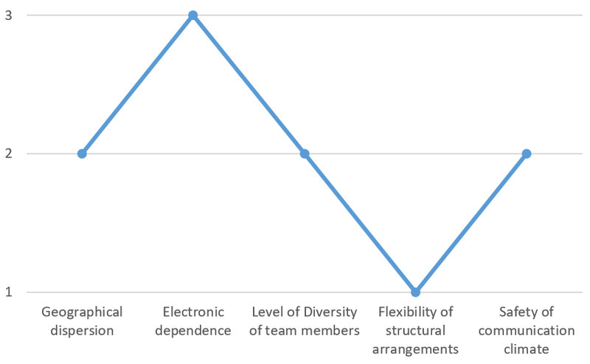
Geographical dispersion: 2
Even though the team all works in Brazil, we should keep in mind that this country (including its offshore islands) is spread within 4 different time zones. Also, given the sales team might not often come into the headquarters to learn about new developments here, we might want to take the gross difference of environment of the different team members into account. Thus, the Geographical dispersion of the team should be considered, but might not be the largest challenge in this case.
Competencies needed:
We would have to keep in mind which regions in Brazil the team is working from, and thus how to deal with possible different time zones.

Electronic dependence: 3
Given the information in this case, we might expect the highest rate of challenge here. Which challenges of electronic dependence do we expect?
The sales representatives ordered the system, which means the IT department is likely dependent on their constant input. This is being made difficult by the fact that those representatives are constantly on the road, which make face-to-face meetings rarely an option. The need for virtual communication is thus high.
As many customers and thus the sales people are located in remote areas, the network connection seems to pose a challenge. Internet is as unreliable as phone coverage. This makes it difficult to spontaneously ask questions when they arise from both sides. It also makes it difficult to use visual contact for team conferences, limiting the format more often to audio-based conversation. The low bandwith also enforces more communication via Email or file sharing platforms like clouds. Sending large amount of data might also prove to be difficult with slow connections.
Another challenge here is the diversity of IT-knowledge, which means not everyone in the team might be aware on how to use e.g. cloud software right away. The IT-Team would need to make sure everyone is on the same knowledge level where it is needed.
The members of this project team also use different soft- and hardware platforms. Software like videochat or cloud platforms might have certain technical requirements that not everyone in the team meets. Even certain documents might look different depending on the software version, which might lead to misunderstandings in the collaboration.
Competencies needed:
As the need for communication in this case is high, and only possible on virtual basis, we need to ensure that following factors are kept in mind when choosing a strategy:
What are the communication needs of the team? What needs to communicate what at what time? How is the reporting and decision making flow?
Based on this, we need to come up with a technical platform that is as low-tech as possible, but still serves the communication needs. One example could be to design a well-structured cloud, in which to collect all needed information. It would enable to the team members to access the information on their own terms, instead of being overly dependent on synchronous methods like phone or video conferences.
The third step would be to make sure every team member has the needed hard- and software as well as the training needed for this particular virtual team collaboration.
Level of diversity of team members: 2
In this given case, we do not find any explicit mention of a high level of diversity. The majority of the team members have been working for the same company for a longer time, all speak the same language. Also, the team most likely grew up in the same country. However, even in a case like this, which shows many common areas, we should not forget that a high diversity is still possible.
We do not know anything about the age structure of the team members. People of different generations might have different perspectives on teamwork or project goals. Some of this team members might also have children, which might lead to a different focus on works-life balance. Of course, the individuals will likely also have their own personalities and strengths, which also might lead to a different preference in communication styles or work processes.

We see that even in a superficially homogeneous team as the one presented in this case, high level of diversity is generally possible. Since there should always be a higher awareness in this area, we would position this point on the level 2. We will discuss the details of possible diverse backgrounds of individual team members in session 4: Team roles.
Competencies needed:
One way to deal with a possibly hidden diversity in the team is with an anonymous survey, e.g. to ask about expectations, goals and feedback for the process so far. It could make possible differences within the team more transparent, and would enable the project leaders to deal with them.
Flexibility of structural arrangements: 1
Given the fact that the described team members in this case have all been working for the company for many years, and no turnover of staff is being projected, we can assume a rather low challenge in this area.
Competencies needed:
If a turnover within the team should arise, it would be important to put effort in a proper on-boarding on the milestones and decisions made so far.
Safety of communication climate: 2
The case does not explicitly state larger challenges here, like e.g. emotional conflicts between the team members or a gross difference of goals within this project. As with the point of "Diversity of team members" though, it is always important to have a focus on possible upcoming challenges here, as well as making sure that the atmosphere within the team stays positive.
Competencies needed:
Based on a possible survey on point 3, the team leaders could present the results in a proper way, and could discuss or present a possible way to deal with different expectations and goals within the team. Also a feedback cycle could be designed to ensure that possible challenges are also being addressed on time in the future. Lastly, it is important for the communication climate not only to discuss challenges, but also to celebrate successes. When particular sales representatives are back in the headquarters for some time, it could be a good idea to take some time to bond with these people, based on the individual needs.

Task: Case "Designing a new office chair"
Maryam from Dubai in the United Arab Emirates works for a US-American company that produces office furniture. She is working in the Marketing Department, and was assigned by her supervisor to work in a project team to brainstorm new ideas for a new premium office chair. Since it is important that this new chair will fit the customs and needs of customers worldwide, the designing team consists of members from China, Japan, Germany, France, South Africa, Brazil and the USA – all the major markets of the company. Instead of having the new product go over different stations one by one, her company decided to have the 15 project team members to come from different departments. This way, possible roadblocks and needs of all relevant departments can be aligned from the first step of designing this new product. Thus, several members of the team are from Research and Development, whereas others are from Sales, Production, Logistics, Purchasing or Marketing like Maryam.
Even though the cooperation is purely virtual and she has never really met any of her colleagues outside of Duabai, she enjoys working on her first international project. From the first week on, she notices several differences on how the project manager from the USA would create a meeting, or how her colleagues from different countries and departments would communicate with each other over email or in a phone conference. She also notices that the commitment level of her colleagues seems to differ at times. She assumes one of the reasons for this might be the different hierarchy level of the team members, as there are specialists and different levels of managers on board the team.
What Maryam finds challenging though is that some of the colleagues have not been in the company very long. She feels there is an especially high turnover from countries with high speed emerging markets, such as her own contry. In the three months she has been working on this project now, four of the colleagues have changed to another department or to another company, and it always took some work to get everyone back on board. Since this project was initiated from upper management, and it was made clear that there are high hopes in the company for this new product, she feels that at least everyone is highly motivated and responsive. The company has invested in new IT equipment and training, which makes the virtual collaboration a lot easier.
Where do you see the level of challenges on these dimensions?
Please rate it from 1 (little to no challenges expected here) over 2 (probably some challenges here to focus on) to 3 (highly challenging- strong focus on this needed).
Most importantly, also write down your reasons for your ratings. Please also keep in mind that there is no strict "right" or "wrong" answer. Depending on the interpretation, many different evaluations could be argued.
- Geographical dispersion
- Electronic dependence
- Level of diversity of team members
- Flexibility of structural arrangements
- Safety of communication climate

Sample answer
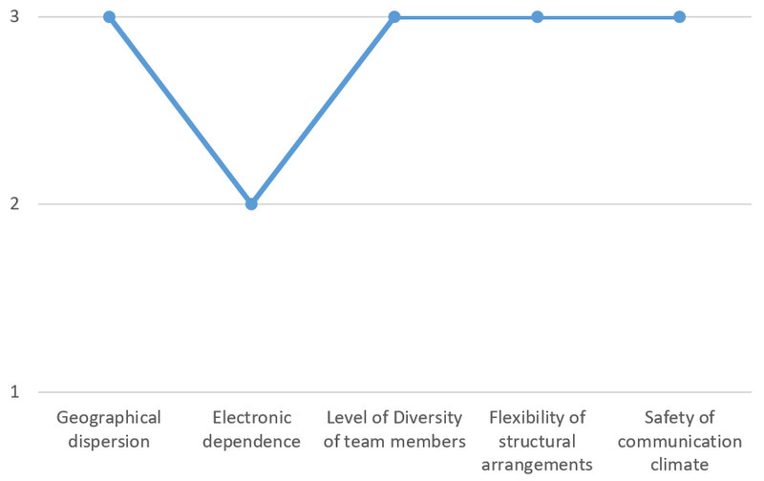

Geographical dispersion: 3
This dimension is certainly highly challenging in our case. The team consists of members of 8 countries spanning 5 continents, which will make dealing with different time zones challenging.
Competencies needed:
It will be important to find ways to incorporate these different times into deadlines or conferences of any kind. Also, we should consider how to get as much work done as possible in an asynchronous matter- which means with people working on the project on their own times, and without e.g. daily conferences.
Electronic dependence: 2
The Electronic dependence could be rated with a 2. On the one hand, the technical environment seems to be conducive of virtual work: The team shares the same hard- and software platforms and is trained to used them. On the other hand: Because the entire team is spread around the world, it will be difficult for the team members to meet each other face to face to work on this project. The team will have to depend heavily on electronic communication.
Competencies needed:
Given that the technical platforms and training seem to be in place for our case, our project leaders will have to ensure that they are using the right tools and methods to accommodate for the variety of geographical and other backgrounds (see later challenges)
Level of diversity of team members: 3
This is clearly another big challenge for our team. From the fact given in our case, we have a high level of diversity amongst our 15 project team members. Here are some examples of the types of diversity we are presented with:
a) The team consists of members of different functions and hierarchies.
The different hierarchies in this case might mean that there are different interests to bring together. Some of the managers might be able to prioritize the work for this project themselves, whereas some specialists might have to coordinate their work for this project for example for some other urgent work for their supervisors.
b) Members of the team are based on 5 different continents, and might be used to other ways of work.
For people in some countries, it might be very normal to conduct phone conferences at night, in order to accommodate for other time zones, whereas this might be highly unusual in other areas. Some of the team members also might be used to different styles of leadership, based on the socialization in their countries. As deadlines in some areas of the world are considered to be fixed, they might be in constant negotiation in other places, due to the general dynamic nature of their work environments. All of these different expectations need to be aligned in order to avoid misunderstandings within the team.
c) The project team comes from different departments.
The engineers within the team might also be used to a different set of communication than the marketing people. Of course, the different departments might also have different interests or working speeds that need to be aligned. While Sales might look into the costs of the final product, the engineers within Research and Development might rather look for a perfect function and design of the final product.
d) Other diversity backgrounds not mentioned:
In paragraph b, we discussed that team members might have different work preferences due to their different cultural backgrounds. Of course, all of these different preferences might also be attributed to different personalities. One team member might come from a place where it is generally unusual to work after office hours, or on vacations, but might personally not have a problem with it. Another one might come from a region where late work is expected, but see this as a challenge because he has a baby a home demanding attention at night. All of this diversity concerning the personality or situation of the individual team members might influence their performance.
Competencies needed:
We can see that the explicitly as well as implicitly mentioned diversity in this case is highly challenging. To communicate and bridge these differences will be highly important for the success of this project. One tool we can use here will be introduced in the chapter MBI: How to Map, Bridge and Integrate diversities. We will also discuss this topic further in the chapter on roles and expectations. It is important for the project leader and team members that we need to create a culture where the diversity in this team is being appreciated, and seen as a resource rather than only a challenge.
Flexibility of structural arrangements: 3
We can see that there is a high turnover of staff, which means that new team members need to be constantly “on-boarded”: They need to know and be aligned about former agreements made. They also need to be constantly informed about the general status quo of the project.
Competencies needed:
Given the indication of the past, we can assume that the high turnover within this project might continue. It will be important to install a proper knowledge management system, which includes good documentations on the most important steps to date. It is not enough to assume that “everyone is on board”, but we need to ensure that this will also happen for the future. The project managers might want to install mentors, who are direct contact persons for new members, as well as a good documentation platform that installs all previous agreements and milestones so far.
Safety of communication climate: 3
Even though we did not gain much information on the communication climate, we can see from Maryam's perspective of the case that differences in working styles already emerged. Given the high diversity of the team, as well as the high turnover rate, we can assume that these factors might have a strong impact on the communication climate. The project leaders will thus need to ensure the individual communication needs, based on their respective diversity, is being met.

1.8 Sources, further reading and web links

Sources
- Gibbs, J. L., Kim, Heewon, & Boyraz, M. (2017). Virtual teams. In C. R. Scott, L. K. Lewis, J. R. Barker, J. Keyton, T. Kuhn, & P. K. Turner (Eds.), The international encyclopedia of organizational communication (pp. 1-14). Chichester, West Sussex, UK: Wiley Blackwell.
- Gibson, C. B., & Gibbs, J. L. (2006). Unpacking the concept of virtuality. The effects of geographic dispersion, electronic dependence, dynamic structure, and national diversity on team innovation. Administrative Science Quarterly, 51 (3), pp. 451-495.
- Huber, J., & Reynolds, Christopher (Eds.) (2014). Developing intercultural competence through education. Strasbourg: Council of Europe.
- Köppel, P. (2007). Konflikte und Synergien in multikulturellen Teams. Wiesbaden: Gabler.
- Martins, Luis L.; Lucy L. Gilson & M. Travis Maynard (2004). Virtual Teams: What do we know and where do we go from here? Journal of Management, 30 (6), pp. 805-835.
- Randhawa, V. (2020). Learning in the course of virtual teamwork: A critical analysis with special reference to communication and trust in virtual teams. MA-thesis, Hamburg University of Applied Sciences.
- Schulze, J., & Krumm, S. (2017). The "Virtual team player": A review and initial model of knowledge, skills, abilities, and other characteristics for virtual collaboration. Organizational Psychological Review, 7 (1), pp. 66-95.
- Wang, Y., & Haggerty, N. (2009). Knowledge transfer in virtual settings: the role of individual virtual competency. Information Systems, 19 (6), pp. 571-593.
- Wang, Y., & Haggerty N. (2011). Individual Virtual Competence and its influence on work outcomes. Journal of Management Information Systems, 27 (4), pp. 299-333.

2. Culture and interculturality, a plea for an open and dynamic approach

Topics
2.1 Prelude 23
2.2 Introduction 23
Task: Culture and virtual teams 23
2.3 A narrow and an expanded concept of culture 24
2.4 An open versus closed concept of culture 24
Task: Switzerland from a closed culture perspective 25
Task: Find your own example 28
Task: 'Zooming' – a new perspective on culture 31
2.5 Interculturality 32
2.6 Common cultural misconceptions and the potential of zooming for developing a collaborative team culture 34
Task: Cultural misconceptions and zooming in intercultural communication 34
2.7 Summary 35
2.8 Learning review 36
Task: Working in an intercultural team – some practical questions 36
2.9 Sources, further reading and web links 38

Learning outcome
Applying a dynamic understanding of culture and interculturality, you will recognise cultural features of virtual teams and realise the key aspects of interculturality and its influence on effective teamwork.
* The text of this session was written by Peter Witchalls and is based on texts by Jürgen Bolten, University of Jena (Germany)

2.1 Prelude
In the previous session we outlined the complexities of virtual teams as well as some of the main competencies needed when working in virtual environments. When working in virtual team settings it is highly likely that participants will come from diverse backgrounds and cultures. For this reason, in this unit we will explore culture and subsequently the concept of interculturality. With this in mind, we will introduce intercultural competence as a form of general ‘action competence’ and conclude by discussing the importance of recognizing culture and interculturality in virtual teams.

Download: Learning journal for session 2
Learning journal (.docx) Learning journal (.odt) Learning journal (.rtf)

2.2 Introduction
Culture is a notoriously difficult term to define and explain. In fact, it has become common to use the term as an explanation for many different phenomena. With regard to culture, it is important to stress that when we speak of cultural affiliation, we take it to mean not only nation states but our membership of a whole range of collectives such as age, gender, role, profession, region, education etc. Everyone is a member of many different cultures, some of which influence us greatly and some to a lesser extent. Each of us is therefore a ‘part’ member of many cultures. These cultures and thus collectives are not only numerous and lack sharp boundaries, but are also dynamic, and shaped by the constantly changing relationships and interactions between people.
If this is so, then how can we capture culture and interculturality? And what does this mean in the context of virtual teams? These are the questions we will explore in this session. Let us start by examining the concept of culture itself.

Task: Culture and virtual teams
Look at the word cloud below, which depicts associations connected with culture. Pick some expressions from here, and consider them in relation to culture's influence in the context of virtual teams. Note down your findings in your learning journal.
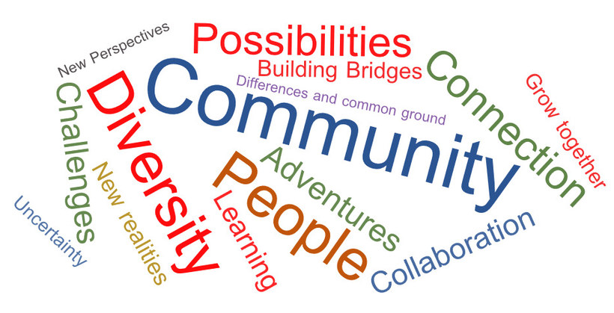
Image developed by Holger Finke for this course

Sample answer
This is what one person noted down:
The word cloud highlights the notions of diversity, collaboration and community. It also points to challenges and possibilities. Linking this to virtual teams, it could mean that a team will need to build a kind of community in order to better collaborate. Doing this on a virtual level could be challenging, but at the same time new possibilities and opportunities could be opened up.

2.3 A narrow and an expanded concept of culture
Working in virtual teams commonly involves performing tasks with people who were socialised in different cultures and contexts, or what sociologists might call lifeworlds (Husserl, 1936). In this sense we refer to culture to mean the all-pervasive social environment that influences what we value, how we think and how we behave in everyday situations. This is known as the expanded concept of culture as opposed to the narrow concept. A narrow concept or ‘high culture’ distinguishes between culture and civilization and refers to the classics, art, architecture and literature, or ‘the beautiful, the true and the good’. Such a narrow concept of culture was advocated by Immanuel Kant and later by Oswald Spengler and was popular until the middle of the twentieth century.
The figure below illustrates these two conceptual views of culture.
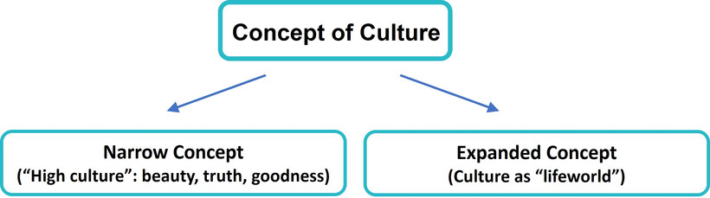
Source: Bolten, Jürgen (2015, p. 46), adapted and translated

2.4 An open versus closed concept of culture
Considering cultures as living environments or lifeworlds means that culture is part of the individual's reality and their environment. Here the lifeworld is seen as the result of the actions of the human beings. Culture as a lifeworld has developed two different variants: the closed conception of culture and the open conception of culture. The closed view of culture embodies the idea that one group of people all possess the same or very similar characteristics and therefore can be clearly defined with sharp boundaries. In contrast, the open view of culture represents a movement away from conceiving cultures as stable and homogenous containers.
However, conceiving of cultures as closed or as containers means leads to considerable contradictions. This can be seen where an attempt is made to clearly define what belongs to a culture and what does not, in the sense of bivalent logic (e.g. 'right/wrong'; 'either/or'). A very typical example of such a thinking would be for example talking about Germans as coffee drinkers and the British as having their tea at five o’clock.
Nevertheless, from a pragmatic point of view, a concept of culture that is closed in this sense may have some advantages since it reduces complexity and, with its typifying simplifications, it enables us to gain an initial orientation with regard to cultural living environments of all kinds. Demarcations, however, are problematic due to migration movements and communication processes that have lasted for thousands of years, and “no living environment is conceivable as a homogeneous culture unaffected by external influences” (Said, 1996).

Task: Switzerland from a closed culture perspective
Switzerland, a comparatively small landlocked country in Europe, is commonly viewed as a country where people speak Swiss German. However, it is bordered by five countries, including Italy to the south and France to the west, with four recognised national languages: German, French, Italian, and Romansh. Furthermore, a distinction can be made between people who speak Swiss German and standard German. Almost two thirds of the population speak more than one language regularly. ("Switzerland", 2021)
If you were only to consider the basic information given here, where might you find indications that a closed concept of culture often does not help us to get to know the people of Switzerland? Note down your answers in your learning journal.

Sample answer
Nations were created through historical processes, such as wars or treaties, and because of this at times people within national boundaries not only share a common government but also a history, a language, common experiences as well as values and norms. Japan is traditionally seen as an example of a nation state displaying a homogenous population group in that sense. However, in many cases, people living within national borders are heterogeneous and in the case of Switzerland, for examples, this relates to languages as well. The fact that so many different languages are spoken in Switzerland suggests that the people may also be diverse on other levels, making it difficult to apply a closed concept of culture to its inhabitants. This should alert us to the importance of being open to cultural differences and avoid making generalisations and assumptions about people. For example, in the case presented, thinking that learning Swiss German will be sufficient to communicate well with the Swiss may actually be a fallacy.
Increasingly, since the mid-1990s or even earlier, an increasing number of arguments have been proposed that reject container thinking. The predominant focus of the criticism has been the idea that culture is synonymous with the nation-state, a type of thinking which is still dominant among the closed variants of the expanded concept of culture. Against the backdrop of globalization processes, however, notions of homogeneity, i.e. that a group of people basically share the same characteristics, are proving to be increasingly untenable since nation-state cultural constructions tempt us into making unrealistic generalizations that encourage stereotypes, as the following example from an intern’s report suggests:
At the office, I asked my supervisor a question, offering two possible solutions (‘Do you think…or should we rather…?’). I wanted to find out which of the two options she preferred. Sadly, she started to reply after the first part of my inquiry and then became furious because I had not waited for her to finish her answer before asking the next question. She argued that it must be because I come from South America that I am not able to wait before immediately asking the next question, thereby confusing the speaker. It may have slipped her mind that I did not grow up in South America.
In the open perspective´s conception of culture, the lifeworld is seen as an open system. It is much more process and knowledge oriented, based on the understanding that culture is dynamic. It is a set of (constantly changing) practices through which social reality is created. Such a process view of culture is linked to an understanding of culture as knowledge. Through learning, individuals acquire knowledge about the way things are done and thereby gradually gain a sense of familiarity. This process leads to cultural cohesion, which means that culture is the glue that connects people. The basis of this is common knowledge and shared meaning.
This understanding of culture has the advantage that it captures the changes within cultures and their dynamics. Thus, culture is diverse, fuzzy, heterogeneous and cohesive. Bolten (2015) describes this perspective as an either/or AND both/and perspective. From this viewpoint, the construction of something that is our own and something that is foreign is no longer tenable. Since the lifeworld is our familiar world, it provides sense and meaningfulness for everyday actions. For the individual, something is meaningful if it is characterized by relevance, plausibility, normality, thus enabling routines (Schütz & Luckmann, 1979, p. 30).
The open view of culture represents a multi-relational type of thinking. According to this, not only national cultures are relevant, but also a range of other cultures, such as profession, age, gender, social or educational status, club affiliation and family among others (Hansen, 2009), all of which influence our values (what is seen as good, bad, to be strived for, to be avoided), behaviour and patterns of thinking. This new open conceptualisation of culture allows for the fact that each person possesses not only multiple affiliations with many different cultures, but also that they might identify with these cultures to a greater or lesser extent. The boundaries from one culture to another are therefore not sharply definable and could be said to be fuzzy (Bolten, 2015). Viewed in this way, the influence of culture on a person’s lifeworld is therefore the ever-changing influence of an intricate and unique mix of the cultures to which they have been exposed or decide to belong.
The following graphic illustrates the narrow and the expanded concept of culture as well as the closed and the open view of culture:
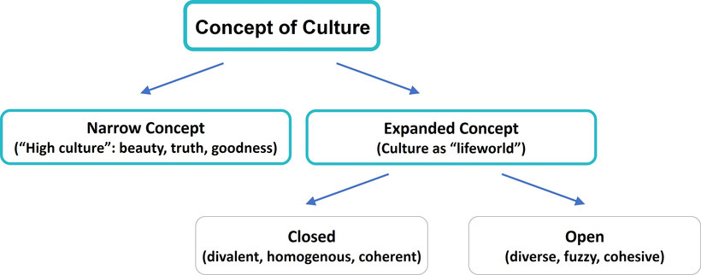
Source: Bolten, Jürgen (2015, p. 46), adapted and translated

Case "Beibei from East Frisia"
Beibei is a freshman at the university and joins an online get-together with lectures and fellow students. She introduces herself to one of the lecturers who comments: ‘Nice to meet you, where do you come from?’ Beibei answers: ‘From Leer’ which is a city in the far north of Germany and which prompts the lecturer to ask: ‘But where do you really come from?’. ‘From East Frisia’ is her reply indicating the region in the north of Germany. And in fact, this is the region where Beibei was born.
Use the closed and open concept of culture to explain the confusion and misunderstanding above. In doing so consider: What are the indications that suggest the lecturer based his question on a closed 'container' type thinking and conception of culture? Please note down your answers in your learning journal.

Sample answer
The reaction of the lecturer leads us to believe that he had a closed concept of culture in mind when posing the question "Where do you really come from?". When Beibei replied that she was from Leer, it is likely that Beibei's name and appearance did not fit his perception of "people from East Frisia", or any other region within Germany. Thus, he probably looked for an alternative explanation that would fit Beibei into a category such as China, for example. By asking Beibei where "she really came from" he indicated that he expected Beibei to feel another affiliation to a region that would fit her appearance and name, at least from the closed culture perspective of the lecturer. Beibei, however, may or may not feel affiliated to a country or region other than East Frisia or Germany.
The fact that there are quite different answers to the question of a person's origin, depending on their point of view, or that someone might have very different roles, makes it difficult to classify them definitively. A non-sharp definition of cultural affiliations therefore corresponds far better to reality: One might have a certain profession but at the same time be involved in numerous other roles and collectives, either within the family or through friendships, leisure or virtual relationships. This type of understanding of multi-collectivity was described by Hansen (2009) and is analogue to Bolten’s notion of multi-relational networks focusing on the relationships between actors (Bolten, 2011).
Along with the individual, this multi-relational concept of culture also affects groups, organizations, and societies in a much more pronounced form, regardless of which cultural actors are involved. Cultures are therefore not conceivable as sharply delimited fields of actors, but should rather be conceived of in terms of their links with other cultures and collectives. As mentioned above, the boundaries are blurred or fuzzy (Bolten, 2015) and should rather be considered as a network.
The following figure shows the networks EGO is a member of by considering four collectives. It shows the linkages and ties between EGO and the people in his/her network but also the relationships between the members. For example, some of the people in the network may be friends as well as fellow students. It also differentiates EGO’s relationships as actively intimate and non-intimate at the time when the image was drawn, showing that not only connections are important, but also the quality of those connections, and that these relationships change over time. For example, through working closely together in a team, a colleague who used to be an acquaintance, may become more of a friend.
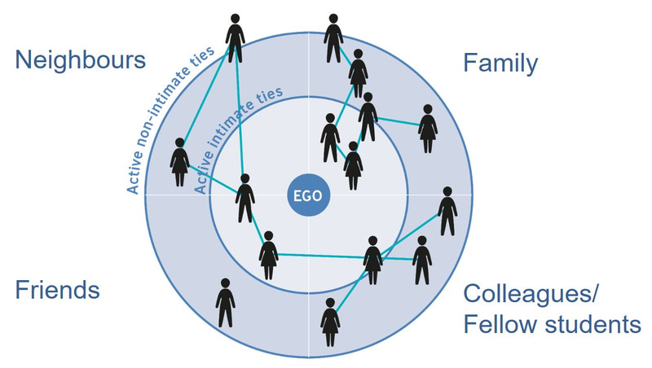
Source: Based on Chua, Vincent, Julia Madej & Barry Wellman (2011, p. 102). Personal communities: the world according to me. In: John Scott and Peter J. Carrington (Eds.), The Sage Handbook of Social Network Analysis. London: Sage Publications, pp. 101-115.
Figure by Julia Flitta (www.julia-flitta.com)
If we view culture in the context of today’s globalization processes, then we can clearly observe that economic, technological and political as well as professional and personal networks have established themselves across national borders. This emphasises the understanding of cultures as open systems and open networks of cohesively connected collectives (Bolten, 2014; Hansen, 2009; Rathje, 2009), rather than coherent constructions of homogeneity.

Task: Find your own example
Understanding culture from an ‘either/or’ AND ‘both/and’ perspective, as the open concept suggests, allows us to consider Beibei’s sense of belonging from a multi-collective and multi-relational perspective. She identifies Leer as her home town and feels attached to it. Her name suggests that she or her family also feels attached to other collectives, which may or may not be China. If this is the case, the answer to the question ‘Where do you come from?’ could be ‘either/or’ AND both/and’, depending on self-ascription. In our case she obviously considered her answer to be the most relevant in the specific context.
Think about an example where an 'either/or' AND 'both/and' perspective could have supported a more differentiated view and note this down in your learning journal.

Sample answer
As an example, take this dialogue between Ian and Gavin from the UK. They chat while waiting for a meeting to start.
Ian:
I am working with this colleague from Bangladesh, Kashif. It’s interesting, but sometimes challenging. It looks like they have a very different understanding of deadlines! It can be frustrating to constantly remind him of the deadlines we agreed on. I know that India and Bangladesh are two different countries, but I visited an intercultural training seminar some time ago, where they explained to us that the attitude towards deadlines is just more relaxed than it is here. That helps me a bit to see that he doesn’t mean it personally at least.
Gavin:
Well, you are right, it is possible that what you observe with Kashif can be explained that way. Have you considered though, that not only is India different from Bangladesh, but that there might also be a big difference between people within these countries? I remember you told me Kashif is new to our company. This might also be influencing his behaviour. We also do not know if he is from the countryside or the city, what his age is, or his general personality. It is even possible that his parents are from the UK, and he himself feels very British. So honestly, I would be a little sceptical with absolute statements from these intercultural workshops, especially when they claim that people from a certain national background necessarily share particular traits. If I were you, I would just take some time to talk to Kashif on an informal level, and see if you can get to know him better, to see what makes him "tick" as a person.
In summary, we view culture as an open, ever-changing system, emphasising its knowledge-based and processual nature. This process aspect of culture leads to cultural cohesion, and thus culture can be seen as the glue that connects people, the basis of which is common knowledge and shared meaning. This understanding of culture is depicted below, and includes the structural as well as the process perspective.
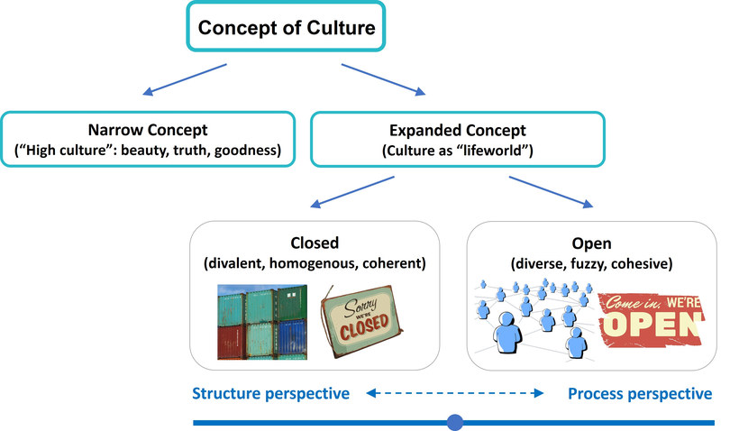
Source: Bolten, Jürgen (2015, p. 46), adapted and translated.
Images by Pixabay. Accessed 15 May 2021. Pixabay License
Using an expanded and open definition of culture requires us to look closer at individuals and their membership of different groups or collectives, thus taking a micro-perspective. If we want to establish a trusting relationship with virtual team members, such a micro-perspective is important in order to gain the necessary in-depth knowledge of the people in our new collective, or team. An in-depth view based on an open definition of culture allows us to take on the aforementioned either/or AND both/and perspective, which enables us to see commonalities as well as differences. With such a perspective, our construction of what belongs to us (‘our own’) and what does not (the ‘foreign’) is no longer tenable and the transition from the ‘unfamiliar other’ to the ‘familiar other’ is gradual and contextual. It helps with the understanding that ‘they are us’. An expanded and open understanding of culture therefore enables opportunities for inclusion and an open, network perspective as the illustration below indicates.
An open concept of culture lays the groundwork for inclusion in the sense that it supports the process of all involved parties becoming part of the collective. In the context of virtual teams this would encourage an awareness of how important it is to establish a collective in such a way that every member feels part of it. The open network perspective takes this a step further by indicating that team members are also members of other collectives. Through these multiple team member affiliations the team can access information that would otherwise have been obscured to them and thus team performance can be considerably enhanced.
We have now seen that cultures are dynamic, ever-changing networks without sharply definable borders. We have also observed that each individual has multiple memberships of a range of cultures. These influences are either consciously or subconsciously combined in order to make up a person’s individual lifeworld.
If this is so, then the question logically arises: ‘If cultural memberships are multiple and the borders between cultures are fuzzy, then how can we make sense of cultures or even describe them at all?’ In order to answer this question, we will take a short digression into the world of “Zooming”!
When we view cultures, we are always taking on a particular degree of abstraction. The process of zooming helps to illustrate this. The closer we zoom in to the actor contexts and focus on the details of the micro-perspective, the more questionable initial macro-perspective constructions of homogeneity appear. This means that zooming helps us to see both structure and process. This also means that rather than seeing zooming-in and zooming-out as two viewpoints and therefore as an ‘either-or’ binary choice, it is more helpful to view them as being located on a gradual continuum stretching from “structure” at one end to “process” at the other. Viewed in this way we have a realistic way of conceiving of culture, and can accept that all points along the continuum might be relevant in particular circumstances and with particular objectives in mind. Culture is therefore both structure and process (this is the “both/and” approach).

Photograph by Adelheid Iken
As we see in the photographs, the image will change depending on how far we ‘zoom out’ and how far we ‘zoom in’. This inevitably creates a paradox, since hardly anyone will deny that despite the obvious heterogeneity of individual actors, there are certain situations in which it can be legitimate and meaningful to talk about ‘German’ or ‘Chinese’ ways of thinking and acting. In other words, what turns out to be heterogeneous from a microcosmic point of view, may well seem homogeneous from a macrocosmic (or 'outside') perspective.
To put it another way: Culture is both heterogeneous and non-heterogeneous (Hansen, 2009, p. 121; Moosmüller, 2009, p. 56). In this case, the idea would be: Both the either-or type of thinking that embraces cultural homogeneity as well as the both/and thinking that embodies a fuzzy understanding of culture are simultaneously equally valid. Accordingly, fuzzy not only relates to the concept of culture itself as a network of relationships, but also to the nature of the perspective that is used when viewing culture: This degree of ‘fuzziness’ determines how homogeneous/ heterogeneous we understand a culture to be (Appadurai, 1996, p. 31). In other words, both binary and fuzzy views are justified under particular conditions and in specific contexts.
In sum, when we view culture holistically and on a structure-process continuum, zooming is a tool we can use in order to change perspective, depending on the context and objective that is relevant at any given time.

Task: 'Zooming' – a new perspective on culture
Watch the YouTube video on 'Zooming – A new perspective on culture' and carry out the following tasks.
- What is zooming?
- What is meant by zooming out as much as necessary and zooming in as much as possible?
- How might zooming in on a virtual team support or hinder the development of a productive team culture?
- Why is zooming an important concept in order to get to know virtual team members? How can zooming help to consider different perspectives?

Sample answer
1. What is zooming?
The concept of zooming in and out of cultural collectives is the technique of looking at something either very closely or from a distance. The technique thus involves looking at something from different angles.
2. What is meant by zooming out as much as necessary and zooming in as much as possible?
Zooming in as much as possible refers to the understanding that we need to capture as many details as possible in a particular context. Zooming out as much as necessary means that we should be cautious not to generalize too much, but can gain some insights from a wider view of the collectives involved.
3. How might zooming in on a virtual team support or hinder the development of a productive team culture?
When we zoom in too much, the diversity of behaviour, goals and values within the team can be overwhelming, making it challenging to achieve consensus. However, when we zoom out too much, we might perceive common ground which in reality does not take into account the real interests and needs of the people we work with. It is therefore important to achieve a balance of focus in order to do justice to both, team members' individual characteristics and needs as well as considering the cultures and collectives involved.
4. Why is zooming an important concept in order to get to know virtual team members? How can zooming help to consider different perspectives?
Zooming out enables us to initially put the team into rough categories. This step allows us to grasp the general level of diversity in the team, which can help us to be more aware of the team members' different perspectives. However, in order to really get to know your team, it is important to also question these categories, and make an effort to see the individual traits of team members by zooming in.

2.5 Interculturality
The video 'Zooming' indicates the importance of the concept when encountering others and working in virtual teams. A key message from the video is that the characteristics and perceived homogeneity of, for example a group of people, change when the viewpoint changes. This should encourage us to question our homogeneity assumptions when meeting new team members. With this in mind, and considering the open concept of culture, the next step is to explore interculturality.
As we saw in the previous section, concepts of culture have moved from the idea of cultures as static, homogenous, nation-bound units or containers (e.g. studies from E.T.Hall 'Beyond Culture' and Geert Hofstede "Culture's Consequences') to conceptions that embrace a more fluid, dynamic and multi-relational notion of culture.
From a practical point of view this means that we understand team members to have relationships with a range of people and to be members of a range of different collectives. Additionally, the figure below indicates that some of the collectives with which a team member feels associated have a stronger influence on him/her than others. For example the turquoise area may show an affiliation to their profession, which is considered to be highly relevant in the context of an upcoming team project.

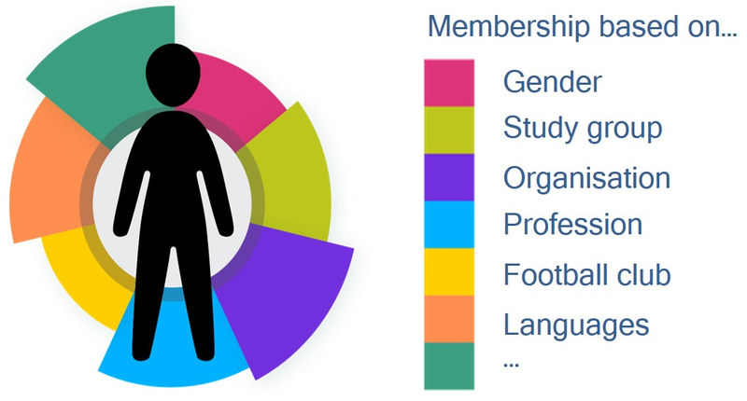

Source: Based on Rathje, Stefanie (2015). Multicollectivity – It changes everything. Key Note Speech at the SIETAR Europe Congress (SIETAR_slides_Rathje.pptx (stefanie-rathje.de)). Accessed 24 May 2021.
Figure by Julia Flitta (www.julia-flitta.com)
Imagine that a team member shares membership of a professional collective with another team member. In this case their relationship is characterised by culturality. At the same time they may diverge in their membership of other collectives, which nonetheless play an important role in their interactions. In this case their relationship can be characterised by interculturality. Thus the relationship between two and more actors can be characterized by both interculturality and culturality (Auernheimer, 2010, p. 60).
The figure below illustrates this with the example of two protagonists A and B: They are predominantly socialized in different contexts and thus diverge in their membership of a number of collectives, while sharing some others. This is the basis for them to explore differences and commonalities. They share membership of the gender collective and thus they are likely to find topics to discuss and observe here. However, because person A spent many years working abroad and person B did not, they are less likely to find common ground with many of the issues that stem from international experience. This will be an area of interculturality.

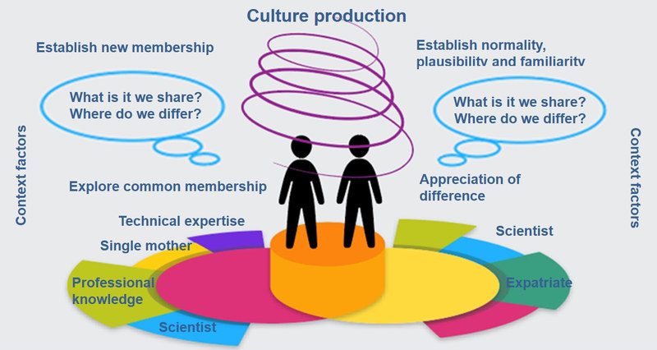

Source: Based on Rathje, Stefanie (2015). Multicollectivity – It changes everything. Key Note Speech at the SIETAR Europe Congress (SIETAR_slides_Rathje.pptx (stefanie-rathje.de)). Accessed 24 May 2021.
Figure by Julia Flitta (www.julia-flitta.com)
Despite this, the figure also shows that through mutual learning and an exchange of experiences during their teamwork they can develop their team culture and thus common conventions, plausibility and rules of normality in a common (e.g. professional) context of action. This means that the interculturality of this cooperation has already gone beyond the fluidity of interculturality and entered into a common culturality. In this context they will now no longer feel culturally different.
However, if B is a committed member of a religious community to which A has had no previous contact, and B invites person A to a celebration within this religious community after work, then suddenly the intercultural perspective in their relationship can dominate once more. Since both spheres of activity, i.e. professional and non-professional, are interlinked by the reciprocal relationship between the two actors, the way in which A and B interact interculturally in the external context described will influence their already culturalised reciprocal relationship (and vice versa).
However, interculturality is not only multivalent and relational, but also relative: The same (common) action context may be perceived by A to be intercultural due to his/ her inability to feel plausibility, familiarity and relevance in the situation, while B may not even notice this due to his perception of culturality and therefore perceived normality.
This is an example.
Starting in December 2019, a global pandemic changed the way people behaved on a global scale. For example, different regions in the world had different ways of greeting. Whereas some people would bow or shake hands, others might fold their hands or give a peck on the cheeks when greeting their co-workers or business partners. After the pandemic began, it became increasingly common to only meet virtually, rendering these forms of greetings obsolete. Colleagues from very different regions of the world thus started meeting in a ‘blank space’, and needed to create a new cultural norm when meeting online. Different forms popped up, from a simple ‘hello’ from everyone to a ‘check-in’, in order to share what is on their mind before the meeting starts, and many other forms in between. As the pandemic has created a new reality for many of us, a new consensus on the way we communicate had to be designed, or culturalised.
Against this background, structure and process approaches can contribute to the realization of intercultural action as a goal-oriented and negotiation-based collaborative activity, which can help to create a new normality in a team, even when the team was previously perceived to be heterogeneous.

2.6 Common cultural misconceptions and the potential of zooming for developing a collaborative team culture
An interview with Prof. Jürgen Bolten, Jena
URL: https://www.podcampus.de/nodes/pWOkq/

Task: Cultural misconceptions and zooming in intercultural communication
Listen to the interview with Prof. Jürgen Bolten and carry out the following tasks:
- Identify the main misconceptions regarding intercultural communication people have and note them down in your learning journal.
- Do you agree with Prof. Bolten’s statements?
Support your answer with well-founded arguments.
- How can zooming in and zooming out help to develop a collaborative team culture?

Sample answer
During the interview the following main misconceptions regarding intercultural communication were identified:
- one communication partner may link something different to what his/her partner mentioned due to the differences in the expression of ideas;
- generalized ideas of one or another national representative are errorsome, because cultures and nations are not homogeneous;
- misunderstanding may arise because people expect them to arise due to different ethical backgrounds or diverse appearances.
Do you agree with Prof. Bolten’s statements?
I totally agree with all of the statements and arguments given by Professor Bolten. He clearly put it forward that people share misconceptions because we tend to confuse our perception of a culture as something uniform and homogeneous influencing all its representatives to the same extent. Though we should never forget that cultures are realms which shape their representatives individually and cultures are not only those ones that correspond to our mother tongues and ethnic communities we were born in. Cultures come from schools, work, neighbourhoods. Additionally, we are prone to relate to other people following stereotypes based on strictly visible conceptions, this means that our attitudes are to some extent self-made and culture-unrelated.
How can zooming in and zooming out help to develop a collaborative team culture?
When we are working in a team, we may refer to the approaches of zooming in and zooming out. The better we zoom in on the field of actors, the better we understand how they interact and structures become dynamic. Change from zooming in to zooming out gives an opportunity to advance from structure-specific and culture-related perspective to process-specific and interculturally-related perspective.
To work in a team, we have to do both things. We should play the game of zooming in and zooming out. When we are interested in structures and aspire to have some certainty, we zoom out. If we are interested more in different things relating to processes, we zoom in. These techniques provide us with a perfect assistance which is about switching attention under control in the context of our personal needs.

2.7 Summary
Virtual teams are likely to be intercultural teams. For this reason we have dedicated this unit to examining culture and interculturality. In fact, with our definition of culture, which includes the idea of a multitude of cultural affiliations, we could even say that all teams are intercultural to a certain extent. We have attempted to capture the fluid nature of culture and the growing interconnectedness we face every day, which exposes us to a wide range of differing lifeworlds. This expanded concept of culture formed the basis of our understanding in this unit.
Taking the expanded concept of culture a step further, a distinction can be made between a structural and a processual perspective, also referred to as a closed and an open concept. While the closed perspective only considers the binary choice of either/or, the open perspective allows for both/and thinking. Through our ‘zooming’ tool we can move between these perspectives. This can be important in order to understand our team members and in this way we will find it easier to develop a working environment characterized by normality, plausibility and routinised actions.
The basis for an open perspective of culture is the understanding that we are all members of a multitude of collectives and therefore have relationships with a wide range of people. This can be visualized as a network. Considering the fact that people are members of various collectives enables us to explore commonalities as well as differences among team members, which we might not have realized from a structural ‘zoomed-out’ perspective. Dealing with intercultural situations in this way gives us the best chance of developing a team culture characterized by familiar and routinized actions as well as a feeling of togetherness and belonging.
Even after a tentative working ‘team culture’ has been created, it is quite possible that the initial feelings of unfamiliarity can surface once more. This happens when memberships of collectives are activated, thus exposing team members to unfamiliar behavioral patterns. This requires team members to explore the new behavior with transparency but without judgment, understand and readjust. This is possible because, as we have seen, cultures are dynamic and boundaries are fluid.
Understanding culture from a structural and processual perspective and the many ‘in-betweens’ along this continuum is a good basis for developing a working culture based on familiarity and routinized action that is embraced by all team members. Being aware of this constant fluctuation between interculturality and culturalisation helps to ensure that the team culture created is one that enables all team members to flourish.

2.8 Learning review

Task: Working in an intercultural team – some practical questions
Imagine that next month you start working for an international company and you know that your team consists of:
- a woman who was born in Ghana
- a woman who was born in Russia, immigrated to the UK as a little girl and graduated in the USA, and
- a young intern you don’t know anything about.
Reflect on the following questions and note down your answers in your learning journal.
How can you apply what you have learned about the open and closed concept of culture to your team, considering the little information you have about your team members?

Sample answer
We have learned that the closed concept of culture can cause us to make assumptions about people that can be misleading. When we learn that one of our colleagues has lived in several countries before joining our team, and another one was born in Ghana, there are still few assumptions we can safely make. The woman in Ghana might be more defined by her gender, age, religion or profession than her birthplace. And even if we have a colleague who spent many years in different countries, we do not know whether she still feels 'Russian', and what she might understand by that. We should keep an open mind with these colleagues and also with the intern about whom we have no information. The initial information we have can, however, serve as a first idea from which to find out more about 'what makes your colleagues tick'.
What are some of the advantages and some of the disadvantages of a closed approach to culture based on national belonging?

Sample answer
One advantage of a closed approach to culture is that it takes away some complexity when dealing with a diverse team. It can also give us a certain sense of security when dealing with people of other nationalities. Another advantage is when we encounter behaviour that we do not like in a colleague, we could take a closed cultural concept to explain this behaviour, rather than take it personally ('he is not late out of disrespect towards me, but because of his cultural background'). One of the biggest shortcomings of a closed culture approach is the generalization of individuals. People generally do not appreciate their individuality being explained away through an external notion of cultural belonging. This is the feeling of estrangement we notice when reading cultural guides on the so-called typical behaviour in our own nation.
In addition, the closed notion of culture is more likely to lead us to 'judge'. We need to be especially aware here of judgments that are absolute and not simply expressing a preference. We might even judge people because they do not correspond to our stereotypical view of a certain nation ('she comes from a culture where people are punctual- but she is not. So, she must be unreliable or disrespectful').
Think about 4-5 work related values or behaviours people from abroad would associate with the country or region you are from. They can be positive, negative or neutral. Note that these attributes come from a closed culture point of view. Please write them down in your learning journal.

Sample answer
Here is an example of an answer from a German person:
- structured
- too honest and direct
- unemotional
- reliable
Now assume that during your first online meeting, your boss introduces you to the team as “This is your new colleague from…” mentioning your home country. Imagine that your colleagues associate you with the behaviour or values you just wrote down. Which expectations would you want to fulfil and which not? How would you feel about this situation, in which you are perceived from a closed-culture point of view? Note down the answers in your learning journal.

Sample answer
The German person cited above noted the following:
While I could relate to some of the traits, I did not feel like I shared some others at all. For example, I see myself as honest and direct, but also I often show up late, and actually feel that I am a very emotional person. Even with the more “positive” stereotypes like punctuality, I felt like I might disappoint my team when I show up late. Realising that my new colleagues might see me as the 'German' puts me in a rather defensive position.
Give examples of situations in which your 'automatic' assumptions and behaviour have been thrown into question by your diverse environment.

Sample answer
Participant 1:
I remember when I returned to the Sudan with a friend and we walked through the streets of Khartoum. It was already getting dark and we had just arrived, having not yet recovered from jet-lag, and feeling a bit insecure when someone called us using the term 'Asma' meaning 'listen to me'. Our initial assumption was that the person wanted to beg and ask for money because we were 'rich foreigners' and so we were tempted to walk faster. When we finally stopped, it turned out that it was someone I knew and simply wanted to greet and talk to us.
Participant 2:
When I was traveling in the Philippines I decided to take a long walk in the country side as I wanted to get away from the tourist centres and explore the area. When I passed people working on the field they waved at me pointing in the direction of the beach. They obviously assumed that I had got lost and that foreigners are only interested in the beach. Because I did not speak their language, there was no way to tell them otherwise.
Participant 3:
Last term I was in a team with a student from Mexico whose English was not very fluent and I was very sceptical as to the contribution he could possibly make towards the term paper we were expected to write together. Actually thinking back, my assumption were threefold. Being Mexican I assumed that he may not know what our standards for writing an academic term paper are. Because of the trouble we had communicating well in English as a foreign language and understanding each other, I also assumed that his contributions may be rather poor and I think I also assumed a more 'mañana' thinking he was from Mexico. And actually I must admit that I was proved wrong. He had less experience than me speaking English, but he had a lot of experience in academic writing and looking back, I am glad that I questioned my assumptions about the 'students from Mexico'.
During these two sessions, we have already encountered a series of situations where 'automatic' assumptions were questioned afterwards. We can take for example the first case from lesson one, where we had a team working exclusively from Brazil, but then saw that even in a situation like this, a high level of diversity was possible. Or take the case with Beibei, who has a Chinese name and possibly also appearance, but might identify much more with her Northern German birthplace. In the ‘zoom’ video we saw that the book the expat consulted before going abroad was written from a closed culture perspective, and led him to wrongly believe that everyone here would behave in a certain way. Automatic assumptions and behaviour make many things easier for us, and it is very challenging to live without them. However, it is still desirable to question them frequently, in order to appreciate the high level of diversity around us, negotiate openly, without prejudice, a new way of working that all parties can embrace, and allow the process to enrich us.

2.9 Sources, further reading and web links

Sources
- Appadurai, J. (1996). Modernity at Large. Cultural Dimensions of Globalization. London: University of Minnesota Press.
- Auernheimer, G. (2010). Interkulturelle Kommunikation, mehrdimensional betrachtet, mit Konsequenzen für das Verständnis von interkultureller Kompetenz. In G. Auernheimer (Ed.), Interkulturelle Kompetenz und pädagogische Professionalität (pp. 35-65). Wiesbaden: Springer.
- Bolten, J. (2011). Unschärfe und Mehrwertigkeit: "Interkulturelle Kompetenz" vor dem Hintergrund eines offenen Kulturbegriffs. In U. Hoessler, & W. Dreyer (Eds.), Perspektiven interkultureller Kompetenz (pp. 55-70). Göttingen: Vandenhoeck & Ruprecht.
- Bolten, J. (2013). Fuzzy Cultures: Konsequenzen eines offenen und mehrwertigen Kulturbegriffs für Konzeptionalisierung interkultureller Personalentwicklung. SIETAR Journal für interkulturelle Perspektiven, pp. 4-9.
- Bolten, J. (2015). Einführung in die Interkulturelle Wirtschaftskommunikation. Göttingen: Vandenhoeck & Ruprecht.
- Bolten, J. (2015). Megacities: A simulation game for virtual classrooms. Retrieved from www.intercultural-campus.org.
- Hansen, K. P. (2009). Kultur, Kollektivität, Nation. Passau: Stutz.
- Husserl, E. (1936, 1970). The Crisis of the European Sciences.
- Moosmüller, A. (2009). Kulturelle Differenz: Diskurse und Kontexte. In A. Moosmüller (Ed.), Konzepte kultureller Differenz (pp. 13-45). Münster: Waxmann.
- Rathje, S. (2009). Der Kulturbegriff. Ein anwendungsorientierter Vorschlag zur Generalüberholung. In A. Moosmüller (Ed.), Konzepte kultureller Differenz (pp. 83-106). Münster: Waxmann.
- Said, E. W. (1996). Kultur und Identität – Europas Selbstfindung aus der Einverleibung der Welt. Lettre International, 34, pp. 21-25.
- Schütz, A., Luckmann, T. (1979). Strukturen der Lebenswelt, Vol. 2. Frankfurt a. M.: Suhrkamp.
- Switzerland (2021, January 27). Wikipedia.
Retrieved from https://en.wikipedia.org/wiki/Switzerland.

3. Developing from a group into a virtual team

Topics
3.1 Prelude 41
3.2 Introduction 41
Task: Differences between a group and a team 41
3.3 The life cycle of virtual teams 42
Task: Developing into a team 45
Task: Central characteristics of team development stages 47
3.4 Features of team development 50
Task: A framework for supporting team development 56
3.5 Summary 59
3.6 Learning review 59
Task: Case "Development of a project team" 59
3.7 Sources, further reading and web links 65

Learning outcome
You will create a framework for analysing how a loosely assembled group of individuals can develop into a virtual team utilising Tuckman’s team development phases and considering such factors as trust and relationship building, goal setting and the communication process.
Objectives
At the end of the session, you will be able to
- describe the phases of the team development process based on Tuckman’s model
- identify factors that influence the team development process
- review the possible impact of these factors on the team’s life cycle
- outline a framework which can be utilised when viewing a group's development from a loosely related gathering of individuals into a fully-functioning team

3.1 Prelude
In the previous two units we have not only discussed the relevance of virtual teams in work environments, but also developed an understanding of the basic theories related to interculturality and proposed a dynamic and open approach to culture. With this knowledge we will now turn to the question of how a group actually develops into a team. To help us to understand this, it is vital that we consider the specific development steps that might lead towards a well-functioning team and therefore successful teamwork.

Download: Learning journal for session 3
Learning journal (.docx) Learning journal (.odt) Learning journal (.rtf)

3.2 Introduction
Have you ever worked in a group that seems stuck in endless discussions, where nothing seems to get done; and then, shortly before the submission deadline, one or two members scramble to complete the task in order to hand in a hurried piece of work on or after the deadline? Or conversely, have you ever been a member of a group where every participant reaches out to their fellow team members, where everybody is glad to contribute and has a clear idea of their tasks, and where you feel that working together has enabled you to achieve more than you would have been capable of on your own?
Most of us are likely to have experienced both, i.e. being a member of a group that never managed to develop into a team, with members pulling in opposite directions, as well as witnessing the satisfying and enriching experience of working in a group with an open and productive atmosphere where everyone's voice is heard and these voices are formed into a consensual group objective. The reasons for each of these very different experiences are manifold, but we can state from the outset that simply 'throwing' people together because they possess certain qualifications, expertise or are located in a geographical area or department with no further thought is unlikely to make an effective team. A fully functioning team, as opposed to a work group, is characterised by collective thinking and the development of a team identity and mutual cooperation.
Knowing that a team matures by moving through different development stages and knowing how this process can be supported is one important precondition for moving from a loosely put together group into a team. It is also vital to understand that a virtual team is an extremely dynamic entity and every team differs in its path and speed of development. Some, for example, develop in an ad hoc manner due to an emergency, and may not even attempt to become a fully-fledged team. In contrast, there are also stable teams with a consistent leadership, clearly defined roles and functions where the members have developed a sound working relationship over many years.
In the light of this, the purpose of this unit is to raise awareness of the different processes involved in becoming a team and to outline some steps which encourage the development of a well-functioning team.

Task: Differences between a group and a team
One of the first things we need to differentiate is the difference between a group and a team. Look at the figure below and in your own words, note down the main differences in your learning journal.
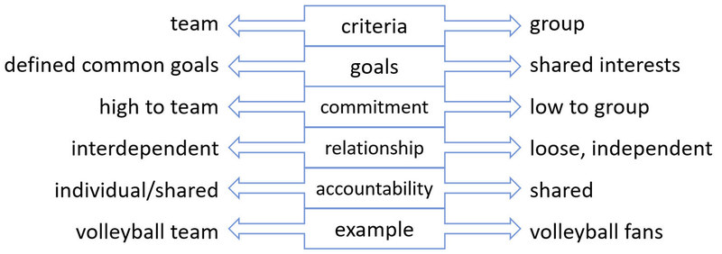
Diagram developed by Andrea Voigt for this course

Sample answer
This is Alexa's answer
A major difference is that a group is a loosely coupled bunch of people sharing an interest and have an understanding of common bonds or in other words, are aware of one another. In contrast, a team is interdependent, has a clearly defined goal and members have a high commitment towards achieving this goal. This means that for a team to become fully effective, they have to cooperate and thus coordinate their tasks closely, develop a common work rhythm and a team identity. Their goal ultimately is to think and act like a team which produces a result which they could not have without the cooperation with other team members.

3.3 The life cycle of virtual teams
If we understand a team as a group of people who become interdependent and work together towards a common goal, then intuitively we can say that this team passes through a process of development, often referred to as a life cycle. The life cycle of a team indicates a series of phases that a team experiences until it reaches maturity. The most well-known model that tries to encapsulate these phases was developed by Tuckman back in the 60s, which includes four distinct phases of team development: Forming, Storming, Norming and Performing. Adjourning was subsequently added as a fifth phase.
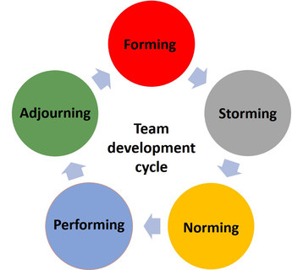
Forming: This is an introductory phase characterised by participants' efforts to gain orientation and test out possibilities. It is therefore often also referred to as the ‘ice-breaking’ phase. The group shares information about themselves, gets to know each other, seeks orientation and initially tries to identify the boundaries of both interpersonal and task behaviours through experimentation. With regard to the objectives, the group attempts to define tasks through the identification of relevant information and respective ground rules relating to each task. All members further try to discover which interpersonal behaviour is acceptable to the group. Here they look towards the team leader, other members or existing structures and norms for guidance and support in this new and uncertain situation. The cooperation is often initiated with a virtual or in-person kick-off meeting, where group members introduce themselves and exchange initial information.
"I believe that this was the easiest stage we went through, getting to know each other better on a personal level. This stage might have taken a bit longer than usual due to the physical distance between us. We all had to overcome the initial shyness to build a team purely through virtual communication. But I think it was the right choice to put a lot of effort into this stage because it was the foundation for all the other stages."
Source: Learning journal, 2020
Storming: This stage is characterised, as its name suggests, by spirited discussions and arguments, more competitive behaviour and polarisation in interpersonal behaviour and at times conflict. Group members start to assess their own needs, and may attempt to put them ahead of the needs of the group. Similarities and differences between the group members become more visible and conflicts may emerge as the group tries to find suitable roles and responsibilities. There is a likelihood that group members disagree with the leader and with one another as a way to express their individuality. They tend to respond emotionally to task demands and exhibit resistance to suggested actions. Infighting and lack of unity are distinct features of storming. In a virtual environment it is especially important for both the team and the leader to develop sensitivity towards potential sources of conflict. This is even more critical in virtual settings due to the limitations on available communication channels.
"Looking back, this was the stage we really struggled and noticed the challenges of only communicating on a virtual basis. Brainstorming and having open discussions only in a virtual conference was difficult."
Source: Learning journal, 2020
Norming: This is the phase when the group has transformed into a cohesive team. It has overcome previous resistance and now, with needs of the various team members having been met, openness to other group members dominates the interaction, both on a task and personal level. Personal and more intimate opinions are exchanged and teams implicitly or explicitly recognise and agree on ways of working together and completing tasks, and rules are made accordingly. On the interpersonal level, members start to accept the group and the individuality of fellow group members, thus starting to form a team identity. In-group feeling and cohesion develop, new roles are adopted and new standards and norms are created through consensus. Cooperation plays a key role in Norming.
Performing: This is the stage when the team works together productively and focuses on producing results. Roles become flexible and the focus is shifted to the individual functions and competencies of the members in the group. Subjective relationships are established, the members adjust their behaviour to the goals of the group and respond to each other in ways appropriate to the task. Conflicts are used to test and align agreements. Constructive attempts to accomplish the task incorporate a variety of opinions and methods. The members are highly motivated and willing to learn from each other. The group, now functioning as a unit, concentrates its energy on the task at hand. A group needs to reach the Performing stage in order to be fully effective and utilise the competencies of the group members to perform at its best as the following quote indicates:
I noticed that during the course of time everything becomes a bit more emotional. People celebrate achieving their goals and the steps leading up to themTOGETHER. But also people get annoyed. You can see it when someone does NOT answer for a certain time, probably because of an unpleasant situation, or loss of enthusiasm.
(Translated from the German quote below)
B8 (l.301—306): "Und ich stelle schon fest, dass im Verlauf der Zeit das alles so ein bisschen emotionaler wird. Man freut sich GEMEINSAM über erreichte Ziele, Zwischenziele. Man ärgert sich. Man sieht, wenn jemand über einen gewissen Zeitraum NICHT antwortet, dass er vermutlich, wenn es eine unangenehme Situation ist, vermutlich eher weniger begeistert ist."
Source: Randhawa, 2020, p. 103
Adjourning: This is the stage when the project starts to wind down and team members complete their tasks. Team members' thoughts start to be diverted and the team is dissolved, or, if possible, reassigned to a new task. Under certain circumstances, the end may cause disruption, and in the process of dissolution, group members may experience feelings of sadness, uncertainty and appreciation of fellow members and the group might experience what could be called a type of ‘mourning’. There may be further self-assessments and evaluations of the group's success.

Critique
The team development phases outlined by Tuckman provide a generalised view of how a loosely bound together group of people moves through various phases of maturity in order to become fully effective. What it highlights is that the mere establishment of a project team is no guarantee for success and that it is crucial to acknowledge that team development is a process which needs to be sufficiently supported and promoted in order for the team to make the best use of the team members' competencies and experiences and thus achieve its full potential.
Crritiques of the model suggest that the linear development through phases cannot be supported by evidence. In reality, some teams shorten phases or skip them altogether. Furthermore, teams spend varying amounts of time in each phase and some teams find it difficult to complete the storming phase and move on to higher levels of development. In addition, it is not uncommon in practice for teams to jump back to earlier phases or start the process all over again as indicated in the illustration below. In reality, therefore, we can see the process as a constant and synchronous movement through all phases, albeit with a focus on one or two of the phases. It can also be seen that teams might become stuck in a certain stage of development, but can still reach higher development phases at synchronization points, and that sub-teams can be in different phases on a social level compared to the overall team.
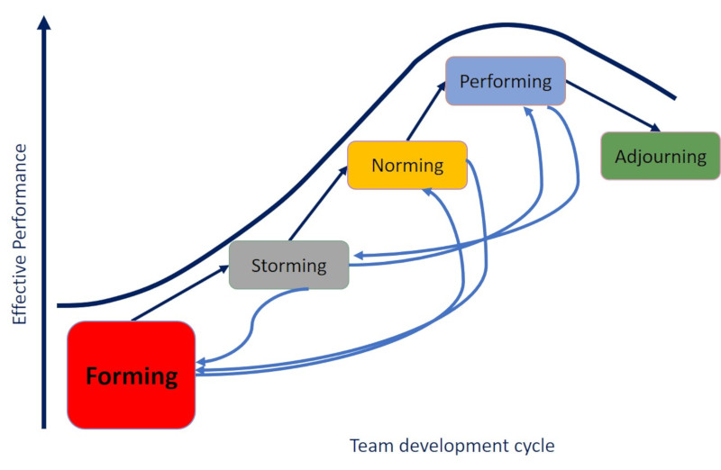
Source: Based on Tompkins, Teri C. (2000, p. 212)

Task: Developing into a team
Think about a team you have been part of: Referring to the team life cycle, how would you illustrate or describe this team's development? Draw / paste the figure into your learning journal or note down the description in the journal (you can also do both).

Sample answer
This is what one participant noted down:
In my opinion, after the stage of forming which was very short, we immediately switched to the stage of norming, where we decided on our goal, divided tasks, started researching and preparing the information.
The forming stage was rather short and a lot later we realised that we should have spent more time on this phase, and actually I would say through our small talk phase now and again we kind of moved back to the forming stage occasionally.
The transition between the norming and the performing stage was smooth and gradual. We were interacting respectfully with each other and our discussions were constructive, yet we were working eagerly and making good decisions. Later on, during the performing stage we at times developed an operational blindness at some point and realised that it would have been better to find out more about our team members. But because we reached this stage at a quite early stage of the whole project, we were still very motivated and wanted to give our best. So we didn’t mind that we kind of had to go to the storming and forming phase at that point.
Because we have not yet handed in our project, the adjourning phase is still to come.
The speed of the maturing process depends on factors such as the skills and competencies of the team members, the time available, the level of virtuality, the requirements of their tasks and the organisational context in which they work. Maturity cannot therefore be measured by time but by signs of group development and the ability of team members to develop shared meaning and working routines and learn from its work processes.
In view of the criticism, it needs to be acknowledged that groups are complex, adaptive systems that are driven by interactions among group members and that developmental paths can deviate from the ideal-typical course described by Tuckman. Some groups may not experience all of Tuckman’s phases or they may experience periods of stagnation, followed by periods of activity and subsequent development. Others may change the order of the stages or go through iterative loops as they loop back into earlier phases.
Nonetheless, the fundamental processes described within Tuckman’s phases are plausible: Every newly formed team needs an acclimatisation period during which the team members try to deal with the unfamiliar situation and strive for orientation and guidance. It also seems plausible that conflicting positions and needs arise over time and that these issues need to be dealt with in a "norming" process to ensure further cooperation, and that, if teams fail to handle these issues constructively, successful collaboration may be endangered. Finally, it seems realistic that teams do not immediately achieve the performance that is expected of them and that it rather takes time for them to mature, or indeed that the team never fulfils this potential. Moreover, the model is convincing in its simplicity and its intuitive character, as it is easy to understand and to apply. Despite the criticism mentioned, it retains its value as a simple tool for analysing and discussing team dynamics as the following quote suggests.
"Sometimes it helps to have such phases and to go a few rounds, then discuss it with the team and present a model, because it often results in pictures. Then I say: '[...] Every team undergoes phases of development and I even have an impression that we are at THIS point now. And what do you think?' [...] And then one can use such a model to show and ask, what it looks like for you?"
(Translated from the German original below)
B2 (l.130-143): "Manchmal ist es hilfreich, wenn man solche Phasen hat und man muss ein paar Runden drehen, dann das mit dem Team zu besprechen und einmal so ein Modell vorzustellen, weil das häufig so Bilder ergibt. Dann sage ich: ‚[…] Jedes Team hat Entwicklungsphasen und ich habe gar den Eindruck, wir stehen an DIESER Stelle hier. Und was meint ihr denn dazu?‘ […] Und dann kann man anhand so eines Modells aufzeigen, wie sieht denn das aus für euch?"
Source: Randhawa, 2020, p. 64
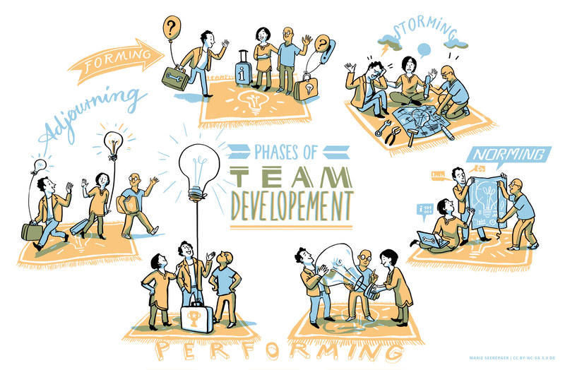
Illustrations by Marie Seeberger (http://www.behance.net/marieseeberger) CC-BY-NC-SA 3.0 license

Task: Central characteristics of team development stages
Look at the images of team development and note down central characteristics of the different development stages in your learning journal.
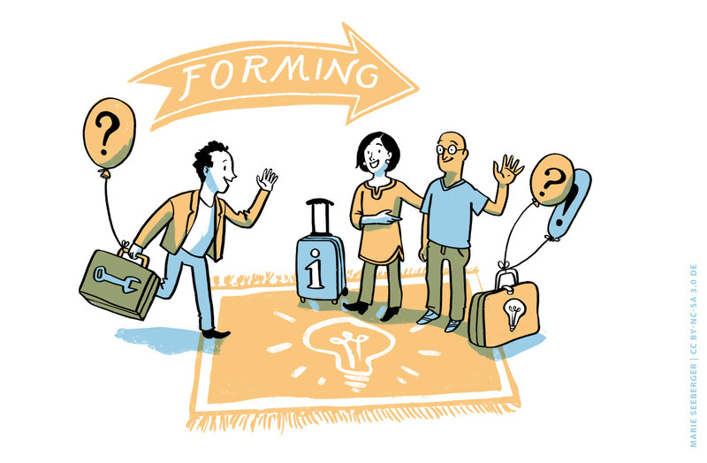

Sample answer
Forming
This stage is characterised by:
- Novelty and the excitement about the project ahead
- Uncertainty and anxiety as to how things are going to work
- Frustrations because things seem to move slowly
- Members asking lots of questions
- Team atmosphere characterised by politeness as the team gets to know each other
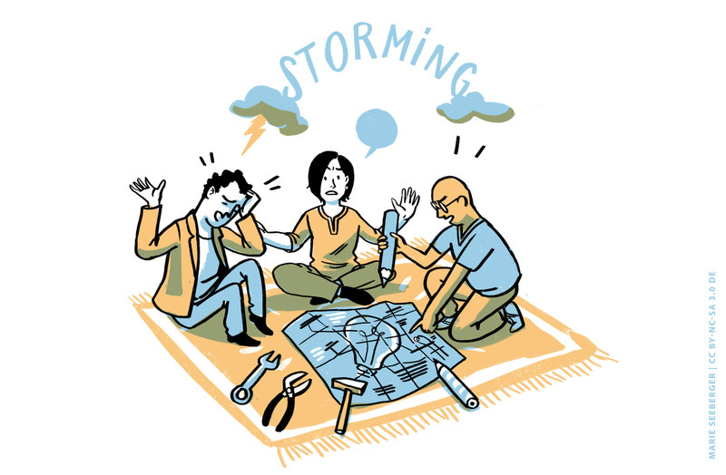

Sample answer
Storming
This stage is characterised by:
- Team members challenging the validity of the task to be performed
- Slow advancement
- Tension between team members
- Disagreements concerning roles and responsibilities
- Negotiation of rules and work routines
- Some team members becoming very active whereas others are more laid back
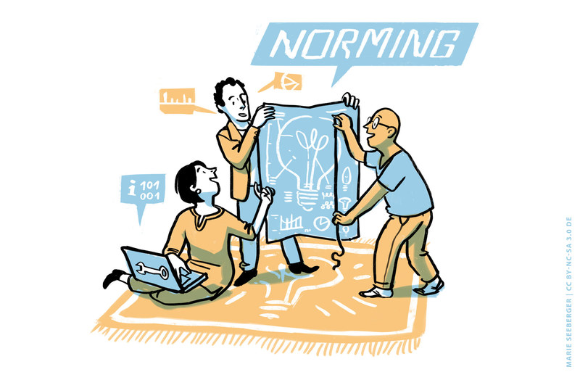

Sample answer
Norming
This stage is characterised by:
- Considerable openness with each other and readiness to express real ideas and feelings
- Team members recognise, acknowledge and appreciate the variety of opinions and experiences among team members
- Starting to focus more on the task
- Team members appreciate to be part of the team and
- Develop their own team routines
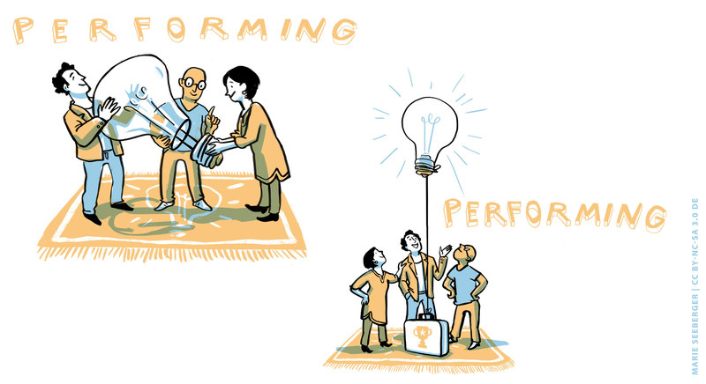

Sample answer
Performing
This stage is characterised by:
- Team commitments to the task goal and collaborative teamwork
- Team members respond to each other in a conducive way
- Problems are solved in a constructive way
- Team members monitor its performance
- The team works hard and effective
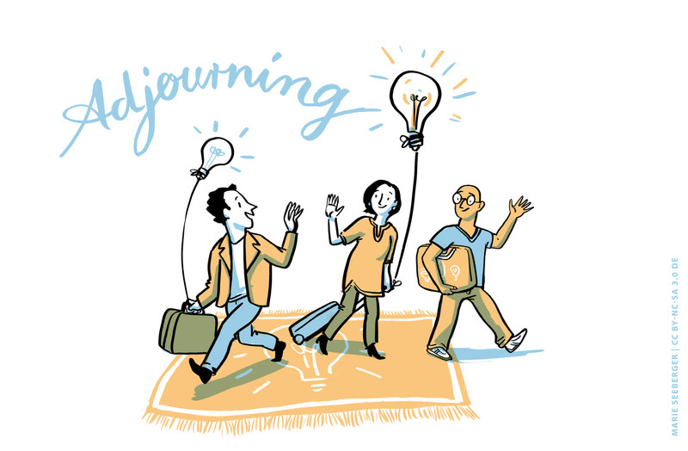

Sample answer
Adjourning
This stage is characterised by:
- Team members slow down in order to prolong the project or speed up in order to finish before the deadline
- A feeling of loss as the team work comes to an end
- Concern and anxiety about the time after the project
- Appreciation of what has been achieved

3.4 Features of team development

Introduction
Each team must find its own speed and pattern of development. There is evidence that the maturing process of a virtual team is likely to be more complex and challenging than is the case with an in-person team. It is important to keep in mind that the stages of development are not mutually exclusive. Activities at one stage may overlap and recur at another and in the course of working together, a team may return to an earlier stage of development. Overall, there are four dimensions that can be clearly highlighted as vital to team development. These are: developing trust, clarifying roles and objectives, ensuring open and friction-free communication, personal relationship-building and collaboration. In the following, these dimensions and their relevance in the various development stages will be discussed.
Trust
A critical driver for developing a positive working climate and achieving task performance is the development of trust. Trust or trusting as a central variable can be understood as the belief in the team’s competence and integrity to manage the task well. Additionally, trust refers to the willingness of team members to be vulnerable in the sense that a person trusts the actions of another person without being able to monitor or control the validity of the action. Furthermore, trust involves disclosure in the sense that a person is ready to share confidential or private information and talks about their own mistakes and weaknesses. Trust is essential in relationships that require collaboration and cooperation and is positively related to a team’s satisfaction, performance and commitment to a task. Trust is also critical to effective communication and a low level of trust may, for example lead to ambiguous information being interpreted negatively.
Well, if you don’t have trust, it’s not a team. How can you work well with people you do not trust? A team without trust is not a team, full stop."
Source: Learning journal, 2020
From a personality perspective, some people more than others are intuitively prepared to trust. People with a high tendency to trust have learned in the course of their life that trusting others affords them more advantages than disadvantages, which is why trust is their default behaviour. This attitude is only expires when a person clearly displays untrustworthy behaviour. People with a low tendency to trust, on the other hand, initially act cautiously and sceptically in many situations. There may also be variations in an individual’s propensity to trust based on subjective beliefs about the extent to which trust is possible and meaningful in certain areas of life. For instance, a person may regard trust as appropriate in private contexts but not as a suitable strategy in work relationships.
At the beginning of a working relationship, where the interaction partners have hardly any information about each other, trust develops on the basis of calculation. Calculation-based trust is founded on an assessment of the extent to which one's own interests coincide and are compatible with those of the other person. The interaction partners weigh up the benefits and costs associated with the relationship, i.e. whether it appears worthwhile to take some risks when entering into a dependent relationship, for instance because there is a prospect of long-term cooperation. This trust can be kept alive through rewards in the event of expectations being met or the threat of punishment in the event of a breach of trust, e.g. loss of reputation. For some relationships trust remains at this level, e.g. because the parties do not need a more complex relationship or trust violations have occurred, thus making it unlikely that further trust will develop.
Knowledge-based trust occurs when the interaction partners get to know each other better through repeated and varied interactions and information sharing. It is based on the observation that the behaviour of the other is consistent over time and in different contexts, and thus one knows the other person sufficiently well in order to be able to predict future behaviour. Even if the increased knowledge about a person leads to the belief that the other is predictably untrustworthy, even this type of predictability enhances trust. Many working relationships do not progress beyond an enhanced knowledge-based trust.
In constructive, long-term relationships, in which the interaction partners get to know each other in depth and share many positive experiences, identification-based trust may develop. This is a deeply felt trust between the interaction partners. It emerges from knowing and identifying with the other person’s beliefs, values and intentions. In this case, strong feelings can develop between the interaction partners. They mutually understand, agree with and endorse each other’s needs and wants, and shift their focus from maximizing self-interest to maximizing joint outcomes. Identification-based trust thus makes it possible to act on behalf of the other and make decisions in mutual interest, so that any form of control or monitoring becomes unnecessary. However, identification based trust requires intensive and frequent interaction and only develops in a small proportion of relationships. This type of trust would be more indicative of the performing phase.
Trust between interaction partners in a professional relationship thus requires a considerable amount of time and develops in small steps through frequent interaction, whereby dealing with knowledge, information and errors is essential. It can also be observed that trust between the interaction partners is initially based primarily on a cognitive foundation, while in later phases of a relationship the affective side of trust plays an increasing role as people invest emotionally in the relationship, express genuine care and concern for the well-being of the other person, believe in the virtue inherent in the relationship and are convinced that these feelings are reciprocated.
"What was a real challenge was to build trust remotely whilst being under pressure to perform. Thinking back, we had little choice but to trust each other in order to complete a common task… I have missed the personal touch of face-to-face communication."
Source: Learning journal, 2020
This quote signals that developing trust in virtual teams appears to be even more important than in face-to-face teams and at the same time it is also a lot more challenging. It requires careful consideration of the technology used, in particular in highly virtual teams, since this often has to replace the spontaneous meeting for lunch or the casual chat at the water cooler, during which informal work and non-work-related conversations help team members to get to know each other on an informal basis. When the visual contact is missing or reduced, it may simply take longer to identify and adjust to the habits and skills of the other team members. And since team members are in different locations and possess a variety of cultural backgrounds and technical expertise, a number of initial ambiguities will need to be clarified before they can start to trust the team. These might involve questions regarding how the information they offer will be used, whether their contributions will be recognised, whether other members will share and contribute equally, and what type of working style will be expected or agreed upon.
When team members experience a trusting attitude towards them, this usually evokes stronger trust, creating a self-reinforcing cycle. However, trust can be broken much faster than it can be built, and has to be seen as a dynamic construct and thus a process. This is why trust development and maintenance is a central issue in any phase of team development. The fact that trust-building is a process is highlighted in the following quotes:

"Initially there was a lack of comfort, rapport, and trust on our team."
"At the beginning interpersonal trust was not high. I sensed a high level of insecurity about positions and roles..."
"There was a lack of comfort and trust among team members, making cooperation and collaboration difficult – at least early on."
Source: Rosen, Benson; Stacie Furst and Richard Blackburn, 2007. Overcoming barriers to knowledge sharing in virtual teams. Organizational Dynamics, 36 (3), pp. 259-273, p. 262
If we understand that team members have a propensity for different levels of initial trust and also acknowledge differences in the developmental trajectories of cognitive and affective trust throughout the working relationship, then we can see that trust development and maintenance is an ongoing task. The pre-existing trust that a person feels acts as an information filter, i.e. new information tends to be interpreted in such a way that existing expectations and impressions of a person are confirmed. Calculation trust would be more indicative of the storming phase, whereas knowledge and identification-based trust would be more indicative of the norming and performing phase of team development.
Sharing personal information and getting to know each other are central pillars for trust development in the storming phase, whereas clarifying group goals, work procedures and expectations are more relevant in the forming stage of team development. Developing common understanding and identity as well as common work routines on the other hand, is central in the norming and performing phase of team maturation. A key factor in team development is therefore how well the team manages to initiate the trust-building process, thus laying the groundwork for a constructive working relationship.

Clarity of roles and objectives
Defining, setting and communicating clear, mutually agreed goals, as well as ensuring a common understanding and motivation towards the tasks to be completed are key aspects of any form of teamwork. However, when teams work virtually, these points are even more imperative simply because team members cannot physically walk into an office and ask for clarification or further details. At the same time, developing a clear purpose is essential for building loyalty and establishing trust in intercultural and virtual teams. It appears that in virtual teams a strong, shared vision of roles and objectives is much more important in staying oriented to each other and committed to the team than a detailed implementation plan. This may be so because sharing a goal and having a common purpose acts as a substitute for the lack of informal in-person meetings, which are crucial in keeping the team attuned to each other and building strong relationships.
The process of clarifying and setting objectives has its first tentative beginnings in the initial phase, and it is likely that more concrete goals can start to form in the storming phase. However, due to the fact that goals are rarely static, require adjustments and at times even change in character, they require regular revision. And even if the overall goal remains the same, the strategies taken to reach the goal are likely to change as teamwork progresses. This means that regular checking, feedback, queries or verification are needed to ensure that everybody has the same understanding of the goals and sub-goals at all times.
Clarity of roles and objectives go hand in hand and ensure that team members know what the purpose of working together is, but also the role they are to play in achieving it. Roles help geographically dispersed team members to relate in the sense that they know when to link up, for what purpose and what their relationships are. It appears that ensuring role clarification is even more relevant in virtual rather than in co-located teams and needs to include all members as well as the team leader. Of course the number of team members has an influence on the intensity of role clarification and as the quote from a team of three shows, it can be done without it. However, this team also sees the danger of not clarifying roles:
"We never specifically decided on our roles and each member took on a role as a task came into force. However, if things had turned out to be heated, and the roles were also unclear, we would have had a disorganised mess, which could have dragged our whole process down.""
Source: Learning journal, 2020
Given the dynamic nature of virtual team work, the clarification of roles and objectives are typical tasks in the storming and norming phase, but with the development of the team, team roles may need to be redefined. This means that although team roles can be defined based on the goal set in the storming and forming phase, they should be re-assessed as the team matures through constant feedback and clarification.
In conclusion it can be said that clarifying roles and objectives is an important task during the initial phases of team development, which needs to be reassessed throughout the team’s life cycle. This helps virtual team members to relate to each other and therefore clarification needs to be even more explicit than in a co-located team in order for the team to function well.

Relationship-building and collaboration
Collaboration, understood as the ability and willingness to ‘pull together’ and work towards a common goal requires a sense of dedication and commitment towards completion of tasks. Developing a personal bond with other team members helps to promote and maintain such a commitment. In fact, it has further benefits since a personal relationship and sense of connection supports the transition from the idea of ‘them and us’ towards a ‘we’ concept. Developing such a common identity supports a positive team atmosphere and thus helps to avoid incorrect assumptions and reduce potential misunderstandings since questions can be asked freely and without hesitation. It also provides an environment in which trust, understanding, compassion and acceptance of all team members can flourish.
In a team environment in which members feel personally connected, it becomes a lot more comfortable to share ideas, admit mistakes and provide constructive feedback, which in turn supports task performance. The development of personal relationships between team members is thus considered to be an important prerequisite for establishing and maintaining virtual working relationships. Indeed, there is ample scientific evidence that personal bonds greatly contribute to a positive team atmosphere and task performance. In such an atmosphere there is a willingness to share personal information and interests as well as supporting each other through difficult times. This kind of sharing is vital for establishing a common 'we' identity and feeling. Developing and using team bonds as a support network solidifies the connections among team members as the following quote underlines:
"The major challenge I see is that working in a virtual team means that everybody contributes a small piece towards the whole project, and therefore many people do not have the big picture. In other words, they don't just deliver software, they are part of an entity [...]. There was something that came up later: 'You've been aware of that for a half a year, why didn’t you tell me about it earlier?', 'Well, that wasn't our task' [...]. And they are actually RIGHT, but they were the only ones who noticed it. To see themselves as part of the whole team, is I think a problem that can also affect a non-virtual team. But this is simply the question, do I feel responsible for the whole project or really only for my small part?"
(Translated from the German quote below)
B11 (l.260-274): "Die Hauptherausforderung, die ich sehe, da ein virtuelles Team auch bedeutet, dass jeder quasi einen kleinen Teil letztendlich zu dem Gesamtprojekt liefert, ist, dass ganz vielen Leuten das große Picture fehlt. Sprich nein, sie liefern nicht nur Software, sondern sie sind Teil des Ganzen [...]. Da waren dann so Sachen, die spät aufgekommen sind: ‚Ihr wisst es seit einem halben Jahr, wieso habt Ihr es nicht vorher schon kommuniziert?‘, ‚Naja, das war ja nicht unsere Aufgabe‘ [...]. Und sie haben erst einmal RECHT tatsächlich, aber sie waren die Einzigen, die es gesehen haben. Und sich DA quasi als Teil des Ganzen zu sehen, wobei ich glaube, dass ich das gleiche Problem in einem nicht virtuellen Team haben kann. Sondern das ist einfach die Frage, fühle ich mich für das Gesamte verantwortlich oder wirklich nur für meinen kleinen Teil?"
Source: Randhawa, 2020, p. 95
Some people need more time to open up, share personal information and develop personal relationships than others. Relationship building as well as developing a team identity is a process which starts in the initial phase of team evolution and may continue throughout the entire team building process. It goes hand in hand with the establishment of trust.
Communication
Communication in virtual teams is of course linked to the technology used. As a starting point, team members need to consider the whole spectrum of communication technology designs that might be feasible considering the team's ultimate goal. They need to decide which synchronous and asynchronous channels are best suited in each situation in their specific work environment. The selection of communication technology is vital since there is no doubt that the technological infrastructure exerts a considerable influence on knowledge sharing, team coherence and ultimately team performance. However, focusing excessively on the technical issues risks ignoring the importance of the people using the technology and their influence on the team's success. Indeed, it is the interplay between technical communication tools and the people who utilise different elements of communication which makes communication in virtual teams a complex undertaking as the quote indicates:
"Talking on the phone you get some kind of a picture of the issue. But due to the challenges of using the telephone, speaking English, intermittent internet problems, dialling in did not work and [...] the sound quality was awful. You wouldn't BELIEVE the things I've experienced. [...] Especially at the beginning it was exhausting. If you're new to the company, first of all you need some kind of acceptance. You want to introduce yourself, but how can you do that when the technical setup is a catastrophe?"
(Translated from the German quote below)
B6 (l. 175-186): "Am Telefon macht man sich ja irgendwie so ein Bild. Aber durch die Herausforderungen des Telefonierens an sich, auf Englisch, unterbrochene Internetleitung, Einwahl hat nicht funktioniert und […] Tonqualität war eine Katastrophe. Ich hab da SACHEN erlebt. […] Es war am ANFANG besonders sehr anstrengend. Wenn du neu bist im Unternehmen, du brauchst erst einmal so eine gewisse Akzeptanz. Du willst dich vorstellen, aber wie soll das gehen, wenn selbst die technischen Herausforderungen schon eine Katastrophe sind?"
Source: Randhawa, 2020, p. 92
Team communication can be conceptualised as an exchange of messages between two or more team members and can thus be regarded as the foundation of any teamwork. It enables team members to express themselves and to share knowledge and information. Interpersonal communication is always a form of social interaction and can be understood as an attempt at mutual understanding and the construction of meaning between at least two people. And it is this aspect of mutual construction of meaning which requires particular attention in virtual teams.
If we want to establish mutual understanding and common meanings then the communication frequency is key. Although high communication frequency does not guarantee identical viewpoints among team members, it increases the likelihood of convergence of perspectives, especially in the earlier stage of team development and when the level of virtuality is high. High communication frequency in the initial stages of team development and a comparatively high density of interactions provides opportunities to establish trust, and contributes to the establishment of a common identity and understanding. At the same time, it is important to ensure the quality of the information shared as many virtual teams suffer from an excess of unnecessary information, resulting in cognitive overload and consequently decreased performance.
Of course it is difficult to measure communication quality but generally speaking it can be defined as the extent to which communication is perceived as clear, complete, understood and timely. The notion of perception in this context is of particular relevance because it draws attention to the receiver of the message. It emphasises that high quality communication involves shared understanding. This shared understanding can refer to preferences for different communication styles, the chosen working language and work locations. When teams have different understandings of terms and concepts and operate in different time zones, the perception of timeliness plays an important role. A team member may receive an e-mail much later than the rest of the team and his or her immediate reaction may be to interpret this as a late response. Time zone differences also limit the opportunities for real-time interactions. In this context the notion of closed-loop communication is relevant, a term used for ensuring that the message has been sent, received and understood. The higher the virtuality of a team, the higher is the proportion of asynchronous communication. And in a virtual team setting, closed-loop communication can mitigate some of the issues that endanger effective communication. The establishment of a closed-loop communication system and thus more positive perceptions of timeliness, is an important activity during the storming and norming phase.
Communication in virtual teams is also susceptible to misunderstandings and misinterpretations when transmitting, understanding and interpreting messages since it is generally more complex when mediated through technology. This is because because the media used is always accompanied by channel reduction and filter effects. The fact that facial expressions and spatial awareness of sounds, which usually guide a conversation and support mutual understanding, are partially or completely missing in electronic communication, increases the potential for miscommunication.
Members of virtual teams need to pay particular attention to the negotiation process regarding the technology used and the frequency of communication required as well as mechanisms to ensure that the content of communication has been received and understood. It is vital that the team understands the particular challenges of communicating virtually, establishing the issues to be agreed upon and a closed-loop communication system. This process is likely to start informally in the first meeting but needs to be dealt with more explicitly during the storming and norming phase of team development and should be part of regular feedback rounds.

Task: A framework for supporting team development
You work for a German company specialised in software development for cash registers. The company has subsidiaries in Austria, Switzerland, France, Russia, China and Mexico. For one year, the project ‘new universal software architecture’ has been in place but did not advance very well. This is why a new team of five has been put together with the task to overcome the issue of having two different software structures for Asian and European/American cash registers.
You are a member of this diverse virtual team and because of your experience in virtual team work are supposed to support the team. As a team you have three months to develop a proposal for a new software architecture. You are sitting in your office and reflect the Tuckman model of team development as well as the knowledge you have considering critical dimensions for developing into a mature team. With this in mind, you are sketching out a framework which should help you to quickly develop into a team. You have a budget for one personal meeting and the proposal is that you have weekly conference calls.
For drafting this framework you may use the graphic below, which you will also find in your learning journal.

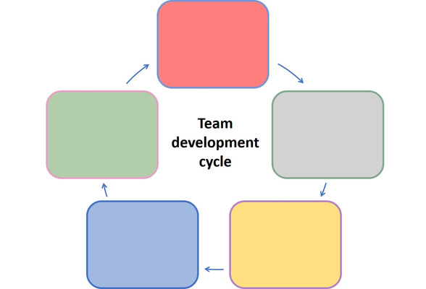

Sample answer (1)
This is what Nuria noted down
Forming:
- Ask team members for a cultural profile
- Find out about individual expectations
- Develop a shared understanding and sense of team identity
- Develop a clear understanding of task
Storming:
- Organise a personal meeting
- Use cultural profile to develop a common ground
- Encourage conflicting members to develop a mode of communication
- Ensure a clear understanding of task and roles
- Support the development of solutions

Norming:
- Develop a team charter specifying procedures and task requirements
- Set individual accountabilities, completion dates, and schedules
- Agree on procedures for information sharing
- Finalise a procedure to manage virtuality
- Distinguish task and social time and how to accommodate it
Performing:
- Ensure team members are supporting each other
- Support monitoring achievements
Adjourning:
- Support team in reviewing their achievements
- Discuss important learnings from the team work
- Celebrate your achievements and team development

Sample answer (2)
This is what Walther noted down:
Forming:
During an initial meeting I would offer to support the team members to get to know each other on a personal and professional level. For this end I would ask team members to send brief biographies around, so that everybody already has some information about the others in advance. I also feel that this could help us to start building a relationship. Whether it is too early to define the roles and functions of the team members depends a bit on the experience they bring along with regard to working virtual and has to be seen. Whether this is also the stage in which we can think about behavioural routines we want to establish I am not sure yet. But we should surely start to develop a shared understanding of the task to be carried out.
Storming:
This is definitely the time to make sure everybody has a good understanding of the task at hand and the role of each and every one and the contribution each can make. This is likely to involve some conflicting issues which need to be dealt with. Developing an understanding of how best to approach a conflict or issues would thus be part of the agenda. Fostering a good understanding and appreciation of each other’s perspective would surely be needed as well as notions as to when and how to reach consensus or other ways of conflict management. Listening to ideas and concerns as well as consolidating views would be important. As people start working together and understand where they depend on each other, we would also need to allocate some time to discuss issues outside of work. So I would suggest to devote some time at the beginning to just share how everybody is doing and try to make this part of a routine for the team to agree on.
Norming:
This is an important phase for agreeing on work procedures and a kind of a team charter. A project plan would surely help in making sure every know what to do when. We also must make sure everybody feels comfortable as a member of the team and ensure satisfaction

Performing:
If things have gone well so far and the team is functioning well, there is little to be added here except making sure that we all monitor and evaluate what we are doing and whether we work according to plan. We also want to make sure that everyone feels comfortable as a team member and is satisfied with the achievements so far. In case things are not advancing as we wanted, we need to make adjustments to our project plan.
Adjourning:
All projects come to an end and this one is the same. It is time to celebrate and review the achievements made. I think everybody should think about personal achievements as well as achievements with regard to the task at hand. I would ask team members how we can best do that and how we can celebrate despite the fact that we will not be able to meet.

3.5 Summary
Simply because people start working together, does not mean they are automatically a team. In order to become a team, a working group goes through several development stages until it reaches maturity. Tuckman called these stages of the team life cycle forming, storming, norming, performing and finally adjourning. Although a team does not necessarily follow this development in a linear fashion, remembering these stages and being aware of the typical developments that take place at each stage helps a team to mature. This is particularly important because in order to perform well, team members need to trust each other and develop a common understanding with regard to their goals and objectives. Only when the team is ready and willing to genuinely collaborate and harnesses the intrinsic motivation of each team member to move towards team objectives are they able to perform well. One precondition for developing into a team is therefore communicating effectively and ensuring common meanings. This brings with it a number of challenges, especially in the context of virtual teams, because it involves dealing with a variety of technological devices. Additionally, virtual communication is more susceptible to misunderstandings and misinterpretations than face-to-face communication.

3.6 Learning review

Task: Case "Development of a project team"
Based on the following case study, written by Gina Abudi, analyse the process of the team's development with reference to Tuckman's development stages. With the knowledge that you have acquired, think about what a team coach could do to support the team's development in each of these phases. Give feedback aimed at enhancing team performance with specific recommendations. Note down your results in your learning journal.
Background and team members
A team has been pulled together from various parts of a large service organisation to work on a new project with the aim of improving how the company manages and supports its client base. The team lead on this project is Sandra from the Chicago office who has 15 years’ experience as a project manager/team lead managing process improvement projects.

The other members of the team include:
- Peter: 10 years’ experience on various types of projects, expertise in scheduling and budget control (office location: San Diego)
- Sarah: 5 years’ experience as an individual contributor to projects, strong programming background, some experience developing databases (office location: Chicago)
- Mohammed: 8 years’ experience working on various projects, expertise in earned value management, stakeholder analysis and problem solving (office location: New York)
- Donna: 2 years’ experience as an individual contributor to projects (office location: New York)
- Ameya: 7 years’ experience in process improvement projects, background in developing databases, expertise in earned value management (office location: San Diego)
Sandra has worked on projects with Sarah and Mohammed, but has never worked with the others. Donna has worked with Mohammed. No one else has worked with any other members of this team. Sandra has been given a very tight deadline to get this project completed.
Sandra has decided that it would be best if the team met face-to-face initially, even though they will be working virtually for the project. She has arranged a meeting at the New York office (company headquarters) for the entire team. They will spend 2 days getting introduced to each other and learning about the project.
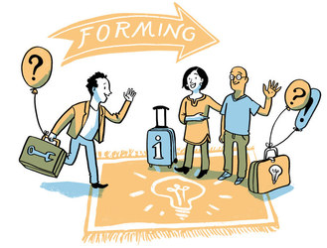
The initial meeting (Stage 1: Forming)
The day of the face-to-face meeting in New York has arrived. All team members are present. The agenda includes:
- Personal introductions
- Team building exercises
- Information on the process improvement project
- Discussion around team roles and responsibilities
- Discussion around team norms for working together
- Introduction on how to use the SharePoint site that will be used for this project to share ideas, brainstorm, store project documentation, etc.
The team members are very excited to meet each other. All of them has heard of the other members, although they have not worked together as a team before. They believe they each bring value to this project. The team building exercises have gone well; everyone participated and seemed to enjoy the exercises. While there was some discussion around roles and responsibilities – with team members vying for “key” positions on the team – overall there was agreement on what needed to get done and who was responsible for particular components of the project.
The onsite meeting goes well. The team members get to know each other and discuss their personal lives outside of work – hobbies, family, etc. Sandra believes this is a great sign that they will get along well – they are engaged with each other and genuinely seem to like each other!
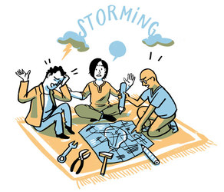
The project work begins (Stage 2: Storming)
The team members have gone back to their home offices to begin work on their project. They interact via the SharePoint site and the project is off to a good start. And then, the arguments begin...
Peter has put up the project schedule based on conversations with only Mohammed and Ameya on the team. Donna and Sarah feel as if their input to the schedule was not properly considered. They believe that because they are more junior members of the team, Peter has completely disregarded their concerns about the timeline for the project. They then challenged Peter’s schedule, stating that it was impossible to achieve, and was setting up the team for failure. At the same time, Sarah argued with Ameya over who should lead the database design and development effort for this project. While Sarah acknowledges that Ameya has a few years more experience than she does in database development, she only agreed to be on this project in order to take a lead role and develop her skills further so that she could advance at the company. If she had known that Ameya was going to be the lead, she wouldn’t have volunteered to join this project team. Additionally, Mohammed appears to be off and running on his own, while at the same time neither keeping the others informed regarding his progress nor updating his information on the SharePoint site. No one really knows what he has been working on or how much progress is being made.
Sandra had initially taken a side role during these exchanges, hoping that the team would work it out for themselves. However, she understands from past experience managing many project teams that it is important for her to take control and guide the team through this difficult time. She convenes all of the team members for a virtual meeting to reiterate their roles and responsibilities (which were agreed in the kick-off meeting) and to ensure that they understand the goals and objectives of the project. She then made some decisions when the team couldn’t come to agreement. She determined that Ameya would lead the database development design component of the project, working closely with Sarah so that she can develop further experience in this area. Also, she reviewed the schedule that Peter created with the team, making adjustments where necessary to address the concerns of Donna and Sarah. She reminded Mohammed that this was a team effort and that he needed to work closely with the others on the team.
During the virtual meeting session, Sandra referred back to the ground rules the team set in their face-to-face meeting and worked with the team to ensure that there was a plan in place for how decisions are made on the team and who has responsibility for making decisions.
Over the next few weeks, Sandra noticed that arguments/ disagreements were kept at a minimum and when they did occur, they were worked out quickly by the team, without her involvement being necessary. Still, she monitored how things were going and held regular virtual meetings to ensure the team was moving in the right direction. On a monthly basis, Sandra brings the team together for a face-to-face meeting. As the working relationships of the team members started to improve, Sandra began to see significant progress on the project.
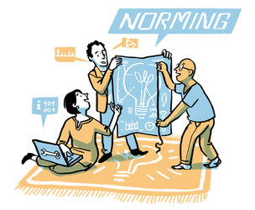
All is going smoothly (Stage 3: Norming)
The team has now been working together for nearly 3 months. There is definitely a sense of teamwork among the group. There are few arguments and disagreements that can’t be resolved among the team. They support each other on the project – for example when solving problems, making decisions as a team, sharing information and ensuring that the ground rules put in place for the team are followed.
Additionally, the team members help each other to grow and develop their skills. For example, Ameya has worked closely with Sarah to teach her many of the skills he has learned in database design and development and she has been able to take the lead on accomplishing some of the components of their part of the project.
Overall, the team members are becoming friends. They enjoy each other’s company – both while working on the project and after hours via email, instant messaging, Twitter, or over the telephone.
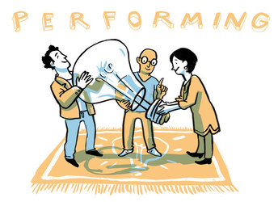
Significant progress is made! (Stage 4: Performing)
The team is now considered a "high performing team". It wasn’t easy to get to this stage, but they made it! They work effectively as a group – supporting each other and relying on the group as a whole to make decisions on the project. They can brainstorm effectively to solve problems and are highly motivated to reach the end goal as a group. When there is conflict on the team – such as a disagreement on how to go about accomplishing a task – the group is able to work it out on their own without relying on the team leader to intervene and make decisions for them. The more junior members – Donna and Sarah – have really developed their skills with the support and help of the others. They have taken on leadership roles for some components of the project.
Sandra checks in with the team – praising them for their hard work and their progress. The team celebrates the milestones reached along the way. When necessary, Sandra provides a link from the team to the executives for decisions that need to come from higher up or when additional support is needed.
The project is on time and within budget. Milestones are being met – some are even ahead of schedule. The team is pleased with how well the project is going, as is Sandra and the executives of the organisation.
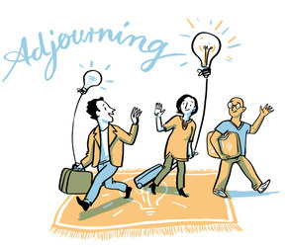
Time to wrap up (Stage 5: Adjourning)
The project has ended. It was a huge success! The internal customer is pleased and there is definitely an improvement in how the company supports its clients. It has been a great eight months working together…with some ups and downs of course. Each of the individuals on the project will be moving to other projects within the organization, but no one is going to be on the same project. They will miss working with each other but have vowed to remain friends and keep in touch on a personal level – hopefully they will work together again soon!
The team has come together in the New York office to discuss the project, including documenting best practices and discussing what worked effectively and what they would improve upon given the chance to do it again. Sandra has taken the team out to dinner. They are joined by the project sponsor and some other executives who are extremely pleased with the end result.
The End!
This is a simplistic view of a team working through the five stages of team development. I hope it provides some benefit to you.
Remember that at any time this team was able to revert back to a previous stage. Let’s assume that another individual joins the team – the team will revert back to the “forming” stage as they learn how to work with the new team member, re-establishing team guidelines, finding their way again, and learning how to work cohesively as a team. Or, let’s assume that Mohammed slips back into his old ways of keeping to himself and not sharing information with the team – this may cause the team to revert back to the "storming" stage.
It is important to remember that every team – regardless of what the team is working on – will follow these stages of team development. It is the job of the team leader to help see the team through these stages; to bring them to the point where they are working as effectively as possible toward a common goal.
Source: Abudi, Gina (2016). The five stages of project team development. https://project-management.com/the-five-stages-of-project-team-development (accessed on 30.10.2020, used with permission).

Sample answer
Here is Olesia's feedback to the team of the case study:
Forming: During this phase as a coach I would recommend to establish better communication and try to build trust among the team members. All the developments described in this phase I find relevant, so far everything is going seamless.
Storming: This phase is a real challenge, so it would be recommended that the team leader helps to resolve misunderstanding and other types of communication issues, so that emerging conflicts won’t escalate. As a coach I would also suggest that team members express their concerns and try to communicate on terms of mutual respect and understanding.
Norming: All the developments at this phase are inherent to the phase description. As a coach I would recommend to keep moving in the same direction and enjoy the effective results.
Performing: This phase shows how successfully established relationships between team members affect the project and bring brilliant results. As a coach I would be satisfied with the described situation.
Adjourning: The final phase is almost always a bit painful if the team-members have achieved mutual understanding and the team functions efficiently as a single entity. It is wonderful to see how this team coped with all obstacles. As a coach I would have been very satisfied with the team’s functioning and their work results.
Illustration by Marie Seeberger (http://www.behance.net/marieseeberger) CC-BY-NC-SA 3.0 license

3.7 Sources, further reading and web links

Sources
- Furst, S. A., Reeves, M., Rosen, B., & Blackburn, R. S. (2004). Managing the life cycle of virtual teams. The Academy of Management Executive (1993-2005), 18 (2), pp. 6-20.
- Marlow, S. L., Lacerenza, C. N., & Salas, E. (2017). Communication in virtual teams: A conceptual framework and research agenda. Human Resource Management Review, 27 (4), pp. 575-589.
- Randhawa, V. (2020). Learning in the course of virtual teamwork: A critical analysis with special reference to communication and trust in virtual teams. Master thesis. Hamburg: HAW.
- Tompkins, Teri C. (2000). Developing mature teams: Moving beyond team basics. Advances in Interdisciplinary Studies of Work Teams. (7), pp. 207-222.
- Rosen, B., Furst, S., & Blackburn, R. (2007). Overcoming barriers to knowledge sharing in virtual teams. Organizational Dynamics, 36 (3), p. 262.

4. Roles and role expectations

Topics
4.1 Introduction 67
Task: Diversity factors 67
4.2 Introducing roles as a factor for diversity 68
Task: A variety of roles 69
4.3 The function of team roles in work teams 70
Task: Team diversity – a risk or an asset? 70
Task: Team roles test 71
4.4 Understanding team roles 72
Task: Three areas of team roles 72
Task: Case "Creative ideas – not appreciated" 73
4.5 Applying the team roles for our self-awareness 74
Task: Strengths and allowable weaknesses in your team roles 74
Task: Your own experiences with strengths and weaknesses in teamwork 75
4.6 Applying team roles in work teams 75
Task: Essential team roles 76
Task: Case "Two job advertisements" 77
4.7 Summary 78
4.8 Learning review 78
Task: Case "A team assignment" 78
4.9 Sources, further reading and web links 80

Objectives
At the end of the session, you will
- have familiarised yourself with the key functional roles in virtual intercultural teams as well as the expectations linked to these roles
- be able to explain the competencies required to fulfil these roles

4.1 Introduction
Working in a team necessarily means managing differences among individual team members, regardless of how diverse the team is. We saw in session 3 how complex the process of transforming a group of individuals into a well-functioning team can be. This, however, can only work when we take individuals' differences into consideration.

Task: Diversity factors
In the first session, "Virtual teamwork in my work environment", we discussed a case study which focussed on Thiago and his team of IT / sales people in Brazil. One of the subsequent questions referred to the level of diversity. This led to the observation that even though the whole team came from the same region and spoke the same language, there can still be a high level of diversity in the team. Can you remember some of the variables we mentioned there? Try to remember three diversity factors we have already discussed here – without looking them up – and write them down in your learning journal.

Sample answer
1. A difference of goals
Even though Thiago's entire team had the obvious common goal of developing a new customer management software, some people within the team might have the goal to make it work with as little latency and hardware requirements as possible, whereas others in the team might focus on having the new system out as soon as possible, and iron the little bugs in the system afterward. To ensure that the team works well, it is important to ensure that everyone is on the same page when it comes to setting the goals and milestones for the project.
2. Personal priorities
There can also be differences in personal priorities: some people in the team might view this project as an important milestone for their career, and are willing to spend many overtime hours on it. Others on the other hand might not be as motivated by it, and see their work-life-balance as far more important, for example when they have children at home to take care of, or see their job solely as a means to pay the bills. When these differences are not discussed, it can lead to frustration when some are doing more for the project's success, while others might have other priorities.
3. Knowledge and skills
In addition to the points mentioned in session 1, the team leader will also need to consider whether the team members have the individual skills or the knowledge to get the job done. What skills and know-how did the team members start with, and what do they individually need to get their jobs done? It is important here to devise individual learning and development plans to ensure those are in place.
All of these factors need to be considered when working within a team, and the respective managers would be well advised to address these issues either in periodical face-to-face discussions, team meetings, or anonymous team surveys.
For this session, however, we will focus on a different, but crucial dimension of individual diversity: the individual (informal) roles of the team members. While some of us are great at coming up with ideas, others might be good organisers. In this context, we will discuss the possible strengths and weaknesses of the individual team members and how to deal with these.

Download: Learning journal for session 4
Learning journal (.docx) Learning journal (.odt) Learning journal (.rtf)

4.2 Introducing roles as a factor for diversity
We all play many different roles every day, with different responsibilities. The fact that we maintain relationships with many different people, and our attention is divided between a whole range of disparate but important tasks in our lives means that we sometimes need to adapt our behaviour in order to fulfil these roles. However, we might feel differently in our roles as friends than we do as daughters or sons. We might enjoy the role of being a volunteer for an important cause more than being a company employee, or one of many students at a university. We are likely to behave differently in each of these roles, and even our voice and body posture might change, for example when we talk on the phone to our bosses, parents or friends. This might lead us to wonder who 'we' are. The fact is, we are all complex beings, capable of taking on many different roles at the same time. Some of our roles, of course, will be more natural to us than others.
Take for example Ghazal. She is a single mom who raises a teenage son. Ghazal works as a software developer in a large cooperation located in the centre of town and is currently in the process of building a home for herself, her son and her father. In addition, she has friends who she has known since her days at university.
Look at the picture below and consider some of the different roles she has. The roles she enjoys most are marked in red.
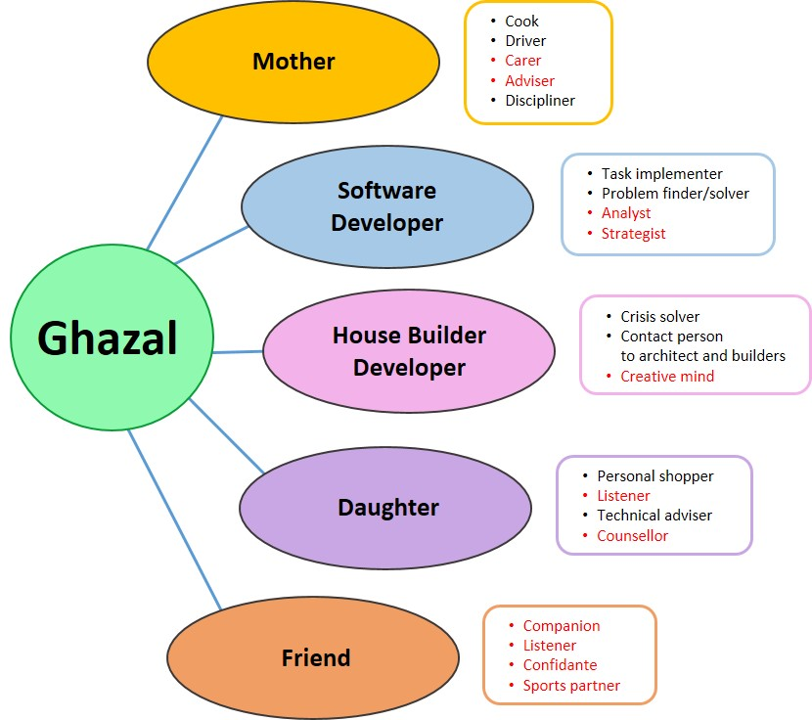
Figure developed by Thu Phong Vuong for this course

Task: A variety of roles
- Refer to the map in the learning journal and fill it out for yourself. In order to do this, take some time now to consider three to four roles you play in your life. Mark your most enjoyable roles in one particular colour, and the ones you find more challenging or taxing in another colour.
- If you find some roles easier than others, then ask yourself: What might be the reasons for this? What could be important factors that influence how easy or enjoyable a role is in comparison to others? Note down these reflections in your learning journal.
We can see that all of us play a wide range of roles every day. So why is it that we find fulfilling some roles easier than others? We might find taking on roles in a student organisation, for example, or as a volunteer, or even as a friend, easier because these are usually roles that we pick ourselves. They play into our strengths and interests and may also be more in line with our self-image.

4.3 The function of team roles in work teams
The idea of team roles was developed by Meredith Belbin. Just as we saw in the previous exercise that we inherit and take up different roles in our lives, we also do this in work teams. And just as we often feel better about roles that play to our strengths and interests away from work, the same is true in teams.
Belbin carried out a number of studies to determine the success or failure of teams in the late 60s. In these tests, teams were put together to observe the process and results of their performance. Psychometric tests were conducted with the individual team members, and the teams assembled according to those test results. The general expectation was that the teams with the intellectually highest test results would do best in these team tests. However, this proved not to be the case. On the contrary, in most instances, these teams regularly received the lowest test results. Intrigued by this repetitive result, he observed that apparently, those (...) team members had spent a large part of their time engaged in abortive debate, trying to persuade the other members of the team to adopt their own particular, well-stated point of view. No one seemed to convert another or be converted." (Belbin, p. 15). According to Belbin, this result can be explained by the educational system and a culture that exerts pressure on intelligent people, as they would be constantly judged by their scholastic pre-eminence, not to come in second. "In other words, overconcentration on coming top of the class provides an unconscious training in anti-teamwork."
If intelligence and creativity are not the decisive factors that determine a team's success, then what is it? Before we answer this question, let us go through our next exercise.

Task: Team diversity – a risk or an asset?
Imagine we take 10 random teams and rate them according to the level of their cultural diversity (according to our open culture concept from session 2). On the left of the scale, we have very homogeneous teams with little diversity, meaning for example that the team members are a similar age, come from the same region, speak the same language and have experienced similar socialisation paths. On the right, we have teams with a higher level of cultural diversity.
Please answer the following questions in your learning journal:
- If we assume ceteris paribus (all things being equal) for this theoretical thought experiment, which teams will be more successful in reaching their goal? Or put in another way, would you assume that a high level of diversity is an asset for a team, or more a risk factor?
Please elaborate on your answer.
- Depending on your answer to question 1:
If you answered that highly diverse in teams is more of a risk, then ask yourself: What would have to happen to turn it into an asset?
If you answered that a high level of diversity is rather an asset, then consider: Under which circumstances could this asset turn into a risk?

Sample answer
The right answer to this question – as is true for so many questions – is "it depends". According to research from Dr. Carol Kovach and Nancy Adler, we can assume the following distribution when comparing the performances of differently diverse teams:
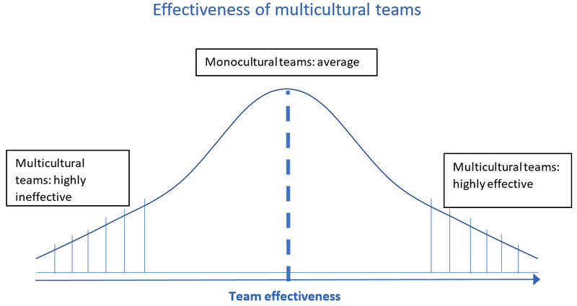
Source: Based on the research of Dr. Carol Kovach and Nancy J. Adler (1991). International dimensions of organizational behavior, 2nd edition, Boston: PWS-Kent Publishing
As we can see, what the researchers found out is that compared to rather monocultural teams, some multicultural teams tended to be more effective while others tended to be less effective. They are on both sides of the extremes, compared to the average monocultural teams. Without going deeper into the research methods and acquired data, one lesson we can take is that diversity has the potential to be a high asset for every team. However, if high diversity teams are not able to tap into diversity as a resource, it might turn out to be a risk factor.
Thus, returning to our initial question of what makes out highly successful teams, one answer we can give is: teams that tap into their diversity as a resource.
Now let us return to the research conducted by Meredith Belbin. According to Belbin, the diversity within a team is not only limited to differences in gender, age or national backgrounds. Rather, he focuses on a variety of traits and capabilities within every team member. According to his study, we all have different traits when working within a team. Depending on the situation, each of these traits can become either a strength or a liability. He initially suggested eight, and later nine roles which should be present in every team in order to perform well. Not all of these roles have to be taken up by different individuals. Just as we often take on different roles in our lives, it is also quite possible to assume a variety of roles in a team.

Task: Team roles test
- For an initial introduction to team roles, please click on the link below to go to the 'Team roles test' website. In this test you will be presented with a series of word pairs referring to different activities or qualities (e.g. 'Practical' / 'Critical', 'Orderly' / Communicative' etc.). You will be asked to choose the one closest to you. Based on your answers, you will then be presented with an example of a possible team role that might be close to you.
https://www.123test.com/team-roles-test/
- Your results will be shown in the form of a pie-chart, with your scores in the nine different team roles. Read through the description of the two roles in which you scored the highest, and answer the following questions: Which of the statements describing these roles would you confirm? Which ones would you refute?
Also, read through the two roles in which you achieved the lowest score. Would you agree that these roles indeed do not describe you very well?
Please note down the answers to these questions in your learning journal.
The idea of these exercises was to give you a first impression of what these team roles might look like, and how they might relate to you. The nine roles that Belbin suggested are slightly different, but nevertheless quite close to the ones you saw in your test.

4.4 Understanding team roles
The table below describes the strengths, allowable weaknesses and possible function of every role. In the leftmost column you can find the role that best corresponds with the one suggested to you by the team role test that you took in the previous section.
Click on the image (if necessary, hold down the Ctrl key while clicking on it) to enlarge the table or click here to download the table as a pdf document.
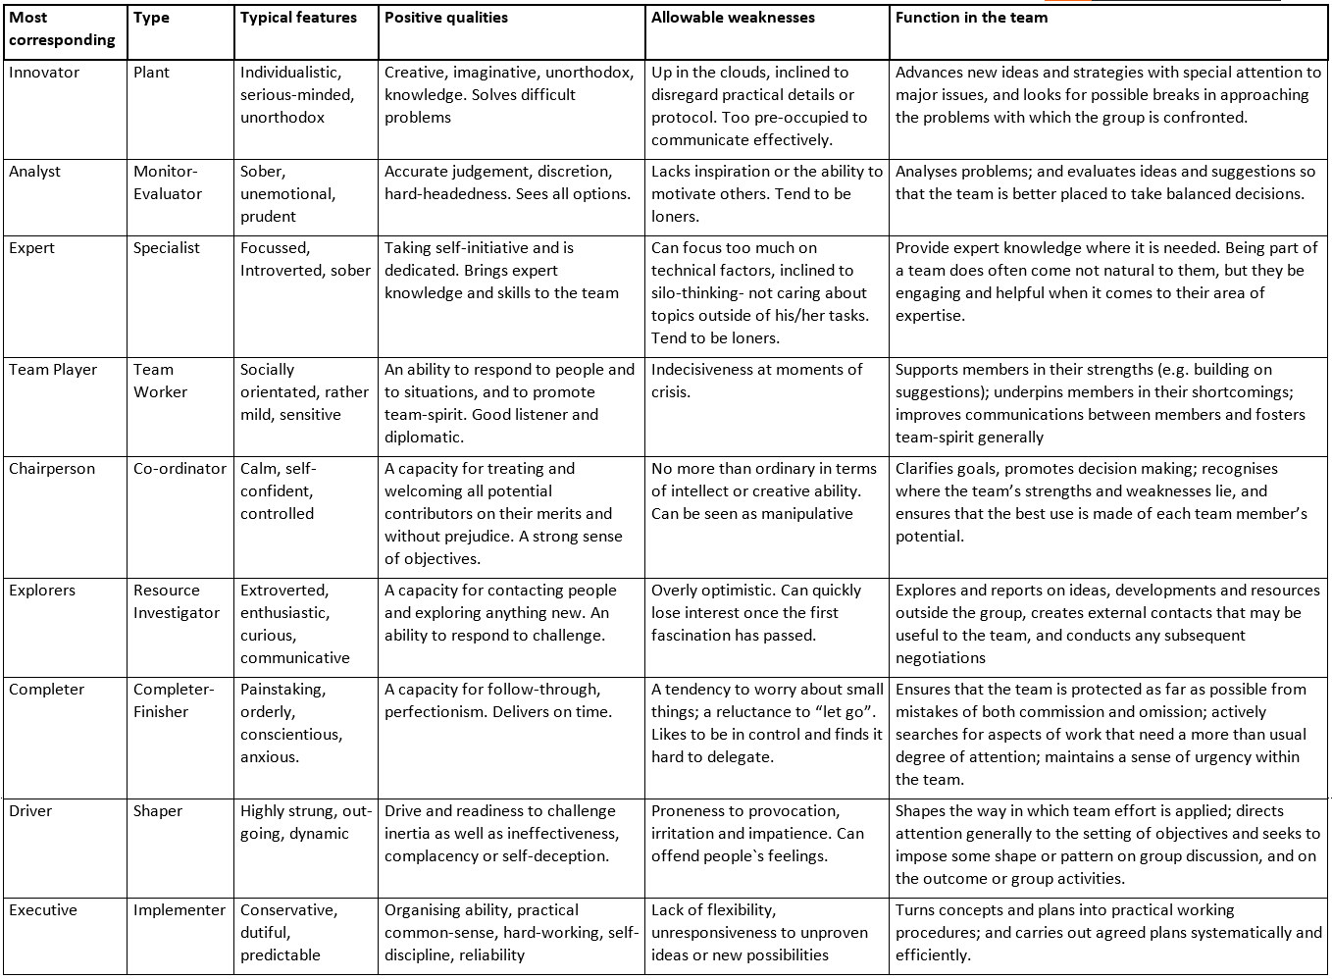
Table developed by Thu Phong Vuong for this course

Task: Three areas of team roles
The nine roles that we have seen can be categorised into three areas:
The first category of roles focuses on action: These roles are about making sure the team stays motivated and that things get done.
The next group of roles has a people-orientation: These roles make sure that people inside and outside of the team feel connected and are in the right place.
The third group has a thought-orientation: These members of the team make sure that there are enough ideas and knowledge in the team in order to come up with good solutions and to avoid mistakes.
Which team role would you place in which area? You should come up with three roles for each. Please move the groups of team roles into the correct area.

You can access this interactive exercise on the Glocal Campus course,
URL: https://glocal-campus.org/mod/page/view.php?id=1524#task-areas-of-team-roles
Figure developed by Thu Phong Vuong for this course

Task: Case "Creative ideas – not appreciated"
Erastus works as a Human Resource manager of a small start-up company. He loves coming up with new ideas and working with his HR team to set them in motion. However, he feels differently at board meetings when he is with his fellow managers. Often when he suggests new ideas for a process, his colleagues roll their eyes or change the topic. Sometimes he feels like his natural creativity here is not valued. A further source of frustration for him is that the team often loses itself in technicalities, rather than asking themselves the big questions, and embarking on new paths.
At a team-building workshop, his team undergoes the Belbin assessment tests, and he learns that he scores high on the "Plant" scale. He finds this interesting but is not sure how this helps him in finding a better way to deal with this team.
Please help Erastus here and answer the following questions in your learning journal:
- Why does Erastus feel frustrated at the board meetings as a "plant"?
- What should his team understand about him? What are the dangers for the whole team when Erastus cannot live out his team role?
- What could the team leader do to ensure that she / he implements Erastus’ strengths in the team, and deal with the weaknesses he might have?

Sample answer
1. Why does Erastus feel frustrated at the board meetings as a plant?
Team members who identify as "Plants" according to the Belbin team roles, often enjoy coming up with new and creative ideas. They do not necessarily want to see all of the ideas implemented but feel validated if their ideas are appreciated and at least discussed. Erastus might feel taxed because his team seems to be rather irritated by his constant influx of ideas.
2. What should his team understand about him? What are the dangers for the whole team when Erastus cannot live out his role in it?
His team would need to understand that Erastus does not need to see all ideas fulfilled, but still needs a space to develop. We could see that while Erastus is a creative mind who loves to come up with new ideas, his team might feel taxed when they feel they don’t get anything done, with Erastus constantly pitching in new suggestions instead of following up on current thoughts. Erastus' weakness then is that he might lose interest quickly in a day-to-day business discussion and that he feels offended when people do not appreciate his creativity.
Often, the team mates we have the largest conflicts with are the people that are most different to us in terms of competencies and interests. In this case, Erastus does not understand how his colleagues could not be excited to try out new ways, but instead cling to the old processes. He is frustrated as he does not see the use that can sometimes come from not constantly "reinventing the wheel". His colleagues, on the other hand, might feel taxed by Erastus because they feel he takes up too much time and energy in trying to change proven tracks. They do not see the value in coming up with more innovative ways. The fact is: we often feel most frustrated by the people that would also complement our weakness the most. If the team should lose someone like Erastus, as they do not appreciate his innovative drive enough, they might miss his ideas when the markets change or the pressure for innovation becomes stronger. Conflicts amongst very different roles within a team will most likely rise when the team is pressured to perform, or in the storming period, when the team is being formed as discussed in session 3.
3. What could the team leader do to ensure she / he implements Erastus' strengths in the team and to deal with the weaknesses he has?
One possibility of dealing with this is to give Erastus some place to develop his ideas where it does not disturb the working flow of the team. She / He could mention in a team meeting: "Thank you Erastus for your suggestions here. I am sorry that we do not have the time today to discuss these new ideas, as our task today is more focussed on the consolidation of the process so far. It would be great if you could send me a list of suggestions these next days. We could then go over them together, and make some suggestions together at the next board meeting."

4.5 Applying the team roles for our self-awareness
In this section we would like to take our conception of team roles one step further and see how we can apply it to gain a better understanding of ourselves and our behaviour in teams.

Task: Strengths and allowable weaknesses in your team roles
Look at the two corresponding roles from the 'team roles test' in section 4.3 where you scored highest. Also, look at the two roles where you scored lowest. Read the additional descriptions and write down in your learning journal which roles can be ascribed to you according to Belbin's table of roles. From these 4 descriptions, write down 3 strengths you believe you have in a team, and 2 allowable weaknesses. You are of course also free to read through the other descriptions and take some strengths and weaknesses from there that you believe might describe you better.
Here is one example to clarify the task. Let us say you scored highest as team player and co-ordinator, and lowest in completer-finisher and resource-investigator. Some of the strengths and weaknesses you take from the roles could be:
3 strengths:
- I am a good listener and can bring people together
- I am good at judging people´s strengths
- I usually stay calm and self-controlled in stressful situations
2 possible weaknesses:
- I sometimes tend to be indecisive
- I am not the most creative person
Please note: Do not feel boxed-in or categorized after the assessments from the tasks "Team roles test" and "3 areas of team roles". The goal is not that you now identify yourself solely as a "Coordinator" or "Specialist". What is important to keep in mind is that we all have traits and behaviours that come naturally to us. All of those can be strengths in some situations, and challenges in others. One of the main purposes of discussing team roles is to give you a basis for self-reflection, i.e. what are your traits and natural behaviours, and therefore which strengths or risks can we deduce from these in a team context?

Task: Your own experiences with strengths and weaknesses in teamwork
Reflect on the teams you have worked in so far. These could be project teams at school, university, during internships, or at your workplace. Sports teams are only suitable when you believe the roles discussed in this module are relevant.
Please note down your answers to the questions below in your learning journal.
1. Look at your list of strengths and weaknesses that you noted down in the previous task "Strengths and allowable weaknesses in your team roles". If you connect them to the teams you have part of so far, which examples can you find where these strengths and weaknesses might have been apparent? Try to come up with at least two examples of a strength, and one example of a weakness. Describe the situations, considering: Who was involved? How did you act or behave? What were the consequences when you were able to display a strength of yours? What were the consequences when you encountered a possible personal weakness in a team role?
2. What can you do to ensure that you increasingly act in a way that maximises your strengths? How can you deal with situations when your traits become a challenge?

4.6 Applying team roles in work teams

Using team roles to put teams together
Why is it important to factor in team roles when designing teams? According to Belbin (Belbin, 2010 p. 26), today's organizations tend to suffer from a so-called “cloning culture”. Managers tend to recruit or advance staff who are similar to them. Even entire organisations can have a certain culture or reputation that draws a certain kind of personality to them. The danger here is that it might become increasingly difficult to create diverse teams where the team members actually supplement each other's strengths and weaknesses. In session two we discussed the fact that multicultural teams don´t necessarily have to be diverse, but it can be strongly beneficial to team performance. In research from consulting firm Boston Consulting Group, we learn one possible reason for this, especially in leadership teams.
Increasing the diversity of leadership teams leads to more and better innovation and improved financial performance. In both developing and developed economies, companies with above-average diversity on their leadership teams report a greater payoff from innovation and higher EBIT margins.
[...]
For company leaders, this is a clear path to creating a more innovative organization. People with different backgrounds and experiences often see the same problem in different ways and come up with different solutions, increasing the odds that one of those solutions will be a hit. In a fast-changing business environment, such responsiveness leaves companies better positioned to adapt.
[...]
We surveyed employees at more than 1,700 companies in eight countries (Austria, Brazil, China, France, Germany, India, Switzerland, and the US) across a variety of industries and company sizes. (…) We looked at perceptions of diversity at the management level across six dimensions—gender, age, nation of origin (meaning employees born in a country other than the one in which the company is headquartered), career path, industry background, and education (meaning employees’ focus of study in college or graduate school). To gauge a company’s level of innovation, we looked at the percentage of total revenue from new products and services launched over the past three years.
[...]
The biggest takeaway we found is a strong and statistically significant correlation between the diversity of management teams and overall innovation. Companies that reported above-average diversity on their management teams also reported innovation revenue that was 19 percentage points higher than that of companies with below-average leadership diversity—45% of total revenue versus just 26%.
[...]
Not surprisingly, these organizations also reported better overall financial performance: EBIT margins that were 9 percentage points higher than those of companies with below-average diversity on their management team
Source: Lorenzo et al., 2018. How diverse leadership teams boost innovation.
https://www.bcg.com/en-us/publications/2018/how-diverse-leadership-teams-boost-innovation (accessed on 10.11.2020)
As we can see, putting teams together based on their diversity is a good idea, but unfortunately it often does not come naturally to us. Let us take a look at good practices regarding the composition of teams based on the team roles we discussed.

Task: Essential team roles
Take another look at the Belbin team roles table and answer the following question: If you had a small team of three people and, hypothetically, these three people took on exactly three roles – which three roles do you believe are the most essential for almost all tasks?

Sample answer
While many different combinations of roles, and thus important competencies in a team, can be argued, one example would be that it is good to have someone in the team with the qualities of the "Co-ordinator". This person would be responsible in assigning the different roles of the team members, and allocating the needed resources. While the Co-ordinator is good at connecting to people and having a general overview, this person sometime would lack a the creativity and analytical skills. If the assigned task for this team should have a constant need for innovation, e.g. because it is in a constantly changing market, a "Plant" could play an important role here. Should it be more important to implement expert knowledge into a project, this slot should rather go to a "Specialist". Thus, if we have someone with the competency to motivate and allocate the team's resources, plus someone to bring in the needed know-how or innovation, then what else could be needed would be someone with the drive to set everything into action. This role could go to a possible "Shaper" for example, when there is a high urgency for the task. If less urgency is required, but more accuracy for the task, an "Implementer" could be advised.
Obviously, every team role comes with its own competency and thus important merits to the team. All of them can be needed at times. To have at least one each of all of the three areas of "People-orientation", "Action-orientation" and "Thought-orientation" though would cover many needed competencies of a typical working team task.
In most cases, organisations describe certain functional roles to their staff. Each of these functional roles also come with certain requisite competencies. A general manager might need different competencies than a finance officer or a Human Resource specialist. As you have probably already noticed, the team roles we discussed are mostly defined by the competencies they inherently bring to the team. It would therefore make sense to consider which of the team role competencies would fit the expectations we have for certain functional roles. The next task will shed some light on this and provide some examples.

Task: Case "Two job advertisements"
A large global company opens a new factory in Vietnam in order to produce screws that are needed by their customers in Asia. The headquarters in Japan puts together a new team for this factory. Two of the functions are still missing. Please read the job advertisement – we have reduced it to the job description as well as the required competencies for each position. When you look at the team roles table again, which competencies described there would correspond with the ones that are required for the two open positions? Could one Belbin team role cover all of the expectations, or is the company looking for someone who has their strengths spread over several team roles? Please write your solutions in the learning journal and elaborate on your suggestion.
1. Job description General Manager
- Communicate between the headquarters in Japan and the local staff in Vietnam
- Efficiently allocate and motivate the workforce in the factory
- Formulate milestones for factory development together with the management team and ensure that these plans are implemented
Required competencies:
- Good communication skills
- Ability to remain calm under pressure
- Strong interpersonal skills
2. Job Description Sales Manager
- Network with our existing and potential customers in the Asian region, and to explore new sales regions for our products
- Create job descriptions for the new sales team, and allocate them for the most effective sales process. Motivate this team to reach the agreed sales targets
- Present and communicate the benefits of our premium product to potential customers
Required competencies:
- Analytical skills
- Strong networking and communication skills
- Strong internal drive

Sample answer
Again, several solutions are possible. One possibility for the general manager could be someone with the team role as a "Co-ordinator", who should bring the competencies of allocating the workforce and planning the milestones with the team and should keep the big picture, even under pressure. It should be ensured that this management team would also have someone with a strong implementation drive, like a "Shaper" or "Implementer".
As to the sales manager, this job description could call out for an "Resource Investigator", who would be good in connecting with people outside the organization. As this person could lose his/her drive quickly once the first excitement of opening a new factory has passed, someone with the role of the "Shaper" could also be useful here, in the long run, to keep the motivation going.

4.7 Summary
Just as we all play different roles in our everyday lives, we similarly inhabit a variety of roles as a member of a work team. There is a natural diversity in every work team, since individuals bring their own interests and traits with them, and these can be either strengths or weaknesses. In order to tap into diversity as a resource, it is important to be aware of this in every team, and to reflect on how we can deal with these different competencies. Since we usually enjoy roles more when they play into our natural strengths and interests, we should also choose our tasks in a team according to this principle, wherever possible. For this reason it was important in this unit to gain an insight into our own profiles, and discover which competencies we bring to a team. Knowing our strengths and weaknesses also brings self-awareness, and encourages us to consider how we might deal with these attributes within ourselves. This process is also likely to promote more patience with regard to ourselves but also with respect to others, and prompt us to realise that nobody is perfect.
We also learned that we can use the concept of team roles to identify which competency we need for each functional role in our organisation. Instead of hiring people purely on the basis of experience and expertise, knowledge of team processes also helps us to recognise which competencies and roles are still missing in our teams.
However, it is also important to realise that diversity brings potential for conflict. We learned that the team members whom we find most irritating are often the ones that have strengths which actually complement our own weaknesses. It is therefore of crucial importance that we realise the need for people that are different from us in order to enhance team performance. A team that consists only of our own 'clones', so to speak, is unlikely to work as well as one in which we include people who complement us.

4.8 Learning review
For a final assessment of your understanding in this course, please read through following case study:

Task: Case "A team assignment"
Richard was taking a marketing class at his university. At the end of the semester, the course participants were asked to divide into teams of three students with the goal of assessing the attractiveness of a specific fictional product (a car accessory) devised by the professor. In order to conduct this market research, Richard was to work together with Gaoya, who was an international student from Singapore, and Mohammed, who had a British background like himself. They were given four days to complete their project and were then to present their results to the class the following week.
The team quickly came to the conclusion that the best way to finish this assignment was to go out and ask people about their feelings towards the new product. The first task they set for themselves was to establish which questions to ask. At the beginning there was a lot of disagreement. Gaoya seemed to be excellent at coming up with ideas, but in Richard´s opinion did not adequately think through whether these questions would actually deliver the results required in the limited time available. Richard took on the task of proofreading the survey questions, making sure that the language and vocabulary employed were unbiased and likely to elicit an open answer. Mohammed did not come up with many ideas of his own, but made sure the team was focussed and did not waste their time on endless discussion of details.
The next task was to find people they could interview. There was little time, and since they thought they needed at least 20 interviews in order to have representative results, Gaoya suggested that they should simply go to any busy shopping mall and start asking people until they had enough results. A 'lively discussion' erupted, as Richard thought that his would just waste their time. His approach would have been to sit down with a plan and consider which people they might want to interview, and where they could best find these people. After all, not all of the people in the shopping mall would even own a car. After a heated discussion between Richard and Gaoya, Mohammed tried to refocus the discussion on the task at hand. The resulting decision ended up being a mixture of both approaches, as they decided to go to the local cinema in the evening, where films for mature audiences were playing, to make sure that they would find as many people as possible of driving age. At the cinema Gaoya found it easiest to simply approach people, whereas Richard was more hesitant.
The third part of the project was to prepare and conduct the presentation. Richard made sure the presentation style and data was in great shape, but he seemed to be nervous about the presentation itself. Mohammed, who observed this, suggested that Gaoya should take on the largest part of the talking as she really seemed to enjoy it and was also good at it. Richard and Mohammed presented the visual results and numbers.
Even though the team went through some heated discussions, the final result earned them a great mark which left all three of them very happy.
In your learning journal, answer following questions for each of the three team members:
- What were the strengths of Richard, Gaoya and Mohammed? What were their weaknesses?
- What do you believe was their respective Belbin team role?
- What could have been the consequences for the team if Richard's competencies had not been there to support the effort? How about Mohammed's, or Gaoya's competencies?

Sample answer
1. What were the strengths and the weaknesses of Richard, Gaoya and Mohammed?
Richard's strength could have been the ability to be detail-oriented. He was good at coming up with structures and plans, and looking for mistakes in written documents, like the presentation or the surveys. His weaknesses might have been to deal with spontaneous suggestions or to move on with a feeling of uncertainty. He also was not very people oriented, having more challenges with doing presentations or approaching strangers for the survey.
Gaoya's strength could have been her creativity and spontaneity, as well as her ability to quickly connect to people. Her weakness then might have been to work meticulously on details in written work or a general plan.
Mohammed's strength might have been to quickly see the strengths in people and allocate their skills with the right tasks. He also might have been good at ensuring the focus in discussions. His weakness could have been a lack of creativity within the team.
2. What was their respective Belbin team role?
Richard's described strengths and weaknesses sound much like the competencies of a Monitor Evaluators. If we got to know him a bit better, he might also be placed somewhere else, like e.g. as a Completer-Finisher. Gaoya's role might have been the one of the Resource Investigator, and Mohammed's role fits the description of a "Co-ordinator".
As we mentioned above, however, the goal of these exercises is not to be able to "put people into categories". First and foremost, the three are individuals. It is important to see though that each of them did bring some strengths to the table which complemented each other.
3. What could have been the consequences to the team if Richard's competencies had not been there to support it? How about Mohammed's, or Gaoya's competencies?
If Richard's competencies had not been available, the team might have gotten many ideas, but an overall strategy might have been missing. The quality of the data and the result might have also not been the same. If Gaoya's competence had not been available to the team, there might have been much longer planning and analysis on how to proceed, instead of "getting their feet wet" and making some important experiences first. The presentation might also not have been as good. Mohammed's competencies made sure that the team did not lose focus in the discussion and that the other team members did not feel unhappy about their tasks within the project.

4.9 Sources, further reading and web links

Sources
- Belbin, R. M. (2010). Management teams. Why they succeed or fail (3rd edition). Amsterdam, Oxford: Butterworth-Heinemann Publishing House.
- Kovach, C., & Adler, N. J. (1991). International dimensions of organizational behavior (2nd edition). Boston: PWS – Kent Publishing.
- Lorenzo, R., Voigt, N., Tsusaka, M., Krentz, M., & Abouzahr, K. (2018). How diverse leadership teams boost innovation. BCG Henderson Institute, https://www.bcg.com/en-us/publications/2018/how-diverse-leadership-teams-boost-innovation (accessed on 10.11.2020)
- 123test.com. Team roles test. https://www.123test.com/team-roles-test/ (accessed on 10.11.2020)

5. Creating mutuality in intercultural and interdisciplinary virtual teams

Topics
5.1 Prelude 82
Task: Which teams perform best? 82
5.2 introduction 83
5.3 The MBI approach in a virtual environment 83
Task: My diversity wheel 86
Task: The meaning of work 86
Task: Task vs relationship orientation 87
Task: Different expectations 88
Task: Hierarchical versus status orientation 88
Task: Opening hours 91
Task: Getting to know myself and my cultural orientation 92
Task: De-centering 95
Task: The meaning of 'team meeting' 95
5.4 Creating mutuality and negotiating culture in a virtual team 96
Task: A common path 97
5.5 Using cultural profiles as a basis for mapping and negotiating culture 98
Task: My cultural profile 98
Task: Commonalities and differences among team members 102
Task: Reconciling differences 103
5.6 Summary 104
5.7 Learning review 104
Task: Learnings from this session 104
5.8 Sources, further reading and web links 104

Learning outcome
By creating identity profiles according to the principles of the MBI model (mapping, bridging and integrating), you will understand how mutuality and commonality in an intercultural and interdisciplinary virtual team can be created.

Objectives
At the end of the session, you will
- explain and apply the MBI approach
- explain and develop an identity profile
- identify commonalities and differences that influence teamwork
- explain how mutuality can be created
- apply activities that further mutuality
- develop criteria to enable the negotiation of a productive and synergetic culture

5.1 Prelude
In the previous session you learned that team members occupy different social and functional roles. In addition, you gained insights into which particular roles you might flourish when working in a team. Whichever roles these are, each and every person is key in supporting the team, mitigating differences and creating mutuality. How this can be achieved is the focus of this unit.

Task: Which teams perform best?
Let's start with a question: Which teams do you believe will perform better, those which are diverse or those which are homogeneous?
Take three minutes to note down your answer in your learning journal.
Here is how Henry W. Lane, who majored in organisational behaviour, and Martha Maznevski, who completed her PhD with research on multicultural teams, have answered this question in their book on "Organisational Behaviour".

Sample answer
Lane and Maznevski argue that the question is complex and the answer depends on a variety of factors, such as the definition of diversity and performance employed. They say that by nature, people with a diverse background are able to contribute different perspectives, and if the team's task is one which is structured and routinized, these may not be called for. However, if the team's objective is to develop a strategy for market entry or other innovative processes, different perspectives are likely to generate solutions which are more appropriate and effective.
According to Lane and Maznevski, the main question, however, is how the full potential of a diverse team can be leveraged. They emphasise that this requires skilful management of interactions within the team so that diversity can be harnessed in a way which generates new and better ways of doing business.
Considering our definition of culture, we might say that a completely homogenous virtual team does not really exist because our team members will naturally display differences, such as different levels and areas of knowledge, different educational and professional backgrounds, different ages and self-identities. Therefore, it is important for every team to explore their differences and commonalities and use these for the benefit of the team. The aim of this session is thus to introduce you to the so called MBI approach. In this endeavour you will use identity profiles to support the mapping process as a first step towards mitigating differences.

Download: Learning journal for session 5
Learning journal (.docx) Learning journal (.odt) Learning journal (.rtf)

5.2 introduction
Diversity and thus heterogeneity has become a mainstream topic in global business. This is not only due to the growing interconnectedness of all business areas but also due to an increasingly diverse, mobile workforce and marketplace, changing workforce demographics, scarcity of labour and the availability of global internet access. These developments have facilitated the organisation and growth of work groups whose members come from a wide range of diverse backgrounds.
These diverse backgrounds indicate membership of different collectives, which can be linked to characteristics such as education, family history, profession, gender, languages and lifestyles. Membership of these collectives influences a range of factors, such as the resources and capabilities members are able to bring to the team; the expectations members harbour with regard to working styles and the way members expect to communicate with each other.
In the workplace environment, culturally diverse teams provide a vast number of opportunities to increase performance, creativity and innovation. However, they equally throw up some challenges which need to be faced and overcome. One of the first tasks is therefore to identify the level and type of homogeneity and heterogeneity of a team and develop strategies that will enable the team to utilise and benefit from its diversity in order to achieve its goal. In other words, a team which ignores its diversity and is not willing and/or ready to manage this issue will find it difficult to fully mature as a team. The purpose of this unit is thus to introduce the MBI approach as a tool to identify commonalities and differences and investigate how these can be used to benefit the team. This 'MBI' approach involves mapping (M), bridging (B) and integration (I).
While the Tuckman model illustrated the process of team development, the MBI approach is a tool which can enhance the quality of the team’s performance by making commonalities and differences explicit and generating a discussion centred around ways of creating mutuality. As a tool, it can be applied during the initiating phase and at any time during the norming phase when anybody in the team feels that there is an issue.

5.3 The MBI approach in a virtual environment
Lane and Maznevski (2019) identified three steps that team members should move through in order to identify the resources available within the team and to use these to their full potential. These are mapping, bridging and integration (MBI).
Mapping involves detecting, describing and understanding the differences and commonalities among team members and the impact these differences might have on teamwork. The metaphor of mapping has thus been chosen quite deliberately since a map is an image that helps people to navigate a new territory. A map needs to be accurate and its level of detail and scale should be appropriate for the purpose of the journey. In our context we refer to a map that displays social features and whose data, in contrast to a geographical map, are difficult to verify. However, if they are carefully constructed and self-ascribed, such maps are very helpful, especially at the beginning but also during the entire course of the teamwork.
While mapping is about getting to know and understanding other team members, this understanding provides little benefit if it is not accompanied by bridging. Bridging refers to communicating and establishing areas of common ground among team members. In other words, it is the process of developing common meaning, while considering all the differences among team members.
The last step, integrating, refers to the management of differences and integration of the various perspectives among team members. The objective during this process is not just to resolve any differences, but to utilise them in order to generate added value and thus create new perspectives and practices as well as innovative approaches with regard to a task and its solution.
Let's look at each step in more detail:
In order to construct a map to illustrate the cultural makeup of team members, we first need to consider which factors should be included in such an analysis. People normally expect others to think and act in the same way they do themselves and usually that this is also considered to be the correct and best way. This, however, is a fallacy, as people have different approaches to all manner of issues such as conducting financial analyses, styles and channels of communication, ways of addressing short-term problems and resolving conflicts. At the same time, it would be wrong to simply think that ‘other people’ are necessarily always different.
So therefore the question that arises is: ‘In which aspects might our team members differ?’ and ‘How many details do we need to know and which reference points should be used?’. There is, of course no general rule as to how thoroughly these questions should be answered, but points to consider are the level of virtuality and perceived differences, the complexity of the task, the amount of time at their disposal, the type of team, as well as the cultural awareness of the team members. A common tool to sketch out differences and commonalities is the diversity wheel originally developed by Loden and Rosener in the 90s. It is commonly used as an instrument for illuminating the areas of diversity that may be present in an organisation or team and it can help identify relevant collectives and diversity dimensions.
The introduction of the diversity wheel sparked lively discussion. One of the results of this discussion was a call for further diversity dimensions to be considered in the original wheel. The same discussion, however, also recommended limiting the number of dimensions outlined, thereby focusing on those which really make an impact on team performance and are therefore relevant in each particular context. The model below was developed by Gardeswartz and Rowe (2003). When using the wheel for mapping cultural differences in a virtual team, it is important to bear in mind that individual and group based differences intermingle in this model.
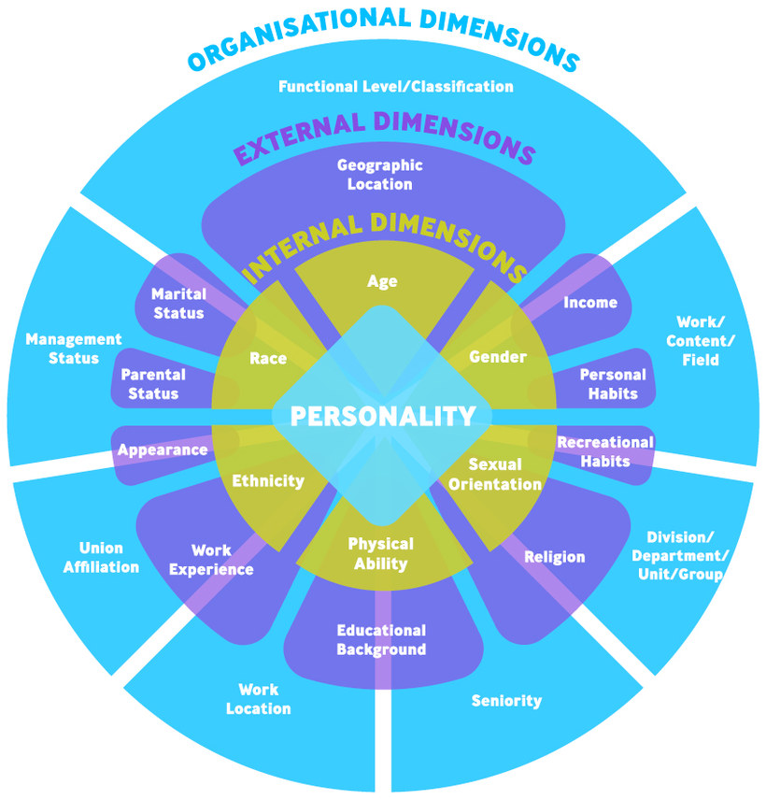
Source: Based on Gardenswartz and Rowe 2003, adapted
Figure by Julia Flitta (www.julia-flitta.com)
The wheel starts in the middle with personality, i.e. the characteristics of each person. This includes for example whether a person tends to be more extroverted or introverted, active or passive, but also how these factors influence interaction with others, and how the person is perceived by others. The internal dimensions relate to aspects that a person cannot influence such as age or physical abilities, and aspects which are usually not changed such as gender, sexual orientation and religious affiliation. In the context of the United States of America, race and ethnicity are also commonly included in this layer. All of these aspects are seen to have a bearing on how a person is treated and perceived by others during interaction.
The third layer depicts the outcome of life experiences and life paths. Commonly, ten dimensions are listed in this context such as education, income and marital status. Depending on how these aspects are valued by the corresponding interaction partner and whether they are seen to be connected, they may influence how these aspects interfere with or affect teamwork. The fourth layer includes elements that are linked to work and organisational contexts. They include hierarchical as well as functional aspects of working life and how a person relates to them in the context of diversity.
The diversity wheel is generally seen as an instrument to sensitise people with regard to diversity issues and make diversity visible among people who work together, thereby raising awareness but also understanding and acceptance. In the context of teamwork, the wheel may be used as an orientation to identify membership of collectives which might be influential when working together. For example, it might bring to light the fact that people in the team belong to different age cohorts. The critical point then is whether this is relevant for task performance and team satisfaction as well as what this may mean in terms of working together. It might also show that team members are very different with regard to their work experience. Digging deeper could show, for example, that some members have profound technical experience, which can be a real asset when working in a virtual environment. This means that the diversity wheel can be used as an initial means of orientation in order to assess which differences might be relevant. After this self-ascribed categorisation, the team can then assess what particular memberships of collectives might mean in the context of their teamwork.
One of the key insights from implementing this process is that that the factors contributing to perceived and real team diversity can vary from one team to another. Some factors will therefore be more or less relevant for teamwork, depending on the context. Also the factors contributing to diversity are not stable, but many of them can change over time. Coupled with the understanding that we need to acknowledge self-ascription and self-identification, the diversity wheel can be used as a basic framework and orientation to acknowledge differences and commonalities in a virtual team.

Task: My diversity wheel
Imagine you work in an intercultural and interdisciplinary team. Use the diversity wheel as an orientation framework and note down a few things you think you should share with your team members in order for them to get to know you well. Keep these notes in your learning journal.
An important element in mapping is asking ourselves how we want to work together. Lane et al. (2019) introduce five cultural dimensions, elaborated by GlobeSmart, which they consider to offer a good combination of validity and practical relevance. These are: task versus relationship, independence versus interdependence, egalitarianism versus status, directness versus indirectness and risk versus certainty. Because virtuality is closely linked to real or perceived proximity and time differences, it makes sense to add the dimensions of space and time when mapping virtual teams.
When we use dimensions for mapping in this way, we acknowledge individual orientations as well as the images connected to individuals in a specific context. Mapping then takes place by locating people on a scale between a low and high level of orientation. This, of course, can never provide a truly accurate reflection of a person’s behaviour. One reason for this is that we have a certain understanding of the concept for comparison when we place ourselves on a scale. Developing a common meaning for concepts is thus an important pre-condition when using cultural dimensions for mapping. In addition, it is also possible that although we have a general cultural orientation, we may not behave in accordance to this in particular circumstances.

Task: The meaning of work
The following is a list of possible associations linked to work. Think about what work means to you and how people's different associations with the concept ‘work’ could influence working together in a team:
- Fulfilment
- Earning a good income
- Keeping myself busy
- Feeding my family
- Providing social contacts
- Doing something useful
- Gaining prestige and status
- Other
The first dimension, task versus relationship refers to the fact that team members need to take care of the tasks at hand. Thus, the question to be asked here is 'what needs to get done?'. The opposite end of this continuum would rather consider the social links between team members and their social well-being. In a team there may be members who primarily want to focus on the task at hand and whose priority is to produce results, thereby placing a lot of emphasis on goal setting, structures and schedules. There may be others who consider it very important to get to know each other before going about the task, thus focussing more on interactions in order to foster positive team relationships and the well-being of its members.
Whereas both are committed to completing the task, the ways of reaching this goal might be quite different. Task-oriented team members want to get started with their work quickly and consider relationship building as something which may develop as the work progresses. They are likely to be the team members who propose putting structures in place and developing a step by step plan in order to get the work done. They are also likely to be the ones who are very particular about deadlines, workplace procedures and reaching milestones. They tend to be task efficient and productive in particular at the beginning of team work. However, they may find it difficult to establish trust on a deeper level, which is particular important in virtual teamwork.

Task: Task vs relationship orientation
The following is a quote from a learning journal of a person who realised that there were people in the team who were task oriented and others who were more relationship oriented. Think about the potential issues this might bring to light:
"Some of my team members are completely focussed on task achievement, which does not leave any room for achievements on a team spirit or empathetic level, especially when members are not very open-minded. My personal wish and willingness to connect on a more personal level in order to establish a basis of trust was completely incompatible with the wishes and willingness of others."
In contrast to those who are more task-oriented, strongly relationship-oriented team members have a desire to get to know the team members on a more personal level and believe that if they know each other and understand the background of team members they are better able to communicate and avoid critical issues. This line of reasoning states that once a stable relationship has been developed and team members are being 'looked after', miscommunication is less likely to occur. Because they are willing to invest time and effort in meeting the team member’s needs and engaging in casual interactions, a non-competitive and conducive work atmosphere is likely to develop, which will support motivation and reduce dissatisfaction with the task at hand. They are likely to view a good relationship among team members and a positive work atmosphere as central to being able to deliver optimal performance.
The second dimension, 'independent versus interdependent' refers to the preference of working alone rather than coordinating with and helping each other to complete tasks. 'Independent' therefore means pursuing one’s own ideas and personal goals and staying in control of events. In contrast, a tendency towards 'interdependence' is based on the understanding that the task can only be accomplished through mutual cooperation and reliance. It highlights responsiveness towards the needs and expectations of others as well as a readiness to support other team members. In order to achieve this, a positive working atmosphere is key, as well as the feeling of a sense of loyalty and duty towards the other team members. It follows that team members who value interdependence over independence are likely to approach teamwork very differently. Interdependent team members, for example, are likely to require frequent interactions, assign roles as and when necessary and are flexible in their approach. On the other hand, independent team members are more likely to work confidently on their own and report back to the team when a scheduled task is completed. For them it is important that roles, once assigned, remain static and that rescheduling and flexibility remains at a minimum. Hofstede ID/IDV
Interactions are important for team members with both independent and interdependent tendencies, however the extent to which they value collective effort differs and will influence their assumptions towards the optimal way a team should work together.

Task: Different expectations
Read the following example and consider the different expectations inherent in having a strong notion of independence and interdependence.
Yunita is based in Indonesia and a new member of a project team that works virtually from different regions of the world. One of her colleagues is Kevin, who is based in the Netherlands. Kevin has been tasked with 'on-boarding' her, including answering any questions she might have in order to fit in well with the team. Yunita is very happy to have someone as competent and helpful as Kevin. For this reason she is surprised when she calls him again one day with a question, and receives the reply: "Yunita, I think I told you that a couple of times already. Look, I am really happy to help you out when you cannot help yourself, but I have a full desk of work myself. Could you please think about the solution yourself next time, and then get back to me when you really don't know the answer?"
Yunita is somewhat disappointed. From her point of view, being in a team means that she can ask colleagues who are simply faster at completing a task than others. The greater the mutual support in her opinion, the deeper the trust in the team would be. She would have been very happy to help Kevin with any task he might have for her, even if "he could do it by himself".
The third dimension, egalitarian versus status refers to how power and responsibilities are allocated and distributed. An equality oriented member of a team is one who believes that all team members are more or less equal and power and responsibilities should therefore be shared as evenly as possible. The assumption is that issues are discussed and decided upon together and that everyone is expected to contribute towards the task at hand. Organisations that have an equality orientation have flat hierarchies, which means that teams have a lot of independence and are allowed to make high level decisions. This means that they might even be able to decide on the recruitment of other team members, their compensation or performance assessment. The aim of such a working environment is to maximise employee commitment and bring out the best in each person.

Task: Hierarchical versus status orientation
The following quote from an internship report illustrates the hierarchical and status oriented structure within a team. Read the quote and answer the question as to how this might influence their teamwork.
"I perceived the work environment as very positive and the teamwork went quite smoothly. However, after some time I realized one thing that I was not used to and that is that the team structure is very hierarchical. Actually, everything works via titles. It is not just in the team itself. Throughout the company there is a strict path of upward mobility. Once you have finished a traineeship the first position or title is analyst. Next step would be associate, then senior associate followed by director."
Source: Learning journal, 2020
In contrast to egalitarian cultures, status oriented cultures expect decisions to be made by superiors and employees are expected to ask questions. Power and responsibility are distributed on a vertical level, which calls for a benevolent and empathetic team leader who makes decisions, maintains an overview of all tasks, allocates roles and additionally makes sure that the different parts fit together. In such an environment, team members expect to be taken care of and the team leader is the one who takes the blame when things go wrong as well as the praise when the work is done well. Team members who are status-oriented are likely to display a high level of sensitivity and respect towards other people’s achieved status, be it through education, performance or merit, but also on the basis of family background, age or heritage, for example.
The fourth dimension, directness versus indirectness, relates to a team member’s communication style. Somebody who values a direct communication style has a preference for frank, concise and to the point way of communicating. The aim is to be as clear as possible, leaving very little room for interpretations and ambiguity, thus ensuring swift and effective communication. This remains the case even when addressing difficult or critical issues, e.g. when giving feedback or when finding errors in the work performed. Direct communication is based on the understanding that the person and the message can be separated, thus avoiding embarrassment threats to a person's 'face'. Short and precise messages, written minutes of meetings and detailed instructions with little reference to non-verbal cues and interpretations are typical for this communication style.
"The physical distance between us due to online communication encouraged me to leave my comfort zone. It usually takes some time before I feel comfortable to open up to strangers and voice my opinion directly. But realising that we are all in the same situation and that I can trust my team members made it a lot easier for me. Not being able to meet in person taught me to approach people more openly and gave me confidence to voice my opinion in a collaborative way."
Source: Learning journal, 2020
People who have a preference for indirect speech use different ways of conveying the message and tend to communicate in a way that leaves room for interpretation. Pauses, silence, tone of voice, and body language are important parts of the overall communication. When communicating the focus is on the receiver of the message and an understanding that other people may have different views on the subject, that everybody operates within a certain context and that reading between the lines opens avenues for exploring areas of common ground without pinpointing any dissonance and thus avoiding embarrassment. Indirect communicators know that gathering additional information from sources other than words such as body language or context is required in order to grasp the meaning of the message. By ‘reading between the lines’ and using nuanced tones in communication, indirectness is very relationship and person-focused and aims at being respectful and showing courtesy to the receiver of the message. Face-to-face meetings and verbal agreements are typical for indirect communicators.
The fifth dimension, risk versus certainty, involves considering how much information is required before acting. Of course we all plan our actions, but how many details do we require and how much room do we leave for unforeseeable and unpredictable circumstances? Team members who are risk-oriented emphasise quick actions and are ready to go ahead on the basis of some basic information providing them with an initial orientation. They trust that through flexibility and the thorough monitoring of the a project's progress, they can make the necessary adjustments as they go along. Thus they are relatively tolerant to change and are usually not bound by too many rules and regulations.
The following is an example of how this difference may surface in behaviour:
Richard is an engineer with an upcoming presentation in front of an group of international colleagues. He has worked on his presentation for a long time in order to give his colleagues all the technical details they need to implement a new piece of software. After about an hour into his presentation, Jenny raises her hand and points out: "Richard, thanks for your presentation, but it is possible that you just tell us what the time is? You do not need to show us how the clock works."
Whereas more certainty-oriented people like to give and receive detailed information in order to make sure everyone is prepared for different scenarios, risk-oriented people perceive this as too detailed and unnecessary, since they are willing to simply try it out and learn from experience.
However, people with a preference for avoiding uncertainty need a thorough foundation of information and a detailed plan before they feel comfortable enough to commit themselves. This might include an intensive and detailed analysis of the project and the consideration of a wide range of different aspects and points of view, along with strategic planning and thorough preparation in order to be able to deal with all eventualities. During the implementation phase the focus is on following the agreed plan rather than adjusting it on the go. Having a detailed and agreed plan is perceived as creating transparency for all stakeholders with regards to objectives. In addition, milestones are understood as anchors to help visualise the progress of the project whereas rules and regulations give orientation regarding the behaviour and actions expected from each participant.
The last dimension to consider is monochronicity versus polychronicity, which refers to conceptions of time, a dimension whose impact on working teams is often underestimated. Since organisations and societies have become increasingly obsessed with the speed of work and therefore time, it is clear that time and the way it is experienced differently must have an impact on workflow and satisfaction within teams. For this reason it is essential to include a time dimension in notions of diversity.
"It bothers me when we run out of time. That’s why I like to start immediately after getting the task. Especially when we started our teamwork, one of my major personal needs was to clarify which member is responsible for keeping us on schedule and updating it with completed tasks so that we all have a kind of a structure which displays our progress and helps us to achieve our goals. My personal preference to get things done immediately and preferably be ready a few days prior to handing in the task also affects my course of action."
Source: Learning journal, 2020
With regard to the dimension of time, an important differentiation can be made between monochronic and polychronic time orientations. This refers to whether a team member feels comfortable juggling several things at once and has a tendency to multitask, or prefers sequential scheduling and the accomplishment of tasks one after the other. The following is a good illustration of this and also highlights that being more monochronic or polychronic can be a cultural orientation but also relate to a specific context.
The work of a hairdresser illustrates the polychronic orientation nicely. Especially in smaller saloons hairdresser need to try to maximise their time. This is why they are likely to attend to several clients at a time. One may be having her hair coloured, while another sits under the dryer and yet another is sent to have her hair washed at the sink. In between, the hairdresser takes phone calls and notes down appointments. A mail courier, on the other hand, needs to behave quite differently as not many of his tasks can be intermeshed and he or she has to complete one transaction before moving on the next one.
Source: Ballard, Dawna I. and David R. Seibold 2003. Communicating and organizing in time. Management Communication Quarterly, 16 (3), pp. 387.
Closely linked to this is the question of flexibility with regard to work schedules and the understanding of punctuality and deadlines. The other aspect of time relates to the notion of events versus clock time. The event time orientation refers to viewing time as cyclical and a continuous flow, where tasks are planned relative to other tasks and activities take place in succession from the past to the present and into the future. This means that you ‘call it a day’ not at a specific time, but when the work that you felt needed to be finished is completed. Clock time in contrast works according to precise schedules and activities are anchored according to time. This also means that days are compartmentalised into activities, e.g. what happens after breakfast at a certain time, etc.

Task: Opening hours
Look at the photograph below and think about when the shop is going to reopen and what somebody who is used to clearly defined opening hours would think about the shop owner.
Note down your thoughts in your learning journal.

Source: Iken, Adelheid, 2002. The photo was taken in Shanghai, China.
Trying to understand our own orientation with regard to the various dimensions and assessing which type of behaviour we would typically display or expect in teamwork not only promotes self-awareness; It also helps to grasp other team members’ perspectives and understand the lens through which they see the world. It also helps to make the network of shared collectives among team members more transparent. In sum, mapping provides a basis with which similarities as well as differences can be detected. It fosters an understanding of possible communication issues as well as potentials for generating added value. Therefore, it contributes to the enhancement of team performance and effective interaction.
Many people question the importance of mapping and as Lane et al (2014) argue, there is a trade-off between investment and results. They acknowledge that mapping takes time but point out at the same time that it provides many opportunities for increased understanding, which may pay off at a later stage. The illustration below provides an overview of the benefits of mapping. When considering how much time to invest in the mapping process, criteria such as the degree of task complexity, team diversity and previous experience of diverse teams should be considered. Maps should be seen as flexible tools that can help us to understand our own as well as others' behaviour and may need adjustment depending on context.
The following table provides an overview of the advantages of mapping.
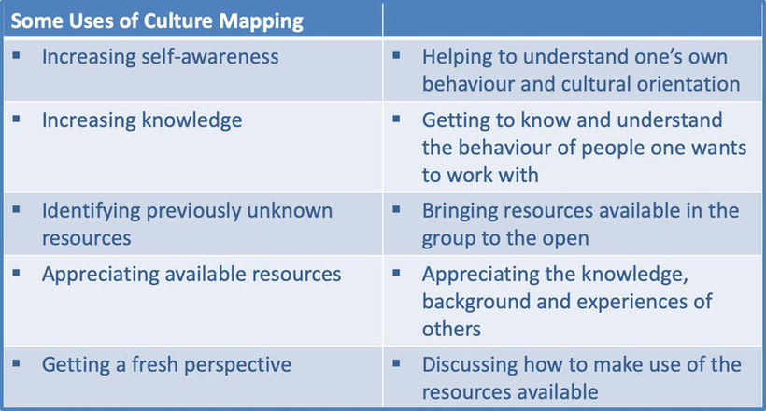
Mapping is a good and important starting point for bridging as it shows where relevant differences might be expected and where similarities exist. But mapping is useless unless it is accompanied by the willingness and openness of team members to accept that no one style and approach is better or worse than any other. When implemented well, mapping thus fosters understanding among group members and a positive approach to integration, which is the foundation for the next phase, bridging.

Task: Getting to know myself and my cultural orientation
Knowing yourself is an important stepping stone if we want to perform well in an virtual intercultural team, and the dimensions discussed can be helpful in achieving this. Using the scales in your learning journal, imagine a work context and position yourself on a scale of one to five.
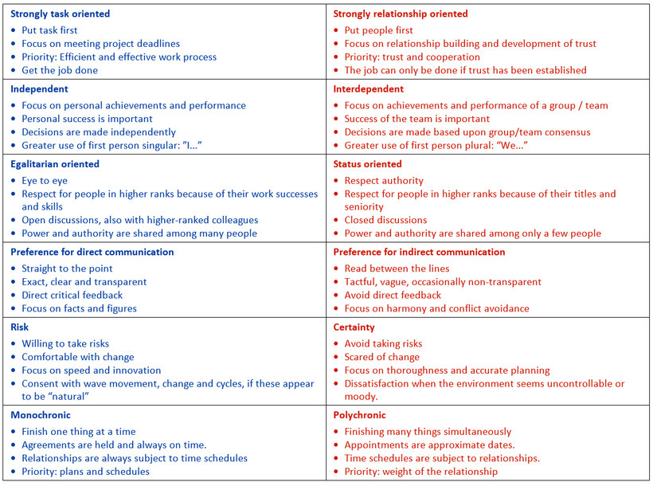
Click on the image for a larger view (if necessary, hold down the Ctrl key)
Once a team has shared its identity profiles, the next step is to identify central differences and commonalities. This can be done by developing a group profile together. The one below indicates commonalities such as all team members' appreciation of a polite, semi-direct communication style. However, they have different approaches when it comes to scheduling and therefore time orientation. In addition, there are certain events such as religious holidays which are important to some team members.
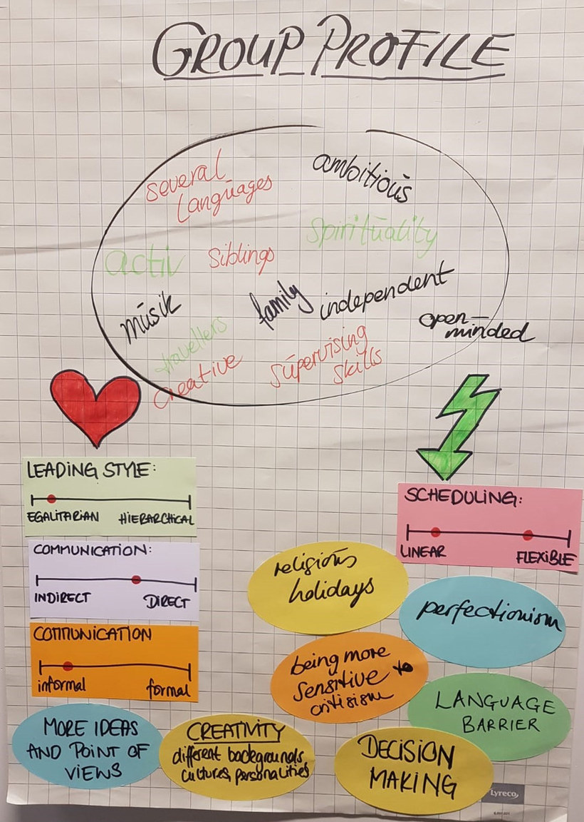
Source: Iken, Adelheid, HAW Hamburg
Bridging could be considered the most important step, as it relates to what Lane et al (2019) call ‘Bridging differences through communication’. The starting point is to understand and interpret correctly what the other people mean by their words and behaviour including perceived differences as well as commonalities. Let us imagine, for example, that all team members share the understanding that they want to communicate openly. In this case we need to examine what they actually mean by ‘open communication’. Further, we should consider which areas this ‘open communication' refers to. So one of the major tasks is to develop a shared meaning in regard to the issues at stake.
In this context Lane et al (2019) refer to engaging, de-centering and re-centering as central skills in order to move through the bridging process. Engaging relates to an open attitude as well as how motivated participants are to put effort into overcoming communication barriers while believing that this is achievable. De-centering is understood as moving away from our own position and centering, i.e. trying to understand and see things through the eyes of the other person.

Task: De-centering
On page 119 of their book "Organizational Behaviour" (2019), Lane and Maznevski quote a manager saying:
"I know that as a Chinese person it's hard for you to disagree openly with your boss, but I want you to know it's okay to do that with me. I don't mind when you disagree with me, in fact I expect you to."
Considering an open definition of culture, why can this not be considered de-centering? Note down your answer in your learning journal.

Sample answer
This is what a participant noted down:
The manager acknowledges possible behavioural differences but he expects the Chinese to behave in a way which, taken the expected behaviour into consideration, must be difficult and possibly even painful to do so. De-centering means more than acknowledging behavioural differences, it means taking an approach which generates the information needed in a way which caters for different communication styles, in this case that of the Chinese.
In the example provided, this may mean asking "What alternative viewpoints could you envisage?" or "How do you think others may perceive this?".
In the context of de-centering, it is extremely helpful to share explanations of behavioural patterns and do this without blaming or making assumptions. This helps to bridge communication differences without making pre-judgments and thus opens avenues for a creative exploration of alternatives. This is also the step of re-centering, i.e. finding a common view of the situation and agreeing on common rules. Bridging is an important step towards developing a shared reality and team culture.
Take a virtual meeting as an example. Initially, each team member might have different assumptions regarding issues such as the reason for coming together, who should be part of the meeting, the relevance of the informal and formal part of the meeting etc. The team therefore needs to develop a common understanding of meanings and based on this develop a commonly agreed approach. If a team does not take the time to clarify these questions, its members may use the same term for very different things. This in turn may result in misperceptions and misunderstandings. However, by going through the re-centering process the team is able to develop common meanings, in this case, with regard to ‘meeting’ and the rules and procedures linked to it. They may even reach the stage of developing new approaches with regard to ‘meetings’, for example.

Task: The meaning of 'team meeting'
The following list specifies some possible meanings when referring to a ‘team meeting’. Think about what team meetings mean to you and how different meanings can influence your teamwork. Note down your thoughts in your learning journal.

A meeting can mean different things to different people, for example:
- a planned occasion
- a casual get-together to share work progress
- people getting together to discuss issues,
- meeting to enjoy sharing information
- people making decisions
- information gathering
- problem solving event
Integrating differences is the last step in the MBI approach. This stage involves benefitting from different perspectives and ideas and using these to create a high level of performance. Three key processes are of vital at this point: generating and ensuring participation, dealing with upcoming issues and building on all ideas available to the team. In the case of participation, it needs to be acknowledged that not every team member has the same norms with regard to contributing ideas and thoughts openly. There may be people who prefer to do this in a team meeting, others may prefer to do this in writing or in a one-to-one meeting, yet others find it easier if they are asked indirectly. Also the status of other team members may be a hindrance. There may be people who find it difficult to bring their ideas to the fore in front of the team leader. Therefore It might be advantageous to develop and agree on routines to facilitate and ensure everyone's participation – in other words, to develop a 'questioning' culture that everyone feels comfortable with.

5.4 Creating mutuality and negotiating culture in a virtual team
Now that the differences in the team are known and understood, the last phase is to manage them. Lane et al (2019) refer to this as integration. And this is where the production of culture takes place. Calling this step 'negotiating culture' or 'creating mutuality', underlines the fact that culture production does not just happen but is a process of indirect or direct negotiation. The following quote is testament to this:
"One of my team colleagues was never on time for our online meetings, which started to be really annoying. Once I asked her why and she told me that it is her understanding that being somewhat late is a sign of politeness. So, after some discussions about time and politeness we agreed that we would use the first ten minutes of our team meetings as social time so that everyone could join without being stressed out but that when I announce a meeting starting ‘at my time’ it is perceived as a matter of urgency to acknowledge clock time."
Source: Learning journal, 2020
Negotiating culture needs to be understood as a process, whose particular outcomes are not known in advance and which is ideally based on dialogue, mutual respect and openness with the purpose of achieving a common goal. Negotiate is, as Brannen (1998, p. 12) argues "...used as a verb to encourage us to think of organizational phenomena as individual actors navigating through their work experience and orienting themselves to their work settings". What this quote brings out quite clearly is that the production of culture is an active process.
The term 'navigating' indicates that negotiations do not take place in a vacuum but that actors consciously or unconsciously take or are forced to take contextual determinants into account. These could be for example, the balance of power between team members and the organisation in which they work, the balance of power and influence among team members themselves, the a priori knowledge and experience of intercultural teamwork, the complexity of team relations and existing knowledge of cultural specifics. As Brannen and Salk (2000) argue, structural, situational and process related factors influence and affect the outcome of the negotiation process and thus what will be maintained, and what will be modified and blended in order to create specific situational work routines and practices.
The image below illustrates the process of 'culture production'. It shows membership of different collectives. Some of these are more relevant to teamwork than others. The illustration shows the influence of contextual factors on the negotiation process and the aim of creating mutuality and thus developing a team culture by establishing normality, plausibility and familiarity.
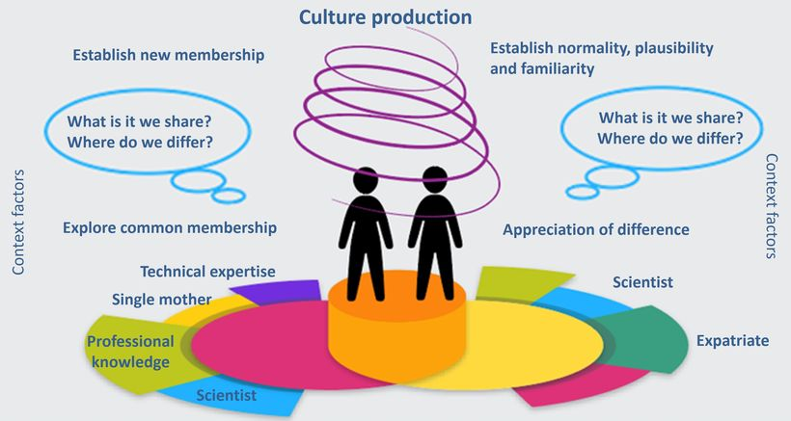
Source: Based on and inspired by Rathje, Stefanie (2015). Multicollectivity – It changes everything. Key Note Speech at the SIETAR Europe Congress (SIETAR_slides_Rathje.pptx (stefanie-rathje.de). Accessed 24 May 2021.
Figure by Julia Flitta (www.julia-flitta.com)
When entering into the process of negotiating culture, there are basically five options. One would be to divide the tasks within a team in such a way that no adaptation is required. Or, one group might adapt to the other, meaning that one party modifies its behaviour. Alternatively, both groups could find a compromise, whereby both parties reduce their demands or change their approach in order to agree on procedures and meet mid-way. A further option would be for both parties to develop a completely novel approach and thus integrate new, effective and mutually acceptable rules and behaviours within the context of the team’s interactions. Such processes are commonly called a ‘third culture’, emphasising the fact that such a culture develops out of the interaction between two individuals with different cultural backgrounds.

Task: A common path
"At the very beginning it was quite hard to find and follow a common path. None of us wanted to move away from their position, but at the same time none had a proper idea, which made it so hard to put it all together. During this time, I recognised how important it is to take a step back, rethink my own position and open it up for others to join, move or discuss. Therefore, I involve myself in their areas of expertise to get a deeper idea about what was going on. When I did so, I was able to understand their point of view, saw connections and managed to readjust my position in order to achieve our goal."
Source: Learning journal, 2020
Think about a situation in which you and others developed a novel approach to something.
The aim of cultural production and negotiation is the synchronisation of incompatible interaction routines. In other words it is the development of mutually agreed interaction routines that every team member feels comfortable with. This is based on an understanding of interculturality as a dynamic process involving the emergence and conscious development of a common culture. Based on the interplay of action, reaction and adaptation, negotiation is something which is always ongoing, but can also be initiated purposefully during the forming stage of the team development process.

5.5 Using cultural profiles as a basis for mapping and negotiating culture

Task: My cultural profile
Imagine you are expected to work in a virtual intercultural and interdisciplinary team of three. Your boss is planning to invite you to an initial call where the team members can become acquainted. He asks you to develop a profile to help other team members get to know you. These profiles will be distributed to all team members so that you can use them to identify commonalities and differences. Because you know that the project is not only going to be challenging task-wise, but is likely to be so due to the diversity of the team members. You want to bring in your previous experiences and in particular you want to achieve a high level of cooperation and mutuality.
As a first task, develop your cultural profile. Your identity profile has four squares and covers issues such as:
- Who am I?
- What can I contribute?
- What have I experienced?
- What is important to me when working in a team?
As a first step you are asked to fill out the four quadrants of the cultural profile in your learning journal. In doing so, you can refer to the questions below as a general guide, from which you may choose relevant questions depending on time, the project itself and other factors. However, for the purpose of this exercise you only need to answer the questions which are highlighted.
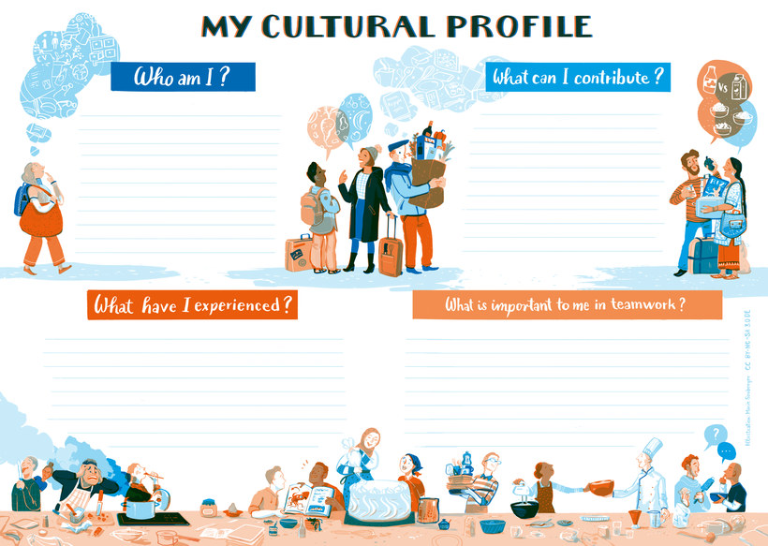
Illustration by Marie Seeberger(www.behance.net/marieseeberger)CC-BY-NC-SA 3.0 license
Who am I?
The answers should provide other team members with personal information that you are ready to share, and that would help them to get to know you better in a working context.
- What are central issues of your life path?
- What is your educational and professional background?
- How old are you?
- What is your marital status?
- What is your parental status?
- What are central collectives of which you are a member? (e.g. professional, leisure time)
- Which collectives had a big impact on you during your upbringing? (e.g. your family, sports club)
- For example, you may have been or are still a member of a sports club which influenced you because of the team spirit and friendships you developed and is still important to you because occasionally you occasionally still joining them for important matches.
- Which collectives are still very influential and powerful when you work with others? (e.g. your university, your family, sports club)
For example, the rituals and traditions in your family may still be very influential and you might, for example, be requested to be with your family on specific occasions, which influences your work calendar.
- Which contextual factors have had a major influence on you and in which way? (e.g. the local church)
- Which contextual issues are still influential when you work with others? (e.g. behaviour I learned at grammar school)

What can I contribute?
This quadrant includes information about experiences and competencies you have, which might be beneficial to achieving the team’s goals and contributing to team satisfaction. Questions that might help you to identify these are:
- Which languages do you speak and at what level?
- Which competencies are you able to contribute, including media skills and knowledge, self-management and efficacy, intercultural competence and team-related competencies?
What have I experienced?
This quadrant refers to experiences you have with regard to teamwork and virtual teamwork in particular. The following questions may guide you in this.
- What motivates you when working with others?
- What irritates you when working with others?
- What drives you crazy?
- What are your trigger points?
- Where have you felt excluded?
- With which groups of people can you easily establish relationships?
What is important to me when working in a team?
- What are your expectations?
- How would you like others to behave when working in a team with you? Consider dimensions such as "independence versus interdependence", "task versus relationship", "egalitarian versus status", "direct versus indirect", "risk versus certainty" and "monchronicity vesus polychronicty"?
- How is your self-image with regard to these dimensions?
This is Natalia's profile:
Who am I?
I am 30 and I am an experienced female professional in the sphere of languages. My core value is communication. I already possess two degrees and now I am pursuing a new program to extend my hard skills and develop soft skills. Currently I live alone in a foreign country which I moved to last year. Every day since I arrived I face linguistic and intercultural challenges on both private and public levels. My newly acquired intercultural competences help me a lot. One of the key things here is not to forget who I am and where I am from.
Everyone belongs to different collectives and I am not an exception. Collectives I can attribute myself to include: my family in Russia, students, students of HS Fulda, friends who live in Russia, friends who live in Germany, foreigners from Russia in Germany, women, women aged 30, linguists, Fulda residents.
My family, my school and my friends had the most profound impact on me during my upbringing.
I believe that during my upbringing I was strongly influenced by my school community, because English was taught at the school right from the first year and this helped to shape my career choices later on. So my school community influenced my my job choices but also my way of working. It was there that I first started speaking in front of an audience, and I became really passionate about it.

What do I bring with me?
My cultural backpack includes my Russian origin, knowledge of English and German. I have been to 17 countries and have always worked in intercultural teams. Recently I started becoming involved in virtual teamwork for diverse projects. Here I understood that working on remote projects is much more difficult because it requires a higher degree of commitment and stricter self-management. Anyway, I believe that I am a a very conscientious team member who always adheres to rules and shows a high level of responsibility. When I work in a team I contribute professional knowledge, commitment, responsiveness, MS Office skills and intercultural competencies.
What have I experienced?
The feeling of togetherness motivates me to work with others, especially when I understand that there is something important that unites me with the team. Miscommunication irritates me in teamwork, so for example when team members are reluctant to speak out. I am motivated to achieve results, especially when I enjoy the topic of the project. My trigger points revolve around the nature of the project, because I can’t work on something that I have no interest in. I feel excluded when I don’t feel updated on the progress of the project and when I don’t have a particular field of responsibility. I am a very easy-going and friendly person, and I feel comfortable with people who share the same feelings with team members.
What is important to me when working in a team?
One of the most important aspects is to be tolerant and understand each other’s differences and uniqueness. Always being able to listen to each other makes the project smooth and seamless.
As far as dimensions are concerned, I would prefer the following:
- Interdependence – makes you feel like you are working in a team;
- Task – any effort should be attached to a goal;
- Status – every team should have a leader;
- Direct – having to read between the lines causes stress for me;
- Certainty – a level of risk is unavoidable, but being more certainty-oriented can bring more stability;
- Monochronicity - deadlines and plans help to achieve goals and lead to better results.
This is Hoang’s profile:
Who am I?
I have a Masters degree in International Business and Cultural Studies and have been working for the past 15 years as a facilitator and consultant for cross-cultural collaboration.
My collectives are first and foremost my direct family with my wife and our three children. I am also a son of parents who originated in China. As I have lived and worked there for many years, many of my friends are also based there. I also am part of several networks of intercultural collaboration, and engaged in non-profit groups who strive to make our society more sustainable on many levels. As a student, I was engaged in a student organization which promotes international exchange. I still am involved here as alumni. These are also the collectives that have shaped me professionally. The student organization gave me the chance to meet and work with people of countries across the globe, and there I already worked as a facilitator. Growing up in Germany, I was heavily influenced by having the ideas of a multitude of worldviews and values from childhood on.

What can I contribute?
I speak native German, and fluent English and Mandarin Chinese. I also speak a Chinese dialect that is rather seldomly used in business context. I am a trained moderator and mediator, as well as trainer and consultant. I have worked as a General Manager and as Freelancer for many years, which enabled me to work in highly independent manner, but I also work well in a team. I consider myself to be creative, and believe myself to be a good listener and motivator of others. I am also highly experienced at working with several virtual collaboration tools.
What have I experienced?
I feel motivated when trying out new things. I love it when the work of the team meshes together, and contributes to something positive at the end. I also like it when there is a positive atmosphere in the team, and the team members also connect on a human level. However, I am also motivated when things get "to the point", and there is no time wasted on needless discussions- so for example on small technicalities. I also do not like it when responsibilities and structures are unclear to me.
What is important to me when working in a team?
Working as a promoter of diversity for my entire working life, it is important for me to see differences as an asset for the team. I prefer working rather independently, but I also do not mind working with an interdependent team culture. I believe that having a good relationship with your colleagues helps avoid misunderstandings, and the team should invest some time getting to know each other. I believe that because of my upbringing I prefer to have clear leadership structures in a team. I enjoy working as equals with my teammates, but it should be clear how decisions are made. I believe that in today´s volatile market situations, flexibility is more important than planning. Some planning is advisable, but rules and processes should generally serve an objective.
I prefer working monochonically, but do not mind working on several different projects at a time, as long as there are certain time slots for them. I also believe that sometimes it can be more productive to work on several tasks at once.
I prefer a clear language within communication, but believe that it is important to also take the feelings of others into account.

Task: Commonalities and differences among team members
Comparing your own profile with the profiles of Natalia and Hoang, use the common triangle (figure below) and highlight commonalities as well as differences.
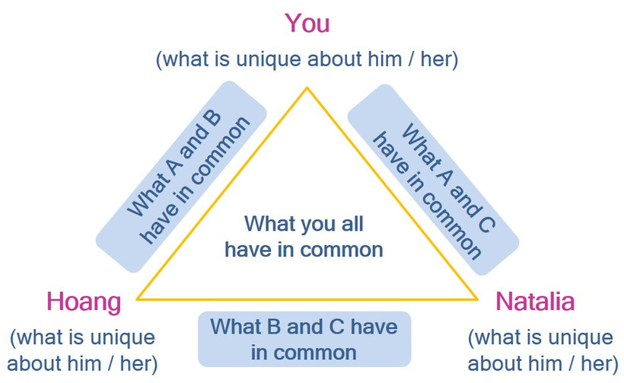
Figure developed by Thu Phuong Vuong for this course

Task: Reconciling differences
How would you go about dealing with differences following the MBI-approach?
Choose two examples and go through the MBI process considering differences and commonalities between the three of you.
As an example, let us consider the differences and commonalities between Hoang and Natalia, referring to their profiles, and see how we could start the process of negotiating culture here.
First of all, we might assess their answers to "What is important to me when working in a team?"
Our comparison shows that Hoang and Natalia have certain common areas:
- Both value tolerance of diversity within the team
- As Natalia believes that listening to each other is important, Hoang mentioned that he believes himself to be a good listener.
- In terms of status, both believe that it is positive to have a clear leadership structure in the team
- Both team members prefer working in a monochronic way
What are the differences in desired working styles?
- Natalia prefers interdependent work, whereas Hoang rather prefers to work independently
- Natalia seems to be more task-oriented, whereas relationships are important within the team for Hoang
- While Natalia strives for more certainty in the collaboration, Hoang believes in a more flexible approach
- In terms of communication, Natalia prefers a direct communication approach, whereas the relationship aspect is also important for Hoang when communicating
We can see that some of the starkest differences relate to the certainty vs. risk orientation and the task vs. relationship aspect. According to Hoang's profile he only has a slight preference for independent work and can also imagine himself working in an interdependent manner. Hoang also mentions that direct communication works for him as long as it is not offensive.
As both believe in diversity as an asset, and seem to be open-minded for each other´s point of view, it might be better to apply the "third culture approach", and negotiate a working style with which both feel comfortable
One way to do this would be to discuss these points as examples:
- What kind of communication would Hoang find offensive? What could be some examples? When could the indirect communication style lead to misunderstandings in Natalia’s point of view? Is there a style they can agree on?
- Where do both view their personal benefits within certainty or risk orientation, respectively? In which scenarios would which style be more helpful? It might be possible to agree on different working styles in specific situations. They could for example agree that in times of emergencies, a risk-oriented approach would be more appropriate, whereas when it comes to long-term strategies, more time should be invested in the planning processes within a certainty-oriented approach.

- Why is it more important for Hoang to be relationship-oriented at work? Why is Natalia rather task-focussed? What could be the benefits for them? As in the case above, the idea would be to see how we can come to a common consensus. It is also possible that Natalia would say "I don’t mind getting to know my colleagues on a personal level as well, as long as the task is not neglected". This would make sure that Natalia and Huong have both benefits in mind when they work as a team.
Instead of looking for a third culture, it is certainly also possible for Hoang and Natalia to work on their individual work assignments in order to avoid friction. However, we can see in this example that by looking for common ground, we have the potential to find a working style that might be much more beneficial for team success.
In the session "Negotiating an E-culture for my team" you will explore some tools which will help you understand how integration and cultural negotiation can be put into practice and use the results in order to develop a virtual team culture.

5.6 Summary
Teams are not homogeneous and differences among members are likely to stem from their memberships of different collectives and cultures. It has become commonplace to hear phrases such as "be open-minded" and "we need to appreciate diversity" when approaching challenges of diversity. However, working well in virtual teams means more than this, and requires us to use well thought-out approaches in order to bridge and integrate differences, thereby enabling the team to work effectively. The MBI approach, which recommends the stages mapping, bridging and integrating, helps us to achieve this. The mapping step acts as a tool to highlight commonalities and differences of a team, while reflecting more on one’s own cultural profile. Bridging and integrating enables us to discover options available to us in our endeavour to negotiate an inclusive, high-performing team-culture.

5.7 Learning review

Task: Learnings from this session
Look back at the results of your cultural profile and the process of creating mutuality in virtual teams and note down three major learnings in your learning journal.

5.8 Sources, further reading and web links

Sources
- Ballard, D. I., & Seibold, D. R. (2003). Communicating and organizing in time. Management Communication Quarterly, 16 (3), pp. 387.
- Barmeyer, C. (2018). Konstruktives Interkulturelles Management. Göttingen: Vandenhoeck & Ruprecht.
- Brannen, M. Y. (1998). Negotiated culture in binational contexts. A model of culture change based on Japanese / American organizational experience. Anthropology of Work Review, 18 (2-3), pp. 6-17.
- Brannen, M. Y., Salk, J. E. (2000). Partnering across borders. Negotiating organizational culture in a German-Japanese joint venture. Human Relations, 53 (4), pp. 451-487.
- Gardenswartz, L., Rowe, A. (2003). Diverse teams at work. Capitalizing on the power of diversity. Alexandria: SHRM
- Lane, H. W., Maznevski, M. L., & DiStefano, J. J. (2019). International management behavior. Global and sustainable leadership. Cambridge: Cambridge University Press.

Weblinks
- Under the following link you will find an interview with Ernest Antoine (Leadership Strategies) on MBI in practice: "Building cross cultural team through MBI technique":
https://www.youtube.com/watch?v=1rSj7hngIZY (accessed on 17.11.2020)

6. Key challenges of virtual intercultural teams

Topics
6.1 Prelude 107
6.2 Introduction 107
Task: Challenges in virtual teamwork 107
6.3 Team performance and team satisfaction 107
6.4 Key challenges of virtual intercultural teams 108
Task: Identifying challenges 110
Task: What makes me trust my team? 115
Task: Drafting an email 119
Task: Changing perspective 119
Task: A team identity 121
Task: A liberated work place 123
6.5 Summary 124
6.6 Learning review 125
Task: Case "Designing a new office chair" (Reprise) 125
Task: Case "The relocation" 125
6.7 Sources, further reading and web links 126

Learning outcome
You will analyse the key challenges that need to be addressed by virtual intercultural teams if they are to achieve a high level of team performance and satisfaction.
Objectives
At the end of the session, you will be able to
- explain the link between team performance and satisfaction
- analyse key challenges in virtual intercultural teams

6.1 Prelude
The previous session laid the foundation for developing areas of common ground. In this way a team can develop that not only able to work well together but also use the resources and potentials of its members. With this in mind, the aim of this session is to identify and analyse the challenges a virtual team faces and the influence they have on team performance and team satisfaction. This is an extensive session and you might consider splitting it into two sessions.

Download: Learning journal for session 6
Learning journal (.docx) Learning journal (.odt) Learning journal (.rtf)

6.2 Introduction
The importance of virtual teamwork cannot be overstated, since it forms the basis of how global business is conducted today. Many people appreciate the variety of people and skills in virtual teams, as well as the learning opportunities and the ability to set their own course. But in order to benefit from virtual teamwork, they need to deal with some key challenges, some of which are unique to working virtually and others which relate to teamwork. Physical separation, whether it be across countries or across offices causes its own challenges. These might be, for example, knowing and accommodating the context in which team members are working, staying updated with what each person is doing, and managing technical issues. Others are more related to working in a team, such as agreeing on work processes, building trust, dealing with misunderstandings, handling the lack of face-to-face interactions and keeping up the team's morale, to name but a few.
Being aware of these challenges and identifying them is a crucial step towards creating a space of shared interaction in which everyone feels accommodated and part of the team, i.e. the creation of an inclusive and productive team culture. Analysing the challenges an intercultural virtual team faces is the goal of this unit.

Task: Challenges in virtual teamwork
Watch the short clip and answer the question: "What do you consider to be central challenges of virtual teamwork?" Then note down in your learning journal the challenges mentioned here. Think about other challenges you may have experienced or which you consider relevant.

6.3 Team performance and team satisfaction
Looking back over a four month period of teamwork that was exclusively online, this is what one course participant wrote:
Considering my initial joy in being able to use this teamwork to bond with my new colleagues, I can say that this goal was achieved. Although we never had the chance to meet and get to know each other in a familiar face-to-face setting, it is remarkable how we managed to build a trust and a foundation for a deeper connection. All in all, I feel very good about our team. We started as strangers, became team members with a common goal and ended up being friends. Despite all the difficulties or precisely because of them, from my point of view we achieved our objective and I feel confident that we did a good job and that it will be evaluated as such.
Source: Learning journal, 2020
Apart from showing that virtual teamwork can be a very positive experience, the quote highlights several things. One is the obvious positive link between team satisfaction and performance. The other aspect relates to performance or the output itself which is obviously understood as ‘achieving a goal’ and ‘doing this successfully’. However, saying that ‘I feel confident that we did a good job’ also tells us that performance relates to an evaluation of the output and that this is linked to standards the team itself set as well as those who evaluate the output.
Effectiveness can therefore be understood as the ratio of input and output relative to the defined goal or expectation related to the team’s task. This, however, is a fairly vague statement and is difficult to measure since the measurements employed very much depend on the type of teamwork and the task. For example, the productivity of a team whose task involves a lot of creativity and experimentation, for example the development of a new product, is much more difficult to measure than, say, the output of a production team.
Equally difficult to measure is the influence of team satisfaction on team performance. According to the definition of the Oxford English Dictionary (Lexico, 2020), satisfaction is the "fulfilment of one's wishes, expectations, or needs, or the pleasure derived from this". We can, however, argue that team satisfaction is a key factor that drives motivation and performance. When one team member is not happy, he or she is likely to be unfocussed, postpone tasks, and be less willing to deal with any challenges at hand. And when one team member performs poorly, this will influence the other team members' output. As a result, their productivity will decline, ending in a vicious circle. Being attentive to team satisfaction by analysing and dealing with the challenges at hand, is therefore vital to the ultimate output of the team.

6.4 Key challenges of virtual intercultural teams
Working in virtual intercultural teams is complex and very often perceived as ambiguous, since, for example, team processes might be unclear, team members could be unfamiliar and the task at hand may not be precisely defined. VI teams are complex due to the tasks' cognitive and emotional demands. And what often goes unnoticed is the fact that virtual teamwork is multidimensional. The work and therefore team success is also influenced by a range of factors not immediately linked to the teamwork itself, such as the fact that team members are embedded in a wider organisational context.
When analysing key challenges in virtual intercultural teams, there are five interlinking areas that require attention:
- Team task
- Team structure
- Team work processes
- The workplace
- The organisational context
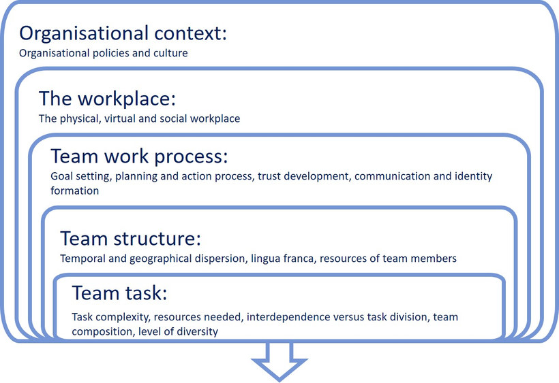
Source: Based on Bosch-Sijtsema, Petra, Virpi Ruohomäki & Mattie Vartiainen (2009, p. 12)

The team task
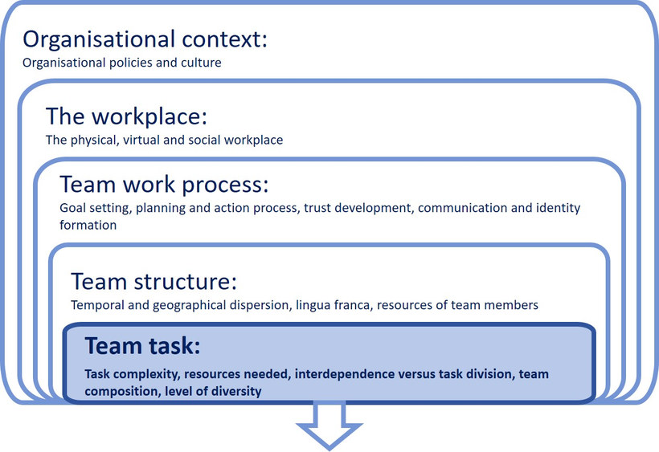
Source: Based on Bosch-Sijtsema, Petra, Virpi Ruohomäki & Mattie Vartiainen (2009, p. 12)

Let us start by looking at the team task as it determines the primary focus of team members' activities and the coordination required. Because team tasks can range from routine to creative and problem-solving in nature, the task also sets the parameter for the resources needed in terms of knowledge, skills and competencies. In addition, the task itself also determines the workflow structure and demands in terms of coordination requirements.
Some of the challenges a VI team faces are developing a common understanding of the task and its complexity and establishing the resources needed to achieve goals as well as identifying those tasks which require collaboration and those which do not.
Even if the team decides on a high level of task division and independent work, there seems to be a consensus that a degree of interdependent working initially supports a feeling of connectedness and cohesion. Further, it fosters the development of trust and common communication patterns and can thus be a strong enabler of team performance. What often goes unnoticed is the fact that higher levels of interdependence and task complexity require greater effort with regard to communication and coordination within the team.
In a nutshell it can be said that the team needs to develop a common understanding of the task and its complexity, the level and specificities of task interdependence and an awareness of the time required for the additional coordination and communication effort.
Usually the team itself is put together in line with the specific task. For this reason, the general team composition will also be considered here. When viewing team composition, an important aspect to consider is the multi-faceted concept of diversity. In this regard, a key issue to be raised in a team is therefore: 'Which diversity factors might stimulate or hinder team performance and satisfaction?'. The answer could include aspects such as gender, the asymmetric distribution of skills or experiences, length of remote work experience, as well as cultural and language differences. The challenge to be met here is simply that of making diversity issues known, addressing their possible influence on the outcome of the team’s task, discussing integration processes and finally how diversity might be transformed into concrete benefits for the team. Developing a cultural profile of every team member as presented in the previous session is a first step in that direction.

Task: Identifying challenges
A French company produces lighting systems for private home use. The marketing team consists of six people at headquarters, plus two to three people in 10 countries where the product is sold, scattered around different continents. The entire global marketing team consists of 30 people. The main goal of the marketing team is to support the sales team in selling their product. In order to do this, following sub-tasks have been identified:
- The team needs to take the main messages that have been developed by the head office, and find a way to localise them to fit local consumers' needs.
- The resources need to be allocated: How much of the budget will each country receive, considering the potential of their market, and the costs associated with marketing platforms and materials. The head office also has the feeling that some locations simply shout louder in their demand for more resources, and assume this might have to do with the cultural diversity of the team.
- The global team needs to be on the same page when it comes to collaboration tools, the information flow from head office and the general processes regarding developing and adapting marketing materials for their respective markets.
Read through the short case study and think about the respective importance of the following aspects:

- task complexity
- resources needed
- interdependence versus task division
- team composition
- level of diversity
Please assess all of these aspects on a scale from 1 (= very low) to 10 (= very high). How would you rate each aspect, and what would your reasoning be for this? In which processes and tasks would it make more sense for the company to stick to the the general standards from head office, and which ones would be better localised?
Note down your ratings and the answers to these questions in your learning journal.

The team structure
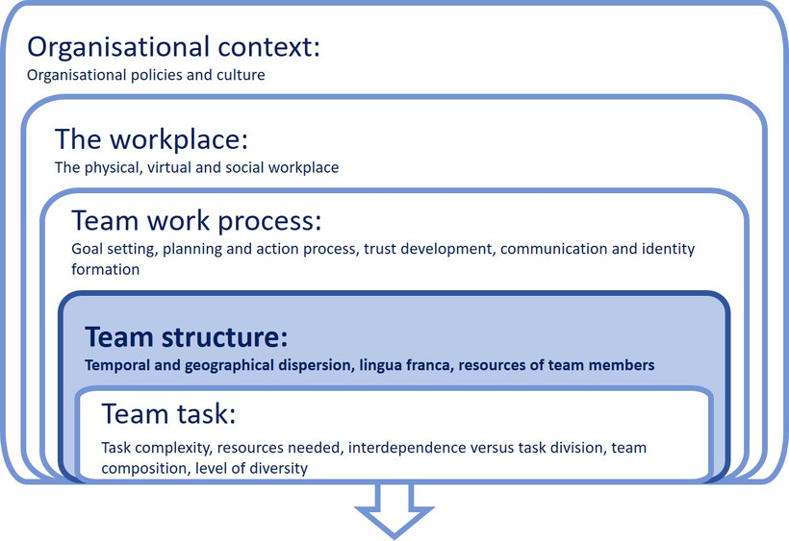
Source: Based on Bosch-Sijtsema, Petra, Virpi Ruohomäki & Mattie Vartiainen (2009, p. 12)
The team structure refers to the properties of the team and includes aspects such as team size, temporal and geographical dispersion, knowledge of the lingua franca used, and the resources and experiences brought to the team by the individual members. According to studies by Bosch-Siijtsema et al. (2011, 2009) these items can simultaneously be enablers and disablers of team performance and satisfaction. Let us examine them in more detail.
Temporal and geographical dispersion: While time zone differences offer the possibility of 24/7-productivity, they are a challenge for teams because they need to find common working hours and synchronous appointments. A normal workday for one may be midnight for the other. This in turn may mean that work days are extended for some team members in order to catch up with others in a different time zone. There can therefore be a mismatch of day schedules, leading to delays and missed information, all of which influences the communication process within the team.
Time allocation therefore requires careful planning and consideration. The following quote highlights the need to recognise different public holidays and other periods of slower paced work such as the summer season or vacation time:
When the person is on a vacation, they actually do not work at all, so the project STOPS for that time. When there are many people consecutively taking vacation we could go 2 or 3 months without any work being done, which I wasn't expecting. Japanese companies’ employees don't take this many vacation days.”
(Source: Nurmi, N. (2009). Unique stressors of cross-cultural collaboration through ICTs in virtual teams. In: B. T. Karsh (Ed.), Ergonomics and health aspects of work with computers. EHAWC 2009. Lecture notes in computer science, Vol. 5624. Berlin, Heidelberg: Springer. https://doi.org/10.1007/978-3-642-02731-4_10, p. 85)
The quote is interesting because it seems as if the writer anticipates that when working on a project, work continues regardless of whether one is on vacation or not and there seems to be a difference as to how many vacation days are commonly taken.
Because geographical distance and in particular different time zones influence the frequency of meetings, this in turn is likely to influence communication flow. Virtual teams therefore need to pay particular attention to the impact geographical dispersion may have on virtual teams in order to avoid a lack of coordination, process delays and reduced feedback cycles.
The vast majority of virtual intercultural teams, as well as most multinational corporations, mandate English as a common language. Using English as a lingua franca of course has the potential to facilitate international corporation. However, it should be acknowledged that the use of English may also cause a lot of stress. This includes issues such as the status imbalance felt by non-native speakers in the presence of native speakers, language performance anxieties, and the potential for communication break-down, leading to inadequate sharing of knowledge and adverse sub-group dynamics. The fact that a single misunderstood term can impede significantly on a relationship is expressed by the following quote, related by an American interviewee:
“[After] four days of meetings and disclosures, a [native English-speaking] person wrote a summary of the meeting and a letter thanking [the French collaborators] for the meeting and so forth, and the last sentence was, ’Maria, we found this meeting to be invaluable.’ And the whole thing collapsed, people were just furious that the perception was that they had come to the meeting and the whole thing was seen to be not valuable. In English invaluable means you can't do without it, it was very valuable. And in French, in means not, and it took weeks to undo and get that whole [collaboration] back on track again, so in language issues one word can completely destroy [everything].” (Nurmi, 2009, p. 83)
Reducing the impact of language barriers through enhanced awareness and by giving each other language support is therefore an invaluable (!) task. The aim of every team should be to develop a safe language climate, which makes people feel included, as the following quote by Jukka-Pekka suggests:
How can Finnish engineers understand what people want in China? No, we can’t. That’s why we have Chinese team members in the project and their knowledge is so valuable for us. We just need to make sure that they share all that information with us over the language barriers and all. […] Everybody is not equally fluent [in English] and we must make sure that everybody understands by asking questions, writing, and using simple language. Video is also important because when I see that somebody doesn’t understand I can immediately react to that by specifying and repeating what I just said. (Nokia R&D, Finnish team member) (Nurmi & Koroma, 2020, p. 7)

The team work process
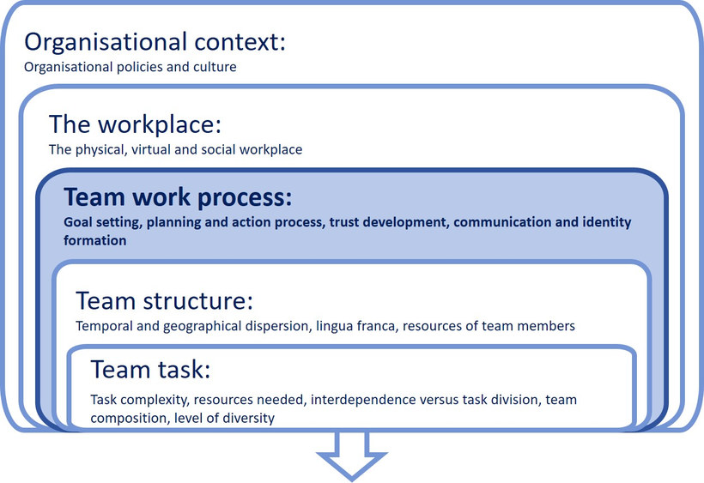
Source: Based on Bosch-Sijtsema, Petra, Virpi Ruohomäki & Mattie Vartiainen (2009, p. 12)
The layer team work processes goes hand in hand with team structure, and refers to team members' interactions and how they use the resources available to them in order to meet the tasks and contextual demands.
They are therefore vital for the team’s success and an important aspect of team effectiveness. In accordance with the study by Bosch-Siijtsema et al. (2011) on knowledge workers in distributed teams, the focus here is on the behavioural aspects of team processes and thus the question of ‘how’ teams use their resources and how they manage to perform well. Activities that we can focus on here are, for example, goal setting, planning and actioning, determining of the communicate style, ensuring participation and monitoring, information sharing and reflection, developing a common identity, trust-building and achieving team satisfaction. In the literature, trust and communication as well as team identification and cohesion are often singled out as the major challenges to be met in order for the team to perform well and will therefore be considered here in more detail.
Trust has been studied extensively in this area for two reasons. Firstly, many factors that might support trust development in a collocated team are unavailable, making trust development particularly challenging. Secondly, virtuality requires more trust, since control mechanisms are lacking. For example, it is difficult to check work progress when team members are not sitting next door. Spatial distance sometimes requires team leaders to transfer responsibilities to unknown team members, despite the fact that this would normally require a significant level of trust. Team members who take on responsibilities must in turn have a high level of self-motivation, discipline and self-management skills because they largely have to fend for themselves. This is particularly difficult for employees who work well with clear instructions from their superiors or who flourish through the “social control” provided by the co-presence of others.
Physical proximity promotes trust-building by allowing individuals to directly observe what others are doing, which is hardly possible in a virtual environment. In a face-to-face conversation, subtle nuances and nonverbal communication signals, which are unconsciously and unintentionally conveyed are usually omitted in the virtual context. However, they do provide valuable information about the other person on a social level, such as personal characteristics, demographic features, social and professional status, strengths and weaknesses, etc. In addition to this, information on the environmental context within which each team member interacts, such as individual working conditions, is often missing. For instance, a teammate may be perceived to be slow to respond to e-mails or requests for information and this can quickly lead to judgments about the person not being reliable or trustworthy. However, knowing more about context issues such as, for example, home teaching requirements because teachers are on strike, public holidays or technical problems might have allayed the pre-judgment.
Another aspect hindering trust development when working virtually is the limited number of contacts experienced in comparison with collocated teams. Spontaneous interactions, e.g. running into a teammate or meeting by chance in the kitchen or at the water cooler, are largely eliminated.
It is commonly argued that the development of trust requires certain conditions to be present, such as time, physical proximity, mutual information exchange, a shared social context, common values and similar cultures. These conditions are rarely met in the context of virtual teamwork. So how can a team deal with the challenges of trust development? One approach is surely to leverage 'swift trust', which generally refers to trust built on role-based interactions. It refers to the fact that we can assume that team members share a notion of ‘we are all in this together’ and that getting the job done well will reflect positively on everyone. If a team is able to maintain this notion throughout the period of working together, then profound trust can develop and carry the team through the entire period of working together.
Because there is a tendency for people to trust those who appear similar to themselves and behave in a similar fashion, sharing cultural profiles that reveal information about ourselves helps to establish commonalities, which might include shared hobbies and other outside interests. Storytelling is another powerful mechanism to develop trust, and especially the stories that can identify with, such as how to deal with home-schooling, can be effective.
Agreeing on communication patterns is another important step on the path to ensuring trust, for example by letting other people know when you are unavailable or unwell for example. Although it is common to work with a common calendar, simply letting team members know when you have, for example, a throbbing headache and are therefore unable to respond as anticipated could make all the difference.
The relevance and influence of trust on communication and therefore task completion is illustrated by the following quote:
It also affects the reciprocal process of knowledge sharing and thus the team's overall effectiveness and performance. It helps to reduce conflicts. If trust is high, the information exchanged may be more accurate, comprehensive and timely. In a virtual team, trust reduces the high level of uncertainty endemic to the technological environment. As described above, trust is dependent on the degree to which you get involved and communicate openly about yourself as an individual, the more your team mates know about you, the more they can assess you and develop trust in you and your skills.
Source: Learning journal, 2020
Virtual teams that do not have the opportunity to meet face-to-face don't necessarily suffer from an atmosphere of suspicion. It is, however, particularly important that they pay close attention to the lack of opportunities for trust-building and that they are be pro-active in this area, making a special effort to create an environment that fosters the development and maintenance of trust.

Task: What makes me trust my team?
There are a number of criteria we can apply in order to assess trust in virtual intercultural teams.
Read through the criteria mentioned below and, in your learning journal, rank them according to their relevance, from 1 (= highest relevance) to 10 (= lowest relevance).
Competence | Trust based on the perception and understanding that team members possess the required skills and competencies
Compatibility | Trust related to commonalities, such as values, approaches to teamwork, work and communication styles, interests and goals
Integrity | Trust based on the understanding that other team members keep their promises, are committed to cooperate and work towards the common cause
Good will of all | Trust based on the belief that everyone is concerned about each other’s well-being and makes constructive comments in this regard
Inclusion and integration | Trust based on the feeling and observation that everybody makes an effort to include and welcome all team members
Well-being | Trust arising from the feeling that other team members mean well and that there is nothing to fear from the team
Predictability | Trust based on the understanding that team members' behaviour is consistent, regardless of the context, stress level and project phase, and that they will complete the tasks they have been assigned to do
Sharing of knowledge | Trust based on the notion that team members don’t hold back information and are committed to knowledge sharing
Figure developed by Thu Phuong Vuong for this course
A vital aspect of any team is communication. In this regard we should focus particularly on the perceived quality, quantity and frequency of communication. Some authors even consider communication to be the greatest challenge to be met when working remotely. To start with, communicating virtually is fundamentally different from face-to-face communication. It is often considered to be more complex than traditional in-person team structures due to the lack of physical presence and the resulting necessity to use technological devices as a mediator of communication. One of the main differences between a co-located team and a virtual team is that the former enables daily face-to-face interactions, whereas interaction in the latter must be intentionally created as the following quote highlights:
"Communication is not conducted in the classical way, like when you sit at your desk and say: 'Hey, take a look here'. Instead you have to use some tool, either Skype or Slack or whatever, in order to talk to each other and THAT is always a HURDLE. Depending on what kind of person it is you are not just talking to him, but you are writing to him. For some reason it FEELS different."
(Translated from the German quote below)
"Kommunikation ist halt nicht so, wie es klassisch geht, man sitzt am Schreibtisch und sagt: ‚Hey, du, guck einmal kurz'. Sondern man muss eben eine Art von Werkzeug benutzen, sei es Skype oder Slack oder was auch immer, um ÜBERHAUPT miteinander zu sprechen. Und DAS ist immer eine HÜRDE, je nachdem, was es für eine Person ist, den dann nicht einfach anzusprechen, sondern quasi anzuschreiben. Es FÜHLT sich anders an, aus irgendeinem Grund."
Source: Randhawa, V. (2020), p. 57
Even if virtual teams have team chat rooms and frequent team meetings, they simply do not have the same frequency of synchronous, real-time communication as co-located teams. Instead, a considerable proportion of communication is asynchronous, i.e. it doesn't happen at the same time. On the one hand, asynchronous media enables team members to interact independently of time, which gives them a high degree of flexibility. It also gives them the time to formulate, reflect and, if necessary, translate messages and ask questions in a thoughtful manner. On the other hand, the use of asynchronous media causes delays and interruptions in the communication process, which can be frustrating if, for example, the team cannot continue without a colleague’s response.
Coordination and communication processes may become lengthy, even more so if time zones need to be considered when colleagues need to wait for feedback, which may lead to tasks not being completed in a timely manner. Especially in communication processes that require a high degree of synchronicity, the achievement of a common understanding can be considerably impaired. The lack of immediacy of feedback makes it more difficult to maintain individual participation in communication, because it is much easier for members to withdraw from communication, which in turn promotes the phenomenon of "social loafing" or “free riding”. Such behaviour is much more difficult to detect in a virtual environment than in a physically located team.
Communication in virtual teams is also much more susceptible to misinterpretations and misunderstandings. Transmitting, understanding and interpreting messages correctly is generally more complex when they are mediated through technology, since the use of technical media is always accompanied by a channel reduction or filter effect. For instance, reactions of team colleagues in the form of facial expressions, movements or sounds usually help to guide a conversation and build up a common understanding by showing whether a topic can be continued (e.g. if everyone nods and thus signals agreement) or whether there are misunderstandings, ambiguities and questions (e.g. if a team colleague looks irritated).
In virtual teams, depending on the technological media used, these signals are partially or completely absent and would have to be explicitly formulated. This, of course, rarely happens as these signals are mostly produced subconsciously. The lack of such communication signals makes it more difficult to interpret a message correctly, which leads to problems of understanding. This is even more challenging for team members who rely on subtle, indirect communication through body language, gestures, facial expressions and proximity. A lack of signals also makes it difficult to assess the importance or urgency of a message, which can lead to a high-priority matter being given lower priority and vice-versa. For all of these reasons, effective communication in virtual teams often requires time-consuming queries and clarifications, which can create dissatisfaction and delays in the task completion process.
Studies show that virtuality gives rise to a number of communication challenges such as:
- the communication mode to use;
- expectations with regard to timing of feedback;
- the lack of a common frame of reference for all team members;
- differences in interpreting and perceiving messages;
- fewer nonverbal cues.
A major task for teams is therefore to clarify and determine how communication processes can best be established, and which communication tools to choose from for each particular situation. To this end, it is helpful to examine the level of richness involved in various media formats. The following illustration attempts to reflect this:
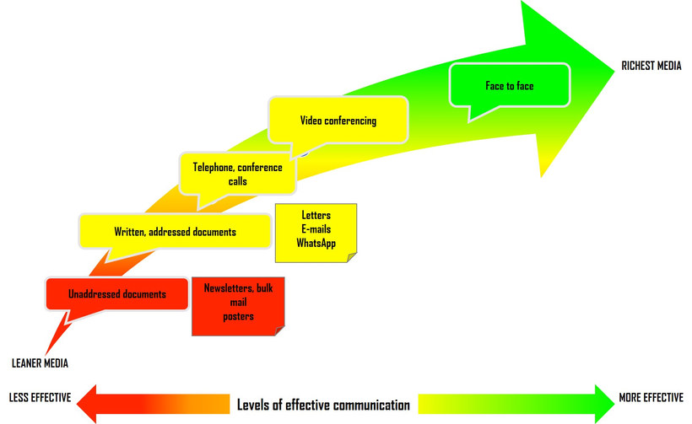
Source: Based on Ehsan, Nadeem; Ebtisam Mirza & Muhammad Ahmad (2008). Impact of computer-mediated communication on virtual teams‘ performance: An empirical study (Conference paper). In: International Scholarly and Scientific Research & Innovation 2 (6), 2008. Accessed 7 September 2021

Rich media such as video conferencing has several advantages such as its ability to convey verbal, para-verbal as well as non-verbal cues, support bi-directional communication and also allow for immediate feedback. It is therefore often used as a substitute for face-to-face meetings as it facilitates interaction and feedback. Communicating through video conferencing also gives team members a feeling of being 'close' and due to its high level of social presence, it usually supports effective communication and is therefore considered to create and support trust. However, team size, time zone differences, efficiency of time and the nature of the task all influence the attractiveness of video conferences. A tool very commonly used for sending and receiving messages in between calls or as a substitute for video-conferences are emails.
However, e-mail messages can be easily misunderstood and sometimes these misunderstandings have the potential to escalate into conflicts, as an American interviewee, cited in a study by Niina Nurmi (2009) warned:
"The written word can be very dangerous when you're dealing with the team at a personal or interpersonal level … especially if it's something that'll upset them, they'll read it again and again and every time they read it they will reinforce their own understanding, which may be the incorrect understanding."
Source: translated from Nurmi, N. (2009), p. 83
In the same study another American interviewee reported that the most stressful problems in his teams occurred when e-mail messages were misinterpreted and taken personally, noting:
"There are connotations in e-mail. The way things are written may be interpreted incorrectly. Especially working internationally, when there are different languages, different translations of words, and different meanings. A person from America or an English speaking country would interpret a sentence it in one way, whereas if you sent that same message to someone, say from Finland, the context may mean something DIFFERENT to them. And often, I think that’s where we begin to have problems as a group, i.e. when people begin to take messages personally or misinterpret them. That’s when the biggest problems occur."
Source: translated from Nurmi, N. (2009), p. 83
It is also very understandable that in a time of stress, emails may be written with less consideration of the receiver and even less care with regards to the words and expressions used, which may then be misunderstood, as the following quote suggests:
"When [work] pressure gets extremely high, the American response will be an e-mail to Helsinki saying, [the] sky is falling in on us, we have all these things to do, if all these things are not done by next Thursday we all lose our jobs and millions of dollars and yada yada, whine whine whine... and then the Finnish response is, don't worry. And so the American gets that response and it's like, they don't understand, the world is ending and what do you mean 'don't worry', of course I worry, … so someone who has not been [in the Helsinki office] and not seen what that ‘don't worry’ really means, will interpret that a little differently, and the Finnish response to that American [panicking] is to stop whining and get some work done. That's the difference."
Source: translated from Nurmi, N. (2009), p. 83
This quote not only shows how the saying 'don’t worry' can be misunderstood, but also that not meeting deadlines may have different implications depending on the organisational context in which team members are operating.

Tasks: Email messages
Background scenario:
You are a member of a marketing team whose task it is to develop a strategy to launch a new software technology in all its markets. Your company has subsidiaries in fourteen countries around the globe and you only recently joined the team. When you were asked to put together the proposal for the product launch, you happily took on the assignment. In order to complete the assignment, you are dependent on the contributions of all regional marketing directors. In one of your online meetings, you all agreed on the format, the level of detail and the deadline for submitting the information.
All but one of them have now supplied the necessary information in the requested format. But one of them has let you down and only provided you with partial information. Despite asking him repeatedly to supply the missing details, you did not receive them by the deadline you all had agreed upon. You feel trapped because on the one hand you are still fairly new to the team and don’t know the team members well, and on the other hand you feel that without the missing information your proposal would have some obvious weaknesses, for which you do not want to be made responsible. As a newcomer you are also concerned that this may reflect negatively on your performance. However, you only have 24 hours left before the deadline is due.

Task: Drafting an email
You are sitting at your laptop and start to draft an email. Before you do this, take a note of all the factors mentioned in the scenario which may influence the way you formulate your email and write them down in your learning journal.

Task: Changing perspective
Now put yourself in the shoes of the team member required to send the missing information. Read through the emails below and note down the answers to the following questions in your learning journal:
- Which of the two emails below would have motivated you to respond? (both, only one of them or none)
- Which factors influence your decision to respond to a specific email?
- If you had been the recipient of the emails below, would any of them have offended you? If so, why? Pinpoint the elements/terms/expressions or phrases that run counter tohow you would expect communication to take place?
- In light of the reminders the receiver of the mail has already received, which of the emails would you consider to be unprofessional? Why?
- Is there an email where you are unsure of its correct interpretation? What could have been reasons for this?
- What would you consider to be cultural about the emails? Highlight two aspects and explain why.
- What do you think are possible implications of the different written communication styles on virtual intercultural teamwork?
Email 1
Dear Sir,
I would kindly ask you to take the time to call me as soon as possible. Some issues regarding the information you submitted have arisen and I urgently need to discuss these with you.
Regards
Email 2
Joe,
Sorry, but as you may have sensed from my previous communication, there are major problems with your contribution to our proposal. Please call me first thing in the morning.
Talk to you soon,
Email 3
Dear Mr,
Thank you for the information you submitted, which is very useful. However, I would like to remind you that there are some significant details missing, which are relevant for the proposal that I am expected to put together and submit within the next 24 hours.
Could you please give some further information, taking into account the necessary details I mentioned in my previous communication? Allow me to stress the importance of this information and the deadline set.
Looking forward to receiving the information from you,
Thank you for your support,
Yours sincerely

Email 4
Dear Joe,
I would like to ask for some feedback with regard to the information I asked you to provide. As mentioned, the information provided was not entirely correct and I feel that we should talk about our communication processes in order to avoid such situations in the future, especially since our strength to perform lies in our teamwork.
Therefore, I would like to call you one of these days and talk to you about this.
Would Tuesday be a good day for that?
Thank you for your understanding
Email 5
Dear Sir,
Despite reminding you several times, I still have not received the details I asked you to provide me with in order to put the proposal together. The deadline has passed and I have submitted the proposal without your submissions, not having any other choice.
This has left me disappointed as our cooperation so far has not fulfilled my expectations.
I imagine there are reasons for your behaviour. Looking forward to your explanations.
Regards
(This exercise was developed as part of the European project ‘Intercultural competence for professional mobility’ ICOPROMO 20070918_B3E (ecml.at) 22.11.2020 and has been slightly amended)
Differences in communication styles, as we observed with these emails can easily lead to misunderstandings and even larger issues which need to be addressed. Understanding and being able to detect differences in communication styles as well as developing an awareness of one’s own communication style is an important precondition to ensure common understanding and meaning. The difference between a more direct and a more indirect communication style is expressed in the following quote from an internship report:
"The [...] rather indirect communication style was reflected in the way my supervisor would give me a new task. While my supervisor in my home office would simply ask me to do something ('Please could you prepare these documents as soon as possible?''), my supervisor in London often used a more indirect approach ('If you happen to have a free moment, please could you take a look at these documents?'). It took me some time to understand this and read between the lines in order to extract the actual task."
It is of course easier to communicate with respect and may be even adapt to other team member’s way of corresponding when the stress level is low. The fact that this is more difficult with time pressure and increased tension is indicated by the following quote from a virtual team:
"However, as the project continued and we had more and more tasks to do in other courses and the stress levels rose, the tone of voice sometimes also got harsher, louder and was not as kind as before. Even though we never saw each other in person, even via video conference I could see that facial expressions and the ability to listen and let other’s finish speaking changed when we had more stress with deadlines and workloads. Moreover, towards the end of the project the motivation levels decreased, which also affected our way of working together harmoniously and efficiently."
Source: adapted from learning journal, 2020
'Team identity' can be defined as the 'perceived oneness' of team members and the orientation towards a common focus and goal. It also embraces the understanding that acting as a team can achieve a higher level of performance than the sum of each member's individual efforts. Further, it is based on the notion that members feel that they are valuable for the team’s success and make relevant contributions. As such, team identity is based on the feeling that we are an accepted member of the team. At the same time, team members also need to be committed to the team and its tasks in order to identify with the team and draw satisfaction or even self-esteem from being a member. A team's identity and understanding of cohesiveness as well as a notion of belonging have been shown to be highly important and relevant for team effectiveness, motivation, good decision making, conflict management, open and transparent communication and a deeper level of satisfaction.
In short, a team's identity alludes to the question: 'Are we all in the same boat and rowing in the same direction?' A major challenge for a team is to develop an understanding that working as a team brings performance benefits and work satisfaction. This understanding also encompasses how such a team identity can best be developed and what is tied up with this identity.
The fact that team identity also fosters team satisfaction is expressed in the following quote from a learning journal (2020):
"Despite all the difficulties, or precisely because of them, our biggest achievement was our team development, because I learned a lot and reflected on it afterwards.
Although we had some difficulties and did not always perform optimally, we still managed to become a team and feel like a team. We supported and motivated each other and we all contributed to the task achievement the best we could. And we did not separate over issues…I learned a lot about giving and receiving feedback, my roles in a team, dealing with different personalities and possible conflict situations. Furthermore, I now understand the impact my actions can have on the performance and morale as a team and how to communicate my strengths and weaknesses in order to avoid problems from the start."

Task: A team identity
Read the quote above carefully and identify five major aspects which you think characterise the team’s identity. Write them down in your learning journal.

The workplace
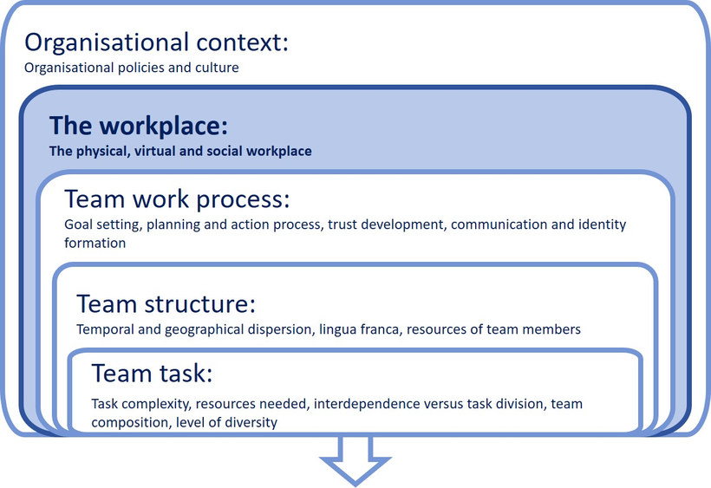
Source: Based on Bosch-Sijtsema, Petra, Virpi Ruohomäki & Mattie Vartiainen (2009, p. 12)
It is also important to consider the workplace as a key factor that influences virtual intercultural teamwork. This is because the context each team member works in can both hinder and facilitate the achievement of team goals. Contextual factors encompass physical, virtual, technological as well as social and psychological aspects, with all of these factors being interlinked.
The physical space relates to the actual environment where work is conducted, which can be in an office, on a bus, in a café, home office, at the airport or any other place. The virtual and technological space refers to the collaborative work environment, consisting of the tools and media used ranging from e-mail, audio and video conferencing to collaborative work environments and the tools and software that facilitate this.
But although mobile technology has largely liberated us from being bound to a particular place, it is important that all team members have access to the same equipment as it is vital to remove any technical barriers that could present a major hurdle to successful virtual cooperation. The technological infrastructure should be set up, which means equipping the team with the necessary hardware such as computers, mobile devices, printers, etc. and software such as project management tools, collaboration software etc. The technology infrastructure must be compatible at all sites, including external organisations. Team members may further have different levels of technical proficiency and experience. Employees who feel less comfortable with technology tend to show lower quality contributions, lower participation levels and poorer individual satisfaction, so they require training to develop appropriate media competencies. Creating the technical prerequisites for collaboration, including expenditure on data security measures and software, can be time-consuming and costly and should ideally be done before the teamwork starts.

Task: A liberated work place
Look at the photograph and think about how the environment might influence the telephone conversation. Which type of work space would you prefer if you had to discuss serious and important aspects of your teamwork? Note down the answers in your learning journal.

Photograph by Adelheid Iken
The social space refers to the social environment in which team members work. This could be team members who share an office, proximity to management, as well as your family, for exam please, if you are working from home. And of course it makes a difference whether I am around co-workers or have my family nearby.
The following is a quote from an internship report showing how the social space and the virtual space at times may overlap and influence team communication.
We have weekly online team meetings and one day our boss was telling us about a meeting he had had with our headquarters. It was a very important meeting because offices around the world were required to cut down on expenses and budgets were lowered. However, his 5-year old son had a more urgent topic. He came running into the room, jumping on my boss’s back and very excitedly asked him whether his father knew what he got for his birthday. He obviously had just found his birthday presents. We all laughed and patiently waited until he finished telling us all about his new game.
Bosch-Siijtsema et al. 2011 refer to Variainen who adds 'psychological space' as another important space to be acknowledged in teamwork. It refers to the feelings and thoughts that are part of an individual’s own space and psychological well-being and therefore not necessarily a representation of reality. For example, if one of your team members receives a promotion for which he or she has been hoping for a long time, this motivational boost will surely influence the spirit he or she brings into the team, despite the fact that the promotion is not linked to the teamwork at all. This could, of course, also cause a distraction in his or her mind. The point here is the appropriate consideration of the mental space as an influence on how we perceive and interpret other space.
The challenge to be met is to acknowledge these different spaces as factors that influence the lens an individual uses to perceive the outside world. This lens, of course, influences his or her behaviour and reactions. For this reason it is important to share social and contextual information, as this helps us to assess and understand one another. This is especially true for the early phases in a team’s development, where team members still have very little information about each other and look for guidance and “tells”: Small cues can mean a lot.

The organisational context
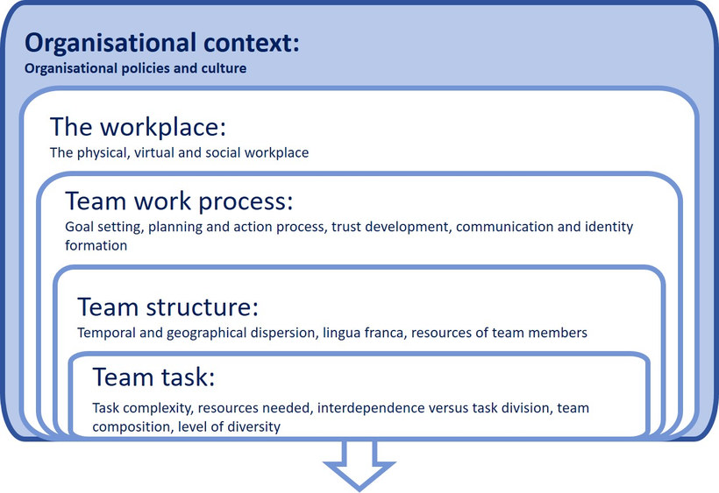
Source: Based on Bosch-Sijtsema, Petra, Virpi Ruohomäki & Mattie Vartiainen (2009, p. 12)
The organisational context refers to the broader organisational system in which a team and the team members operate. At times, team members may come from different organisations or different departments and are bound to follow departmental or organisational guidelines and policies that limit and influence the scope of their ability to adapt, negotiate and develop new team-oriented ways of working, i.e. form a new team micro-culture. As such, the organisational context can be enabling but also disabling with regard to effective team work. In many instances the organisational framework determines areas within the teamwork that cannot be negotiated.

6.5 Summary
In order to analyse potential challenges in virtual intercultural teamwork there are five specific areas that need attention. These are: team task, team structure, work processes, the workplace and finally the organisational context.
When we consider team work processes and thus the interaction of team members, trust and communication stand out as areas on which to focus. The development and maintenance of trust is of particular concern since there are fewer opportunities for in-person encounters, where trust-building is reinforced considerably. Added to this, other conditions conducive to trust development are also lacking, such as a shared social context, ample time for interaction, as well as common behavioural routines such as information sharing. Communication is also key here because virtuality influences every aspect of this, including the communication channel, and the perceived quality, quantity and frequency of communication. Because virtual communication is very different from a face-to-face meeting, how we communicate requires considerable reflection and rethinking, including the development of specific skills and approaches.
An awareness of the potential challenges that face a virtual intercultural team is an important stepping stone towards developing a negotiated E-culture that suits all parties. Beyond this, being able to integrate and synthesise different work processes and together sketch out a satisfying team culture is a major precondition for successful and enriching teamwork.

6.6 Learning review

Task: Case "Designing a new office chair" (Reprise)
Read through the case study and identify the issues and challenges that were not considered, but could have helped the team if they had been addressed. Note them down in your learning journal.
Let us get back to the case "Designing a new office chair" that we discussed in session 1. Do you remember this case with Maryam from Dubai, who worked with her team from eight different locations on four continents? The goal of the virtual team was to come up with the design and production of a new office chair. You might remember that the diversity of this team was high, due to different age and hierarchy levels as well as a high participant turnover.
Let us see what happened with this team. The task of this team was fairly transparent, i.e. they were to produce an office chair in the next 16 months that would sell well in all of the company´s relevant markets. Despite this clarity of task, the teams within the different locations had very different priorities, which were never aligned. While the US team was fighting off a competitor that frequently sold their office furniture at a cheaper price, the Japanese location felt it was not innovative enough and expected to finish the new product within the next 8 months at the latest. The locations were unwilling to compromise much with regard to their individual goals.
This resulted in a lower level of cooperation. Since the Japanese location wanted to speed things up, they went ahead with many design steps, but did not translate them into English due to time pressure. The design was also tailor-made for the Japanese supplier market, which meant that the German or Chinese locations were not able to obtain the correct screws from their suppliers in order to build this chair. Japan was then somewhat frustrated when they did not receive the resources in terms of budget and manpower, as the headquarters in the US felt that other markets were more relevant for the company.
In the end, the project failed: The different markets designed a different chair that was not very innovative, and the quality was considered to be generally lower than that of the competition. Since every team worked for themselves, the chair could not be produced at high volume, which resulted in higher production costs. Most of the team members, as well as the management at head office were unsatisfied with the team's results.

Task: Case "The relocation"
Read through the case study and highlight the issues that were addressed, and are likely to have helped the team's development and performance.
A Dutch company that produces screws for industrial purposes wants to relocate the production of a certain type of screw from Bulgaria to Vietnam. The production start date was set for 12 months' time. There was already a factory in Vietnam, which was producing some other lines of screws. It would be necessary to add another line here.
The task was to have the factory in Vietnam up and running with the help of their Bulgarian co-workers. The beginning was somewhat challenging, as the Bulgarian workers had been producing their screws for more than 15 years. They were not only sceptical as to how the Vietnamese staff could be trained swiftly enough to take over from them, but were also concerned that there would be less work for them in the future.
Due to budget restrictions the collaboration was mainly virtual. The Dutch project managers had regular meetings with the Vietnamese and Bulgarian factory leaders to explain to them the potential for both locations. Whereas Vietnam would get an important new product line for the large market in Asia, Bulgaria would free up resources that they could use for a more modern line of screws to be delivered to European customers. After several sessions, it was possible to create more trust amongst the team members. Instead of mutual distrust, the co-workers from the two locations saw themselves as one team that was completing a crucial project for the future of the global company.
Communication was crucial. Cultural training workshops helped here, which among other things illustrated the differing communication styles: When the trainer introduced an email exercise, some Dutch co-workers were surprised to see that even their own colleagues from the Netherlands would sometimes rate their emails as offensive. The management always made sure that all documentation of all the meetings was written in English.
The new production line ended up starting with a delay of a few weeks, but the customers were happy to wait, benefitting from lower-priced consignments of screws due to the lower production costs.

6.7 Sources, further reading and web links

Sources
- Bosch-Siijtsema, P., Fruchter, R., Vartiainen, M., & Ruohomäki, V. (2011). A Framework to analyze knowledge work in distributed teams. Group & Organization Management, 36 (3), pp. 275-307.
- Bosch-Sijtsema, P., Ruohomäki, V., & Vartiainen, M. (2009). Knowledge work productivity in distributed teams. Journal of Knowledge Management, 13 (6), pp. 533-546.
- Education First. (2015). Virtueller Konflikt: Hindernisse bei der Zusammenarbeit in Globalen Teams. Retrieved from https://www.ef.de/__~/media/centralefcom/corporate/
2015/Resources/pdf/VirtualConflict_DE (accessed on 20.11.2020)
- Lexico (2020). Satisfaction. Lexico.com dictionary. Retrieved from https://www.lexico.com/
definition/satisfaction (accessed on 24.10.2020)
- Nurmi N. (2009) Unique stressors of cross-cultural collaboration through ICTs in virtual teams. In B. T. Karsh (Ed.), Ergonomics and health aspects of work with computers. EHAWC 2009. Lecture notes in computer science, Vol. 5624. Berlin, Heidelberg: Springer. https://doi.org/10.1007/978-3-642-02731-4_10, p. 85.
- Nurmi, N., & Koroma, J. (2020). The emotional benefits and performance costs of building psychologcally safe language climate in MNCs. Journal of World Business, 55 (4), pp. 1-15.
- Randhawa, V. (2020). Learning in the course of virtual teamwork. A critical analysis with special reference to communication and trust in virtual teams. Master thesis. Hamburg: HAW.

7. Negotiating an E-culture for virtual teams

Topics
7.1 Prelude 128
7.2 Introduction 128
Task: Benefits of virtual teamwork 128
7.3 Culture, interculturality and cultural negotiations, a quick review 129
7.4 Cultural leverage in teams or negotiating an E-culture 130
7.5 An E-culture, best practices 133
7.6 Approaches for finding best practices 135
Task: My dune model 136
7.7 Summary 140
7.8 Learning review 141
Task: Case "An Austrian-US-American teamwork" (Part 1) 141
Task: Case "An Austrian-US-American teamwork" (Part 2) 147
7.9 Sources, further reading and web links 148

Learning outcome
You will recall the basics of negotiating an effective e-culture and apply selected approaches in order to identify best practices for your virtual team
Objectives
At the end of the session, you will be able to
- explain the processes and possible outcomes of negotiating an e-culture
- identify and evaluate best practices
- apply approaches in order to select best practices for your team

7.1 Prelude
In the previous two sessions, we became acquainted with the major challenges that VITeams need to tackle and got to know the MBI approach. In addition, we examined some theories with respect to the creation of mutuality and commonality in VITeams. The goal was the establishment of a team-based culture. This unit will help us to understand the basics of negotiating an electronically based team culture (E-culture) for virtual teams. Because the content and thus the outcome of the negotiation process cannot be predicted, a key focus in this session will be the introduction of best practices, including two approaches that will help us to find the best and most suitable path for our team.

Download: Learning journal for session 7
Learning journal (.docx) Learning journal (.odt) Learning journal (.rtf)

7.2 Introduction
Without doubt, VITeams are becoming ever more commonplace and crucial for a whole host of business activities. These range from the development of a new product, to the provision of services and creative collaboration. Employing VITeams involves sourcing talent and expertise from around the world for a specific task and offers new opportunities for collaborative task completion. Today's almost universally accessible technology allows VITeams to bring together culturally diverse groups of individuals in order to enhance organisational performance, creativity and innovation. The interview clips that follow highlight some of the major benefits of VITeams:

Task: Benefits of virtual teamwork
Watch the video clip and from the benefits mentioned, select those you consider to be of relevance for your VITeam and note them down in your learning journal.
Because VITeams have access to rich resources, combining practices, knowledge and experience, they are increasingly being called upon to leverage these resources in order to enhance performance. However, simply assembling teams does not necessarily translate into a high level of efficiency, as diversity not only functions as an enabler but can also function as a barrier to performance. One argument put forward in this session will be that VITeams simply need to be treated differently from face-to-face teams. This means that a team needs to evaluate which work processes work best for them and how to meet their own particular challenges. These could be, for example, temporal and geographical dispersion or the lingua franca used. A second area for consideration is that in order to benefit from the diversity of teams, team members need to leverage different work processes and thus negotiate an E-culture for their team. The assumption here is that a strong E-culture geared to meeting the needs of the VITeam will support the development of a strong and healthy team identity. In this way we can benefit from the diversity of its members as an enabler for team effectiveness and satisfaction. A third argument is that an E-culture can be expressly and deliberately developed and cultivated.
Session 5 already made a start in this direction when discussing the mutuality that can be created by employing the MBI approach. This laid the groundwork for the understanding that outlining differences and commonalities is a first step towards integrating differences. Bridging enabled the transition from this initial understanding to the successful integration of differences. Session 05 also provided a framework for developing an identity profile which can be used in the application of the MBI approach. In addition, session 06 (Challenges of VITeams) generated an awareness of areas particularly worthy of consideration and focus. What is missing is a more detailed practical perspective of how integration can actually be put to creative use. The focus of this session, therefore, is the introduction of tools and processes, which aid the leveraging and integration of different resources, with the aim of creating a synergetic E-culture.

7.3 Culture, interculturality and cultural negotiations, a quick review
In order to begin developing a team culture, it is helpful to adopt an actor-field perspective. From this viewpoint, we are primarily concerned with the members of the team and their cultural orientation. Inherent in the open perspective of culture is the acknowledgement that culture exists within human collectives. Typically, some of the collectives associated with the team members will be considered more relevant than others in each particular virtual teamwork environment and at any specific point in time. The term collective here refers to different types of groups such as professions, sports clubs, corporate organisations and nation states.
In our case, when diverse people meet for a specific purpose, they bring with them a range of assumptions. These could be for example their understanding of work processes, which they may have learned in the context of their professional socialisation and membership of collectives. When meeting other team members for the first time, participants are likely to perceive an atmosphere of unfamiliarity and possibly even strangeness due to differing understandings of work and working together. They find themselves in a situation where there is a lack of normality. With this absence of normality, plausibility and a lack of routinised actions, we can speak of 'interculturality'. Interculturality can thus be understood as a process of social interaction and communication in which the team members are involved in modifying their cultural practices in various ways, but at the same time attempting to assert their interests and objectives.
The result of this process is the emergence of a team culture related to the development of a work environment in which team members feel comfortable. This happens when behavioural patterns are perceived as suitable and normal, and where team members behave in a way which makes sense to the team. Additionally, routine actions have been established which are understood and acceptable for all and are therefore shared. In order to achieve a situation where routine actions are accepted and shared by all, a process of negotiation is necessary. A negotiated culture thus indicates a reciprocally and collectively formed team culture that develops out of an interactive, communicative process involving all team members. A negotiated culture is -as with any culture- also fluid, which means that in the course of the team’s life cycle, renegotiations can take place as well as refinements of the team culture. A negotiated culture is therefore both the outcome and the beginning of a process. Developing an E-culture evolves therefore, requiring time and effort from all team members, as well as everyone's openness and willingness towards ongoing dialogue.
Apart from the openness and willingness to invest enough time and effort in the negotiation of an E-culture, the level of unfamiliarity or strangeness experienced by each team member may differ, and this needs to be considered too. Lastly, the negotiation process also depends on the quantity and relevance of the work areas involved. For example, in a team where all members are already experienced and confident in English as a lingua franca, there is little need to debate which language to use. This is different in teams with a mix of members who are unfamiliar with using English in a team setting and others who are quite conversant in English, even understanding different accents and nuances. In such a team constellation, members may, for example, come up with a solution where breaks are taken in order for some participants to discuss in their mother tongue. Alternatively, a team member might summarise important issues in a language other than English to make sure that all contributions are heard and understood.

7.4 Cultural leverage in teams or negotiating an E-culture
When we talk about negotiating culture or negotiated interculturality, we refer to the synchronisation of incompatible routines of interaction. The aim is to develop an e-culture which is shared by all team members and supports team performance and team satisfaction. Negotiation as such involves co-creation and the process of sense-making or generating common meaning. This starts with the analysis of domains that require negotiation. Subsequently, cultural attributes are modified, recombined, or adapted. The following is an illustration of such a process:
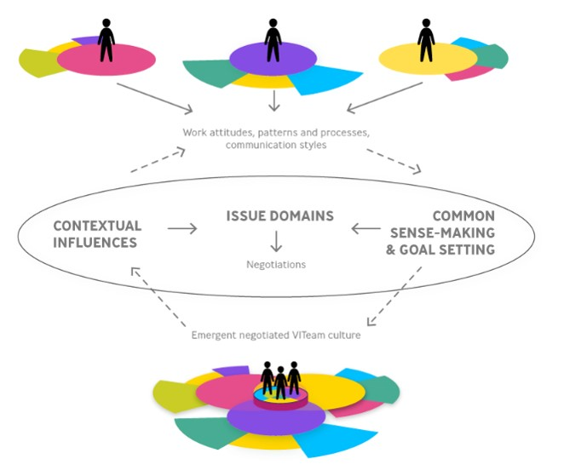
Source: Based on Brannen, Mary Yoko & Jane E. Salk (2000, p. 457)
Figure by Julia Flitta (www.julia-flitta.com)
It shows actors coming together, bringing with them their work attitudes, patterns and processes as well as communication styles. In the process of team development, they need to assess which contextual factors are relevant and the degree of influence each one exerts . Contextual factors could be, for example, the organisational frameworks in which both the team and the individual members operate. Here we might expect to observe power and dependency issues. But contextual issues can also include areas such as family commitment or limited access to the internet. The process of team development then, is tied up with the notion of sense-making and meaning creation. We therefore need to focus on shared meanings. Examples of this could be the meaning and significance attached to deadlines or meetings. Finally, the goal and the vision, in other words the ‘what do we want to achieve together?’, needs to be clarified, and this will in turn determine many of the issue domains. Once the issue domains are clear, the team can then negotiate its team culture. The arrow pointing towards and away from the team and its negotiated culture indicates the processual character of culture development.
The illustration below provides an overview of team challenges and thus domains that may need to be part of the negotiation process:
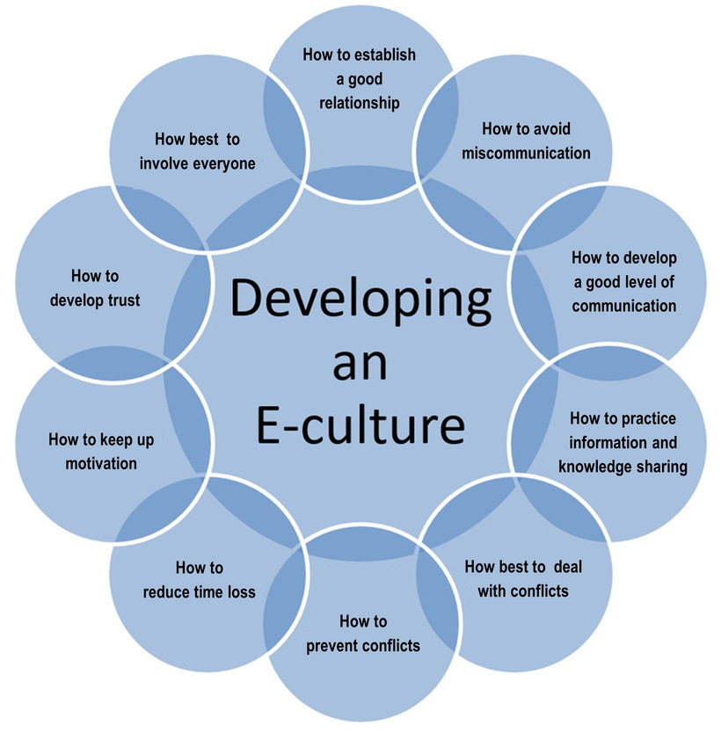
The outcome of the negotiation process is unpredictable, but generally speaking several options are possible:
- Divided labour, which refers to a high level of separation of work and individual work areas. A team very quickly decides to allocate work packages and divide responsibilities, with each team member working on their own.
- Complementing each other refers to pooling resources such as knowledge and skills, with the aim of achieving a better outcome through this combination.
- Adapting refers to the ability and willingness to adjust one’s own behaviour and accept different and new behavioural patterns or work approaches in accordance with the situation and the team’s goals.
- Finding a middle way or compromise refers to the outcome of a negotiation whereby all team members 'give in' to a certain degree. An example would be a team that decides to start a team meeting with a short ‘social get together’. This could be, for example, not as long as some team members would prefer, but also, through its brevity, would accommodate those who would rather focus directly on work-related issues.
- Novel ways of interacting or synergies refer to the constructive approach of searching for new and innovative ways of working together. It is different from complementary approaches because it focuses on the added value of teamwork and the creation of something new through a combining process. Novel outcomes can develop when social interactions among team members trigger new interpretations and products, which the individual team members on their own would never have envisaged.
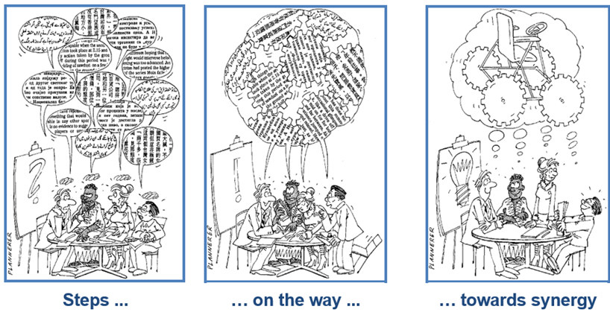
Source: Cartoon by Jörg Plannerer
This approach is therefore also referred to as the development of synergies, acknowledging that the whole is greater than the sum of its parts, as the illustration indicates. It is therefore qualitatively different from the mere adding together all team members' contributions.
The following quote from an internship report illustrates an example of this kind of value creation:
"Another example where the international team added value was when we were all working together on one analysis. While I for example got too much into detail and lost a lot of the time because I wanted it to be perfect, my colleague reminded me of what we still have left to do and why we should not get lost in detail. First, I thought this was not the way to go because we were not taking into account all the information we had but in the end I learnt that it was good to have the overall idea and look at the overall numbers. The way my colleagues were working was quite interesting because they defined a result they wanted to have and then found a way to get that result while I tried to do everything step by step towards the best result possible. By using a mix of both approaches we got a very meaningful analysis in the end and our boss was very happy with the result."
What this quote highlights is the fact that value creation requires openness and time. It is therefore crucial that we set aside the time for this open-ended process to unfold.

7.5 An E-culture, best practices
People who work from a physical office space see and feel the culture of the company all around them. There are cues from the way people talk, the ways things look and the activity surrounding them. Because these are absent in a virtual team, virtual teams should pro-actively, explicitly and purposefully develop an e-culture. This process starts with the first get-together and continues throughout the entire teamwork. A positive team culture encourages team members to feel that they are visible, connected (virtually), respected and listened to.
A positive e-culture grows and evolves in the course of the team’s life cycle. It starts with an evaluation of the current situation with regard to team members' awareness of their own cultural diversity relative to other team members. Other initial steps involve the achievement of an understanding of the context in which the team works and the goals the team wishes to achieve. In order for this to be successful, the pro-active development of a team culture requires a general commitment to teamwork and openness.
In the following, examples of best practices are presented. All of these should give useful insights into how you might develop your own team e-culture.
Develop and commit to a communication charter
- Specify mutually agreed guidelines on how the team will communicate with regard to communication styles, communication approaches and information flow. This could involve, for example, who passes on what to whom; a common understanding of how to address each other; who and how conference calls will be facilitated; who should be copied 'cc' in emails; and how a sense of togetherness in calls can be created
- Specify which communication tools to use in which circumstances. This could regulate, for example, when to reply via email rather than picking up the phone. It is generally advisable to restrict the number of communication channels in order to ensure that everyone has access to them and can use them competently
- Agree on communication technologies that fit the team and its working environment
- Guide and assist participants in the use of the technologies chosen
- Specify how to ensure sound knowledge sharing and documentation procedures. This could involve outlining good routines and rituals in this regard and might, for example, specify whether hand-overs should be completed daily and which software should be used to share documents
Clarify tasks and processes, not just roles and goals
- Specify and ensure clarity about work processes, for example who does what and when; how information should flow, and who sends what to whom
- Agree on areas which are non-negotiable and those which can be negotiated

Develop a common spirit and virtual closeness
- Agree on how to ensure that everyone is ‘on-board’. For example, you may want to start every meeting with a check-in, asking team members how they are and how they are feeling
- Agree on how to ensure common meanings relating to the content and agreements reached at a meeting. You may, for example close with everyone just noting what they will take away from the meeting
- Specify actions that help to hold the team together, for example by communicating daily or integrating the work processes of various team members
- Decide on mechanisms that encourage both the giving and receiving of constructive feedback, e.g. by considering when feedback is most appreciated and when it is not, as well as which media might be perceived as most appropriate
- Agree on what a voicing culture entails and how best to apply it. This will include clarification of what and how exactly to voice in which situation
- Specify how to ensure that everybody is being heard, e.g. by developing a team clock, an approach developed by Hildebrandt, Jehle, Meister, & Skoruppa (2013, p. 54)
A team clock
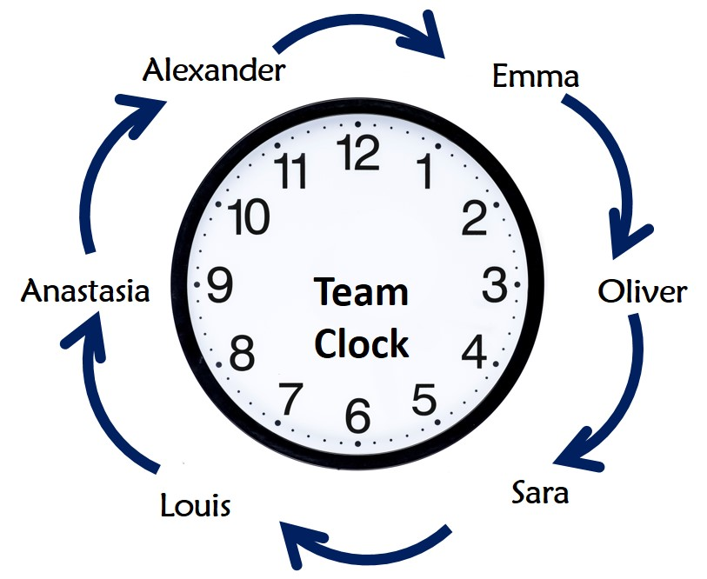
Clock image by OpenClipart-Vectors from Pixabay. Accessed 6 June 2021. Pixabay License
A team clock (Hildebrandt et al. 2013, p. 54) helps to structure airtime and also ensures that everybody's thoughts are being shared. Using the team clock you rotate and provide every team member with a specific speaking time. By doing so everybody knows when it is his or her turn to speak. A team clock is a good instrument to listen to different ideas and points of view and ensure that everybody is heard.
Establish a team rhythm
- Be disciplined in creating and enforcing rhythms in virtual team work (e.g. by holding meetings regularly and establishing and sharing the meeting agenda in advance)
- Ensure that there is enough time for socialising (e.g. by establishing a virtual water cooler or coffee break) to support the development of authentic human connections

A virtual coffee break

Photograph by Elena Martou
A virtual coffee break is a break during which time is intentionally allocated to low-fidelity activities such as chatting about personal issues, hobbies and family, or maybe films you have watched. You may also want to decide to have virtual coffee breaks to facilitate brainstorming and general reflection. The idea of a virtual coffee break is to compensate for the casual and informal talk people might have in a physical office space, thus contributing to a positive team spirit.

7.6 Approaches for finding best practices
Negotiating culture is a way of joining, overlapping and mixing cultures through interaction and communication. New cultural practices are generated, thus enabling routine actions to be established that are relevant and suitable for the team and the task. Culture production is based on an understanding of interculturality as a dynamic process involving the emergence and conscious development of a common culture within a specific context. Based on the interplay of action, reaction and adaptation, negotiation is an ongoing process and should be initiated purposefully during the forming stage of the team development process and should continue throughout a team’s life cycle.
With this in mind, the next step refers to the 'how' of this negotiation process. Two models will be introduced here to assist us in this regard, the dune model and Bono's six thinking hats. The dune model is helpful in establishing and clarifying the influence of contextual factors on negotiations within the team. Bono’s six thinking hats encourage viewing issues from new perspectives. This process can help to decide on practices that are well suited to the team.
The dune model
The dune model visualises behavioural rules and the potential for changing or amending them. Bolten (2014) uses three types of rules: These are the 'must', 'should', and 'could' rules. Within a social and organisational context, there may be rules which are not negotiable and may be even formalised in company laws and regulations.Therefore, they might have a binding force for team members and as such must be accepted. These are the 'must' rules. These could, for example, be company rules for reporting, data protection or codes of conduct. Other examples of rules which a team may see as binding could, for instance, relate to public and school holidays. The team may decide to consider them strictly as ‘non-working days’ regardless of work pressure.
The second category relates to generally valid behavioural rules and conventions which can be considered to be how one ‘should’ behave. Because they are not manifested in norms and laws, they can be changed by teams. An example for a ‘should’ rule is how employees are compensated. It might be common in a company to acknowledge achievements by giving out individual incentives and rewards. However, in a team context it may be possible to amend compensation incentives and address the needs of the team and find alternative ways to motivate team members. On a social level, a team might decide that team members should not work on the weekend but that this is not a 'must' rule.
Finally, we encounter the 'could' rules. These are conventions which may still be very young, are context specific and highly negotiable. Using the metaphor of the dune, these can easily be ‘blown away’ and therefore amended and changed, or simply become lost. Many of the issues related to work processes are likely to fall into this category. A ‘could’ rule, for example, might relate to rituals when starting a meeting, such as having a ‘check-in’ round where everybody quickly states how they feel.
The following is an illustration of the Dune model adapted from Jürgen Bolten (2014)
The dune model
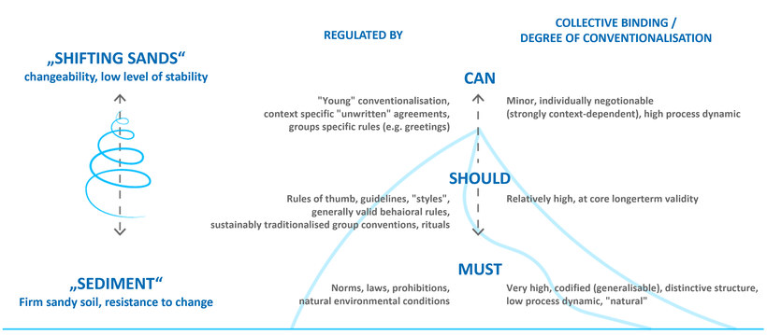
Source: Based on Bolten, Jürgen (2014). The Dune Model – or: How to Describe Cultures. Reprinted with permission. Accessed 22 May 2024
Figure by Julia Flitta (www.julia-flitta.com)
Click on the image for a larger view (if necessary hold down the Ctrl key)
Applying this model to the creation of an e-culture means that team members need to develop an awareness of those context factors and behavioural rules which are binding (or ones they wish to be considered as binding), and those which can be amended, i.e. areas where there is greater scope for negotiation within the team.

Task: My dune model
Considering a team you have been or are anticipating to be a member of, note down three rules you would place into the must, should, or could category. These can be company or social rules.

Bono's thinking hats
The idea of the six thinking hats by Edward de Bono dates back to the 60s. The idea behind the hats is that you cannot dig a hole in a different place by digging the same hole deeper. This means that trying harder in the same direction may not be as useful as changing direction. And you can change the direction of thinking by asking different questions, represented by the different coloured hats.
Applying Bono’s hats is therefore a strategy to develop flexible thinkers as they help to consider different perspectives. This can help you to find a way of reconciling different approaches of working in a team and finding a well suited approach for your team. It can also be used as a tool to handle difficult issues.
Let us start by looking at the different hats in more detail:

Illustrations by Marie Seeberger(http://www.behance.net/marieseeberger) CC-BY-NC-SA 3.0


The white hat calls for pure information, i.e. just simple facts. Possible questions that help to search for information might be: What do I know and what else should I know in order to be able to assess the situation adequately? What does the information I have tell me? What questions should I be asking?

The red hat signifies feelings, hunches and intuition. It is through the red hat you express emotions and feelings and share fears, likes, dislikes, loves and hates. Questions which might elicit feelings could be: How did I feel earlier on, how do I feel now? What are my feelings and emotions around the issues at stake?




The black hat relates to logic. Can we identify the reasons? Why are things not working? It identifies the difficulties and dangers, and where things may go wrong. This is probably the most powerful and useful hat, but it can be problematic when overused. What do I need to be cautious about?
What could be difficult? What could we improve?
What could go wrong?

The yellow hat symbolises brightness and optimism. Under this hat you explore the positives and probe for value and benefit. Is there anything positive I can take away from this situation regardless of my critical approach? What could be possible benefits?



The green hat refers to creativity, possible alternatives and new ideas. Or it could be considered to be an opportunity to express new concepts and new perceptions. What other options do I have to handle the situation (e.g. playfully, with humor)? Are there any other or new ideas? Is there a new way to do this?

The blue hat manages the thinking process; it controls the ‘thinking outside of the box’ mechanism and thus refers to reflection: Where do I stand and what is it I have to do next? The blue hat relates to management or in other words, what is the subject? What are we thinking about? What is the goal? Can we see the big picture?

There are different ways of using Bono's thinking hats. One idea is to think back to a situation that irritated you where you were not sure how to respond. Instead of responding immediately, take your time and use the Bono's hats in order to find an adequate response and possibly even a solution. This can then lead to a new routine or approach that could become an integral part of your team culture. Let us look at an example for this.

Example: Case "Understanding and meeting deadlines"
Moniq is rather unhappy with the behaviour of her colleague Richard. Ever since he joined her VITeam three weeks ago, he has not met a single agreed deadline. She spends a considerable amount of time reminding him and becomes increasingly annoyed about his behaviour. She is also afraid that the project will suffer as a consequence. She considers whether to escalate this by bringing it to the attention of their boss…
Before making a decision, she applies Bono's Thinking Hats and comes up with the following:
White hat / Facts: What do I know?
Richard joined the team only three weeks ago. I don’t really know anything about him and am not familiar with his cultural or personal background. In what kind of situation is he in right now? Maybe he has family issues, maybe he has a different understanding of what is meant by deadline, maybe he feels a bit overwhelmed with the novelty of the task and doesn’t feel comfortable enough to admit it? Or maybe he is unmotivated because he was pushed into joining our team?
Red hat / Emotions: What are my feelings and concerns?
I am actually frustrated and angry because Richard is just not doing his job. I have been working with this team for a long time and really feel committed to the team spirit and doing a good job.
Black hat / Judgmental: What are worst-case scenarios?
Richard keeps missing deadlines and the project fails. If I escalate the case and this turns into a personal conflict between us, which could also endanger the project's success and make everyone miserable in the process.
Yellow hat / Optimistic: Is there anything positive about this situation? Am I actually being too stubborn about the issue of meeting deadlines and stifling from my own anger? Are the deadlines simply not realistic? Is this situation telling me that I might be working too hard and am missing out on my private life?
Maybe we, as a team need to rethink the setting of deadlines and how to approach milestones? Maybe we are not being realistic about them and could rethink them to save us from being too stressed.
Green hat / Creativity: What options do I have?
Instead of escalating this, Moniq decides to find out more about her colleague Richard and schedules a phone call with him. She also decides to review the milestones they have established critically. Another decision she makes is to take an afternoon off and clear her mind.
Blue hat / Direction: Where do I stand and what are my next steps?
With the knowledge, ideas and thoughts she gathered she decides to not directly accuse Richard, but to review milestones and take up the issues in her team from a more general perspective. She also initiates a discussion in the team as to how they could improve their approach to deadlines and develop a common understanding about this. What she could envisage is to establish a traffic light system whereby the green light indicates that there are still two weeks to go, the yellow light shows that the deadline is approaching and the red light indicates that the deadline has not been met. She could also envisage establishing a routine whereby every team member briefly reports where they stand at the beginning of their meeting and whether they anticipate problems meeting the deadline. Whatever practice they decide upon, this would then become part of their e-culture.
The thinking hats can also be used in your team, for example prior to making a decision, as the hats will help the team to consider different viewpoints and ways of moving towards a good solution. It provides them with a wider and much more detailed picture of the options, and it allows emotions and scepticism to be brought into the picture as well. The following is an example:

Example: Case "Independence vs teamwork orientation"
Andy, Martha and Nuri are members of a project team. They have developed their identity profiles and started to chart out how they want to work together. Martha is a very independent person whereas Nuri values cooperation and would rather that they work together on tasks as a team as much as possible. Together they apply Bono’s hats to evaluate how they might reconcile these two approaches.
White hat / Facts: What do I know? Here it would be helpful for Martha and Nuri to highlight what they mean by pursuing independent and a cooperative working styles. Martha may be arguing that working independently allows her to schedule her work according to her own rhythm and irrespective of time zone differences. She may also say that working on her own enables her to concentrate better and be more effective. Nuri might say that he is better able to generate ideas when talking to people rather than sitting down in front of his computer and that it doesn’t bother him whether he works at night or during the day.
Red hat / Emotions: What are my feelings and concerns? If they perform most of the tasks together as a team, what could Martha's concerns be? Would she worry that they will spend too much time on tedious discussions and thus risk missing deadlines? Or would she fear that the team might get into arguments over issues which are difficult to solve online? She might feel that she won't be able to show what she is capable of when she is dependent on the other team members. What could Nuri’s concerns be? Maybe that he might lose track of what Martha is doing and so fail to see the overall picture? It could also be that he feels working on his own all the time is uninspiring and that he will miss the social aspects of working together. He might fear that Martha will present the team with finished results and will no longer be willing to compromise on issues. He could also worry that if they don’t work together closely they may need more time at the end to integrate all the parts. Added to this, he strongly believes that working together brings out the best ideas.
Black hat / Judgmental: What are worst-case scenarios? What is the worst thing that could go wrong if they decide to work independently or cooperatively? The worst thing that could happen if every team member works independently is likely to be that the team's results are a patchwork and the different parts do not fit. If they work cooperatively, the worst scenario is likely to be that they become engaged in endless discussion, lose track of what they are supposed to be doing and struggle to meet the deadline. In both instances they could end up with poor results.
Yellow hat / Optimistic: Is there anything positive about this situation? It could encourage Martha and Nuri as well as Andy to think about the pros and cons of both working approaches and put these into perspective.
Green hat / Creativity: What options do we have? There are various options as part of the negotiation process. However, with the previous discussion in mind it may be helpful to go through the work schedule and identify those areas which can best be tackled independently and those areas where cooperation is most effective. Because Nuri and Andy are not concerned about working times, they might want to accommodate and follow Martha’s daily rhythm when scheduling their meetings. They could also install a system to structure their meetings and speaking time in order to use their time together constructively.
Blue hat / Direction: Where do we stand and what are our next steps? The team may decide on a trial phase and follow a mixture of cooperative and independent work approaches and re-evaluate after a couple of weeks.
Their agreed working style would then become part of their e-culture.
What both approaches offer is that they facilitate constructive and complementary utilisation of the differences and contradictions inherent to interculturality. It is important that the results of these approaches flow into the development of an e-culture, which should then fit both the task and the team members, enabling each one of them to flourish.

7.7 Summary
Developing an e-culture for is especially important for VITeams because many of the cues that members of in-person teams use to establish how 'things are done around here' are lacking. In particular, working together virtually calls for agreement on work routines, communication processes and a commitment to the development of a common spirit and virtual closeness. Teams that set aside time and resources to pro-actively establish and agree on an e-culture and thus a positive work climate are likely to avoid unnecessary problems and misunderstandings. Developing an e-culture therefore has the potential to bring out the best in teams and lays the groundwork for the emergence of synergies.
The Dune model and Bono's six thinking hats are two approaches that help to identify best practices for a team. Whereas the Dune model enables a team to establish basic parameters for their teamwork, Bono’s hats help us to identify best working routines for the team. By asking a variety of questions, Bono's hats encourage team members to consider different perspectives and thereby find the most suitable solution. In addition, both approaches have the advantage of being simple to implement.

7.8 Learning review
The following learning review is largely reproduced from a learning activity originally developed as part of the ICOPROMO project (MCT_Tension_in_MCTs.doc (uc.pt) https://www.ces.uc.pt/
icopromo/materials/MCT_Tension_in_MCTs.pdf, accessed on 21.12.2020). It contains statements which were written as part of a reflective essay following a team project between a group of Austrian and US students. The Austrian team included Austrian nationals as well as international students, whereas the US team was solely made up of US nationals.
The statements collected have been edited slightly and are indicative of the various issues and problems that surfaced during teamwork. It is very likely that similar situations may occur in business settings.
The names (changed) and nationalities of the team members are as follows:
Austrian team:
- Anton, an Austrian national
- Jiri, an international student from the Czech Republic
- Carmen, an international student from Spain
US-American team
- John, a US national
- Ashley, a US national
- Jenny, a US national

Task: Case "An Austrian-US-American teamwork" (Part 1)
This first round of reflections will relate to the 'getting to know each other' phase.
The following statements and extracts from the reflective essay illustrate three different phases in the development of the teams. Considering the team challenges as well as the best practices we have seen, read through the statements and for each project phase:
- Identify the challenges the team is facing.
- Note down what may be causing the issues that surface.
Write down your answers in your learning journal.
Phase 1: Getting off to a start
Anton (Austrian team member)
"My first impression of my team [in Austria] was quite good as my teammates seemed to have a friendly and open attitude towards me. … We got to know to each other during class and also during our "social meeting" which was a good idea to organise. I think that we are able to do good work together because we already built up trust within our group."
"Another difficulty for our first assignment is the Easter break in which my local team members travelled back to their home countries, so communication is as difficult as with our Cincinnati members."
"As my team members can communicate in English as well as in German possible communication problems are not likely to arise."

Jiri (Austrian team member)
"The deadline was due on April 12. … There was no communication till April 12. We started the emailing on the April 12 and until now it is working."
"I think a big disadvantage is that here in Austria we have got holiday. We are not sitting by the computer every day. Some of us did not have internet connection like I had until yesterday."
John (US-American team member)
"There are obviously two components to the make-up of my virtual team: my teammates from Cincinnati and my teammates from Austria."
"Before this class I was already familiar and friends with Ashley. We are in the Honors-PLUS program together and I am already aware of her capabilities. Jenny and I have placed our trust in Ashley as our team leader from our past positive experiences we have had with her."
"I have worked in virtual teams before during my co-ops at Credit Suisse in London and New York City. The knowledge that I gained from working in virtual teams while on co-op is priceless and I hope that I am able to share some of my expertise with my teammates."
"During our video conference with Austria we experienced a bad connection which made it nearly impossible to communicate with our counterparts in Austria. Since then we have only used e-mail to communicate with each other."
"Because the Austrian students are on holiday there has been a very light volume of communication between the team members in Cincinnati and those in Austria. I believe that the volume of communication will pick up dramatically when the Austrian students return to school from holiday and the case deadline approaches."
"We have been briefed in previous classes of these cultural differences and both Ashley and I have experienced these rifts in cultural norms firsthand. If any problems arise due to cultural differences, I believe that we will be able to immediately diffuse the situation."
Ashley (US-American team member)
"In the email, I briefly introduced myself, and encouraged the rest of the group members to reply introducing themselves, as well. The replies varied."
"Within 24 hours, I received a reply from Anton, my teammate from Austria. … I asked Carmen and Jiri if they received my email. They both said they did receive my email, and responded back. However, I did not receive their email. I am not sure what to expect from Carmen and Jiri, because I've not spoken with them."
"Over a week later, I received an email from John, a US-American teammate. John is an ideal teammate; he is extremely knowledgeable about international affairs, and goes above and beyond in his school work."
The second round of reflections are focussed on the storming phase of the team's development.
Phase 2: Unexpected tensions and issues
Anton (Austrian team member)
"I have the feeling that our communication finally broke down. Not within our local "Linz-group" but with the Americans. We sent some work we had agreed on last week and I have not received any response from them. Maybe something went wrong with the e-mail transit. I am quite frustrated at the moment.
I think that Carmen, Jiri and I should get together this weekend and get some research done. I hope that we can decide on an appointment in the next couple of days, but unfortunately Jiri is at home in The Czech Republic."
"I would have expected the Americans to correct some of our mistakes. The grammatical and "using the wrong word" mistakes were still in the paper and I think that they have not even read our parts. Therefore we should improve our communication and ask them read over our work again."
"I wonder what the Cincinnati group thinks about us and why our communication is so slow. Maybe they have a lot of work at the moment."
Jiri (Austrian team member)
"I also experienced some problems with my email address. I was very surprised when I received an email from Ashley which informed me, that she is still waiting for an answer (not only from me) and reactions to her proposal though I send it to her."
"We also arranged an online conference which will be held on next Friday. … But then problems started. The Americans didn't replay at all. They didn't send to us the necessary information and suggestions to our tasks. On Friday there was no online conference, no discussion about our tasks. To be able to do the oral presentation of our project on Monday, we had to do a part of the task the Americans were supposed to do. Worst of all is that we didn't receive for a period of almost two weeks any email from our American team members. I really wonder what happened."
Carmen (Austrian team member)
"There is only one point that we, the Austrian team, have seen as a mistake: no one has read the complete text. The Americans have the responsibility for revising the English language aspects of the paper.
"We have forgotten to talk about that in the videoconference, so we should say it by mail and we have to select very carefully which words we are going to use."
"Following with the videoconference, I have to admit that it was not too much productive. The American team sent us one structure to follow for resolving the case that was given to us. I thought that it was not very good because nothing new appeared there, but everyone, I mean, in Austrian team, thought that was better than the one that we suggested. I didn't agree, but I was the one that had that point of view and I decided to cede."
"We distributed just a few tasks from the whole project. I don't know why but it was like that. After the videoconference we talked a little bit more about the meeting and the future work and we three agreed in what little had been the tasks distribution."
"By this day, we have finished our first tasks but we haven't gone on the project and not even talk about it. The reason for that is clear: the exam. We have been so concentrated in it that we have forgotten somehow the paper."
"I would like to take more responsibility inside the team because I think that I can contribute profitably in it but I have some limitations with the language. I feel sometimes that people don't understand the idea that I won't to communicate. It is very frustrating for me. I can build a sentence, but the meaning that they understand is not the one that I want to communicate, so I have to give up with it."
John (U.S. team member)
"… my first impressions and expectations had changed rather dramatically based on my experience thus far."
"First, my team thought it would be a good idea to designate a team leader from both the University of Cincinnati and from JKU. Both team leaders would be responsible for compiling the work from their domestic teammates and then communicate that material to the other team leader. We designated Ashley as our domestic team leader and she has done a good job with communicating with our Austrian counterparts, setting up team meetings, keeping everyone on task, and leading us towards a final product. However, after receiving a grade equivalent to a 'C' on the Leo Burnett case it has come to my attention that this process is obviously not the best way to approach our virtual team cases. Jenny and I are going to have to take a more hands on approach and communicate with our Austrian counterparts as well. There needs to be more discussion between Ashley, Jenny, and I at home and with each individual in Austria in order for our team to arrive to the best possible solution for our final team project."
"Also, I blame myself for the poor grade that our group received on the Leo Burnett case because I did not take the time to review the final product before we turned it in."
"I initially believed that this classroom experience with virtual teams would help me fine tune my virtual team skills. So far this has not been the case because of my lack of involvement in communicating with my Austrian counterparts."
"However, I have yet to establish friendships or personal trust with my Austrian teammates. I need to immediately change this so I can work more efficiently with them and leave them with a positive view of the University of Cincinnati. Besides learning about virtual teams and completing work worthy of a good grade I still have hope that after this class has ended my three European teammates will spread the word about the talent, potential, and calibre of business students at the University of Cincinnati."
Jenny (U.S. team member)
"Wow, I'm shocked. I have many different expectations now than I had when the class first started."
"It's really hard to communicate efficiently with everyone in a group from America; it's a million times harder to communicate with people from a country across the world with a six-hour time difference."
"For us American students, it's our last quarter and we have so many things that need to be done in order to graduate and I know that I'm guilty of not checking my emails and not responding as quickly as I can because I have so many other things going on with mycapstone classes and working 6 days a week."
Finally, the third round of reflections will show the norming and performing.
Phase 3: Getting to a good finale?
Anton (Austrian team member)
"Ashley invited me on Zoom and I could talk to her for quite a while (for the first time). This is very fortunate because my conversation with her unveiled some for me unbelievable things. As she is the only team member from America who answered on our emails I asked her what had happened to the other two members. She answered that they had absolutely nothing to do with our group project and had never sent her anything. For me, this explains a lot. Now I know why she is late on our work and she also apologized for this. I would have rather found out weeks ago than now that she is the only one doing something."
"My conversation with Ashley put new light on our problems. In my second personal reflection I wrote that the communication finally had broken down and now I know why. I will apologize to Ashley because I was quite unfriendly to her in one of my emails I sent her."
"I also realised that communication is the most important factor for a project with international virtual teams – when it works you do good at your tasks and if not – you fail and you don't even know why."

Jiri (Austrian team member)
"In the beginning [of the team work] there was much more enthusiasm to work together but this enthusiasm was slowly diminishing."
"Another problem which occurred in our email communication was the speed in responding the emails. It happened quite often, that somebody received an email and although there was some question which should be answered, he didn't respond. It didn't evocate a good feeling when you received a confirmation that an email was displayed on his/her computer but after it there was no reaction."
"Finally, after the crash of communications with the Americans, there was no discussion among the two teams. Every body just submit his/her part and Ashley put it finally together."
Carmen (Austrian team member)
"Unfortunately, the last reflective essay is going to be the most disappointing one. I will start with my reflection from the days before to our presentation."
"We have arranged a meeting by mail for preparing the presentation. In that meeting only were Anton and me because Jiri had one course at the same time. Before doing anything we already had a problem: American people hadn't sent us anything about their part and we needed it. We tried to get in contact with them by mail and also by phone, but we didn't get any answer. We structured our presentation and had to begin searching the information that the Americans should have sent us. We finished the meeting with all the information ready to be shaped. We said that we would meet again the next day from 9 am until the afternoon. Jiri was there when we decide that but the following day he didn't appear until Anton had called him. He said that he haven't realise about the meeting time. For that time we had, not only the presentation, but also a big part of the paper done."
"The presentation was quite good. We were a little bit nervous, but we have worked very much on it –Anton and I- and I think that it reminded clear. As soon as I went on the work I found it more interesting and perhaps it will help me in the future."
"After that we received an e-mail from the USA telling us that they had technical problems and because of that, they haven't received the e-mails. I know that the mistrust is very bad in a working group but I must hesitate about those technical problems. Perhaps one mail is possible to get lost, but we sent them lots of them and even we called the by phone. We were very disappointed with the American part of the group but the worst hadn't appeared yet."
"The last week I sent an e-mail to everybody regarding the death line for our paper. I received a replay from the Austrian group members but nothing from the USA. They have the work that we did and now there was their turn for going on the paper. Although our part was done, I thought that perhaps they will need help and that some parts of the paper would be necessary to be commented. The days moved forward and I haven't received any news from the American part of the team. Anton was also worried and we talked by phone about this point two days ago. I sent another mail regarding that our death line was almost here and that we needed to send the paper. Ashley replied me that they were working on it and that she would send me the work as soon as they finish. I was more relaxed after that, but yesterday everything was wrong again because Ashley told me that they are not going to finish the paper until Wednesday. I asked her that we needed for that day and she sent us saying that she didn't recommend us to send it because there are some things wrong. I was really surprised. In all my life I have never seen that. There must be a misunderstood because it is really inconceivable."
"In one hand, if we are the same group, with the same case and the same paper, we should have the same death line. I don't understand why we had to present the paper in Monday and they on Wednesday. In the other hand, the American part of the group not only don't have respect the group's death line, but also they haven't respect us when we have asked them the work finished because we have to deliver it. Without the paper that they were working on we couldn't do anything. It was very annoying."
"There has been another misunderstood because Anton sent to you an e-mail explaining the situation and you haven't received it. I was surprised when I realise that you haven't received that mail because Anton is very responsible and committed with the group. The rest of the group has disappointed me day by day. I really had good vibrations with the team but today everything has changed."
John (US-American team member)
"The last couple of weeks of the quarter were difficult for me to fully participate in my group. I had to move to New York City and at this point my communication with the rest of the team diminished."
"… Especially, with being in office training from 8am-10pm in NYC for the last two weeks I have fallen out of touch with my group's progress. It would have been nice to know how our presentation went and to have contributed in the final stages of its completion."
"The work that I turned into Ashley about the Chinese culture flowed through into the final paper. While the extensive work that I did on establishing management structures to deal with cultural differences did not. I would have liked to have been able to add this material to the final paper but I was too busy with my head buried in the sand with my investment banking training to do so. … Also, I have not seen our final paper and I do not know how our presentation turned out so I do not have a complete opinion of my team's success (or failure) as a virtual team."
"Condensing all of this work into one week, preparing for my job, and getting ready to move to New York City really handicapped my ability to work in a timely manner. I tried my best to stay organised and meet deadlines but twenty-four hours in a day was simply just not enough time. I had too much on my plate and certain tasks took priority over others. Because all of this was going on in my life I was unable to step up as a leader in the group and push Jenny and Ashley to meet their own deadlines."
"All of this confusing could have been avoided if prior to setting the deadlines I would have informed all of my teammates that there was a very high possibility that my life was going to slide into complete chaos a few weeks before I left for New York City, that they should proceed on without me, and my assignments might be a few days late. I should have also taken on some none crucial assignments so that the project could proceed and my work could just be added to the final product and would not serve as the backbone of the project."
"One thing that I feel strongly about when it comes to the success of virtual teams is structure. Our team needed more structure to our work. We needed to set up a meeting time on instant messenger or Skype to discuss certain aspects of our project at least once a week. In a work setting this structure is established by the team leader. However, in our group we had two team leaders; one in Austria and one in Cincinnati. The lack of structure really hurt the efficiency with which our team worked."
Ashley (US-American team member)
"As this project comes to an end, my impressions and thoughts of my team resemble a rollercoaster."
"A few weeks into the quarter I realised that this group project may be similar to every other group project, with the typical "slackers" and the "over-achievers" and the constant tension between the two."
"In the middle of the quarter, we received our grade on the case study, a 3.5. I do take responsibility for this low, disappointing grade because I was responsible for integrated everyone's delegated portion, and editing and submitting the paper."
"After confirming they would attend the meeting, neither Jenny nor John showed up for the meeting. At this point, I was annoyed with their work ethic and unreliable attitude of the US-American team members."
"… I am conflict-avoidant: I spoke with Jenny and John on a few occasions, asking them to contribute more to the group, cite their sources, and attend scheduled meetings. However, I did not want to argue with my team."
"Working virtually did not present as many obstacles as I originally thought. During the first few weeks, we had issues figuring out the time difference, using Skype, and communicating via MSN. However, in five weeks, I was able to communicate with the Austrians one a daily basis. We could ask and answer questions in a few hours, and even convey thoughts and ideas using Skype telephone. This class taught me that it is relatively easy to communicate globally. The language, distance and technological barriers are not as difficult as I once thought."
Jenny (U.S. team member)
"On top of the already difficult task of getting a group of people to have the same free time; add the extremely long distance and time difference in to the mix and you get by far the hardest thing to ever successfully accomplish…a virtual team. I think that I would have definitely enjoyed the class more if I wasn't taking four others, if I didn't have two 30 page papers that were due by the end of the quarter, if I had the technology to better communicate with the people across the country and if I had more time to devote to the assignments that were due."
"I think that the lack of face-to-face communication was detrimental to the project. We only had two video conferences in 10 weeks."
"I also think that on my part of the group work anyways, I lacked the technology to effectively communicate with the Austrian group members."
"Also some of their emails were "gappy", meaning they didn't make sense and we had clearly not received a few of their emails either. To solve this problem, we just again remained patient and I just let Ashley be the mail contact and communicator between all of us because her email was working the best. I don't know how the Austrian students felt about this but it seemed to start working better that way towards the end of the quarter."
"There was a lot that everyone overlooked IE: cultural differences, language differences, time differences, differences in work ethics, schedule differences and expectation differences in general. I don't think that there is enough literature to fully prepare anyone and fill them in on the difficulties of working in a virtual team.

Task: Case "An Austrian-US-American teamwork" (Part 2)
- Think about and note down in your learning journal what the team could have done to avoid the issues that surfaced, applying the dune model as well as Bono's thinking hats and giving three examples.
- Use the results of your analysis to sketch out elements of an e-culture that encompasses a communication charter, specifying tasks and processes, developing a common team spirit and working rhythm.

7.9 Sources, further reading and web links

Sources
- Barmeyer, C. (2018). Konstruktives Interkulturelles Management. Göttingen: Vandenhoek & Ruprecht.
- Bolten, J. (2014). The Dune Model – or: How to describe cultures. https://www.researchgate.net/publication/311425195_The_Dune_Model_-_or_How_to_
Describe_Cultures (accessed on 26.6.2024)
- Hildebrandt, M., Jehle, L., Meister, S., & Skoruppa, S. (2013). Closeness at a Distance. Leading Virtual Groups to High Performance. Oxfordshire: Libri.
- Warner, M. (2001). Complex problems, negotiated solutions. Tools to reduce conflict in community development. London: ITDG Publishing.

Recommended reading
- Bolten, J. (2014). The Dune Model – or: How to describe cultures. https://www.researchgate.net/publication/311425195_The_Dune_Model_-_or_How_to_Describe_Cultures (accessed on 26.6.2024)
- Management Centre (2015). Six Thinking Hats: how to work out what’s a good idea. http://www.managementcentre.co.uk/downloads/6TH.pdf (accessed on 21.1.2019).
This article introduces the approach and application of the Six Thinking Hats

Weblinks
- The 'Dune Model' YouTube video explains and illustrates the dune model.
https://www.youtube.com/watch?v=-7Jb-X4NLGs (accessed on 19.12.2020)
- Edward de Bono and his thinking hats, an explanation can be found under
https://www.youtube.com/watch?v=o3ew6h5nHcc (accessed on 19.12.2020)
- How to apply Bono's thinking hats is illustrated in the following YouTube video:
https://www.youtube.com/watch?v=PASrBGtcrdU (accessed on 19.12.2020)

8. My competences for working in a virtual intercultural team

Topics
8.1 Prelude 150
8.2 Introduction 150
8.3 Developing competences for working in VITeams 150
8.4 Key areas of virtual intercultural competence and my personal achievements 152
Activity: Changing your work routines 154
Activity: Joining a team (1) 156
Activity: Dealing with irritating behaviour 157
Activity: Joining a team (2) 159
Activity: Dealing with a touchy topic 160
Activity: The interaction between the team lead and the employees 162
Activity: Contextual issues 164
Activity: Changing perspectives 166
Activity: Privileges 168
Activity: Reflecting on positive and negative experiences 170
Activity: Developing the communication flow within the team 171
Activity: Synergies through differences 173
8.5 ...and the journey continues 173
Task: Benefits of virtual teamwork 173
8.6 Sources, further reading and web links 174

Learning outcome
You critically assess your competences for working in a VITeam

Objectives
At the end of the session, you will be able to
- identify and explain central skills and competences relevant for working in a VITeam
- critically assess the competences you gained for working in VITeams

8.1 Prelude
In session 6 you analysed specific challenges a virtual team is facing and how these challenges can influence team performance and team satisfaction. You also dealt with ways and means of establishing an e-culture to support the development of a team-identity and thus mitigates many of the challenges to be faced. Going through these processes enabled you to proliferate your competences for working in virtual intercultural teams. This concluding session is meant to look back at your achievements and learnings.

Download: Learning journal for session 8
Learning journal (.docx) Learning journal (.odt) Learning journal (.rtf)

8.2 Introduction
Working in VITeams can be exciting and challenging at the same time and it definitely constitutes a new way of collaborative work. This is also why working in VITeams requires a different set of knowledge, skills and abilities than working in face-to-face teams. The sessions you worked on so far opened a path of enhancing such competences and using them for making virtual teamwork a positive, enriching and successful experience.
Having virtual and intercultural competences and continuously improving upon them is a key qualification in today’s business world. This is in particularly so because with further advancements of computer technologies, virtual teamwork is not only there to stay but likely to increase and influence our work environments in the future even more.
With this in mind, this concluding session is meant to highlight competences which are of particular relevance when working in virtual and intercultural teams and provide you with an opportunity to reflect upon your learnings and achievements. The aim is thus to raise your awareness of the competences you improved upon and reflect on how they are expressed in teamwork enabling you to pinpoint personal achievements and further study paths.

8.3 Developing competences for working in VITeams
Working in VITeams is a complex undertaking. As discussed in previous sessions it requires the ability to handle a range of technologies, dealing with different levels of virtuality, knowing when and how to use synchronous as well as asynchronous communication tools, acting in a way that creates a trusting and inducing work environment. It also requires working with and benefitting from a diversity of team members as well as recognising and adjusting to different stages of the team development process to mention but a few aspects. Overall competences for working in VITeams should enable you to achieve interdependent goals, support collaborating work processes, the development of a negotiated team culture and enable synergies. In short it can be argued that team members need virtual, intercultural and collaborative competences to interact efficiently, effectively and appropriately in a given context.
This also means that successful and satisfying work in virtual intercultural teams requires a range of intertwined and interdependent competences. These are commonly understood as clusters of related knowledge, skills and attitudes (KSAs). The ones discussed in session one in particular referred to virtual competences understood by Wang and Haggerty (2009, p.578) as the knowledge, skills and attitudes required to work and communicate in virtual environments with the aim of completing collaborative work projects. From a technical point of view this includes the proficiency to apply available communication technologies such as email, instant messaging, telephone or video conferencing tools which are basic enablers of virtual teamwork, at times also referred to as digital fluency. Closely linked to these is the ability to handle geographical and temporal dispersion. Being set apart from work colleagues necessitates inter alia enhanced time and self-management skills, mitigating challenges related to communication and emotional disconnects and at times dealing with different times zones.
Apart from such dispersed work related competences, another set of competences relates to working in a diverse and thus intercultural team. This includes the ability to positively influence collaborations and the development of supportive relationships among diverse team members in a virtual context. Generally speaking, it comprises the ability to communicate with diverse people in a way that supports mutual understanding, earns their respect and trust, while encouraging a cooperative and productive virtual workplace conducive to the achievement of team goals and team satisfaction. This skill set represents both the “knowing what” and the “knowing how”, because it refers to understanding the uniqueness of encounters in virtual settings and having the skills to handle these in an adequate way.
Another set of competences discussed in session 1 refer to specific team competences which are closely linked to communication and include the flexibility and ability to develop interactional routines. With regard to flexibility, the ability to both adapt behaviour as well as suspend judgement are key. Adaptive behaviour can be understood in the sense that team members need to flexibly select from a repertoire of actions those that fit a range of different social and intercultural situations as well as unexpected circumstances.
This short review of competences for virtual teamwork highlights several things. One is that the competences supporting virtual intercultural teamwork are complex, interdependent and intertwined and that one cannot really be set apart from the other. In a nutshell it can be argued that working in VITeams requires a combination of virtual, dispersed work and team related as well as intercultural competences. For example, feeling competent in communicating and supporting a conducive work atmosphere but not in using computer based technologies would only be part of the equation.
Adding to this complexity is, as mentioned earlier, that competences as such need to be understood as a trilogy linking knowledge, skills and attitudes (Wang & Haggerty; 2009; Deardorff, 2020; Byram 2009). Or in other words having an affective and emotional as well as cognitive and behavioural or actional component (Spitzberg & Chagnon, 2009, p. 7) For example, having the technical knowhow of using computer based technologies is one part of the competency, but when best to use which medium for knowledge transfer, how to substitute for missing communication cues and the timing of a response for example are equally important and refer to the skill component. And yet, having the knowledge and skills to deal with the challenges posed by working in virtual teams needs to be complemented with a positive attitude, openness and motivation to apply the knowledge and skills. In our example it would refer to the motivation of actually overcoming any anxiety to use computer mediated communication systems, being ready and open to learn and overcome any negative emotions associated with the use of technology or working in virtual settings in general.
To the knowledge, skills and attitude Fantini (2000, p. 28) rightly adds awareness turning the trilogy into a quartet of A+ASK (Awareness, attitudes, skills and knowledge). He argues that awareness is an essential component of competence development although it seems to be of a different order. According to him awareness ‘emanates from learnings in the other areas while it also enhances their development’ (Fantini, 2000, p. 28). Awareness is required at the onset of virtual teamwork in the sense of recognising and accepting that virtual intercultural teamwork is different from working together face to face and being mindful and alerted to diverse cultural identities. Awareness also refers to the ability to critically look at oneself as a member of the team. Awareness is also central in the course of working together and going through a process of learning in the sense of a critical consciousness of what is happening is central for the team to develop. Fantini (2000, p.29) refers to awareness as involving, exploring, experimenting, and experiencing and as such considers awareness to be reflective and introspective. It can therefore lead to a deeper understanding of one self and other team members and accepting them on their own terms.
Intercultural competence can be characterised as encompassing the ability to develop and maintain relationships, to communicate effectively and appropriately and the ability to obtain compliance and cooperation with others. Although such competences may be “desirable for everyone everywhere” as Fantini (2000, p.27) argues, they need to be considered in the specific context in which they are needed. Competences relevant and successfully applied in one context may not be useful and achieving the desired goal in another. This means that in the context of virtual teamwork, the intercultural competence required has specific peculiarities.
Last but not least, competences need to be considered with regard to the anticipated goal and output. Generally speaking, they can be understood as accounting for the process of managing team interactions in a way that is likely to produce appropriate individual, relational, task and team outcome.

8.4 Key areas of virtual intercultural competence and my personal achievements
Working in VITeams poses challenges with regard to handling computer based communication technology, coping with the absence or reduced face-to-face interaction, communicating using asynchronous technology, developing an e-culture and collaborating with diverse team members. And reaching the goals set, working well together as well as developing satisfying relationships requires a range of interdependent competences. Four areas appear to be of particular relevance in this context and converge on similar challenges: Openness, communication, culture-reflexive knowledge and negotiating culture. In the following the meaning of these as well as sub-competences are being explained, examples are given and subsequently an activity offered to assess your achievements with regard to the specific competence.
***
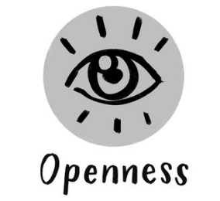
Openness in the sense of being ready to explore new situations and feeling comfortable in unfamiliar and at times highly complex situations is surely a valuable trait to address intercultural encounters constructively. Openness encompasses New Thinking and a Welcoming Attitude, which can be understood as the readiness to initiate relationships with new people and those who may be very different for example with regard to their different backgrounds, experiences and behaviours. If we want to develop a common ground, Acceptance is also important, which refers to accepting behaviour that may be very different from our own or even be in conflict with our own sense of best practices.
An attitude of openness is especially important when we work in virtual environments. The willingness to regularly deal with new communication technologies and to develop a virtual media competency is a key prerequisite for an effective and constructive collaboration of a virtual team.
Openness also plays a vital role in building trust and developing strong relationships with other members of a virtual team. Virtual communication is often limited because of a lack of non-verbal communication such as gestures and facial expressions or of rare opportunities for informal talks amongst other things. This might hinder the development of understanding and empathy for the different opinions and working styles in a virtual team. Being prepared to accept these limitations and to find new ways to build up team spirit and working relationships is thus a central competence for successfully working in virtual contexts.
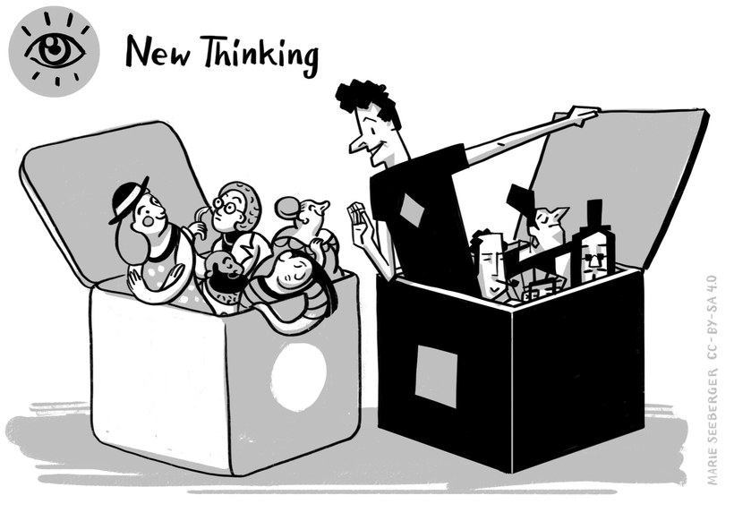

Meaning
People who have the competency of New Thinking feel passionate about following up with new ideas or developments. These are people who have a natural curiosity and like to venture into new and unfamiliar fields. They also like to view things from different perspectives, challenge established facts, and like to get “to the bottom” of things by learning more about the background and connecting the dots. Using their curiosity as well as their natural sense of creativity they like to find “out of the box” solutions for established challenges.
The ability to rethink work routines and the willingness to explore new ways of working together is especially important for members of intercultural virtual teams. Given the fact that these teams often consist of very diverse people with different backgrounds and experiences it is critical that all team members are able to reflect their own thinking and behaviour as well as to accept different perspectives on how the work should be done and on how best they can make use of the resources in the team. In particular, these competences are required in virtual settings when the team members do not have the opportunity to regularly meet in person.
The willingness to behave flexibly and to analyse issues from different angles without judgement allows a fresh look at organisational or strategic challenges and often provides chances for finding innovative, non-expected solutions for them.

Example
Anne is working in a global pharmaceutical company and leads an international research team. In the last years her team has developed an efficient working routine with regular virtual team meetings. All team members have access to a VPN based shared drive and they can use a couple of collaboration tools when they are working together for a project. Now Anne has just hired Malia and Faki, two postgraduates from Uganda with excellent skills that her team urgently needs to have.
The challenge: Due to the poor quality of their internet connection Malia and Faki have to join the team meetings without camera and often without sound. Also it is not possible for them to get access to the VPN shared drive which heavily impairs the collaboration with their team colleagues.
In a team meeting Anne therefore asks her team members to develop new ideas on how they could improve their cooperation and exchange of information with the two new colleagues.
The team agrees on the following steps: Each team member will send important documents and research results via e-mail to Malia and Faki. In team meetings they will write their thoughts and ideas in the chat while the team is waiting for their input. Every two weeks the team will meet in an audioconference. In addition to the shared drive the team will use a cloud based storage platform.
Although these new working processes are more time consuming, the entire team is pleased with the results of the meeting as they allow Malia and Faki to contribute their insights and to build up their relations with their new colleagues.

Activity: Changing your work routines
Think about a situation in a virtual team you are (or have been) part of where you had to adapt your work routines (e.g. use a new IT software, switch to another language, work with new colleagues). What was the main challenge for you? What has helped you to come up with new ideas? Which competences are important to successfully manage this change? How could you develop them further? Note down your ideas and strategies for New Thinking in your learning journal.
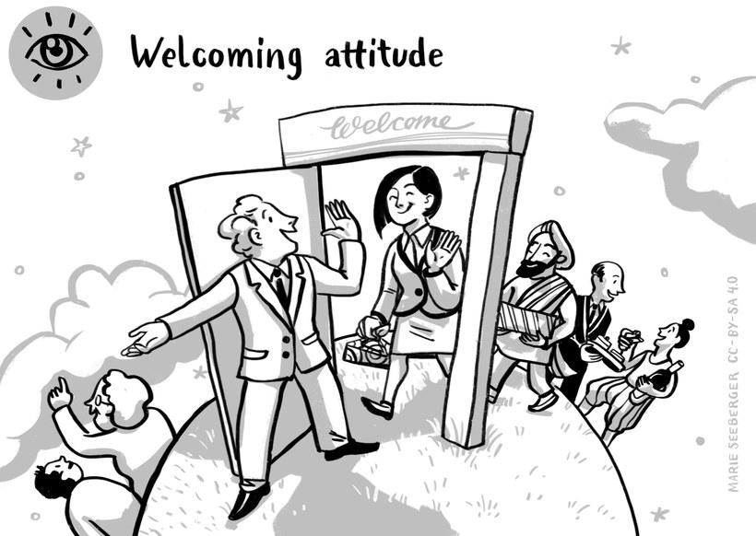

Meaning
People with a Welcoming Attitude like to get to know to and learn from individuals that might have different thoughts or backgrounds compared to their own (e.g. age, gender, educational background, personal interests, professional experiences). They find it interesting to exchange thoughts with people that have very different perspectives. Besides, these people find it well within their comfort zones to take the initiative and approach people that might dress, speak or behave differently than themselves or also speak another language. They also find it fulfilling to help those who join a group or a team and look for orientation.
For members of virtual intercultural teams, a welcoming attitude is especially important as communication and cooperation mainly happen in a virtual environment. In this setting team members rarely or never have the chance to meet in person and are obliged to use technology based communication tools. As important communication channels such as gestures and facial expressions are limited in this environment each team member has to find other ways to show his or her welcoming attitude e.g. through asking, offering support during the start phase, sharing personal information.
The ongoing development of this competence allows virtual teams to integrate new team members very quickly and to develop satisfying and effective work relationships.

Example
Cristina has accepted a new position in an international pharmaceutical company. Today she is very excited as she will meet her new team colleagues in a virtual meeting for the first time. When she enters the meeting room she receives a very warm welcome from her team lead and all team members. All of them have prepared a written personal profile in which they name their professional experiences but also their private interests e.g .hobbies, preferred music styles and book preferences etc. Cristina is happy to hear that two team members share her passion for singing while another colleague loves yoga as she does. Prior to the meeting her team lead Svenja has sent her a “surprise package” she is now allowed to open. Inside Cristina finds some delicious cookies and chocolate bars which all are vegan. She mentioned this preference in the informal part of the job interview but is surprised that Svenja remembered that detail. During the meeting the team members explain their individual responsibilities and current work tasks to Cristina and invite her to ask all questions she might have. In addition to the regular team meetings Cristina will also have regular meetings with her team lead who will explain working and communication processes so that Cristina will quickly come up to speed. After the meeting Cristina is perfectly happy as she feels herself appreciated and welcomed. She is convinced that the cooperation with her new colleagues will work very well.

Activity: Joining a team (1)
Remember your thoughts and feelings when you joined a virtual team for the first time, either in your professional or your private life. What did you do differently in comparison to a personal meeting? How did you behave in this situation and how did your new teammates? Do you also remember some inner hurdles and hesitations you might have had? What helped you to get in contact with your colleagues? What have they done to welcome you as a new team member?
Note down the three main lessons learned from this experience in your learning journal. In addition write a short commentary as to what was helpful in dealing with the situation well and what you would do differently the next time. The strategy you used is a valuable resource to remember when you become part of a new virtual team again or when new members join a team you are already part of.
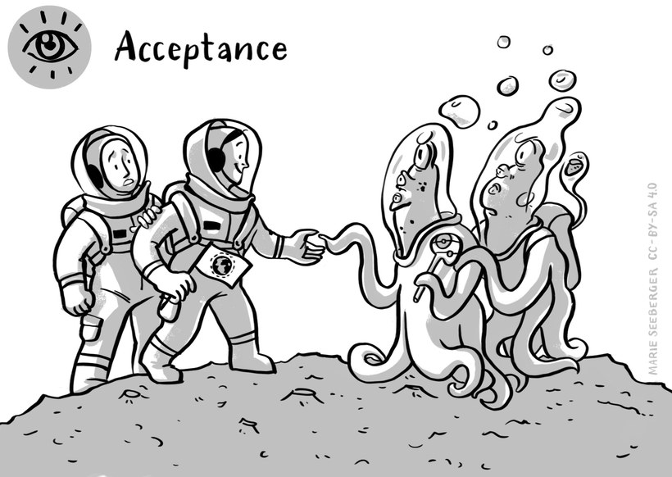

Meaning
In short, to have a high level of Acceptance means to avoid judgments about other people´s behaviours, especially if these do not conform to our expectations. Especially when we work in intercultural virtual teams the chance is high that we encounter behaviour that might be seen as disrespectful from our personal experience and perspective. In this case we need to try to understand the background rather than to judge too quickly. Because a quick judgment can hinder us from understanding other possible reasons behind other people's behaviour, to be open-minded enables us to see the bigger picture. However, Acceptance is about more than tolerance and understanding our counterparts. It is also the awareness that other work practices can expand our own horizon and also increase the team performance.
It does not, however, mean that we need to like or copy any other behaviour from other people. All of us have limits to our level of acceptance, which are often deeply rooted in our value system. There are several ways to deal with these limits in an “accepting” way. As mentioned, we can see them as an opportunity to learn and grow from them. Another way may be to tolerate these differences. That means, if a behaviour or concept might be very difficult for us to accept, it could also be a viable strategy to try avoid the confrontation and to withhold our judgement. The prerequisite of acceptance is to respect an approach that differs from my own.

Example
Brian is used to start his working day very early, usually at 7am. Weekly team meetings with his colleagues from other branches are scheduled at 8:30am. Two months ago two new team members have been hired. Both of them joined the team meeting several times too late and Brian is increasingly getting upset about this behaviour. Why are his colleagues so impolite? Why do they let the whole team wait for them? Don´t they know that it is a waste of time for their colleagues? Do they even care about that?
Brian decides to discuss this issue with his team lead Linda. She fully understands his anger but also explains that both of his new colleagues have good reasons for their behaviour: Marcus has to drive his two children to school. Classes start at 8am making it very difficult for Marcus to join the team meetings in time. Marisa is a “late bird”, she loves to work late at night so it really is a challenge for her to get up early in the morning. Linda also refers to the fact that both Linda and Marcus are still available for customer requests in the late afternoon when the rest of team has already left the office. Thus Linda could extend the service times of the team by two hours.
After the conversation Brian knows more about the motivation behind the behaviour of his colleagues. He, too, would have good reasons for joining the team meetings later or not at all at times but decided make the meetings a priority. It is difficult for him to accept but he decides to deal with it.

Activity: Dealing with irritating behaviour
If you think about your experiences in a virtual team: Which behaviour of one of your colleagues did you perceive as impolite, rude, disturbing or annoying? Which thoughts and strategies have helped you to overcome your negative emotions? Reach out to a friend or a colleague and ask them how they cope with a behaviour they cannot understand at all.
Note your answers in your learning journal.
***


Another set of competences is linked to Communication and thus the ability to absorb, share and understand information considering the sender’s perspective and respond in a way that is comprehensible from the receiver’s point of view. In short, it is the ability to communicate in a way that minimizes the potential for misunderstandings. It is thus not surprising that ensuring the Co-construction of Meaning is an important aspect in this context. Being able to establish and maintain trust by Exposing Positive Intentions is another valuable trait to support the development of a common ground. Knowing about different communication styles and interpretations and usage of non-verbal signals is the basis for the ability to be receptive to Communication Styles and Non-verbal Signs. Such an ability greatly supports understanding and the co-creation of meaning.
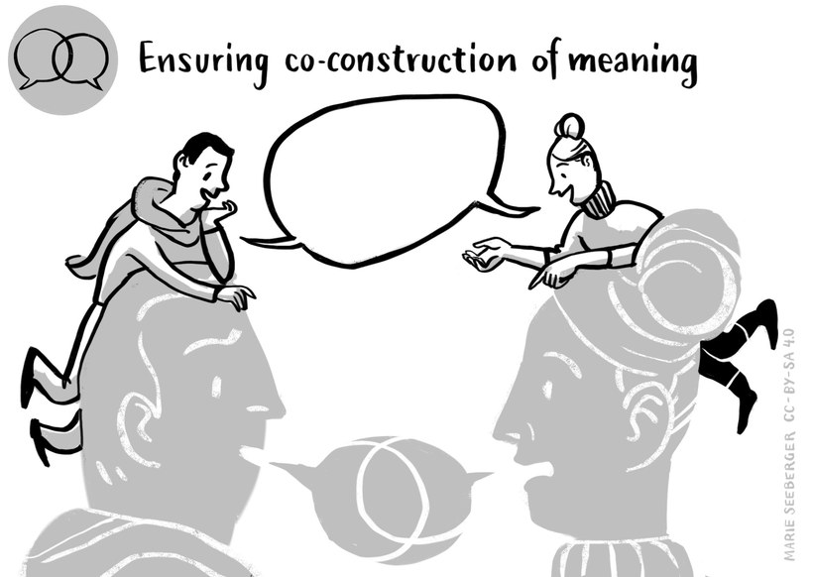

Meaning
Patterns of meaning and interpretations at times collide in intercultural situations because very often we use terms which mean different things to different people. This especially applies to VITeams as team members often have a different functional knowledge due to their professional qualifications or speak different languages which might also include a different understanding of the concept of a specific term. Also new team members regularly have to learn the professional and technical language of their teams as well as the technical terms that are relevant for their work.
As a consequence, all team members should be confident in Co-construction of Meaning and place emphasis on communicating and dialoguing with all people involved. They make sure that everyone involved has an understanding of how something is meant. The process behind this may or may not lead to the generation of a common meaning for a specific term or concept. Most important is that all people involved have a thorough understanding of how something is understood by a person.

Example
Li-Ming is a research manager in an international consulting company. She has just finished a 1to1 with Carlos, a new hired research specialist. Carlos has told her that he really was confused after having read the agenda for the next (and his first) team meeting. So Li-Ming re-reads the agenda trying to assume the perspective of a new team member:
- Top 1 Welcome round for Carlos
- Top 2 Reports from CRM, F&A, BPS
- Top 3 List of new WBS
- Top 4 Postings in the KM db
- Top 5 New global responsibilities in Industries + SL after "RapidChange 5.0"
Now she can clearly understand Carlos confusion about the technical language and the abbreviations used in the meeting invitation. She decides to put the following measures in place in order to facilitate the initial training period of new hired team members:
Her team will create a glossary explaining the most important abbreviations and technical terms.
Li-Ming will prepare a global organisation chart showing the most important contact persons for her team.
For every new team member, she will nominate a personal mentor who will closely work with his or her mentee and answer all upcoming questions during the orientation phase.

Activity: Joining a team (2)
If you think back on a situation when you joined a (virtual) team in your professional or private life: What was important for you in order to quickly become acquainted with colleagues, responsibilities, working processes etc.? What might have confused you?
In the light of your personal experiences: What do you think should be done if new colleagues will enter a team you are already part of? What could you do yourself? Note down your ideas in your learning journal.
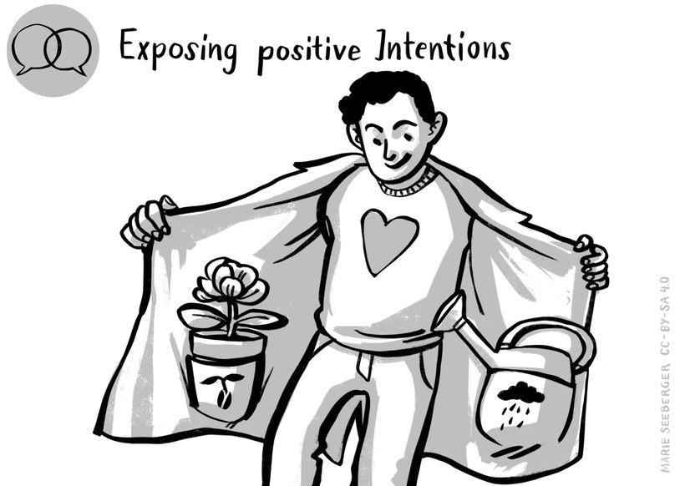

Meaning
Having an open mind when working with people of different backgrounds and perspectives is not always enough. To know how to Expose our Positive Intentions means that you are also able to deliver this attitude in a way that it is being understood by your colleagues. Team members with this competency know how to deliver their message in a clear and transparent context, but also consider the communicative needs of their counterparts. It especially means to be clear about your intentions, wishes and expectations, and that you are sure to display your position in a constructive and non-threatening way.

Example
Zamil has a new colleague who just joined his marketing team some weeks ago. Unfortunately, Zamil sees that his new colleague has not been meeting any of the set deadlines so far. Also, whenever she finally sends the information needed, Zamil sees that it often is not the data they agreed on to be delivered. The next time they meet, Zamil makes an extra effort to small-talk with her, using phatic expressions to ensure that a personal bridge is developing between them. He transparently highlights his needs but also emphasizes his offer for support and their common goals for the project.
His colleague is now clear about what Zamil needs from her and does not feel threatened by his feedback.

Activity: Dealing with a touchy topic
Write down in your learning journal the conversation Zamil might have had with his colleague (only Zamil's part). What could Zamil have said (quote!) to express his positive intentions? Note down the beginning of the conversation, and how he cultivates the relationship. Also write down how he approaches the touchy topic by showing his positive intentions.
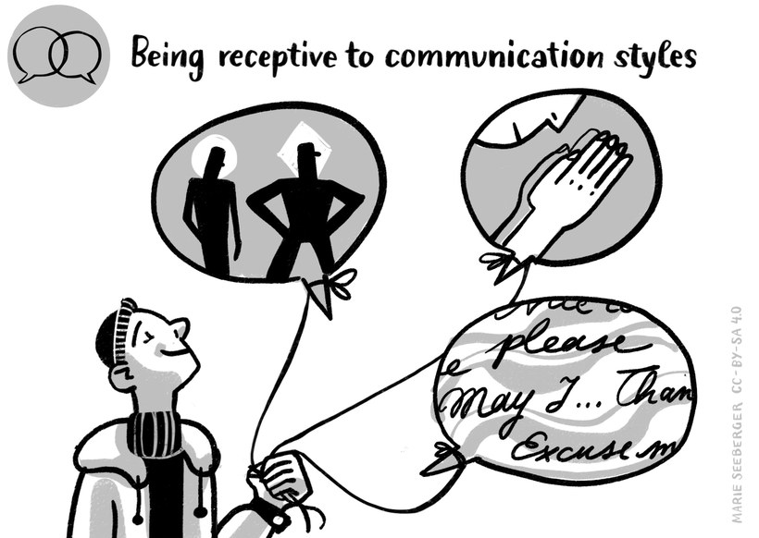

Meaning
While Exposing Positive Intentions enables us to make ourselves understood in a way that displays our open-mindedness, Being Receptive means that we are also open to the communication needs of our team colleagues. It means we not only have an open mind but also know how to transport this attitude to our communication partners. We know which questions to ask in order to display that we do not seek to convince, but rather to understand our counterparts. We are sensitive to possible signs, for example, body language and mimics, and can correctly understand the intentions in high- or low-context messages. This might be a challenge in virtual teams as the communication is mainly limited to phone call, chats and web conferences. In this environment we have to be very attentive and mindful in order to react to verbal or nonverbal signs adequately and appreciative.

Example
Today Julie hosts the weekly online meeting of her team. In the course of their lively discussions she observes that Marcus, one of her team members behaves slightly different than in other meetings: Usually he is very engaged in every discussion. Today he explains his thoughts about various topics but his intonation seems to be a bit flat. From time to time he closes his eyes, his face is pale. Julie is not sure how she should interpret her observations. So after the meeting she calls Marcus, shares her observations with him and asks if everything is alright. Marcus is quite surprised that she has noticed these small differences in his behaviour. He then tells her that his wife and his daughter are ill so that he hadn´t slept the night before. Julie spontaneously offers him a couple of days off so that he will be able to take care of his family and to take over some of his projects in this time. Marcus is really grateful for this offer.

Activity: The interaction between the team lead and the employees
YouTube video by Simon Sinek: 'How Teams Can Meaningfully Connect Remotely',
URL: https://www.youtube.com/watch?v=tKEtm3HCrsw
Please watch this YouTube, starting from minute 2:15 until you reach minute 8:15, and have a look at the interaction between the team lead and the employees. When doing so, pay particular attention to the non- and para-verbal communication of all participants. Choose four spots or situations and analyse and interpret them from the perspective of the team lead. It may be helpful to either describe them or take a screen shot to indicate which one you are referring to.
In a second step think about how you, as a team lead, would react to accommodate the needs of your team members.
Which of the ideas present in the video would help your team to communicate better? Choose two ideas and argue why you would be ready to integrate them into your teamwork.
Put your answers in the learning journal.
***
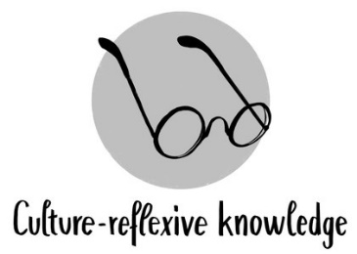
The next set of competences considered in this session relate to a Culture-reflexive Knowledge. This encompasses more than referring to knowledge such as “this is how things are being done around here”. Reflexive knowledge is knowledge based on conscious reflection and reasoning. It follows the rules of rationality and the knowledge that there is more than one way of doing things right. Reflexivity is thus understood as the ability to step outside one’s own frame of reference and enhancing one’s understanding of reality through the eyes of the communicators and thus in their own terms.
Developing culture-reflective knowledge thus requires the ability to Reflect Perspectives which refers to the ability of viewing things from different points of views and to consider issues in their relations, interdependencies and relative importance.
Another important aspect of culture-reflexive knowledge refers to being Sensitive to Context. This entails to acknowledge that context has an important influence on an interaction. And that an interaction not only takes place in a specific physical context (e.g. online, office, at the doctor) and is thus influenced by environmental conditions but that the people themselves are enmeshed in a personal context (e.g. strict order from their superior, organizational culture, immediate social context) which guides their encounters.
The last aspect to be considered is the Awareness of Global Social Positioning. This refers to given asymmetries in encounters as it is important to acknowledge that there is a limit to changing perspectives. This is so because there are experiences we cannot share and perspectives we cannot take. For example, a “White” person can hardly anticipate how a Person of Colour (PoC) experiences a world where whiteness is the privilege. A person able to walk will not have the same perspective on side-walks and footbridges as someone who is reliant on a wheelchair in a world of pedestrians with two healthy legs. We therefore are required to meet the continuous challenge of balancing different approaches to the world and to overcoming the dominance of selective perspectives.
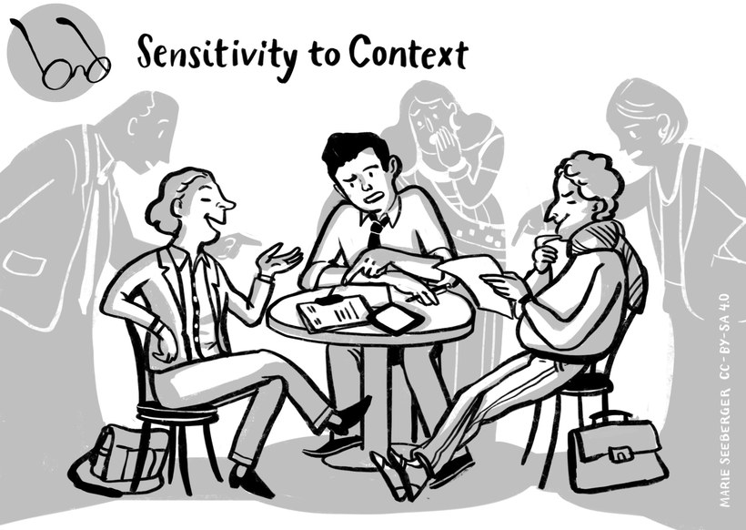

Meaning
We all have a tendency to overemphasize personal characteristics when judging a person's behaviour and ignore situational factors. In social psychology this is called "fundamental attribution error". People who are Sensitive to Context place emphasis on inquiring, sensing and understanding the influence the context has on the interaction and the communication. The overall context relates to the environment, the setting and the location in which an interaction takes place or communication is practiced. Sensitivity to context also includes considering the immediate context of the people involved. This can include the organizational context they are in, social rules and mutual expectations that guide communication, interdependencies in relationships as well as aspects referring to the interpersonal history and type of relationship which exists between the people involved (so the counterpart is the basis for the reaction). Other contexts can be the emotional and mental well-being, a region, things that just happened shortly before the incident etc. People sensitive to contexts are able to sense possible expectations of language and behaviour related to the overall and personal environment.
Trying to see this perspective can prevent us from becoming agitated, and thus start a negative communication circle. It also keeps us from feeling disrespected or frustrated based on the reasons of misunderstanding.

Example
Luis is part of a virtual software development team which he feels really pleasant to work with. However, more recently he noticed that Raoul, his Portuguese team member, appears to be absent minded, stressed out and at times joins their meetings ill prepared. Luis decides to pick up the phone and enquire about Raoul and his situation. He learns that Raoul’s father in law is hospitalised and that Raoul’s wife is needed to take care of him because her father finds it difficult to cope with the situation in hospital. As the hospital is some 200 kms away from their home, his wife left him to take care of their 5-year-old twins. As a consequence, Raoul tries to work from home but finds it difficult to concentrate and on top has to juggle work, the care for his children and the household. Luis is glad he phoned and quickly feels his anger vanishing. Knowing about the circumstances and the context in which Raoul works makes it a lot easier for him to be empathic and they both agree that Raoul should mention his current situation in their next meeting so that, as a team, they can try and find a way of supporting him.

Activity: Contextual issues
Think about one person you worked with recently and draw an image of that person indicating the many contexts he or she may be involved in. Do the same for yourself and think about your own contextual issues and how they influence your work day and work processes. Note down three examples of how your contextual issues influence your work and how context is likely to influence your co-worker or team members.
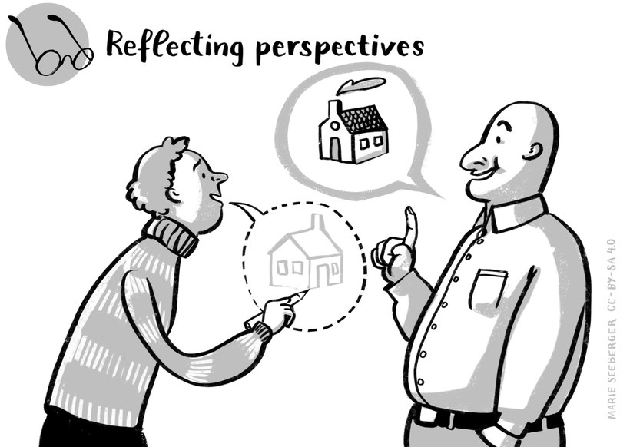

Meaning
The competence of Reflecting Perspectives is essential in a virtual diverse media mediated working and life world. Hardly any perspective is from the same position as team members find themselves in totally different situations. Here are some examples:
A father of two toddlers in the home office relies on special hours for the team meetings so that he can participate. He thus considers meeting hours through this perspective.
A colleague in Delhi working with a European team is the only one in a different time zone than European standard time where most of the team members orient to. Also, she is the only native speaker of English. However, she was never outside of India and no one from the team members have ever been to India or know enough about the diversity of languages and cultures.
How does a situation look from the perspective of a person who needs hearing aid and devices in online and present meetings?
How is virtual work for someone who prefers to meet in person to the ones who love to use technical devices? Many examples and perspectives could be added.
Take any situation, we never have the whole picture, we only have one or some perspectives that we understand as the whole view. Acknowledging this and reflecting our perspectives on purpose we raise our awareness that there are more approaches than those that we might have in mind, and that there is not just one “truth” and reality. Reflecting perspectives means keeping in mind different cultural orientations and values but also numerous other perspectives at times difficult to anticipate.
A team leader as well as team members need to anticipate the others’ potential perspective and plan for how they might receive information and react to how content is delivered. A culturally competent team leader and member would consider language, gender, culture, and a multitude of other factors. Reflecting perspectives is a critical competency to master in general but particularly in virtual settings due to the missing non-verbal cues many depend on for deciphering a message.

Example
Pablo recently participated in a workshop to improve communication in virtual teams. The workshop started with two examples of e-mails and Pablo was asked to analyse them considering the four-side model by Schulz von Thun. This model is based on the assumption that every message contains content and relational facets as well as a request and it also reveals something about the person who sends the message.
This meant Pablo was asked to analyse the mails considering
- the content or actual facts conveyed,
- what the message may reveal about the relationship between the sender and the receiver,
- what the message may say about the sender, and
- what the sender wants the receiver to do.
The two e-mails read as follows:
E-mail 1:
Minutes of meeting required by tomorrow morning, thanks Dave
E-mail 2:
Dear Roberto,
How did you perceive the meeting? Sorry it took so long and I knew that you were aiming at heading home real early. How is your cold, any better? Following up on the meeting, I am wondering whether you could possibly send me the minutes by tomorrow so that I can distribute them among participants?
Best regards, Madeira
Comparing the two e-mails it kind of hit Pablo that he actually has a tendency to write short and very factual oriented e-mails and that in doing so he may not show any of the appreciation he has for his team members. He is especially thinking of his two team members who always write elaborate mails inquiring about him and his family and that they may perceive the relationship with him as very distant and may be even cold. He also thinks that his e-mails may reveal and be perceived as if he has no interest in his team on a personal level.
During his next social call with his team members Pablo told them about the workshop and his findings. He happily took note of the fact that his thinking was right about his two team members who empathically nodded during his speech. He was also surprised how his disclosures positively influenced and helped to improve team spirits and relationships showing the positive influence of reflecting perspectives can have.

Activity: Changing perspectives
The next time you have an important message for your team members, carry out the following exercise.
Ask yourself: What is it I want to convey?
- in terms of information and factual issues (factual level)
- with regard to the relationship with those who are going to listen to me (relationship level)
- with regard to myself, e.g. that I am stressed (self-revealing level), and
- with regard to what I want them to do (appeal level)
In a second step put yourself into the shoes of a team member and think about how he/she may perceive the message content.
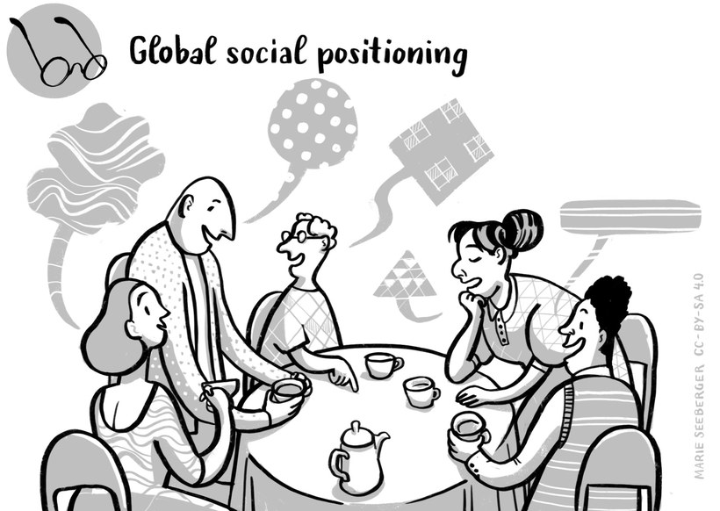

Meaning
Persons who are aware of Global Social Positioning take macro influences of an encounter into consideration and incorporate pre-distributed privileges. Whenever people meet there is one thing we have in common: we are all human beings with own dignity, but there is diversity in the way that societies and cultures judge the value of attributes like gender, age, physical abilities, religion or spiritual beliefs or any worldview, wealth, educational background, sexual orientation, parental status , language skills and many more factors. These judgments have huge influences regarding our chances in life. Some differences are not only prejudged by most societies, also living conditions are oriented towards a specific normality that discriminate or excludes variances. Hence, pre-distributed privileges and chances for career and success in life are a result. Keeping this in mind, we might be easier able to accept a perspective we do not share and balance powerful differences. It is a practice to deconstruct power asymmetries and acknowledge collective experiences like living in a diaspora.

Example
Diane, a UK citizen, worked as a development consultant and had recently joined a project team involving experts from different parts of the world. The team members were quite diverse in terms of gender, work experience, level of international expertise and country of origins. It was decided to have a four-day kick-off conference in Kenia to facilitate traveling for participants from East Africa. Everybody was excited to meet face-to-face for the first time. By the early evening, everybody had arrived and the whole group enjoyed their dinner. After a pleasant meal, Diana decided to go to the meeting room, write the flipcharts, have the agenda printed out and have everything set for their meeting the next morning. When she looked outside of the window, she saw a minivan pulling up at the hotel entrance and a happy crowd waiting to be taken to town. It was then that she recalled hearing conference participants talking about the need to leave the conference venue in order to explore and enjoy the evening in town. And here they were happily chatting along and hopping on the minivan. Nobody had asked her to join them and Diane felt a disappointment creeping in on her. Why was she left out? Didn’t she organise all this so that they could become a team? Was it because she was from the Global North and the others from the Global South? She decided to let go for the time being but on the second day proposed to discuss the topic of global hierarchies and how these may impact their team work. She was surprised about the comments made. A Namibian participant complained about the lack of transparency of project funding and suspected that this was due to the vast and unfair difference in daily allowances Diane coming from the UK and the rest of the team coming from different countries in Africa received. The point a participant from South Africa made was linked to what she perceived as ‘knowledge hierarchy’. She described this as a practice employed by Diane to have everything prepared, the agenda but also the content to be discussed with the result that there was little opportunity for the rest of the group to contribute substantially. She complained that they were not being involved right from the start although Diane repeatedly said that she wants them to develop into a team. Diane was baffled to realise how much the global North/South divide influenced their perception and interpretation of what was happening and was glad to have brought up the issue. That night they all went to town, explored the local bars and encouraged each other to be more open in their communication and also in revealing their perceptions.
Brian (Mongolian, homosexual) studies International Management, a Master program where his fellow students come from many different countries. Together with Marie, Debbie and Marcus he works on a paper addressing issues of diversity and its impact on management. One day, Marie listens in to a conversation among other class mates about Brian being homosexual. Marie realises that she knows very little about homosexuality itself, how it influences one's life being around a majority who has the support of a dominant sexual culture nor is she sure about how to approach the issue and how to talk about it. But listening to the rather stereotypical comments of her class mates she also feels the urge to ask Brian about his sexual orientation, how he would position himself and try to capture the world from his position. After listening to him and how being homosexual influences his life and affects his studies they decide that it would be beneficial to make homosexuality a topic in their paper on diversity and management.

Activity: Privileges
Have a look at the following checklist (see link below) that lists over 130 privileges.
Choose three categories and put a cross on each sentence that you can confirm.
URL: https://sites.google.com/a/u.boisestate.edu/social-justice-training/about-us/our-training/
privilege-checklist
Put the answer to the following questions in your learning journal.
- How many privileges do you have? How does it make you feel?
- Name one disadvantage you face yourself. How do you handle it? Give an example.
- How do you handle disadvantages of others? Give two specific examples
***

Negotiating Culture refers to the understanding that culture is being created and that a VITeam needs to develop an e-culture in order to establish a work environment and work routines which are being appreciated by all team members and are conducive to the work atmosphere and outcome. A negotiated culture is a reciprocally and collectively formed team culture that develops out of a communication process and interaction involving all team members.
This means that a team – especially when being established – starts working together without knowing and being clear about how its members are going to work together from its onset. This is a very unsettling situation for many as it requires the ability to work in an environment where things are not clear cut, to acknowledge that different interpretations of what should be done and how things should be done are possible and need to be addressed. Often, even the outcome of such a team work can best be described as a vision rather than a clearly defined project aim. In such team constellations the aim is continuously being developed and refined as part of the work process – especially in the beginning or when team members leave or new members join. This requires a readiness and ability to accept complexity not only of tasks but of human interactions without seeking simplistic solutions. To be able to deal with ill-defined nature of issues, uncertainties and the readiness to deal with rapid changes is a competence generally referred to as a tolerance of ambiguity.
Teams who embark on such an open ended journey have a high potential to produce outstanding results, adjust to changing demands, be innovative where needed and to grow as a team and personally. They believe that in order to thrive in our turbulent and ever changing world, we need to be flexible and develop a new way of thinking. However, such teams need to be ready to make mistakes, at times make detours or delay work processes as a normal part of work whose end result is not predetermined and can best be termed a vision. Being Resilient – understood as being able to bounce back, being ready to get back on one’s feet and to rethink approaches and processes – is thus a competence required in such team settings.
Appreciating the benefits of diversity contributes to more flexibility, supports the readiness to seek and find Options for Actions, be on the alert that things can be done in different ways and that these ways may be better able to achieve a good outcome. This is the basis for Synergies to emerge as well as for enabling them to develop, which can be understood as the collective performance yielding better and higher results than an effort which is solely based on the sum of the individual performances.
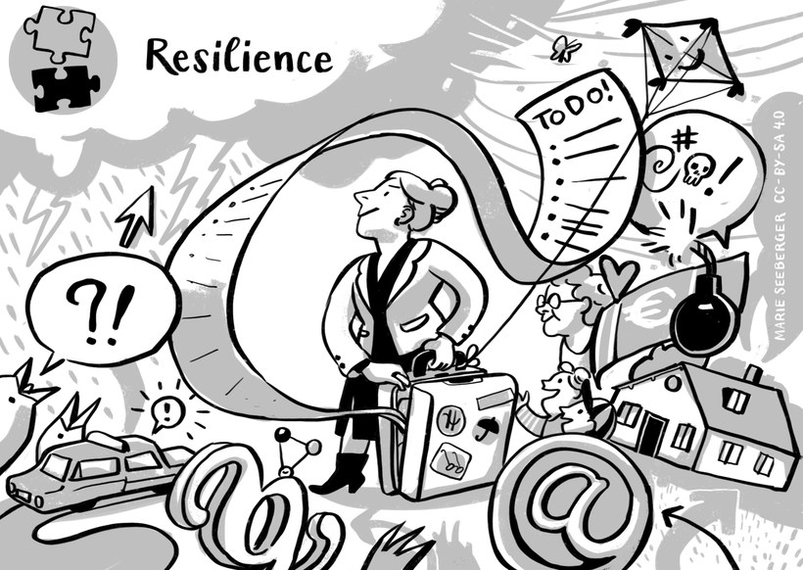

Meaning
The original meaning of Resilience refers to the ability of material such as rubber to spring back to its original shape after deformation. In our changing world the term is generally used for the ability and quality that enable people who have been knocked down by adversities, suffer from set-backs or negative emotions to recover, adapt to the challenging circumstances and to bounce back being as strong as before and at time even stronger. Rather than letting issues and problems overcome you, high resilient people find a way to change course and continue moving forward towards their goals and learn that making mistakes is fine as long as they take them as a way of learning and personal development.

Example
Elisabeth is in charge of task coordination and disappointed because two members of their team are not well prepared for the meeting. Because this happened before, she lets go of her frustration. The team decides to adjourn the meeting in order for the two to catch up. Elisabeth airs her view that she is upset because her time is not being respected but at the same time wants a constructive solution to the issue. By voicing the issue in a friendly manner, Elisabeth makes herself understood. She is glad that the ill-prepared team members not only acknowledge her view but show appreciation of the team being flexible enough to allow them to catch up. Looking back at it she strongly feels that this incidence strengthened their team identity and the mutual adjustment highlights their resilience as a team.

Activity: Reflecting on positive and negative experiences
Positive emotions can apparently help you strengthen your resilience. For the next couple of days carry out the following activity:
In the evening, before calling it a day, sit down and note down three good things you encountered during the day. Think about one experience which dragged you down or upset you and write it down as well. Note how you felt and the frustration which went along with it. But rather than focusing on the frustrations, think about two things which could also be interpreted as positive. What was a good thing about the experience?
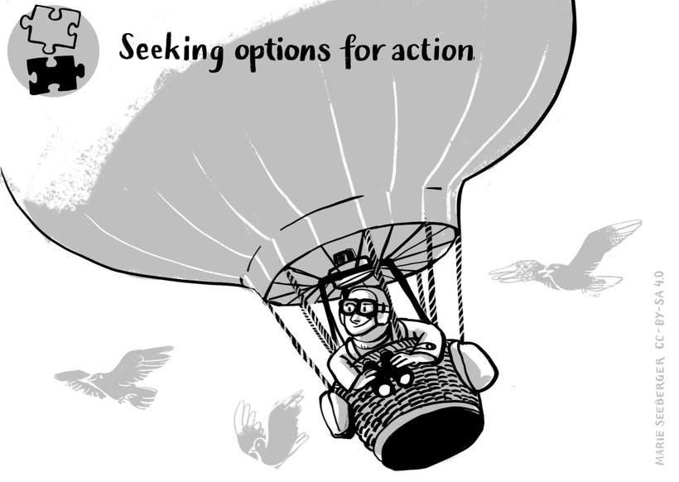

Meaning
Instead of dwelling on issues and their negative impacts, on one’s mood or frustrations, seeking options for action refers to an attitude of accepting unsettling and at times also ambiguous situations as a normal part of working life. It also refers to a general openness towards diversity and the ability to see diversity as a benefit and potential strength of a team. Diversity in this respect also includes diversity of tools, touch points, communication situations and the like Thus seeking for alternative options refers to the readiness of accepting variety, change and stimulation.

Example
Hülya recently started to work for an organisation specialised in providing psycho-social-support in a home for refugees. During the Corona pandemic some of her colleagues from a team of about thirty members had to suddenly work from home (for health reasons) or in shifts which caused some major challenges. The technical situation was difficult as only some were equipped with official mobiles and computers and cameras were in short supply. This made hybrid team meetings were difficult to conduct. As a consequence, communication flow within the team dwindled and was reduced more and more.
Hülya more or less only talked to her mentor at the beginning of her work. And it was the same with the residents she was expected to take care of. How could she get in touch with her clients who came from all over the world and were now confined to stay inside their rooms following contact and hygiene rules. How could she build up a personal relationship as no one knew her? And she surely had other expectations with regard to her on-boarding into her new job.
Finally, Hülya encouraged herself to ask some of the (mostly unknown) team members to meet with her (some virtually / some in person) to get advice. Also a collaborative whiteboard as well as a flipchart paper were installed with her questions to the team so that all could note down their tips. Her colleagues brainstormed and came up with many brilliant ideas for Hülya. These included the use of bulletins with pictures and easy language which were translated in many languages. They contained information about the task and service and where and when to find her. They motivated Hülya to bring along sweets as presents for the kids when meeting them for the first time. Another idea was to play different types of music outside of the home to get attention and wait for visitors to come by and talk to her.
She decided to use many of the ideas and included a playlist in her bulletin with the hours of music to be played from around the world. Her mentor introduced her to one of the networking persons in the group of residents and bit by bit she made contacts, established relationships and could start her important psycho-social support work for the refugees.

Activity: Developing the communication flow within the team
As Hülya suffers from the missing communication flow in the team she decides to think about collecting ideas for fostering the team's communication flow. Put yourself in the shoes of Hülya. What would you think of in a context in which people have no or very limited opportunities to meet face to face and a not enough technical device to strengthen the communication flow? Note down your ideas in your learning journal.
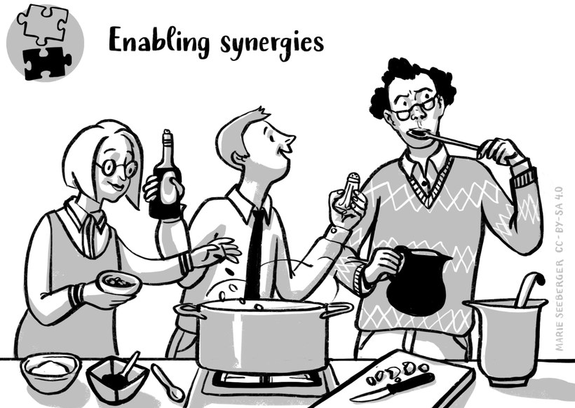

Meaning
A wonderful image of synergy can be found in nature watching the migration of geese. They get together and fly in a V-shape formation in order to minimise wind resistance for the birds following. When the bird in front gets tired, another one takes the lead. Together they can fly a lot further using less energy than they would if each of them would fly on its own. Even more so in case a goose would fly on its own trying to cover the distance, it is doomed to fail.
Enabling synergies requires to be sensitive to the needs of the team, to ensure that different perspectives are actively thought for well, understood and used in problem solving situations. It is the belief that a team works at its best when is acting together and trust that joint or coordinated effort achieve a greater impact and efficiency than each team member working on his or her own. In such environment ideas can spring up and solutions can be found which hitherto were not thinkable.
Sources of synergies often revolve around cost savings for example through access to new researches and developments which allow for an advancement in production, or software teams that yield cost savings. More generally speaking enabling synergies relates to the combined effort and action when different individuals team up and collaborate in developing new solutions that improve the result by sharing of perceptions, insights and knowledge. Enabling synergies is a complex task and not easy but worth the effort as it is the basis for teams to outperform and develop a high team satisfaction.

Example
One way of enabling synergy effects is by complementing talents and expertise as is often expected from project teams. The Blundy team is an example. Whereas Yuki is very strong in engineering and manufacturing, she finds it difficult to communicate. Olusio however is very good at internal as well as external communication and Pete is being appreciated for his strength in finance. To complement their project team, they are looking for a member bringing in expertise in marketing and advertising.
Timo and his team are an example where synergies came into being due to cognitive stimulation. Timo was more the person thinking that working on his own saves time and effort to liaise with others, explain oneself as well as dealing with team related issues. But when he was offered a new job as a business consultant one of the precondition was to work in a virtual interdisciplinary team. Thinking back at the achievements they made in their virtual team he was glad that he got passed himself and able to view the opportunities available in his team. Right from the onset, he felt welcomed and his views and knowledge being appreciated. He started to trust his team members and felt confident to rely on others. But most importantly he realised that they were able to benefit from the diverse knowledge and experiences as well as their different characteristics. While Pierre was the one who brought in ideas and proved to be very spontaneous implementing them, Timo realised that he was truly trained to be very particular, collecting a lot of information before making a proposal and engaged in deep thinking before putting an idea forward to their client. Aruba, was quite different again and very strong at considering different perspectives and the pros and cons of different approaches. Because they got on really well and all eager to achieve a good result, they were not only able to provide an expert advice which fitted their clients’ situation but also level headed and innovative.

Activity: Synergies through differences
Go back to the exercise of the common triangle in session 5, section 5.5 (Creating mutuality in intercultural and interdisciplinary virtual teams). Choose two areas where you detected differences. Looking back at these, which potentials for synergies do they entail and how could synergies look like? Note down the results in your learning journal.
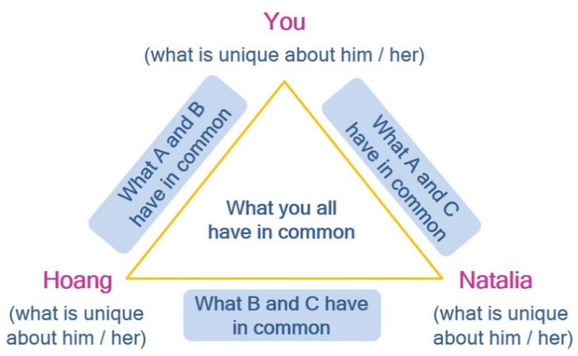

8.5 ...and the journey continues
Virtual teamwork provides many advantages for companies as well as employees. It offers the opportunity of working together regardless of location, allows for flexible work arrangements and companies benefit because they can access talents and experts from around the globe as well as benefitting from time differences to name but a few. And VITeams offer the chance and opportunities to enable synergies and thus find novel solutions to issues, develop products and thus benefiting from diversity.

Task: Benefits of virtual teamwork
What are the advantages and benefits some people working in VITeams mentioned you haven’t thought of before? To answer this question watch the following video clip on the advantages and benefits of virtual team work.
But in order to benefit from VITeams, companies as well as employees need to realise and accept that virtual teamwork requires a thorough understandings of collaborative work and a complimentary set of knowledge and skills as well as awareness and attitude. These dimensions are intertwined and can be captured in a set of competences linked to openness, communication, culture-reflexive knowledge and negotiating culture. Whereas some of the competences needed may be easier to develop, other may require more effort and time. Generally speaking, it can be argued that competence development is a lifelong process. At times it may even feel as if we are stagnating but then there will be moments of new challenges opening new opportunities to enhance our competences. Language proficiency may serve as an example. Using English as a lingua franca when working in VITeams is common but if it is not our mother language, we rarely attain complete and native –like fluency. This also means that there is always potential to learn and even more so with team members joining who bring along e.g. US-American English vocabulary, pronunciations common in India or accents typical for French second speakers.
Developing virtual intercultural competences and continue to do so offer the opportunity to transcend the limitations of our own world and world view, to change perspectives and appreciate commonalities and diversity alike. And it offers the opportunity to enable synergies. But for all of this to happen we need to accept that such a development takes place over time and requires a process of ongoing interaction and reflection. This is why the development of intercultural competence is often visualised through a spiral as the illustration below indicates:
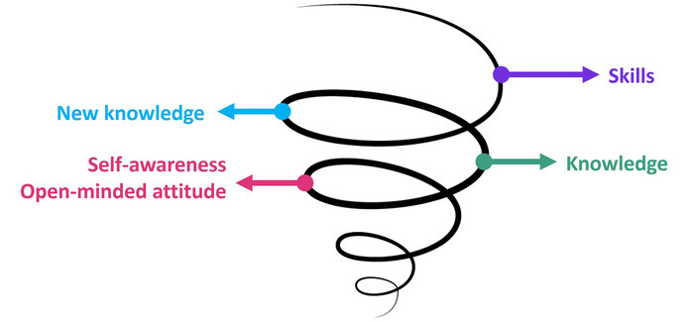
Figure: Development of intercultural competence
Diagram developed by Thu Phong Vuong for this course
Intercultural competence also necessitates us to accept that if we manage one situation well this is not an assurance that the next situation will equally be dealt with adequately well. This is why we can speak about a process of maturity a continuous journey which, if we stay open-minded and ready to learn is a fascinating and personal enriching one for all.

8.6 Sources, further reading and web links

Sources
- Arasaratnam, L. A. (2016). Intercultural Competence. Oxford Research Encylopedias: https://doi.org/10.1093/acrefore/9780190228613.013.68 (accessed on 16.4.2021).
- Bertelsmann Stiftung und Fondzione Cariplo (2008). Intercultural competence – the key competence in the 21st century?
https://www.ngobg.info/bg/documents/49/726bertelsmanninterculturalcompetences.pdf (accessed on 16.4.2021).
- Deardorff, D. (2020). Manual for developing intercultural competence: story circles. (UNESCO, Ed.) Routledge: London.
https://unesdoc.unesco.org/ark:/48223/pf0000370336 (accessed on 16.4.2021).
- Degbey, W. Y., & Einola, K. (2020). Resilience in virtual teams: developing the capacity to bounce back. Applied Psychology: An International Review, 69 (4), pp. 1301-1337. https://iaap-journals.onlinelibrary.wiley.com/doi/epdf/10.1111/apps.12220 (paid article, accessed on 16.4.2021)
- Fantini, A. E. (2000). A central concern: developing intercultural competence. https://agustinazubair.files.wordpress.com/2013/04/6-developing-intercultural-competence1.pdf (accessed on 16.4.2021).
- Ferreira-Lopes, L., Bezanilla, M. J., & Elexpuru, I. (2018). Integrating intercultural competence development into the curriculum through telecollaboration. A task sequence proposal for higher education. Revista de Educación a Distancia, 58 (7).
https://www.um.es/ead/red/58/ferreira_et_al.pdf
- Schulze, J., & Krumm, S. (2017). The "virtual team player": a review and initial model of knowledge, skills, abilities, and other characteristics for virtal collaboration. Organizational Psychology Review, 7 (1), pp. 66-95.
- Spitzberg, B. H., & Chagnon, G. (2009). Conceptualizing intercultural competence. In D. K. Deardorff (Ed.), The SAGE Handbook of Intercultural Competence (pp. 2-52). Thousand Oaks: SAGE.
- Wang, Y., & Haggerty, N. (2009). Knowledge transfer in virtual settings: the role of individual virtual competency. Information Systems, 19 (6), pp. 571-593.

Weblinks
- Theresa Sigillito Hollema – Building cultural competence across globally distributed teams
https://www.youtube.com/watch?v=8xt0zhaDVV0

