Intercultural Communication

Welcome to our online self-learning course version 2.0. It is a self-learning course which will continue to grow, develop and change. We may, for example, include other case studies and material. This is why we understand our work as a 'work in progress'.
For those, who want to use the material or part of it in their teaching and training sessions and are looking for didactical information and additional tasks and case studies, we have developed a Trainer Manual which can be accessed here:
https://glocal-campus.org/course/view.php?id=22
With increasing global and local diversity, having the skills and expertise to communicate effectively and appropriately across cultures is key. In fact, it is an important competence that is required in a range of professional, social and work contexts. Improving your expertise, experience and skills in this area will therefore not only help you in your everyday life but also in your job search and career development.
With this in mind, we would like to welcome you to our online course ‘Intercultural communication’. This course will help you identify and analyse key challenges of working in intercultural contexts and develop professional as well as social competencies to support and enable a high level of performance and work satisfaction. In a nutshell, the objective of this course is to enhance your intercultural competencies so that you can work competently in a range of diverse social and work environments.
The following video will highlight the key elements of the course:
Video introduction: intercultural communication, https://www.podcampus.de/nodes/RYONW/

Copyrights
We are committed to providing higher vocational education based on scientific evidence free of charge. It is our strong belief that contributing to providing equal opportunities of education will help us all to grow and learn to interact as global citizens.
Therefore the content of this online course is, unless stated otherwise, licensed under a Creative Commons Attribution-ShareAlike 4.0 International license (CC BY-SA), which means that it is freely available for anyone to use, adapt and share as long as the author collective is being credited and any derivative works are shared under the same terms.
Please credit the author collective as follows:
Bolten, Jürgen / Iken, Adelheid / Nazarkiewicz, Kirsten / Voigt, Andrea / Vuong, Thu Phong / Yildirim-Krannig, Yeliz (2023): EduBox – Intercultural Communication – Online Modules (Version 2.0. Hamburg Open Online University HOOU). Glocal Campus Jena, https://glocal-campus.org
Copyright information on images / graphics / videos can be found directly with the images or videos.

Content

1. Towards a dynamic and multi-faceted approach to understanding culture 1
1.1 Prelude 2
Task: Case "On the way to the cafeteria" 2
Task: Case "Exchanging business cards” 3
Task: Case "Being a good student" 4
1.2 Introduction 5
1.3 A narrow and an expanded concept of culture 5
1.4 An open versus closed concept of culture 6
Task: Being efficient 7
Task: Case "Where do you come from?" 8
Task: Find your own example 9
Task: The "Fridays for Future" movement 12
1.5 Summary 13
1.6 Learning review 13
Task: Case "On the way to the cafeteria" (Reprise) 13
Task: Case "Exchanging business cards" (Reprise) 14
Task: Case "Being a good student" (Reprise) 15
1.7 Sources, further reading and web links 17
2. Interculturality and intercultural interactions in a professional and personal
context 18
2.1 Prelude 19
2.2 Introduction 19
2.3 Diversity and heterogeneity of lifeworlds 19
Task: Changing eating habits 23
2.4 Interculturality and intercultural interactions, the attempt of a definition 24
Task: Defining the term 'intercultural encounter' 27
2.5 Intercultural encounters in my social and work environment 29
Task: Analyzing an intercultural encounter 30
Task: Reflexivity in perception 32
Task: My intercultural encounter 33
2.6 The relevance of dealing with intercultural interactions 35
Task: Case "Negotiating with Chinese business people" 36
2.7 Summary 37
2.8 Learning review 37
Task: Case "Experiences abroad" 37
2.9 Sources, further reading and web links 39
3. The characteristics of culture, an individual perspective 40
3.1 Prelude 41
3.2 Introduction 41
3.3 Culture and the concept of multi-collectivity 41
Task: My collectives 45
3.4 Culture as a repertoire of knowledge 46
Task: Culture and knowledge (1) 47
Task: Culture and knowledge (2) 49
Task: Culture and knowledge (3) 49
3.5 Culture as learned and passed on 50
Task: Teaching and learning 50
Task: Socialisation across cultures 51
Task: Socialisation at Disneyland 53
3.6 People as products and producers of culture 54
Drinking water from the tap or from a bottle? 55
Task: Culture scripts – giving a tip 56
3.7 Culture and its link to context 57
Task: Culture and context, the job interview 58
3.8 Summary 58
3.9 Learning review 58
Task: Biographical reflections 59
3.10 Sources, further reading and web links 60
4. Social behaviour and culture or how do I want to engage with others? 61
4.1 Prelude 62
4.2 Introduction 62
4.3 The link between culture and social behaviour 62
Task: At the doctor 63
Task: The missing information 64
4.4 How do we want to engage with others? 66
Task: My fellow researchers 66
Task: Getting to know each other 67
Task: Working together? 68
Task: Hierarchical versus egalitarian orientation 69
Task: A cup of coffee with my professor 69
Task: What you think and what you say 69
Task: A team presentation 71
Task: Business deal 72
Task: Differences in time orientation 73
Task: Opening hours 73
Task: Getting to know myself and my cultural orientation 73
4.5 My cultural identity profile 74
Task: My cultural profile 74
4.6 Bridging cultural differences 76
Task: Comparing profiles 76
Task: How to bridge the differences 78
Task: Bridging cultural differences 79
4.7 Summary 79
4.8 Learning review 79
Task: Case "To cut a long story short..." 79
4.9 Sources, further reading and web links 81

5. Communication and the communication process 82
5.1 Prelude 83
5.2 Introduction 83
5.3 Communication, the attempt of a definition 83
5.4 The elements of the communication process 85
Task: My personal distance zone 90
Task: Accents 91
Task: At a hotel reception 91
Task: Counting on your fingers 92
Task: How miscommunication happens 95
5.5 The transactional model of communication 95
Task: The internal audit 97
5.6 Summary 98
5.7 Learning review 98
Task: The meeting 98
5.8 Sources, further reading and web links 99
6. Intercultural communication and the co-creation of meaning 100
6.1 Prelude 101
6.2 Introduction 101
6.3 Culture, communication, and intercultural communication 101
Task: My speech communities 104
6.4 Expanding the transactional model of communication 104
Task: Exploring my communicative resources and preferences 106
6.5 Managing challenging communication situations 112
Task: Active listening 112
6.6 Conclusion 115
6.7 Learning review 115
Task: Case "Waiting for my colleague to be ready" 115
6.8 Sources, further reading and web links 115
7. Pulling the strings together: Analysing interpersonal encounters by
applying a culture-reflexive approach 117
7.1 Prelude 118
7.2 Introduction 118
7.3 Example 119
7.4 Background theories 121
7.5 Quasi-natural worldview 121
Example: An email to my colleague 122
7.6 Systemic-constructivist multiplied perspectives 123
7.7 Power-reflexive practice 126
Task: White Fragility 128
7.8 Synopsis: three meta-perspectives 128
7.9 Summary 130
7.10 Learning review 130
Task: Case "Wearing a headscarf at work" 130
7.11 Sources, further reading and web links 131
8. Creating a common ground of understanding and a space for interaction 132
8.1 Prelude 133
8.2 Introduction 133
8.3 Culture and interculturality, a quick review 133
8.4 Negotiating culture, the model 134
8.5 Negotiating culture, a step by step approach 137
Task: Case "Mario's team" 137
8.6 Intercultural competence, the concept 138
Task: My intercultural competence repertoire 139
8.7 Developing a common ground, a case study approach 140
Task: Case "Made in Germany (Or India?)" 140
8.8 Summary 142
8.9 Sources, further reading and web links 143
9. The journey continues 144
9.1 Prelude 145
9.2 Introduction 145
9.3 Developing intercultural competence 145
9.4 Key areas of intercultural competence and my personal achievements 147
Activity: Dealing with opposing views 149
Activity: Mastering an unknown situation 150
Activity: Case "Not telling the truth" 151
Activity: Exploring the other's perspective and meaning 153
Activity: Case "How to tackle a difficult topic in a constructive way" 154
Activity: Interpreting non- and paraverbal behaviour 155
Activity: Finding explanations for irritating behaviour 157
Activity: The world upside down 158
Activity: Privileges and disadvantages 160
9.5 ... and the journey continues 160
9.6 Sources, further reading and web links 161

1. Towards a dynamic and multi-faceted approach to understanding culture

Topics

1.1 Prelude 2
Task: Case "On the way to the cafeteria" 2
Task: Case "Exchanging business cards” 3
Task: Case "Being a good student" 4
1.2 Introduction 5
1.3 A narrow and an expanded concept of culture 5
1.4 An open versus closed concept of culture 6
Task: Being efficient 7
Task: Case "Where do you come from?" 8
Task: Find your own example 9
Task: The "Fridays for Future" movement 12
1.5 Summary 13
1.6 Learning review 13
Task: Case "On the way to the cafeteria" (Reprise) 13
Task: Case "Exchanging business cards" (Reprise) 14
Task: Case "Being a good student" (Reprise) 15
1.7 Sources, further reading and web links 17

Learning outcome
This session will help you to understand the complexity of intercultural interactions based on different understandings of culture and a dynamic and multi-faceted approach to cultural analysis.

Objectives
At the end of the session, you will be able to
- reflect different understandings of culture and their influence on the interpretations of interpersonal encounters
- define culture from a dynamic and multi-faceted perspective
- differentiate between culture as structure and process
- assess interpersonal encounters based on a dynamic understanding of culture
- discuss the opportunities inherent in applying a dynamic understanding of culture

1.1 Prelude
There is a saying that "culture is everywhere and culture is nowhere”, already hinting at the fact that the culture as a concept is notoriously complex to define and explain. Despite this, the term is frequently used to explain a wide range of phenomena. Before we take a more detailed look at the concept from a theoretical perspective, let us look at some incidents and try to identify where culture might have influenced the encounters.

Task: Case "On the way to the cafeteria"
Read the short case study and answer the questions. Note down the answers in your learning journal.
Tom, a postgraduate philosophy student, and his German roommate Christian go to the cafeteria. Suddenly Christian notices that his cafeteria card is not charged and asks Tom whether he can borrow 3 Euro from him. Tom doesn’t have a problem with this, so he gives his friend the money and both go and eat together. When they have finished, Christian immediately goes to the bank and withdraws money, so that he can give it back to Tom. Tom is surprised. He was happy to give his friend the money, and he definitely didn’t want it back. But Christian insists and makes Tom accept the money. Tom is disappointed and from now on prefers to go to the cafeteria with other friends.
Source: Translated and adapted from the research project "Mehrsprachigkeit und Multikulturalität im Studium" (Multilingualism and multiculturalism in studies / higher education, MuMis project, 2011)
- What might be reasons for Tom’s disappointment with his friend’s behaviour?
- What could the gesture of helping his friend out with 3 Euro have meant to him?
- Why might Christian be adamant about paying back the money?
- What might friendship mean to Tom and Christian?
- What could be cultural about their behaviour and perception?

Sample answer
1. What might be reasons for Tom’s disappointment with his friend’s behaviour?
Tom was disappointed because he treated Christian, as he thinks, with respect and was generous, while Christian couldn’t accept his generosity. Christian behaved impolite in Tom’s eyes. He also might have been disappointed because he might have seen Christians behaviour as a sign of mistrust. He might have thought that Christian did not wanted to feed "indebted” to him. Tom also might feel unwell around Christian now because he finds Christian’s behaviour petty, and is afraid that his German friend might also expect the same behaviour of him for favours he barely finds noteworthy himself.
2. What could the gesture of helping his friend out with 3 Euro have meant to him?
His gesture might have meant a sign of trust. It is also possible that for Tom, it was not a big deal at all, especially not with the specified amount.
3. Why might Christian be adamant about paying back the money?
Because in his culture borrowing money is not common and money relations are not mixed with private sphere, e.g. friendship. Also, Christian asked Tom to lend the money to him, not to give it. For him, it might be a sign of accountability to make good on the implicit concept of borrowing something- to give it back as soon as he is capable of. Christian might not have wanted to be seen as unreliable to his friend.

4. What might friendship mean to Tom and Christian?
Tom: generosity, help, trust
Christian: time together, common interests
5. What could be cultural about their behaviour and perception?
The cultural aspect could be about trust and readiness to help. Tom was ready to help Christian immediately, he also trusted him with money. However for Christian it was a matter of fact to give money back as soon as possible to eliminate possible misunderstanding.

Task: Case "Exchanging business cards”
Read the short case study and answer the questions. Note down the answers in your learning journal.
Janina, a recently graduated IT student, has been invited to give a short talk at a local consumer electronics conference. At this event she gets into a conversation with a participant at the conference, Seo-jun, who is on his first trip to Germany from South Korea. His knowledge of German is not particularly good, but the two talk to each other intensively and get along well. During the course of the day, they decide to keep in touch and exchange their business cards. First Seo-jun takes his business card out of a silver case and gives it to Janina. Janina then begins to look for the business cards that she had printed a long time ago for such cases. She reaches into her back pocket and takes out her wallet. The card is a bit bent, and Janina comments on this with a laugh when it is handed over. Despite this, the card is still easy to read. Seo-jun, who was previously friendly and open-minded, is suddenly visibly reserved and becomes quieter and quieter. This irritates Janina. She senses something is wrong, but she doesn't know what.
Source: Translated and adapted from the research project "Mehrsprachigkeit und Multikulturalität im Studium" (Multilingualism and multiculturalism in studies / higher education, MuMis project, 2011)
- What could be possible interpretations as to why Janina behaves the way she does?
- What could be possible interpretations as to why Seo-jun behaves the way he does?
- What might Janina be thinking?
- What is cultural about interpretations and thinking patterns?

Sample answer
1. What could be possible interpretations as to why Janina behaves the way she does?
Janina saw that her business card was a bit worn-out, that is why she tried to joke about it while handing it over to Seo-jun.
2. What could be possible interpretations as to why Seo-jun behaves the way he does?
Perhaps Seo-jun found it impolite to get a worn-out business card.
3. What might Janina be thinking?
Janina now thinks that South Koreans behave inappropriate, because a business card is just a means of sharing and exchanging contact details. Although her business card was old, still the information there was quite readable.
4. What is cultural about interpretations and thinking patterns?
The cultural aspect could be about respect. It might be important for Asians to be given something new from a suitable box, because it means that they are treated with respect.

Task: Case "Being a good student"
Read the short case study and answer the questions. Note down the answers in your learning journal.
Jane, an American student, spends a year at a German university. She finds it particularly difficult to contact German lecturers. In America you can speak to your lecturers at any time and anywhere and when you do, they take a lot of time for each issue that you might have, while in Germany you have to make appointments with the lecturers or go to their consultation hours. Jane needs a lot of help with her first term paper, so she tries to ask her lecturer questions about writing the term paper at every opportunity. But the lecturer is usually in a hurry and asks her to come to his consultation hour. However, even during the consultation, Jane has the impression that the time for the consultation is relatively limited, because there are many other students waiting in front of the door of the office who also want to have their turn. This causes Jane to be briefer than she actually intended. At the same time she is disturbed by the time pressure she feels.
Source: Translated and adapted from the research project "Mehrsprachigkeit und Multikulturalität im Studium" (Multilingualism and multiculturalism in studies / higher education, MuMis project, 2011)
- What is Jane's guiding behaviour?
- What might be reasons for the lecturer to behave the way he does?
- What might the lecturer be thinking about Jane?
- How does Jane feel about the lecturer?
- What could be cultural about the encounter?

Sample answer
1. What is Jane's guiding behaviour?
Her original American behaviour guides her in this situation. She is used to have closer connection with lecturers and always refer to them when needed.
2. What might be reasons for the lecturer to behave the way he does?
Traditional behaviour typical for lecturers in Germany. The understanding that students are more independent.
3. What might the lecturer be thinking about Jane?
Perhaps the lecturer thinks that she is too dependent on him, pushy, requires too much help and attention. He might not conceive her behavior as something regular. He might also think that it is important to structure his time for the students in a fair way for everyone.
4. How does Jane feel about the lecturer?
She feels irritated that she doesn’t receive enough help and she is also shy because she is in a foreign country. She might feel she receives a lesser degree of service from the lecturer in Germany than from her professors in the United States.
5. What could be cultural about the encounter?
The aspects of how we structure our time and communicate with each other could be different depending on where we come from.
What we can take away from our discussion so far is that culture has many facets. It may relate to behaviour, influence perceptions, expectations, values and norms and cultural differences obviously may cause confusion and irritations which in turn influence behaviour and reactions to behaviour.
In the following, we will discuss the various concepts of culture and argue that an open, multi-relational approach to culture serves as a good foundation for intercultural understanding and cultural analysis.

Download: Learning journal for session 1
Learning journal (.docx) Learning journal (.odt) Learning journal (.rtf)

1.2 Introduction
Through the case studies we gained an initial glimpse into the complexity of culture. An important point here was to show that when we refer to cultural affiliation, we take it to mean not only nation states, but our membership of a whole range of collectives such as age, gender, role, profession, region, education etc. (Hansen, 2000). Each of us is a member of many different cultures, some of which influence us greatly and some to a lesser extent. Which ones are particularly prominent and relevant also depends on the context of the interaction. We are all therefore a ‘part’ member of many cultures. These cultures and thus collectives are not only numerous and lack sharp boundaries, but are also dynamic, and shaped by the constantly changing relationships and interactions between people.
If this is so, then how can we capture culture with its many facets and complexity? And what does this mean for our understanding when meeting people from different cultures? These are questions we will explore in this session. Let us start by examining the concept of culture itself.

1.3 A narrow and an expanded concept of culture
One major conceptual distinction can be made between the expanded concept and the narrow concept of culture.
The narrow concept or ‘high culture’ distinguishes between culture and civilization and refers to the classics, art, architecture and literature, or ‘the beautiful, the true and the good’. Such a narrow concept of culture was advocated by Immanuel Kant and later by Oswald Spengler and was popular until the middle of the twentieth century.
The expanded concept considers culture to be akin to the living environment or lifeworld and thus represents social practice. The sociological concept lifeworld considers environmental factors such as education, technology, religion, law etc., which enable human beings to interpret, communicate and become socially engaged. Culture as the living environment or lifeworld is part of an individual’s unquestionable and self-evident reality as well as clearly the result of actions by human beings.

The figure below illustrates these two conceptual views of culture.
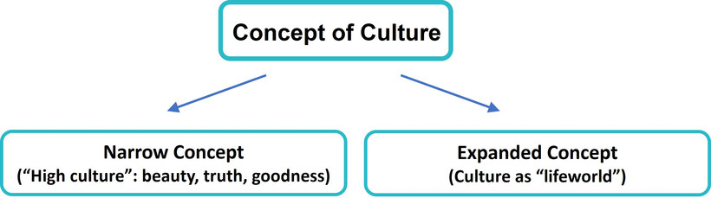
Source: Bolten, Jürgen (2015, p. 46), adapted and translated

1.4 An open versus closed concept of culture
Culture as the living environment or lifeworld has developed two different variants: the closed concept of culture conception and the open concept of culture. The closed view of culture represents the idea that one group of people all possess the same or very similar characteristics and therefore can be clearly defined through sharp demarcations. In contrast, the open view of culture represents a movement away from conceiving cultures as stable and homogenous containers.
If we conceive of cultures as closed or akin to containers, then we naturally run into a number of contradictions. This can be seen where an attempt is made to clearly define what belongs to a culture and what does not, in the sense of bivalent logic (e.g. 'right/wrong'; 'either/or'). A typical example of such thinking is evident when referring to the Germans as coffee drinkers and the British as having their tea at five o’clock.
Nevertheless, from a pragmatic point of view, a concept of culture that is closed in this sense may have some advantages since it reduces complexity and, with its typifying simplifications, enables us to gain an initial orientation with regard to cultural living environments of all kinds. Demarcations, however, are problematic because, due to migration movements and communication processes that have lasted for thousands of years, "no living environment is conceivable as a homogeneous culture unaffected by external influences" (Said, 1996).
Take language as an example. Today there are about 30,000 German speaking Namibians. Some of these are of German descent and their family history dates back to the time when Namibia was a German colony at the end of the 19th century. Others migrated to Namibia more recently and yet others were Namibian born but raised and educated in the former GDR and through this process they brought the language to Namibia. To perceive them as a homogenous group would not do justice to their identity.
Increasingly, since the mid-1990s or even earlier, an increasing number of arguments have been proposed that reject container thinking. The predominant focus of the criticism has been the idea that culture is synonymous with the nation-state, a type of thinking which is still dominant among the closed variants of the expanded concept of culture. Against the backdrop of globalization processes, however, notions of homogeneity, i.e. that a group of people basically share the same characteristics, are proving to be increasingly untenable since nation-state cultural constructions tempt us into making unrealistic generalizations that encourage stereotypes, as the following example suggests:

Task: Being efficient
Read through the short excerpt and think about where the writer is actually generalising.
The imperfection of it all and the fact that nothing went exactly as planned was quite challenging for me. As a Dutch person I am motivated to work as efficiently as possible and therefore spend as little time as necessary at work. Since here in India people do not work that efficiently and waste a lot of time by not being punctual to meetings or not showing up at all to meetings or not responding to calendar requests, I felt like I was constantly wasting time and therefore wasn’t able to work efficiently. I can’t even tell you how many minutes and hours I just spend waiting around, which simply drove me nuts.
Source: Riehl, Cosima, 2019. Working towards synergies in international teams – the experience of Europeans in India. Unpublished MA-thesis, HAW Hamburg
What the writer actually suggests is that being Dutch means working as efficiently as possible, indicating that all Dutch people have this objective, in contrast to people in India. He is not only generalising about Dutch people but also Indian people by saying that they are unpunctual and do not respond to calendar requests. In doing so he emphasises an either/or thinking, with the connotation of them and us. Such an undifferentiated thinking neither opens avenues to understanding his own behaviour nor the behaviour of his colleagues, let alone finding consensus and common ground.
The open view of culture represents multi-relational thinking. According to this understanding, not only national cultures are relevant, but also a range of other cultures, including profession, age, gender, social or educational status, club affiliation, family, all of which influence our values (what is seen as good, bad, to be strived for, to be avoided), behaviour and patterns of thinking.
This new open concept of culture allows for the fact that each person possesses not only multiple affiliations with many different cultures, but also that they might identify with these cultures to a greater or lesser extent. The boundaries from one culture to another are therefore not sharply definable and could be said to be fuzzy (Bolten, 2013). Viewed in this way, the influence of culture on a person’s lifeworld is therefore the ever-changing influence of an intricate and unique mix of the cultures to which they have been exposed or decide to belong.
Such a view would have enabled the Dutch person in our previous example to realize that he shares a number of affiliations with his colleagues and that while some may not share his sense of time and organisation, others will.
This emphasises once more that affiliation to a national culture is only one of many collectives that influence a person. Cultures therefore should not be conceived as sharply delimited fields of actors, but should rather be conceived of in terms of their links with other cultures and collectives. In this way the boundaries can be seen as blurred or fuzzy (Bolten, 2013) and should rather be considered as a network.
The following graphic illustrates the narrow and the expanded concept of culture as well as the closed and the open view of culture:
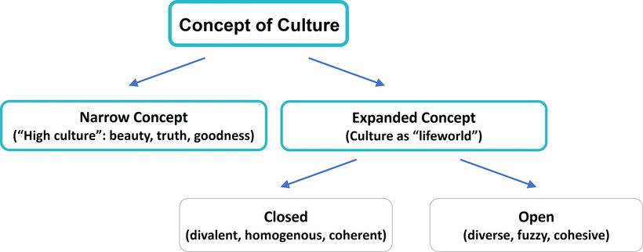
Source: Bolten, Jürgen (2015, p. 46), adapted and translated

Task: Case "Where do you come from?"
Beibei is a freshman at the university and joins an online get-together with lectures and fellow students. She introduces herself to one of the lecturers who comments: ‘Nice to meet you, where do you come from?’ Beibei answers: ‘From Leer’ which is a city in the far north of Germany and which prompts the lecturer to ask: ‘But where do you really come from?’. ‘From East Frisia’ is her reply indicating the region in the north of Germany. And in fact, this is the region where Beibei was born.
Use the closed and open concept of culture to explain the confusion and misunderstanding above. In doing so consider: ‘What are the indications that suggest the lecturer based his question on a closed ‘container’ type thinking and conception of culture? Please note down your answers in your learning journal.

Sample answer
The reaction of the lecturer leads us to believe that he had a closed concept of culture in mind with the question "where do you really come from". When Beibei answered she was from Leer, it is likely that Beibeis name and appearance did not fit into her closed understanding of "people of East Frisia", or any other region within Germany. Thus, she looked for alternative explanation that would fit Beibei in to the closed category that she rather expected, like e.g. China. By asking Beibei where "she really came from", he indicated that he would expect Beibei to at least feel another affiliation to a region that would fit into her appearance and name, at least from the closed culture perspective of the lecturer. BeiBei, however, may or may not feel affiliated to a country or region other than East Frisia or Germany.

The fact that there are quite different answers to the question of a person's origin, depending on their point of view, or that someone might have very different roles, makes it difficult to classify them definitively. A non-sharp definition of cultural affiliations therefore corresponds far better to reality: One might have a certain profession but at the same time be involved in numerous other roles and collectives, either within the family or through friendships, leisure or virtual relationships. This type of understanding of multi-collectivity was described by Hansen (2009) and is analogue to Bolten’s notion of multi-relational networks focusing on the relationships between actors (Bolten, 2014).
This understanding of culture has the advantage that it captures the changes within cultures and their dynamics. Thus, culture is diverse, fuzzy, heterogeneous and cohesive. Bolten (2015) describes this perspective as an either/or AND both/and perspective. From this viewpoint, the construction of something that is our own and something that is foreign is no longer tenable. Since the lifeworld is our familiar world, it provides sense and meaningfulness for everyday actions. For the individual, something is meaningful if it is characterized by relevance, plausibility, normality, enabling routines (cf. Schütz & Luckmann, 1979, p. 30).
If we view culture in the context of today’s globalization processes, then we can clearly observe that economic, technological and political as well as professional and personal networks have established themselves across national borders. This emphasises the understanding of
culture as a multitude of open systems and open networks of cohesively connected collectives (Hansen, 2009; Rathje, 2009; Bolten, 2014), rather than coherent constructions of homogeneity.
Understanding culture from an either/or AND both/and perspective as the open concept suggests, allows us to consider Beibei’s sense of belonging from a multi-collective and multi-relational perspective. She identifies Leer as her home town and feels attached to it. Her name suggests that she or her family also feels attached to other collectives, which may or may not be China. If this is the case, the answer to the question of ‘Where do you come from?’ could be an either/or AND both/and, depending on her self-ascription. In our case she obviously considered her answer to be the most relevant in the specific context.

Task: Find your own example
Think about an example where an ‘either/or’ AND ‘both/and’ perspective could have supported a more differentiated view and note this down in your learning journal.

Sample answer
As an example, take this dialogue between Ian and Gavin from the UK. They chat while waiting for a meeting to start.
Ian:
I am working with this colleague from Bangladesh, Kashif. It’s interesting, but sometimes challenging. It looks like they have a very different understanding of deadlines! It can be frustrating to constantly remind him of the deadlines we agreed on. I know that India and Bangladesh are two different countries, but I visited an intercultural training seminar some time ago, where they explained to us that the attitude towards deadlines is just more relaxed than it is here. That helps me a bit to see that he doesn’t mean it personally at least.
Gavin:
Well, you are right, it is possible that what you observe with Kashif can be explained that way. Have you considered though, that not only is India different from Bangladesh, but that there might also be a big difference between people within these countries? I remember you told me Kashif is new to our company. This might also be influencing his behaviour. We also do not know if he is from the countryside or the city, what his age is, or his general personality. It is even possible that his parents are from the UK, and he himself feels very British. So honestly, I would be a little sceptical with absolute statements from these intercultural workshops, especially when they claim that people from a certain national background necessarily share particular traits. If I were you, I would just take some time to talk to Kashif on an informal level, and see if you can get to know him better, to see what makes him "tick" as a person.

Viewing culture as an open, ever-changing system emphasises its knowledge-based and processual nature. This view is based on the understanding that culture is something which is dynamic, and uses a set of practices to create social reality. Such a process view of culture is linked to the understanding of culture as knowledge. We acquire knowledge through learning about the way things are done and thereby gradually gain a sense of familiarity. In this way, during the process of learning and developing meaning, the transition from the ‘unfamiliar’ to the ‘familiar’ is gradual. For an individual, something is meaningful if it is characterised by relevance, normality and enables routinised behaviour (cf. Schütz & Luckmann, 1979, p.30).
One example for a process in which people transition from the "unfamiliar" to the "familiar" is when we go for a longer time abroad, for example as expatriates, who are being sent by their companies to work for some years in another country. Take for example Alberto, who started to work in the Netherlands for his company as a manager. After some time of living there, he learned that how staff speak to their supervisors may sometime be a bit more forward than what he is used to at home. After it took him some time to get used to this, he grew familiar with this, and might even miss this way of communication when he is back in Italy. The same might be true for people who are switching their employers, even it is just at another side of the town. A start-up company might have different ways of communication as for example a large insurance company, which might also take some time to learn how to do things around here.
This process leads to cultural cohesion, and thus culture can be seen as the glue that connects people. The basis of this is common knowledge and shared meaning. This understanding of culture has the advantage that it captures the changes within cultures and across cultures.
We have now discussed cultural learning and change as a process. However, when things become more familiar and routinised, then structures are laid down, which we can refer to in future for orientation. This could be called culturalisation (Rathje, 2009). Thus, in the sense of both/and (see above), not only the process is important, but structure too. Therefore, we can place the various perspectives of culture along a continuum of structure and process (Bolten, 2013). Any one perspective should therefore not be seen as belonging to either structure or process in a binary sense, but rather as being situated on a gradient between the two.

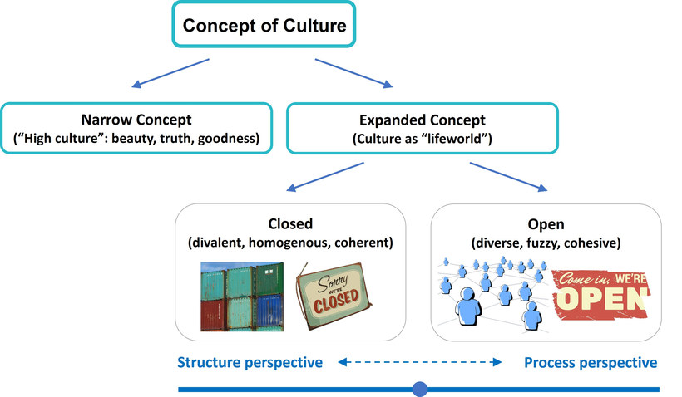
Source: Bolten, Jürgen (2015, p. 46), adapted and translated. Images by Pixabay. Pixabay License
In a complex, globalised world we will often want to apply a perspective that tends more towards an open (and therefore processual) definition of culture. In order to do this, we need to look more closely at individuals and their membership of a number of groups or collectives, thus taking a micro-perspective. Equally, when we want to establish a trusting relationship with others, such a micro-perspective is important in order to gain the necessary in-depth knowledge of the other participants and to make a human connection without reference to pre-conceived categories. This allows us to see commonalities as well as differences. Hansen (2009) argues, in fact, that due to expanded mobility, migration and communication technology, an individual’s cultural affiliations are in one way becoming more complex, but in another may be becoming more similar. Today, for example, there is a much greater likelihood of sharing music preferences regardless of geographical location than was the case say 50 years ago. Also, it is more probable that we will meet people who, from their appearance seem to be migrants, yet were born and socialised in the domestic country.
With regard to cultural affiliation, it is important to bear in mind that new opportunities influence our identity. In fact, Hsueh-Hua Chen (2014) argues that: "In a globalized world, with a growing number of intercultural encounters, cultural identity is constantly being enacted, negotiated, maintained, and challenged through communicative practices". This could translate, for example, into someone feeling more strongly affiliated to the Spanish speaking community because they completed their internship in Spain and immersed themselves in the Spanish community in their home town. This example highlights that, from a multi-collective and multi-relational perspective, our construction of what belongs to us (‘ours’/the familiar) and what does not (‘theirs’/the foreign) no longer makes sense and the transition from the "unfamiliar other" to the "familiar other" is gradual and contextual.

Task: The "Fridays for Future" movement
Read the short excerpt and (1.) note down in your learning journal to which other collectives those who support the movement "Fridays for Future" might belong. (2.) Which interests could these groups have in the movement?
"Fridays for Future" shows what is possible in the manifestation of culture. This movement has grown into a global social movement whose collective members unite around climate policy goals. The way they achieve this goal is different, depending on the context (country / region) and the collectives the members belong to (scientists, critics of capitalism, vegans, etc.). The collective "Fridays for Future" is culturally heterogeneous.
Source: Yildirim-Krannig, 2020, p. 61

Sample answer
To which other collectives those who support the movement 'Fridays for Future' might belong?
Some examples of possible sub-collectives within the larger Fridays-for-Future collectives could be:
- Scientists
- Children / Young adults
- Left-wing politicians
Which interests could these groups have in the movement?
- Scientists might see that the value of their scientific research is openly questioned by a certain part of politics and society. They might see themselves as part of this movement as they see the danger, not only of ignoring the results of climate researchers, but of using or ignoring scientifically proven facts based on political interests.
- Children or young adults might take to the streets to support the movement because they believe the consequences of a drastically warmer climate might directly influence their livelihood. They might be inpatient to drive the political change that they believe the established politicians are too hesitant to install.
- Left-wing politicians might generally view the climate change as a result of an unchecked capitalist politics of the past, and might see themselves in this movement to help curb the consequences. They might also hope to gain more votes for their politics if those consequences became more clear in society.
As we can see that the "Fridays for Future" movement is not a closed, homogenous group in itself, what could be the consequences of this diversity within the group? On the one hand, the group might experience some sort of conflict within itself. Whereas the younger people believe to go into extreme measures to counter the extreme climate changes, the politicians might also look into other interests like endangering workplaces, and thus their voter bases with those measures. The scientist on the other hand might see themselves more in a counselling role, and might get easily frustrated in a harshly polarizing debate that works more on the basis of personal interests and feelings, rather than facts. On the other hand, it is possible that these different cultures might bring different perspectives and strengths to the table to drive the change that their movements is targeting.
We can see that "Fridays-for-Future" is a multi-collective in motion, whose dynamics is difficult to foresee, and will have to find an own culture to embed the different values and interests that it is made of.

1.5 Summary
Culture can be viewed from different perspectives. The expanded concept of culture and in particular the open perspective of this concept inherently leads to an understanding of culture as our living environment or lifeworld, i.e. the part of an individual’s reality that is seen as self-evident and unquestionable. From such a perspective culture is something which is created through social practice in everyday actions. This also means that the open perception of culture acknowledges that culture is dynamic and thus subject to change. The open concept of culture also acknowledges that we are members of many different collectives and maintain relations with people from a variety of sub-cultures. As such it also takes cognisance of the fact that in today’s world it is possible for people to come from a variety of backgrounds, acknowledge membership of a wide range of collectives and yet identify with the same overarching collective (or ‘roof collective’ (Hansen, 2009)). An open concept of culture therefore not only unites in diversity but also allows us to search for commonalities as well as differences across cultures and lay the groundwork for consensus-based, synergetic interaction, through which everyone can flourish.

1.6 Learning review
You should now be able to define and explain culture from a dynamic and multi-faceted perspective and discuss interpersonal encounters based on a dynamic understanding of culture as well as discuss the opportunities inherent in a multi-faceted perspective of culture.
As we have seen, cultures are dynamic, ever-changing networks without sharply definable borders. Each individual is 'part' member of a multitude of cultures. With this knowledge in mind, read the case studies from the beginning of this unit again and go through the questions below.

Task: Case "On the way to the cafeteria" (Reprise)
Read the short case study and answer the questions. Note down the answers in your learning journal.
Tom, a postgraduate philosophy student, and his German roommate Christian go to the cafeteria. Suddenly Christian notices that his cafeteria card is not charged and asks Tom whether he can borrow 3 Euro from him. Tom doesn’t have a problem with this, so he gives his friend the money and both go and eat together. When they have finished, Christian immediately goes to the bank and withdraws money, so that he can give it back to Tom. Tom is surprised. He was happy to give his friend the money, and he definitely didn’t want it back. But Christian insists and makes Tom accept the money. Tom is disappointed and from now on prefers to go to the cafeteria with other friends.
Source: Translated and adapted from the research project "Mehrsprachigkeit und Multikulturalität im Studium" (Multilingualism and multiculturalism in studies / higher education, MuMis project, 2011)
Answer the following questions in your learning journal:
- If Tom had been living in Germany for a longer time and had experienced that Christian's behaviour is not a singular case but that the majority of his friends here behaved like Christian, how might this influence his thinking and behaviour?
- If you look into the answer above, which of the ideas we discussed within the concept of open culture is it based on?

Sample answer
If Tom had been living in Germany for a longer time and had experienced that Christian's behaviour is not a singular case but that the majority of his friends here behaved like Christian, how might this influence his thinking and behaviour?
Tom might realize that Christian's behaviour might not be a sign of distrust, but a common expectation in the collective he is in. However, let us keep in mind that Christian's behaviour might not be typical for the German collective as a whole. Many Germans might argue that they would not share in his behaviour. It is entirely possible that Christian has a family that influenced him to repay any debts, no matter how little, so his way of behaving could be a sign of respect, or he might be influenced by any other cultural group, other than "being German". This being said, if Tom observed this behaviour with many of his German friends, he might feel obligated to behave in the same way. Having lived in this environment for a longer time, he could adapt to the same behaviour over time.
If you look into the answer to the previous question, which of the ideas we discussed within the concept of open culture is it based on?
Mainly, we can see two ideas embedded in the previous answer. Firstly, the notion not to interpret Christian's behaviour based on his nationality points to the open concept of culture. Here, we discussed that members of one nationality are not one homogeneous group whose members all share the same behaviour or values. Rather we should keep in mind the multi-relational idea of culture, and that Christian's behaviour might be influenced by many different factors (his age, profession, family upbringing etc.) other than his national culture.
Secondly, we discussed that culture possess a knowledge-based and processual nature. Living in another cultural context might enable us to gain this new knowledge about "how things are being done here”. This in turn can influence us in our cultural behaviour, as we discussed with Tom. The firstly unfamiliar behaviour Tom observes with Christian might become very familiar over time, to a point where he might even adapt it for himself.

Task: Case "Exchanging business cards" (Reprise)
Read the short case study and answer the questions. Note down the answers in your learning journal.
Janina, a recently graduated IT student, has been invited to give a short talk at a local consumer electronics conference. At this event she gets into a conversation with a participant at the conference, Seo-jun, who is on his first trip to Germany from South Korea. His knowledge of German is not particularly good, but the two talk to each other intensively and get along well. During the course of the day, they decide to keep in touch and exchange their business cards. First Seo-jun takes his business card out of a silver case and gives it to Janina. Janina then begins to look for the business cards that she had printed a long time ago for such cases. She reaches into her back pocket and takes out her wallet. The card is a bit bent, and Janina comments on this with a laugh when it is handed over. Despite this, the card is still easy to read. Seo-jun, who was previously friendly and open-minded, is suddenly visibly reserved and becomes quieter and quieter. This irritates Janina. She senses something is wrong, but she doesn't know what.
Source: Translated and adapted from the research project "Mehrsprachigkeit und Multikulturalität im Studium" (Multilingualism and multiculturalism in studies / higher education, MuMis project, 2011)

Answer the following questions in your learning journal:
- Let us review the answers you gave to the questions in the beginning of this session. When you guessed the interpretations of Seo-jun's and Janina's behaviour, were they based on an open or closed concept of culture?
- What could be the danger of viewing this case solely from a closed-concept perspective?

Sample answer
When you guessed the interpretations of Seo-jun's and Janina's behaviour, were they based on an open or closed concept of culture?
If your answer tried to explain the behaviours of our two protagonists being "German" or "South Korean", it would be more based on a closed culture concept. It is a possible explanation: In South Korea, business cards might be seen as a symbol for the person behind it, and not just as a means to exchange information. Based on this, Seo-jun might have felt disrespected to get a worn-out business card from the wallet, as he might think that Janina did not think of him as a serious business partner. This closed concept scenario does not consider however that Janina and Seo-jun might also be influenced by other collectives rather than the origins of their passports. Possibly, in the IT-department Janina works in, her colleagues barely use business cards at all, as contacts would be exchanged virtually. For her, the reason to give any business card at all could have been to pay Seo-jun the same respect he did to her. Seo-jun might have worked in a more traditional setting like a bank, where business cards were still important, regardless of the national background.
What could be the danger of viewing this case solely from a closed-concept perspective?
If Seo-jun assumed that Janina behaved like this because "she is German", he might conclude that all Germans would be like this as a homogeneous group. He might not bother with business cards himself in his next meeting with his German banking clients, which might lead to other misunderstandings. If Janina interprets to always treat business cards with high regards when passing them to South-Koreans, she might be confused if the next person she meets from this region does not behave like this at all, as he might be influenced by another cultural background. It might lead her to wrongly assume that this person would not respect her.
Even though it is attractive to explain the behaviour of others with quick categories, we should keep in mind they might not be the only, or even a right explanation at all.

Task: Case "Being a good student" (Reprise)
Read the short case study and answer the questions. Note down the answers in your learning journal.
Jane, an American student, spends a year at a German university. She finds it particularly difficult to contact German lecturers. In America you can speak to your lecturers at anytime and anywhere and when you do, they take a lot of time for each issue that you might have, while in Germany you have to make appointments with the lecturers or go to their consultation hours. Jane needs a lot of help with her first term paper, so she tries to ask her lecturer questions about writing the term paper at every opportunity. But the lecturer is usually in a hurry and asks her to come to his consultation hour. However, even during the consultation, Jane has the impression that the time for the consultation is relatively limited, because there are many other students waiting in front of the door of the office who also want to have their turn. This causes Jane to be briefer than she actually intended. At the same time she is disturbed by the time pressure she feels.
Source: Translated and adapted from the research project "Mehrsprachigkeit und Multikulturalität im Studium" (Multilingualism and multiculturalism in studies / higher education, MuMis project, 2011)
Answer the following questions in your learning journal:
- To review some of the principles we discussed in this session, let us take another look at your answer to question 2 from the first series of questions about this case in the prelude ("What might be reasons for the lecturer to behave the way he does?") Knowing now about the open concept of culture, would you change your answer?
- How can this answer help Jane in this situation?

Sample answer
"What might be reasons for the lecturer to behave the way he does?" > Knowing now about the open concept of culture, would you change your answer?
In your previous answer, you might have argued with a possible German background of the lecturer, and tried to find an explanation for his behaviour through a closed culture lense, arguing with a possible typical German behaviour. This is a possible explanation. However, keeping the either/or AND both/and perspective in mind, let us not forget that we do not know the specific background of the lecturer. Even if he has a German name, he might not have grown up in Germany, or has any direct affiliation here.
Even if the lecturer was born and raised in Germany, let us not forget that, like all of us, his cultural identity is much more than only based on the country he grew up in. It is quite possible that the lecturer offers fixed sessions because this is expected in the university context he works in, and because it allows him to help his students in the best way possible, without being late for other responsibilities.
How can the answer help Jane in this situation?
Her disappointment with the lecturer was mostly based on her frustration that she felt she did not get the help she needed. When Jane comes to the conclusion that "I guess the service towards students is just not as good in Germany as in the States”, it could lead her to simply accept her level of frustration, and build further stereotypes. When she acknowledges that she does not really know the reason for the lecturer's behaviour, she could think about a way to solve her problem. For example, Jane could openly tell the lecturer in Germany that she had quite some questions on her term paper and ask if he minds to take the time to answer them. They might then either conclude that her worries about the term paper are unfounded, or he might suggest another time to answer the remainder of her questions.

1.7 Sources, further reading and web links

Sources
- Bolten, J. (2011). Unschärfe und Mehrwertigkeit: "Interkulturelle Kompetenz" vor dem Hintergrund eines offenen Kulturebegriffs. In W. Dreyer, & U. Hößler, Perspektiven interkultureller Kompetenz (pp. 55-70). Göttingen: Vandenhoeck & Ruprecht.
- Bolten, J. (2013). Fuzzy Cultures: Konsequenzen eines offenen und mehrwertigen Kulturbegriffs für Konzeptionalisierung interkultureller Personalentwicklung. SIETAR Journal für interkulturelle Perspektiven, pp. 4-9.
- Bolten, J. (2014). Reziprozität, Relationalität und Mehrwertigkeit. Ein Plädoyer für einen holistischen Kulturbegriff. In R. Eidukeviciene, & A. Johänning (Eds.), Interkulturelle Aspekte der deutsch-litauischen Wirtschaftskommunikation (pp. 18-39). München: Iudicium.
- Bolten, J. (2015). Einführung in die Interkulturelle Wirtschaftskommunikation. Göttingen: Vandenhoeck & Ruprecht.
- Hansen, K. P. (2000). Kultur und Kulturwissenschaft: Eine Einführung. Tübingen: A. Francke.
- Rathje, S. (2009). Der Kulturbegriff. Ein anwendungsorientierter Vorschlag zur Generalüberholung. In A. Moosmüller (Ed.), Konzepte kultureller Differenz (pp. 83-106). Münster: Waxmann.
- Riehl, C. (2019). Working towards synergies in international teams – the experience of Europeans in India. Unpublished Master thesis: HAW Hamburg.
- Said, E. W. (1996). Kultur und Identät - Europas Selbstfindung aus der Einverleibung der Welt. Lettre International, 34, pp. 21-25.
- Schütz, A., & Luckmann, T. (1979). Strukturen der Lebenswelt (Vol. 2). Frankfurt a. M.: Suhrkamp.
- Yildirim-Krannig, Y. (2020). Migration, Kultur und Migrationskultur(en). (Euro-FH, Ed.) Retrieved from https://www.euro-fh-campus.de/kulth02

Weblinks
- Guess Who’s Muslim (Shahbaz) Lineup
A short video questioning assumptions about ‚how a Muslim looks‘
https://www.youtube.com/watch?v=k3YtZUyaNzw
- What means home and being at home?
A video cut from the project ‚7 billion Others‘ by Yann Arthus-Betrand highlighting the different meanings of home
https://www.youtube.com/watch?v=EnCRAMNu7Ic
- All that we share
A short video illustrating the ‚open approach to culture‘ by highlighting the variety of collectives people may be members of
https://www.youtube.com/watch?v=jD8tjhVO1Tc

2. Interculturality and intercultural interactions in a professional and personal context

Topics
2.1 Prelude 19
2.2 Introduction 19
2.3 Diversity and heterogeneity of lifeworlds 19
Task: Changing eating habits 23
2.4 Interculturality and intercultural interactions, the attempt of a definition 24
Task: Defining the term 'intercultural encounter' 27
2.5 Intercultural encounters in my social and work environment 29
Task: Analyzing an intercultural encounter 30
Task: Reflexivity in perception 32
Task: My intercultural encounter 33
2.6 The relevance of dealing with intercultural interactions 35
Task: Case "Negotiating with Chinese business people" 36
2.7 Summary 37
2.8 Learning review 37
Task: Case "Experiences abroad" 37
2.9 Sources, further reading and web links 39

Learning outcome
In this session you will analyse intercultural situations in professional and personal contexts with respect to the aim of interculturality.

Objectives
At the end of the session, you will be able to
- Explain the concept of interculturality
- Analyse professional and personal interactions from a cultural perspective
- Understand and discuss the relevance of the topic in a global, professional and personal context

2.1 Prelude
In the previous session you dealt with the complex nature of defining and conceptualising culture and discussed why using an open and multi-relational approach to culture serves as a good foundation for intercultural understanding. Following on from this, we will start this session by enhancing our understanding of the contexts in which such a definition can be applied. In particular, we will discuss aspects of what Vertovec calls ‘Super-diversity’, as this will help us to understand changes in our social and work environments. With this in mind, we will subsequently define and explain the concept of interculturality and explore intercultural interactions.

Download: Learning journal for session 2
Learning journal (.docx) Learning journal (.odt) Learning journal (.rtf)

2.2 Introduction
At no time in human history have the opportunities for contact and communication between individuals, groups and organisations around the globe been greater. Because of this growing worldwide interconnectedness, migration and mobility, societies find themselves dealing with people who grew up in different cultural and institutional environments or have different family migratory histories. We are therefore experiencing flows of goods, thoughts and information, which accelerate the mixing of cultural elements and give us the opportunity (or challenge) to adapt to hitherto unknown lifestyles. These developments have caused us to rethink our understanding of culture and reflect on the impact of culture on our daily lives. It has also led to the need for both cultural understanding as well as the establishment of common ground when meeting people. We might ask, for example, 'How and why do we differ and what brings us together?' Intercultural communication has in fact become part of our daily actions at home, in school, at work and elsewhere.
Before we analyse intercultural situations in more detail and explore what interculturality means, let us look at a few examples that show the heterogeneity and diversity of people and their lifeworlds.

2.3 Diversity and heterogeneity of lifeworlds
We are experiencing an accelerated process of diversification in most western societies. These are mostly migration driven, and involve more and more identities, differences in lifestyles and family formations. These processes are currently inducing cultural, economic, and developmental changes. The photograph below serves as an example of cultural changes such as the growing variety of food and dishes, changing eating habits, cultural mixing as well as changes in the use of language. It shows a so-called ‘sandwicherie’ in Barcelona.

Photograph by Adelheid Iken
A sandwich is commonly understood to be two pieces of bread with food in between, which is eaten by hand. It is considered to have its origin in the 18th century in Great Britain with John Montagu, the 4th Earl of Sandwich as its namesake. In the 19th century its popularity as a lunch option increased in Spain and England when the rise of industrial society and the working class made it necessary to eat while away from home. In Spain, where the word Sandwich is borrowed from the English language, it commonly refers to food made from English soft sandwich bread. But it appears as if a sandwicherie as seen on this picture is used in a much wider sense, encompassing different forms of snacks and luncheons such as Americains, Hamburgers and crepes. Sandwicherie might be translated as 'sandwich bar' or 'sandwich shop'.
The next example is insightful because it deals with the fairly commonly held stereotype in Germany that many, if not most, migrants of Turkish or Moroccan descent would agree with the statement that women should not work outside the home while their children are still young. Again, the figures tell us otherwise, showing that responses differ across countries and that education is one of the strongest impact variables on gender role attitudes.
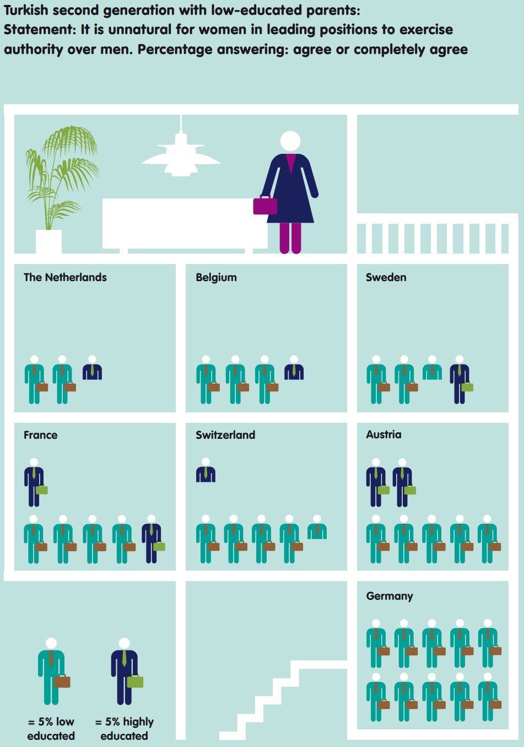
Source: Cul, Maurice; Schneider, Jens & Frans Lelie (2013, p. 21). Superdiversity, A new perspective on integration. Amsterdam: VU University.
Infographic by Annelies Vlasblom / Zeppa Creative Studio (Amsterdam), reprinted with permission. Available at elitesproject.eu. Accessed 11 June 2025. Not CC licensed.
The previous example shows the findings of the Sinus Institute, a renowned body that studies people’s changing values and everyday lifeworlds. The illustration shows the so-called 'Sinus Meta-Milieus' or the day to day realities in German society. It highlights in particular the heterogeneous nature of modern values and lifestyles and the fact that within a country we can differentiate between many different milieus or groups, which all share a similar outlook on life. For example, the 'performers' tend to dispose of a global economic mindset, are efficiency-oriented and perceive themselves as avant-garde with regard to consumption and style. Modern mainstreamers on the other hand are people ready to adapt and aim to achieve a secure and harmonious life. They tend to be achievement-oriented and strive to become established in professional as well as social circles.
So on the one hand a variety of values, lifestyles as well as life strategies can be found within a country, and on the other transnational similarities can be found. In other words, a performer is likely to find people in other countries with a similar mindset.
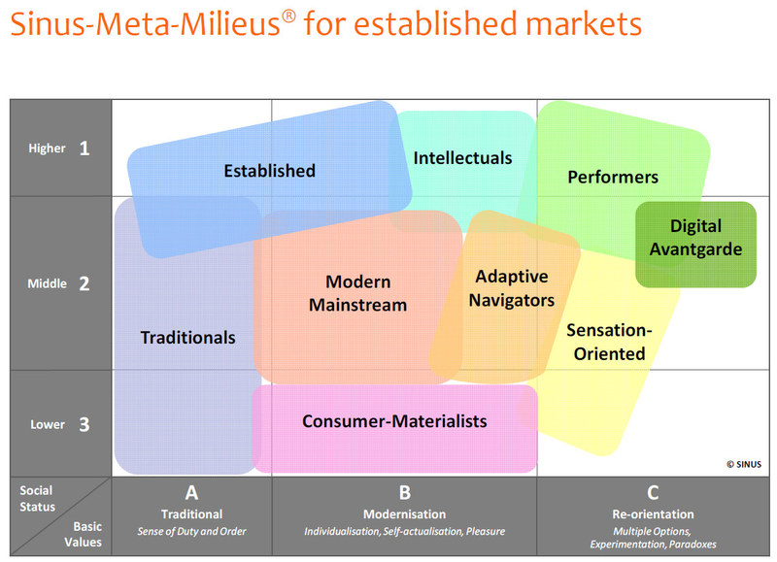
Source: SINUS Markt- und Sozialforschung GmbH (2006). Information on Sinus-Milieus
2015, pp. 23. https://www.sinus-institut.de/fileadmin/user_data/sinus-institut/Downloadcenter/
20150805/2015-01-15_Information_on_Sinus-Milieus_English_version.pdf. Reprinted with permission. Accessed 5 November 2020. Not CC licensed.
What we learn from these examples is that many societies are experiencing an unprecedented level of diversity within them, while these are also triggered by outside influences. This may precipitate challenges such as communication barriers and interpersonal conflict due to bias and prejudice, but at the same time it can bring many opportunities such as novel experiences, skills and perspectives. One of the safest predictions we can make about the next generation is that it will be more diverse than it is today.
The term Super-diversity, coined by Steven Vertovec, underlines this development and emphasises that we are currently experiencing a level of complexity that surpasses anything previously experienced. Over the past decade, far more people have moved from one place to another than in the preceding decades. Additionally, an increasing number of individuals have been raised in one or more cultural contexts other than that of their parents, and ever more children are born to couples from differing cultural backgrounds while more and more people spend a large part of their lives outside their home country. All these phenomena are tied up with a vast increase in levels of immigration and diversity.
In addition to the diversity induced by migration and immigration, it is important to acknowledge other variables that influence the complexity of social relations and behavioural patterns. New forms of diversity and heterogeneity have gone hand in hand with more encompassing identities, for example. A very recent example of this is the acknowledgement of a third gender in societies, which is now officially recognised in a number of countries.
People today are also strongly influenced by social media, with internet exchanges influencing their habits, preferences and behaviour. The tremendous international success of movies made in India with high drama and traditional costumes commonly referred to as ‘Bollywood’ serves as an example here. And there are other relevant variables that contribute to emerging, acquired and inherent diversities, but which have received less attention in the past such as gender, social status, profession and power structures to name just a few.
It can therefore be argued that although Vertovec focuses on migration patterns, the concept of Super-diversity should encompass a whole range of factors and we should acknowledge that it concerns everyone, including people who live where they were born, but are increasingly exposed to cultural others in their workplace or social environment. Super-diversity may therefore rather be seen as a lens through which intercultural encounters can be analysed.
To conclude, we can say that the speed, scale and spread of diversity has reached unprecedented levels and that this development is challenging our understanding of intercultural interactions and intercultural communication.

Task: Changing eating habits
Changing eating habits are easier to reconstruct and reflect than changed behaviour.
Go on the internet and search for the following:
- the origins of pizza
- the dissemination of pizza in your home country
How far do you think the original recipe of pizza has been amended to meet local demands?
Note down the answers in your learning journal.

Sample answer
This is Olesia's answer:
The history of pizza begins in antiquity, when various ancient cultures produced basic flatbreads with several toppings. Modern pizza evolved from similar flatbread dishes in Naples, Italy, in the 18th or early 19th century. Pizza was mainly eaten in Italy and by emigrants from there. This changed after World War II when Allied troops stationed in Italy came to enjoy pizza along with other Italian foods (information taken from Wikipedia).
In Russia, where I come from, pizza is a very popular dish. People cook it themselves, buy it as a semi-product, order in restaurants, etc. Many restaurants have developed their own recipes for pizzas with some special toppings. People enjoy eating pizza, but still it is considered to be fast food and mainly goes with Coca-Cola. Pizza is popular for parties or other festivals. It is mostly preferred by young people.
I think that the original recipe has been drastically amended – first of all because nowadays we have more spices, new cooking technologies and our tastes have changed. Moreover, people tend to experiment more and have sophisticated preferences. Finally, each place on the Earth has its own cooking traditions, so even a globally accepted dish should be in accord with the local conditions.

2.4 Interculturality and intercultural interactions, the attempt of a definition
Given our understanding of diversity and super-diversity, in any given situation in which two or more people meet it is very probable that there will be differing notions of a range of issues. These could relate to a different sense of belonging and identity as well as disparate experiences, value sets, expectations and action chains. The development of the concept of interculturality over the past decades has made us aware of this.

Before we continue, think about the following question:
When would you characterize an encounter as intercultural and why?
Our understanding of interculturality is linked to our understanding of culture (our culture perspective). There are two ways to approach interculturality: the closed perspective and the open perspective.
From the closed perspective´s conception of culture interculturality describes an interaction between participants from culture A and culture B. Participants from culture A and B perceive each other as foreigners and strange. From this perspective, "national culture" or "ethnicity" is the predominant force driving all decisions made in human interaction. Intercultural interaction is seen as action between two or more people from different countries with different cultures.
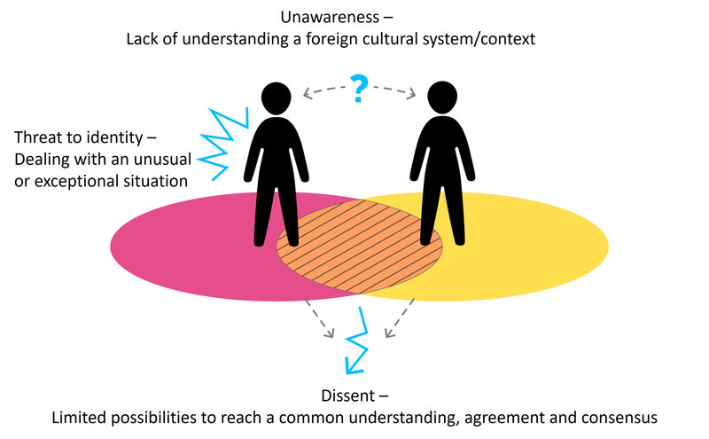
Source: Based on Rathje, Stefanie (2015). Multicollectivity – It changes everything. Key Note Speech at the SIETAR Europe Congress (stefanie-rathje.de). Accessed 24 May 2021.
Figure by Julia Flitta (www.julia-flitta.com)

'Otherness' is commonly held responsible for dysfunctional interaction and ineffective cooperation. Thus, culture and interculturality are seen as problematic. An orientation towards national cultures combined with efforts to find easily conveyed generalisations is risky, as one may take on stereotypical notions of a "national character", for example by characterising the French as vain and the US-Americans as superficial. Such generalisations can also be perceived as having a positive connotation as the following example describing the Dutch as being ‘gezellig’ suggests:
"Coming through the cultural aspect there is one word which describes the Dutch culture perfectly: ‘gezellig’. Directly translated, the word means ‘socialable’ or ‘cosy’, but actually this word has no accurate translation. Dutch people use this word to describe everything positive. A place can be ‘gezellig’, a room can be ‘gezellig’, a person can be ‘gezellig’, an evening can be ‘gezellig’. ‘Gezellig’ or ‘gezelligheid’ are less about a word and more about a feeling. It describes the moments of happiness, being together and to share beloved moments. I notice that Dutch people are very open and warm-hearted."
Usually otherness or strangeness is linked to misunderstandings, dysfunctional encounters and is held responsible for ineffective cooperation as the following quote from an intern indicates:
"I remember one time when Louis called me late in the evening and said that he needed the draft for the new flyer 'most urgently' and 'until tomorrow morning'. Then I sat all night finishing the draft so that he could take it the next morning. However, the next day he did not even show up at the office and when I called him later that day telling him the flyer was ready, he just told me to relax and wait. I was really annoyed and disappointed but thinking back at it guess this was an example of a cultural misunderstanding, as in Peru tomorrow seems to have a wider timely extension."
Interpreting "most urgently" and "until tomorrow morning" literally obviously and from the point of the intern understandably caused disappointment and frustration. However, whether this misunderstanding can be explained by referring to 'the Peruvians' needs care and closer examination. Applying an open concept of culture might not only have cast doubt on this assumption, but also opened up avenues to deal with the situation in a constructive manner through its understanding of interculturality as a negotiation process.
From the open perspective of culture, cultures simply exist within human collectives. As the term ‘collective’ includes all kinds of groups composed of individuals from football clubs to corporate organizations to nation-states, individuals have multiple belongings and are culturally heterogeneous. This approach differs from the closed ‘inter-national’ understanding of culture, which considers exclusively ‘national traits’ as in the above example.
With an open concept of culture, interculturality is an ongoing negotiation process (cf. Bolten 2015). This perspective offers a constructive approach for analysing and understanding the dynamics of intercultural communication in intercultural encounter. In the following we will discover why this is so.
From an open perspective interculturality can be characterised as follows:
In an intercultural encounter individuals find themselves in a situation in which there is no normality, they cannot create any plausibility and routine actions are not possible. People who meet, may perceive each other or each other’s behaviour as strange and unfamiliar. This feeling of strangeness can be due to a difference of any kind and can include subtle things such as gestures, facial expressions, use of language as well as larger phenomena such as traditions, ways of dealing with issues, or the way an education and economic system is structured. In such circumstances it is quite normal that people judge the experience by comparing it to their own behaviour and what they expect and are accustomed to.
"I think the most obvious and most distinctive difference I experienced is the directness in conversations. The German culture is very direct. Conflicts and problems are approached directly, real opinions are given straight away and there is less talking around the topic. I experienced British people to be more discrete. It is very important for them to stay friendly. Feedback one receives always sounds positive and the negative aspects are not mentioned that clearly. There were situations where my colleagues and I were fuming about something another department said or did, but once we sat in the meeting to talk about it, everybody was joking around and the topic was approached as if it was not a big deal anyway."
What happened is that the intern experienced the communication style as unfamiliar, not necessarily as a threat but as different and possibly somewhat annoying and strange. She also based her experience on belonging to another group, i.e. nationality. The following illustration indicates this.
Imagine two people, let us call them Pedro and Mareike. Pedro is an international student and Mareike comes from the south of Germany. They are both in their first year at the university which has just started. They are given an assignment to work on and when they meet for the first time, they realise that what they have in common (yellow circle) is that they are fellow students and both have an interest in the subjects chosen. Apart from that they also realize that they belong to the group of people whose second language is English (indicated by the blue colour). When they meet to work with each other, at first they feel very insecure because everything is new, they don’t know what to expect and they are a little anxious that differences may prevail, which might make working together difficult. Because they do not share the same mother tongue, they also perceive themselves as belonging to different groups or collectives. When they talked about the assignment they also realised that they seem to understand the task differently and would therefore also approach the task differently.
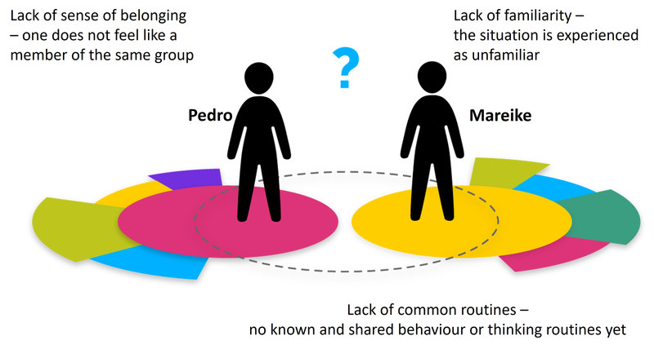
Source: Based on Rathje, Stefanie (2015). Multicollectivity – It changes everything. Key Note Speech at the SIETAR Europe Congress (stefanie-rathje.de). Accessed 24 May 2021.
Figure by Julia Flitta (www.julia-flitta.com)
Two weeks later, the situation looks quite different. Pedro and Mareike not only feel a lot more comfortable at the university, they have also met several times and got into the habit of talking about the course for a short while before working on their subject. They have also exchanged WhatsApp messages (indicated by the pink area) and know that any time they can text message each other when there is an issue. Mareike is a member of a capoeira group (indicated by the green area) and asked Pedro to come along. As he really enjoyed being part of the group, they decided to go there together (indicated by the green area around the two).
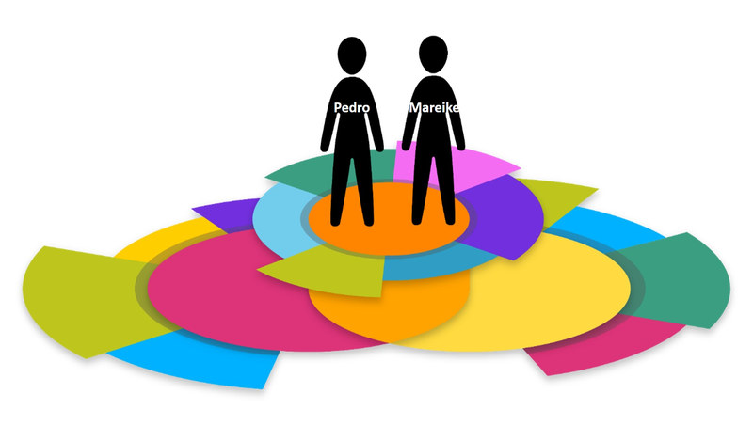
Source: Based on Rathje, Stefanie (2015). Multicollectivity – It changes everything. Key Note Speech at the SIETAR Europe Congress (SIETAR_slides_Rathje.pptx (stefanie-rathje.de)). Accessed 24 May 2021.
Figure by Julia Flitta www.julia-flitta.com)
The degree of strangeness Mareike and Pedro experienced initially was probably not extreme. However, we still need to acknowledge that they nevertheless experienced a lack of normality, plausibility and routines at the beginning. So as we can see, in any new encounter there will be a level of interculturality. If not dealt with skilfully, people can feel threatened due to insecurity and anxiousness. As a consequence, it can even lead to people withdrawing from an intercultural encounter or avoiding meeting others.
In our previous session we defined culture as referring to groups of people, the boundaries of which are blurred. Within the group, people share a certain amount of knowledge and have developed a sense of familiarity and shared code system. This means that in an intercultural situation it is of paramount importance to establish normality and routine actions in order to make this interaction a stimulating and enriching experience.
In a nutshell, the term interculturality describes the absence of normality, plausibility and lack of routines. In an intercultural encounter, therefore, people with different concepts of normality, plausibility and routine actions meet and find themselves in an unfamiliar situation.

Task: Defining the term 'intercultural encounter'
1) What do the definitions have in common and in which ways do they differ from one another?
Note down your answers in your learning journal.

2) Sort the definitions / explanations according to their position on a scale of an "open" vs.
a "closed" understanding of culture by giving them a grade from 1 (= most open concept) to 7 (= most closed concept).

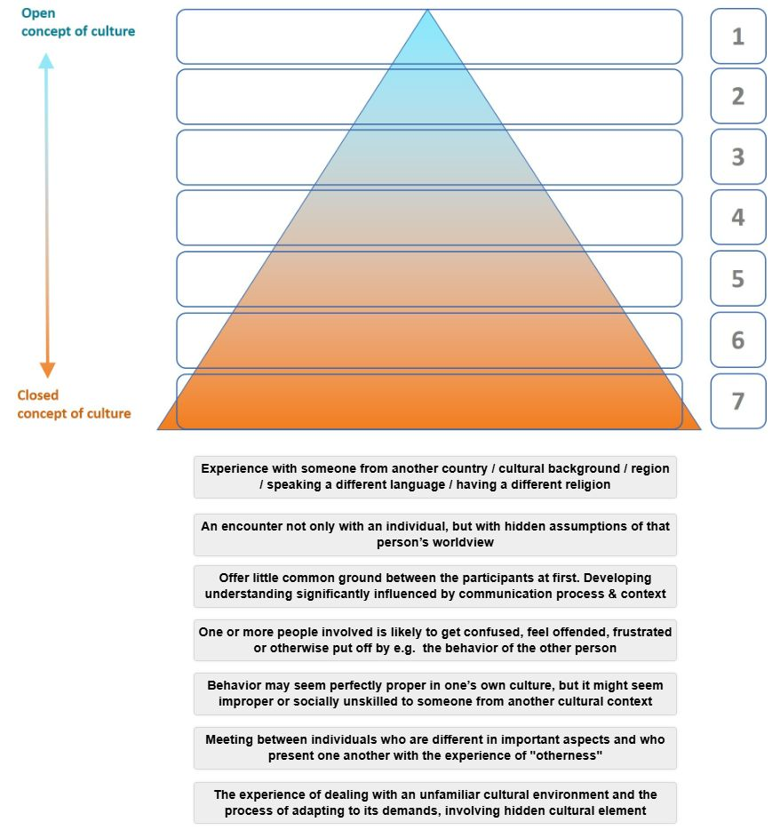
Link to the interactive version of this task in the course "Intercultural Communication" on Glocal Campus
Diagram developed by Yeliz Yildirim-Krannig for this course.
3) Now look again at your answer to the first question. Would you change your answer or add something? Note down your thoughts in your learning journal.

Sample answer
Here is Olesia's answer:
- What do the definitions have in common and in what ways do they differ from one another?
Some definitions refer to individuals as representatives of different groups (countries, etc.).
Others refer to behaviour or some experience of dealing with unfamiliar environment or representatives of this environment.
- Sort the definitions / explanations according to their position on the scale
of an "open" vs. a "closed" understanding of culture by ordering them from 1 (= most open concept) to 7 (= most closed concept).
1) encounter with my hidden assumptions of the other person's worldview
2) little common ground at first, understanding depends on communication process + context
3) participants differ in important aspects, experience of "otherness"
4) likelihood of feeling confused, offended, frustrated by the behaviour of the other person
5) contrasting views on what is proper and improper / socially unskilled behaviour
6) meeting somebody who is different / from another... (country, region, religion, cultural background)
7) dealing with and adapting to an unfamiliar cultural environment
- Looking again at your answer to the first question, would you change your answer or add something?
Olesia added the following to her answer:
After doing the second part of this task it came to my mind that some definitions refer to other cultures and groups as the "other" meaning "foreign" and thus very different, whilst other definitions share a milder shade of meaning in the sense of unfamiliarity or difference.
Sort the definitions / explanations according to their position on a scale of an "open" vs. a "closed" understanding of culture by giving them a grade from 1 (= most open concept) to 7 (= most closed concept).

2.5 Intercultural encounters in my social and work environment
As we saw in the previous section, concepts of culture have moved on from the idea of cultures as static, homogenous, nation-bound units or 'containers' (e.g. studies from E.T. Hall, Hofstede) to conceptions that embrace a more fluid, dynamic and multi-relational notion of culture.
From a practical point of view, this means acknowledging that members of society and of a team maintain relationships with a whole range of people and are members of a range of different collectives. Additionally, the figure below indicates that some of these collectives have a stronger influence on them than others. For example, the blue area may show an affiliation with their study group, which is highly relevant in the context of an upcoming team project.
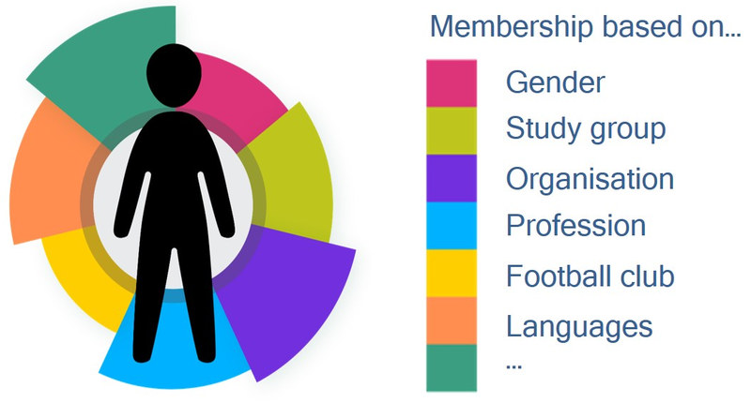
Source: Based on Rathje, Stefanie (2015). Multicollectivity – It changes everything. Key Note Speech at the SIETAR Europe Congress (stefanie-rathje.de). Accessed 24 May 2021.
Figure by Julia Flitta (www.julia-flitta.com)
Earlier on we talked about how Mareike and Pedro met at university and developed routine actions together, until after a short while they felt comfortable with each other. However, even here it is possible that the notion of strangeness and difference will surface again. Imagine that Mareike is also a committed member of a religious community, a fact that she had never mentioned to Pedro. When one day she invites him to a celebration within this community after class, suddenly the intercultural perspective in their relationship dominates once more, since Mareike’ s religious affiliation is new to Pedro. Joining her for the celebration places him in a very unfamiliar and even awkward situation. He is very happy that people walk up to him, greet him and are ready to explain the meaning of the celebration to him. They also invite him to sing with them, making Pedro feel welcomed and integrated.
Since both spheres of activity, i.e. professional and non-professional, are interlinked by the reciprocal relationships between the two actors, the way in which Pedro and Mareike interact 'interculturally' in this external context will influence their already culturalised reciprocal relationship (and vice versa). In other words, despite the fact that Mareike and Pedro had already developed a common culturalised relationship, the lack of plausibility, normality and routines inherent in interculturality can and did occur once again due to this new experience . By joining Mareike, being interested in the celebration, getting to know more about her religious affiliation, this then becomes a new aspect of their culturalised relationship.

Task: Analyzing an intercultural encounter
Where have you come across intercultural encounters and communication situations? Choose one intercultural encounter which you have experienced. The event could be a visit to a person´s home / house. It could be a meeting with someone from a foreign country, a foreign region within your own country. It could be something happened during a team project where team members had different professions, perspectives etc. To help you to analyze your intercultural encounter answer a sequence of questions about various aspects of that encounter and note down the answers in your learning journal.

Questions about the encounter:
- Description: What happened when you met this person / these people?
- Time: When did it happen?
- Location: Where did it happen? What were you doing there (e.g. study, leisure, at work)?
- Importance: Why did you choose this example?
- What was your reaction?
– It surprised me
– It disappointed me
– It pleased me
– It angered me
– It changed me
...because...
Add any other reactions in your own words and say what you think caused your reaction.
Questions about the person / the people:
- Who was involved?
- What was the first thing you noticed about them?
- What did they look like?
- Were they male / female, older / younger, same nationality / different nationality, same profession / different profession, or anything else you think might be important about them?

Sample answer
My first intercultural encounter happened when I was 14 years old, it was in a resort center not far from my home city in Russia. I stayed there with my parents. A group of school students from the USA with their teacher as a group leader stayed there for a month. My first intercultural encounter happened outdoors when I was walking alone and met the group leader. She was in her 40s and looked as an alien for me. We started talking, from my side that was a fabulous experience – I had never talked with an English native speaker before and wanted to take the chance. Everything went on smooth until I started talking about the nature. At that very moment I understood that I misused one word and completely changed the meaning of my sentence which certainly led to misunderstanding. Further on I explained my point of view and our conversation went on seamless. I can’t say that I was disappointed or frustrated, I felt that the way we understand words and their meanings is absolutely different in comparison to other cultures. There we speak of "nature” meaning a place or a forest, other people may understand this as a referral to human nature and perceive it as a character of a person. Moreover, I understood how it was important to understand the context and be ready to these incompatibilities.
In my case, I think I had a complex intercultural encounter that encompassed both linguistic and cultural aspects.
As we have seen, normality, plausibility and routine action are missing in intercultural interactions. In order to understand why this is we need to return to the nature of culture itself: It is a social construct, where meaning is constantly produced and reproduced through communication through and for its participants. And if we understand language as a system of signs and symbols, then it becomes clear that language is used as a basis for developing a common understanding and therefore interculturality.
From this perspective, interculturality encompasses the communication process that takes place when two or more people with unfamiliar cultural backgrounds meet in a specific environment as illustrated in the example below:
"On top of that, I was impressed by the fact that they often spoke simultaneously and interrupted each other for questions. To me, at the beginning, this seemed rude. But I learned that, on the contrary, my way of listening silently and only speaking when the others had said what they wanted to say, had two negative results: Firstly, I noticed that my way of communicating irritated my colleagues and I found out that it made them think I was not interested. Secondly, it made it difficult for me to express my opinion because I never found a moment in which no one was speaking. Another difference concerning communication is the use of gestures. I adapted quickly to using my hands in order to emphasize what I was saying. When I was at home for Christmas, my family suddenly broke out laughing while listening to me and explained that my hands were moving wildly which seemed strange to them. As I had done this unconsciously, I was a bit annoyed that they laughed at me and immediately, also unconsciously, used the gesture that Italians usually use when something is going wrong."
What this example highlights is that the communication style was both the cause of irritation but at the same time the means through which interculturality was being created.
Intercultural interactions are commonplace. They are just as prevalent in our own residential area, educational institutions or at work just as they are when travelling abroad. We are constantly and often unconsciously engaged in reaching agreements and determining positions – in the sense of "communicare” (lat.), meaning joint action to create common meaning. Understanding intercultural interaction as joint or collaborative action has the potential to enrich various aspects of our lives. In order to act / interact well in various cultural contexts, it is important to keep an open mind and avoid making assumptions about others’ cultural belongings. While we may be able to identify some aspects of the cultural context within a communication encounter, there are likely to be cultural influences that we cannot see.
How individuals interpret a situation (e.g. as familiar or unfamiliar), and which actions are selected and performed, depends on a range of factors. One of these is a person's previous experience of normality in comparable contexts. The less diverse this previously experienced normality is, the less flexible the images in the individual’s mind are (cf. Bolten 2015). If our previous experiences are similar, then behaviour can be easily conventionalised (and repeated). A further influencing factor lies in the fact that the experiences we collect have an impact on our self-image, the image we have of others and the meta-image. By meta-image here we mean the image we believe another person has of ourselves. All three images are interdependent and are related to the context in which they are generated. Furthermore, how we perceive objects around us or the people we encounter is orchestrated by our mental models and by the interplay of these three images (self-image, image of other, meta-image). We tend to group things together or use a known model in order to better understand something new and to interpret new experiences.

Task: Reflexivity in perception
Let us carry out a short excursion into the field of perception and mental models by watching the short YouTube ‘Reflexivity in Perception’ or reading the poem below.
Source: IntercultureTV: Reflexivity in Perception, 2017, URL: https://www.youtube.com/
watch?v=VcHT10xICKg
John Godfrey Saxe's poem "Six Blind Men of Hindustan" from the 19th century which is based on an Indian fable is a good example to illustrate how mental models are used to create an understanding of new experience:
Once upon a time, there were 6 blind men who lived in a village. An elephant has been brought to the village. These blind men were curious and wanted to experience it by touching it as they had no idea what an elephant is:
When the first man touched the side of the elephant, he said: "it is like a wall".
The second man when touched the tusk of the elephant, he told that it is strong and smooth, just like a spear.
When the third man touched the trunk of the elephant, he said: "It is like a snake".
The fourth men said: "It is like a tree" when he touched the feet of the elephant.
The fifth men touched the ear of the elephant and told that it is like a fan to him.
The sixth man touched the tail of the elephant and said, "It is like a rope".
Each of the six men started to suspect each other thinking that the remaining five are lying. They started arguing with each other.
What we learn from this YouTube video / poem is that each person interpreted the new experience by using a mental model, i.e. they used their previous experiences. Their perception of the elephant is based on their mental models. Perception in this context can be defined as the process of making sense of the world around us, which involves deciding which information to notice and how to categorise and interpret it. However, perception is not the same as reality because it is based on an individual’s feelings, knowledge and experiences, which are all subjective. However, perception determines a person’s interpretation of a specific situation and their response to it.
This also means that our expectation and perception of intercultural encounters is influenced by our mental models. And it is in our mental models where our knowledge of intercultural interactions is stored. It is key to recognise here that a mental model is simply an abstraction or a simplification of a part of reality, acting like a filter. It is therefore personal and subjective (cf. Jonassen & Cho, 2008). Nevertheless "essentially, all models are wrong, but some are useful" (Box & Draper, 1987, p. 424). They are wrong because they are simplifications, and they can be useful because they give orientation. The ways in which people understand and create meaning from interacting with people to a particular end can be explained through the expression of their mental models (cf. Johnson-Laird, 1983).

Task: My intercultural encounter
Go back to your answers to the questions regarding your intercultural encounter and continue analysing it with the new knowledge gained by answering the following questions about that encounter. Note them in your learning journal.
Questions about your feelings:
Describe how you felt at the time by completing these sentences:
- My feelings / emotion at the time were...
- My thoughts at the time were...
- What I did at the time was... (For example, did you pretend you had not noticed something that was strange? Did you change the subject of the conversation, which had become embarrassing? Did you ask questions about what you found strange?)
- I expected them to be / to act / to speak / to look like...
Questions about the other person's feelings:
Imagine yourself in their position...
- How do you think the other person / people felt in the situation at the time? How did you know?
- What do you think they expected you to be / to act / to speak / to look like...?
- What do you think they were thinking when all this happened? Do you think they found it strange, or interesting, or something else?
- Choose one or more options below and complete the sentence or add your own ideas.
For them it was an everyday experience / an unusual experience / a surprising experience / a shocking experience / because...
I noticed this because of what they did / said and / or how they looked, for example they...
I am not sure because they seemed to hide their feelings...
Looking back at the situation
- What are possible reasons for your description / perception and feelings in that intercultural encounter? Think about what interculturality (open culture perspective) means.
- How do you see your own thoughts and actions now? Where did these come from?
- How do you see the actions of the other person / people now?

Sample answer
My feelings at the time were not extreme, I was only trying to find some new words to explain myself better. My thoughts at the time were wondering about the difference that may occur between people speaking different languages when they discuss some universal concept. That time I gathered valuable experience that I could be misunderstood and that it was not such a serious problem at all. I expected nothing special from my conversation partner, perhaps only patience when I was trying to explain my idea. I guess that the other person may have felt some sort of confusion because I was talking her native language and she couldn’t understand me properly. I would have never known her feelings, I could only guess. I don’t think that she expected me to act in a special way, we didn’t have such a problem that had to be taken that serious. I know that she was very much surprised in a good way that I could speak English that good regardless of this misunderstanding.
For her it was a surprising experience that a school child from Russia could speak English that good. I noticed this because she mentioned that to me.
I think that our situation could be referred only to close culture perspective because it was clear that misunderstanding arose as a result of different meanings hidden behind a universal concept.
I see that my actions fit the situation. Her actions were also situation-relevant.
Although perception is a largely cognitive and psychological process, how individuals perceive people and objects around them not only affects the interpretation of any encounter but also communication. For example, individuals respond differently to an object or person that they perceive favourably than they do to something they find unfavourable.
When two people meet, person A will perceive person B in a certain way based on expectations, knowledge and previous experiences. However at the same time the perceiver A is also part of the interaction process as person B will react and be affected by the behaviour of A. The perception process is therefore also influenced by the response patterns that ensue. This process can be described as "you see what you expect”. These expectations, assumptions and response patterns are in turn influenced by socialisation contexts (lifeworlds), which are, among other things, influenced by culture.
In intercultural communication, interpersonal perception leaves more scope for error and distortion than perceiving a particular object. Although interpersonal perception is more complex than object perception, it does, however, follow similar rules and can equally lead to errors.
Perception and communication are inextricably linked. How individuals communicate depends on the way they perceive the other. In the communication process, all events and feelings are activated and stored.
As we have seen, cultural differences can cause misunderstandings if we are not open-minded and aware of our mental models. These models are generated by our perceptions, expectations and experiences.

2.6 The relevance of dealing with intercultural interactions
Due to today's global interconnectivity (media, business, trade), mobility (traveling) and migration, our home environment has changed and intercultural encounters have become much more frequent. In fact, if we acknowledge an open definition of culture where everyone possesses a unique membership combination in relation to a range of disparate collectives, all interactions are intercultural. Intercultural interactions are omnipresent in our local, professional or global environment. We might think of situations such as employees who work in a culturally heterogeneous (virtual) team, managers who are responsible for employees from different cultural and professional backgrounds, fellow students with different family migration histories, neighbours in a diverse neighbourhood sharing common spaces, to name but a few.
Intercultural interactions are often considered to be particular challenging, whereas in reality many of them pass successfully without any issues. This is especially so if we have some understanding of the process involved in interculturality and are able to analyse intercultural encounters.
Being successful in intercultural interactions gives organisations a global business edge because they are able to use the resources a diverse workforce can contribute. Thus they can make use of the positive dynamics and outcomes that can be generated from these. In addition, cultural differences can be turned into an advantage, for example when they can be pooled, used complementarily or even synergistically so that when different ideas are brought together, something new is created.
In order to achieve this, a learning process is required that supports intercultural negotiation processes as well as a readiness to share, be open about one’s own preferences, cultural orientations and communication style. These negotiations take place though a communication process, which needs to be established in such a way that it is comprehensible and plausible to all participants. Due to the differing contextual conditions in which individuals commonly communicate and act, it is not always easy to establish comprehensibility and plausibility (cf. Bolten 2015, p. 9). This also means that the results and outcomes of intercultural interactions cannot be anticipated.
Intercultural interaction can result in a new, jointly negotiated culture, based on an ongoing communication process, reciprocal learning and knowledge acquisition as well as knowledge sharing. When this stage is reached, intercultural interactions are an enrichment for all involved.
In a nutshell, intercultural interaction can then be characterized as:
- goal-oriented interactive cooperation of interested parties from a network of cultures where new interaction rules are unconsciously or consciously negotiated
- a dynamic, unpredictable process of spontaneously developing something new
- a creative environment, which is constantly redefined
- synergetic cooperation from culturally different perspectives, and
- a continuous negotiation and renegotiation of meaning

Task: Case "Negotiating with Chinese business people"
Read the case study and, in your learning journal, note down what you think went wrong. Refer to your knowledge about interculturality, perception, experiences and expectations and be guided by questions about the encounter, the people involved, and the feelings of the participants.
A manager of a German company was on his fourth trip to China within a short period of time to negotiate a joint venture contract. However, the negotiations simply didn’t progress. Meanwhile, the German manager was beginning to have serious problems with his head office. Time was running out and his superior in Germany felt that the negotiations were not being conducted effectively enough. He expressed displeasure at the representative’s inept handling of the negotiations. The manager himself was annoyed and frustrated. During the following round of negotiations, after which they still did not seem to have reached an agreement, the manager believed that he had finally understood the Chinese partner’s tactics. He felt that the Chinese wanted to stall the negotiations so that they could extract as much information from him as possible. This, he felt would then be used to play off his company against competitors. Realising this, he felt angry and annoyed with his negotiating partners. In addition, he felt the strain of a couple of weeks’ gruelling negotiations.
Finally, he reacted in a way that you might describe as 'giving them a piece of his mind'. Completely without warning, the German manager screamed at his Chinese partner that he was not prepared to be kept waiting any longer, that there should be no more 'beating about the bush', that his patience had finally come to an end and that he really had expected more transparency and commitment.
For the Chinese, these grievances were expressed in a shockingly loud and direct manner. The Chinese partners turned pale and said nothing. Negotiations did not reach a conclusion.
Upon his return home, the manager learned from his superior that this had been his last trip to China. The Chinese, without uttering one word about the negotiations he had undertaken, wrote to say that they were still interested in the planned joint-venture. The company would have to start over again more or less from scratch, using a new representative.

Sample answer
This intercultural encounter is an absolute example of intercultural misunderstanding. It involved a manager from Germany who came to China for the forth meeting in a row over a short period of time and his Chinese partners. As it can be understood from the case study the German manager before his arrival in China already had negative perception of his Chinese colleagues because of a number of reasons.
First the situation was escalating, as the mentioned visit to China was forth in a row over a short period of time. Secondly, he was pressured by his boss in Germany. These two factors together affected to some extent his perception of situation in a negative way and made him biased.
Apart from the issue of perception, it should be noted that for Germans, who belong to monochronic culture, processes are set to be carried out in a faster pace than for the Chinese, who represent polychronic culture. I may suppose that this cultural difference, and German manager's ignorance of it played a bad game in the whole story. So, his regular expectations of negotiating pace presumably was incompatible with the one of his counterparts.
The German manager lost his patience and instead of somehow encouraging his counterparts to advance negotiations he accused them of intentional stalling and taking actions in favor of his company's rivals. These accusations were based on no evidence and possibly were unacceptable to the Chinese counterparts, who expressed no direct reaction to him but later on refused to work with him. This incident accounts for another cultural difference, when Germans speak and express themselves directly, whereas Chinese act in a quite opposite way.
Although I may say that both sides belonged to business culture, their national cultures played a major role in interactions.
Possibly emotions experienced by both sides could be described in the following way: The German manager was frustrated, anxious, desperate, he felt deceived, and to some extent perhaps panicky, which later on led to his outburst and accusations.
The emotions of the Chinese partners are relatively difficult to describe, but it may be supposed that they were calm. They felt that their negotiating strategy was dominating and they felt secure and confident despite the German manager's accusations. Even afterwards they wanted to continue negotiations, but with a different company representative.

2.7 Summary
Intercultural encounters are commonplace. They are encountered in local residential area, at educational institutions, at work as well when we travel abroad. Our understanding of interculturality is linked to our understanding of culture. Depending on our understanding of culture we experience intercultural encounters in two possible ways. Approaching interculturality from a closed perspective of culture, interculturality is understood as the encounters experienced between two or more people from different countries and different backgrounds. Intercultural interaction is seen here as problematic. From the open perspective of culture, interculturality is an ongoing negotiation process. The term 'interculturality' describes the absence of normality, plausibility and lack of routine action. Intercultural interaction is viewed here as an unfamiliar situation. How individuals perceive one another and how they interpret the actions of the other depend on their experiences. This also means that our expectations and perception of intercultural encounters is influenced by our mental models. Thus, cultural differences can cause friction if we are not aware of our mental models (perceptions, expectations and experiences) and if we are not open-minded in regard to this.
Although intercultural interactions are often considered to be particular challenging, many of them pass without any problems. This is all the more so if we have an understanding of the process involved in interculturality and if we are able to analyse intercultural encounters. Cultural differences can be turned to our advantage, and even used to create synergies. In order to achieve this, a readiness to share, as well as a willingness and openness to learn something new is required. When this is present, intercultural interaction can result in a new, jointly negotiated culture based on an ongoing communication process, sharing of knowledge and reciprocal learning.

2.8 Learning review

Task: Case "Experiences abroad"
Read the case study and in your learning journal note down what you think went wrong. Refer to your knowledge of interculturality, perception, experiences and expectations and be guided by questions about the encounter, the people involved and the feelings of the participants.
One of the more apparent challenges for me was living with my Indian colleagues. I had big problems adjusting to loud noises, pungent smells and the pretty much non-existent hygiene of some of them. I met four Indian colleagues during my time at the company. I lived with three of them under the same roof. Two of them had the habit of conducting early morning phone calls. One of them did not want to clean at all because apparently believed that it was beneath his dignity. After I had told him several times that he had to clean like everybody else and he finally accepted. But I realized that he only pretended to clean when it was his turn. On top of that, he did not clean the toilets at all. Apparently, they do not do that where he is from. On another occasion, one of the other guys from India who had adapted slightly to the European standards cleaned the kitchen floor with the same rag he used for the bathroom floor. When I confronted him and said that this is definitely not a hygienic move he replied that he always does it this way.
I was willing to accept their habits but most of the time they did not accept what was important to me or criticised ‘European habits’. For example, there was an occasion where the lab leader came over for a beer with Malu our lab technician. I was cooking some Spaghetti Bolognese. He opened the pot and laughed. "What kind of shitty food is that?”, he asked. I said: "Just try it. Maybe I can prove you wrong.” Then he just walked away. In situations where I wasn’t so sure whether my stomach would be capable of handling Indian food, I sometimes declined their offer. Immediately, you could see that they were disappointed and sometimes even angry at me for declining.

Sample answer
The given situation describes an intercultural encounter between a European man (nationality is not specified in the case study) and his three Indian colleagues, all of them lived together. Problems they faced were mostly of household character because they had absolutely different understanding of housekeeping.
Early-in-the-morning phone calls, hygiene and cleaning issues – all of the mentioned were parts of their routine confrontations. On top of this the European felt criticized when he was trying to explain his neighbours the universal rules, he believed everyone should adhere to. The case study also describes a situation when the European offered a dish to his Indian neighbor who refused from it in a rude manner. Moreover, the European also felt sort of frustrated because he was trying to accept his neighbours’ ruler, while they were reluctant regarding his rules.
Feelings experienced by the both sides can be assumed to be the following: the European felt disregarded, criticized and disappointed, Indians were dominating in the situation and felt that his rules were not obligatory as they had no motivation to change their own habits because of the European neighbour.
I guess that they lacked good and comprehensive conversation and a compromise. For making living together more comfortable and easier they should have discussed some points instead of walking away. Clash of cultures could be avoided if both of the parties are ready for the dialogue.
I can assume that this piling tension between the sides also negatively changed the mutual perception. To be able to overcome the feeling of otherness could certainly help the participants of situation and give them some space for privacy.

2.9 Sources, further reading and web links

Sources
- Bolten, J. (2015). Einführung in die Interkulturelle Wirtschaftskommunikation. Göttingen: Vandenhoeck & Ruprecht.
- Box, G. E., & Draper, N. R. (1987). Empirical model-building and response surfaces. New Jersey: Wiley & Sons, Inc.
- Johnson-Laird, P. N. (1983). Mental models: towards a cognitive science of language, inference and consciousness. Cambridge (MA): Harvard University Press.
- Jonassen, D., & Cho, Y. H. (2008). Externalizing mental models with mindtools. In D. Ifenthaler, P. Pirnay-Dummer, & J. M. Spector (Eds.). Understanding models for learning and instruction (pp. 145-159). Boston: Springer.

Recommended reading
- Rathje, S. (2009). The definition of culture. In Bolten, J., & Rathje, S. (Eds.): Interculture Journal, 8 (8), pp. 87-93. http://stefanie-rathje.de/wp-content/uploads/2014/08/Rathje_
The-Definition-of-Culture_2009_08.pdf (accessed on 24.10.2020).

Weblinks
- Vertovec, St. (2019). ‘Latest Thinking’ about the challenges of super-diversity: ‘How can we best respond to the challenges presented by super-diversity?’
https://lt.org/publication/how-can-we-best-respond-challenges-presented-super-diversity (accessed on 24.10.2020).
The parts on ‘question’ (0:00) and ‘findings’ (3:05) are of particular interest.
- Vertovec, St. 2016. ‘Super-diversity as concept and approach: whence it came, where it’s at, and whither it’s going’ https://vimeo.com/161619990 (accessed on 4.11.2020)
To learn more about the concept of ‘Super-Diversity’.

3. The characteristics of culture, an individual perspective

Topics

3.1 Prelude 41
3.2 Introduction 41
3.3 Culture and the concept of multi-collectivity 41
Task: My collectives 45
3.4 Culture as a repertoire of knowledge 46
Task: Culture and knowledge (1) 47
Task: Culture and knowledge (2) 49
Task: Culture and knowledge (3) 49
3.5 Culture as learned and passed on 50
Task: Teaching and learning 50
Task: Socialisation across cultures 51
Task: Socialisation at Disneyland 53
3.6 People as products and producers of culture 54
Drinking water from the tap or from a bottle? 55
Task: Culture scripts – giving a tip 56
3.7 Culture and its link to context 57
Task: Culture and context, the job interview 58
3.8 Summary 58
3.9 Learning review 58
Task: Biographical reflections 59
3.10 Sources, further reading and web links 60

Learning outcome
You will be able to assess your own multi-cultural embeddedness by considering the core characteristics of culture.

3.1 Prelude
Having established the fact that intercultural interactions are part of our daily and professional lives, we will now turn our attention to analysing the characteristics of culture. In doing so we will explore our own cultural embeddedness.

Download: Learning journal for session 3
Learning journal (.docx) Learning journal (.odt) Learning journal (.rtf)

3.2 Introduction
We communicate and interact with people every day, be it at university, at the grocery store, at work or when meeting friends and family. Culture is one important variable that influences the process and the outcome of such interactions. At times, this involves meeting people whose ways of thinking and behaving is quite distinct from our own routinised behaviour. It is at this point that we become aware of the fact that we are operating according to different sets of knowledge, beliefs and values, which in turn may provoke a sense of unease in one or both communicators.
If we recognise culture as one important variable influencing the process and outcome of our interactions, then this raises further questions about the nature of culture. Which aspects of culture, for example, can cause a sensation of unease or even irritation and at the same time offer tremendous learning opportunities and potential for personal growth?
Understanding the characteristics of culture will serve as a stepping stone to understanding intercultural communication. And within this context we will embark on the objective of this session: to explore ourselves as a person who is surrounded by and embedded in culture.

3.3 Culture and the concept of multi-collectivity
You already encountered the notion of multi-collectivity in the first session. Now we will dig deeper and explore your membership of various collectives. Let us start by watching a short video about Emil and his collectives.
As the video shows, culture always refers to a plurality of people, i.e. more than one person, and is therefore a group phenomenon. Such groups may be as small as a local football club or as large as an organisation or a nation. We can, in fact refer to an entire society as a cultural group and also maintain that in each society there are smaller groups that share a lifestyle and other features quite distinct from those of other members and groups. This is why Hansen (2009) introduces the term ‘collective’, a term he uses for groups sharing a certain amount of commonalities and consistencies.
As an example, Hansen (2009) refers to Germany as a roof collective and to the local catholic community as a secondary or sub-collective (cf. Hansen, 2009, p. 82). The major difference between the two is that sub-collectives are made up of individuals and roof collectives are made up of sub-collectives. A tennis club is a sub-collective because it consists of individual members as opposed to the German federation of trade unions for example, which is made up of several single unions and thus a roof-collective. We could also call this an "umbrella collective”.
The notion of collectives allows us to understand how we feel a strong affiliation to a variety of groups at the same time and are therefore multi-collective people. These collectives can be linked to a profession, migration history, kinship, language, interest, ethnicity, occupation, world views, institutional membership or socio-economic or regional characteristics. In addition to these, we also need to acknowledge further variables that influence social relations and behavioural patterns. One is, for example, the influence of social media. And some other variables, which have traditionally received less attention such as gender, social status and power structures should not be overlooked. These examples show that some of our affiliations are given by birth, some are developed and others are intentionally chosen by the individual over the course of our lives. Some of the collectives that we belong to may exhibit opposing values or principles, whereas others are intertwined and can be viewed as a network.
As the figure below illustrates, people from the same roof collective can be members of the same and different sub-collectives. The thickness of the lines indicates that the strength of the affiliations may differ. The arrows indicate that roof collectives influence sub-collectives and vice-versa, showing that culture is dynamic, an aspect we will return to at a later stage.
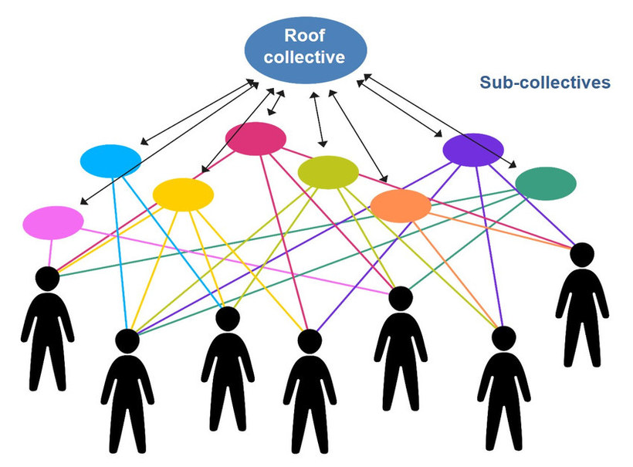
Source: Yildirim-Krannig, Yeliz (2014, p. 212). Kultur zwischen Nationalstaatlichkeit und Migration: Plädoyer für einen Paradigmenwechsel. Bielefeld: Transcript.
Figure by Julia Flitta (www.julia-flitta.com)
Generally, it can be argued that multi-group membership tends to increase with the growing complexity of social systems. In particular, in complex societies people are members of many different collectives and thus combine different belongings and allegiances, a multitude of interests, roles, values and practices. People are therefore always on the intersection of a number of group memberships. These collectives may overlap but can equally be added to like a mosaic.
This also means that multi-collectivity relates to the diversity within cultures. It implies that two people who share the same national or ethnic background might have different lifestyles, views of the world and behavioural patterns.
Consider for example a rural family in Eritrea whose members have received no formal education and make a living from their land. They meet a woman in the capital who is a trained doctor, has travelled extensively and speaks English fluently. Despite their shared nationality, their views, experiences and references are likely to differ in many ways. In fact, it is likely that the medical doctor will have more in common with her professional colleagues in other parts of the world.
Considering memberships of collectives thus helps us to be aware of commonalities as well as differences within and across national borders.
Another example is illustrated by a Chinese passport holder who is a member of a collective of illustrators. Some of the other members of this collective were raised in Great Britain and Germany. When they meet and communicate, their professional identification as illustrators is much more relevant than their national identity, especially because they share English as a lingua franca. In a different context, the fact of having been raised in China might be take on greater importance than the professional identification.
The arrows pointing away from the sub-collectives indicate that some members of the roof collective are also members of other roof-collectives.The classical example are people who hold two different passports or people who spend a lot of time in one country and feel a strong affiliation to that roof-collective country but equally to their country of birth.
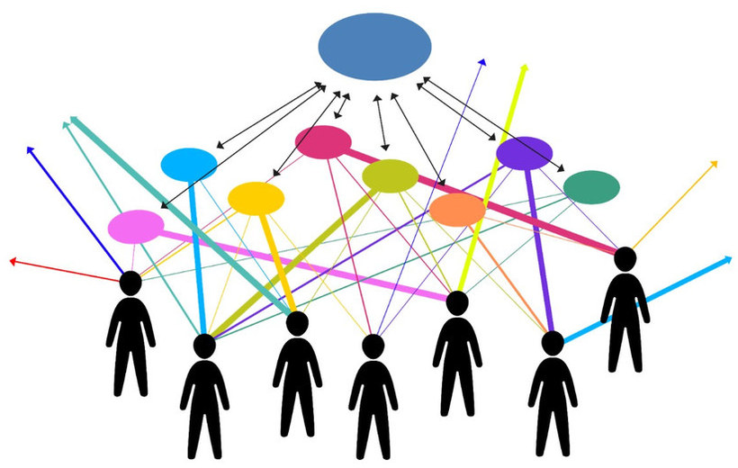
Source: Yildirim-Krannig, Yeliz (2014, p. 212). Kultur zwischen Nationalstaatlichkeit und Migration: Plädoyer für einen Paradigmenwechsel. Bielefeld: Transcript.
Figure by Julia Flitta (www.julia-flitta.com)
By introducing culture as a group phenomenon and acknowledging membership of different collectives, we move away from considering culture solely in relation to a ‘passport identity’ or as ‘ethnic groups’ such as the offspring of Turkish migrants in Germany or British pensioners moving to France and living in a so-called ‘cultural enclave’. Instead of simply acknowledging ‘the migrant’, we can observe a large degree of variation in migration histories, educational backgrounds, length of residence, world view and economic backgrounds. Germany for example can be considered a roof-collective and people who belong to the German roof-collective may follow the way of Buddha and thus consider themselves to be members of the sub-collective of Buddhists. They share this membership with many other people in the world in attempting to follow the teachings and practices of Buddha.
The illustration below shows a person who is a member of various collectives, indicated by the different colours surrounding them. Meeting a group of people at a party, for example, might show that he or she shares their interest in Buddhism with many others.
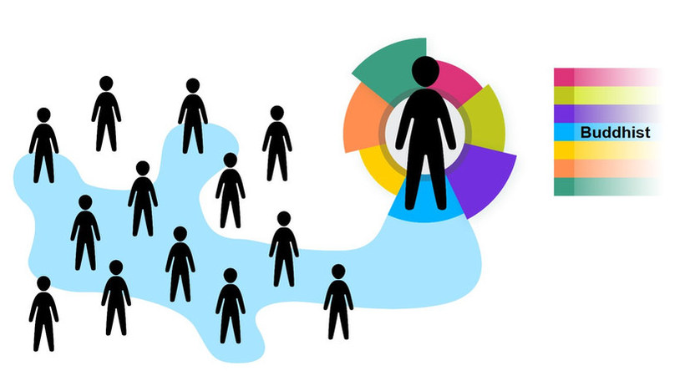
Source: Based on Rathje, Stefanie (2015). Multicollectivity – It changes everything. Key Note Speech at the SIETAR Europe Congress (Presentation slides (stefanie-rathje.de)). Accessed 10.11.2024.
Figure by Julia Flitta (www.julia-flitta.com)
They might also realise that many people at the party share membership of the student collective. Some might be students and have an affiliation to Buddhism, which is indicated in the illustration below.
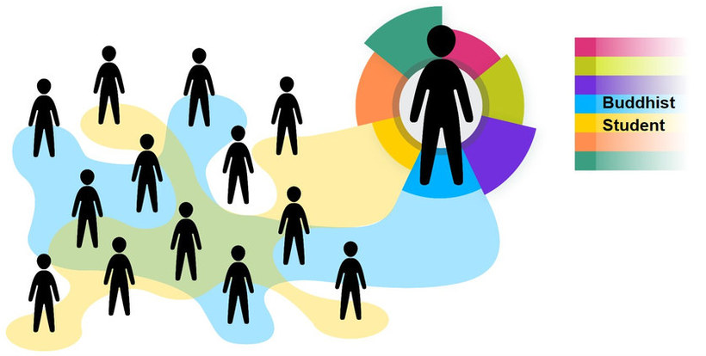
Source: Based on Rathje, Stefanie (2015). Multicollectivity – It changes everything. Key Note Speech at the SIETAR Europe Congress (Presentation slides (stefanie-rathje.de)). Accessed 10.11.2024.
Figure by Julia Flitta (www.julia-flitta.com)
The speed, scale and spread of diversity has reached previously unknown levels. People increasingly have more and better opportunities to relocate, whether it be for leisure, work, political or economic reasons and therefore increase their horizons and cultural orientations. And ideas and information are moving as well in an unprecedented level, enabling people to adapt and adjust to new and very different life styles and behaviours. The speed with which diversification is taking place and the spread of diversity is challenging our political, economic and social systems. Indeed, we are only beginning to understand the changes and challenges that are linked to these developments.
They also have an influence on our identities or how we perceive ourselves of who we are. In this context it appears to be helpful to think about what Amin Maalouf (2000, p.86) calls a ‘vertical’ and ‘horizontal’ heritage. The vertical heritage comes to us from our forefathers or ancestors and relates to our learning of traditions, local values and norms. The horizontal is linked to our age and social groups and the environment we live in which usually has a very determining influence. These heritages coexist and add to the sum of our diverse affinities and belongings. Maalouf himself was born in the Lebanon and spend most of his life in France and argued that he feels not just a belonging to both countries and their cultures but also that he is ‘the result’ of both countries. This follows the thinking that we can be home in more than one country and supports the notion that we should acknowledge multiple belongings and allegiances and thus multi-collectivity.
In today’s complex societies and environments understanding ourselves as members of many and at times quite different collectives enables us to study small entities and carry out what Clifford Geertz (1973) calls a ‘thick description’ by moving away from surface and generalising level. Recognizing membership in collectives also means to depict commonalities where one may anticipate differences and thus develop a common ground for understanding among members of different groups within and across countries. It thus acknowledges the interconnectedness across boundaries, the notion of cultural adaptations and mixes as well as the diversity within societies. This is important because focusing simply on nations as a cultural signifier would not do justice to the diversity of people around us.

Task: My collectives
Which collectives are you a member of?
Name five of them and note them down in your learning journal.

Sample answer
Other participants named the following collectives:
- My family
- My project team
- My study group
- My group in the fitness studio
- My close friends
- My sports team
- My gender
- My age
- My music band I am playing in
- My volunteers group
- My religious affiliation
- My church
- My neighbourhood

What you will realise is that some of these collectives, as for example your project team, are easy to grasp, while others, such as your gender collective, are very difficult to confine.

3.4 Culture as a repertoire of knowledge
In a given culture or collective, people share a repertoire of knowledge. This is knowledge that we acquire and use in order to make sense of the world around us, to interpret experiences and to generate social behaviour. As Hoffman and Verdooren (2019) argue, this can refer to practical ‘everyday knowledge’ in the sense of ‘this is how things are done around here’. This could, for example, relate to opening hours of shops and government institutions, traffic rules, and the legal and political systems. Imagine, you want to travel on the bus and are new in town. You might come across a system whereby you have to buy a ticket before entering the bus and maybe you would be able to do this via an app or by going to the nearest kiosk. In another context you may be required to buy the ticket on entering the bus or there might also be a ticket inspector. People familiar with the environment share this knowledge about ‘taking the bus’. As newcomers we may feel confused if ‘taking a bus’ functions differently to what we expect and are accustomed to. Being knowledgeable about ‘how things are being done around here’ is important as it helps us to manage day to day affairs.
When and how to greet people can be another relevant piece of everyday knowledge. Imagine you are doing an internship in an international company and on your first day your supervisor takes you around the office to meet your new colleagues. He stops at every desk and introduces the person to you. What are you going to do? Shake hands? Give the person a smile?
But cultural knowledge also relates to more abstract knowledge such as knowledge of philosophy, arts, history or science inasmuch as it is prevalent within a collective. Such knowledge can be the source of ideas, inspirations and discussion and within a collective can constitute what Hoffman and Verdooren (2019: 28) call a group’s ‘frame of reference’ or a cognitive map. Such maps guide people to assess what is being considered as right or wrong and they contain some principles and an orientation regarding how to respond to and interpret such situations. This does not mean that they necessarily compel us to follow a particular course. It also does not mean that such maps cater for all circumstances, but they do contain some principles and an orientation regarding how to respond to and interpret certain situations. Whereas knowledge is something that people carry in their minds, behaviour is directly observable. And it is knowledge and information that underlie behaviour. By referring to the fact that culture consists of the shared information in people’s minds and their behaviour, we acknowledge that it includes mental as well as behavioural phenomena. Furthermore, we acknowledge that the knowledge of one cultural group can be distinct from the knowledge of other groups and this enables group members to behave in a way that is meaningful to them and acceptable to other group members.
Knowledge which is reasonably easy to articulate, capture, store and retrieve is called explicit knowledge. For example, if you start working for a company, you are likely to be given a booklet containing information about the history, organisational structure and a guideline of what is expected from you when working for the company. We can find explicit knowledge, for example, within a company's help centre, knowledge bases, process documentation, user guides, white papers, research reports, data sheets, specifications, organisational charts, formal documentation, as well as video and audio recordings.
Spain represents another example. The fact that Madrid is the country’s capital is well known and also that Spanish is the officially recognised language of the country. It is knowledge which can easily be gained, recorded and passed on.
A concept that is much more difficult to grasp is tacit knowledge, which is unconscious and unacknowledged information that is silently acquired through experience, socialisation, and habitual practices. It is unconscious knowledge that, if asked for, would be the most difficult to write down, articulate, or present in a tangible form, or at least it would take a lot of time and effort to articulate it.
Think, for example, about your grandmother’s most delicious cake. Even though she has given you the recipe or has told you all the ingredients you need, when you try it out, you feel as if something is different or missing. The reason is that after years of experience, she has learned the exact feel of the dough, or exactly how long the cake should be in the oven. It’s not something she can write down; she simply feels it.
Understanding culture as common practice, it should be clear that a large part of culture-specific everyday knowledge is tacit knowledge and this is difficult to transform into easily attainable explicit knowledge.
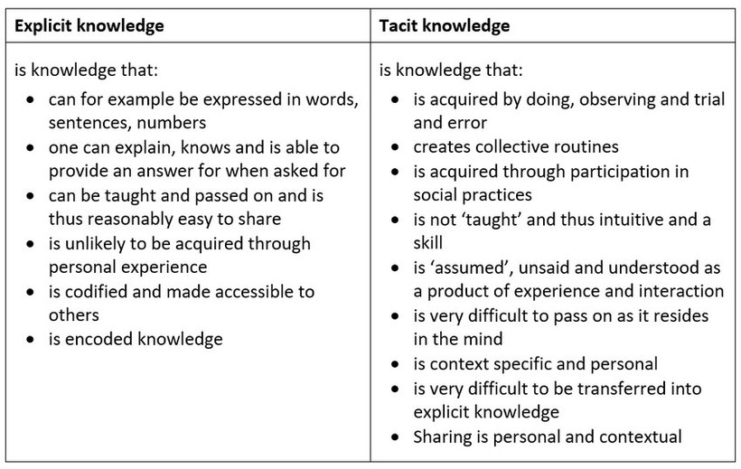
We can observe a further example by thinking of how we learn a language. Learning the alphabet, the sentence structure and vocabulary is the explicit knowledge that we acquire. But pronouncing words like the locals or acquiring an accent specific to a region usually requires the acquisition of tacit knowledge, which may well only occur after we have lived in the region for a while and become immersed in the culture. But having obtained the local accent, are we able to recall how we actually did it? Generating innovative ideas could be another example of tacit knowledge. How do we generate new ideas, new ways of doing things and developing a product? Is it based on intuition?

Task: Culture and knowledge (1)
Please look at the two photographs below. The one on the left shows a footstool at a market in Laos and the one on the right rats pinned to sticks in Mozambique.
Note down in your learning journal the impressions that come to your mind when you see these pictures.

Photograph on the left by Adelheid Iken. Photograph on the right by Yeliz Yildirim-Krannig

Sample answer
Other participants noted the following:
- I feel disgusted, how can someone eat rats?
- The people must be really poor if they have to eat rats.
- I could never ever do this.
Explanation of the pictures shown:
In Mozambique and Laos some people see rats as food or bush meat and eat rats out of choice. In fact, it is said that wild rats eat berries and grains and therefore provide safe nourishment.
The picture below was taken in New York’s underground. Many would look at the picture with the understanding that rats are unclean, vicious and parasitic animals that steal foods and are spreading diseases. This may be related to the historical memory of the so-called Black Death, one of the most feared diseases in the 14th century which led to the death of several million people in Europe. It was spread via the bite of infected rat fleas. This experience might have led to the believe that rats are especially unclean animals, unfit for consumption.
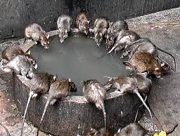
Source: Photograph by Yeliz Yildirim-Krannig
In the temple of Karni-Mata in India rats are treated well and provided with food as the picture below illustrates. Here people perceive rats as holy animals called kabbas. This belief has its origin in the 14th century and is based on the understanding that rats carry the souls of people who have passed away.

Photograph by Simon from Pixabay, licensed under the Simplified Pixabay License.

Task: Culture and knowledge (2)
Now that you know more about rats, read again what you wrote as a first reaction when you saw the pictures of the rats offered in food stands in Laos and Mozambique. Taking into account the explanations from above, how might they help you to understand others and our own behaviour? Note down your answers in your learning journal.

Sample answer
Looking at the picture with rats on sticks was really difficult for me, I must say I even found it somewhat repulsive. The thought of people eating that would lead me to ask myself: "Who would want to eat something so dirty, and what does that say about those people?"
However, after I read the related text, I noticed that the people eating those rats could just as well ask me: "What is your problem with eating rats?" After all, they are certainly not more or less dirty than chicken, cows or other animals that I would have no problem eating off a stick. After reading that my behaviour towards rats comes from historical reasons, with rats being seen as spreader of diseases hundreds of years ago, I came to think that it is worth looking into my own judgments, and to find out where they actually come from. That also helps me to understand behaviour that I do not understand right away.

Task: Culture and knowledge (3)
From your experience, think about one example where knowledge in a work or university context helped you to understand different behaviour or signs.

Sample answer
Linda from Germany did an internship in Shanghai. Working with her Chinese colleagues, she noticed that when they asked her to get something done, they would often repeatedly emphasize how urgent the task was, and ask her days before the agreed deadline whether she could really deliver it on time. She found this rather disturbing since, after all, she had promised to get it done till that day. Her colleagues' reminders would sometimes give her the feeling that they did not think of her as a reliable intern. She would feel even more so when she saw that more often than she was used to, the colleagues themselves would not stick to the deadlines. After she grew somewhat frustrated with this behaviour, she talked with her colleague Xiao Hong about this. She really liked Xiao Hong, and saw her more as a friend than as a colleague.
Xiao Hong explained to her: "I can see that you are frustrated because you think our colleagues do not think you are reliable. But that is really not the case. You see, in our industry, things just constantly change. Deadlines that we agreed on can be quickly obsolete, because the customer does not need something anymore, or our boss changes her opinion. This is why we feel the need of constantly reminding our colleagues that the task is indeed still important. This is also why when you do not remind our colleagues of the urgency once in a while, they might sometimes think that the task might not be so important anymore. This is especially the case when our customers or bosses suddenly give them something urgent to do, which happens very often here."
This information really helped Linda to understand the behaviour of her colleagues and to make her less frustrated. She now realised that this was not something she should have taken personally.

3.5 Culture as learned and passed on
Very closely linked to the idea of culture as a map of orientation is the understanding that culture is learned and passed on. In other words, people are socialised into collectives such as a family, an organisation, a sports club or a university study group. When we say that culture is learned, then we are simply negating that culture is something we are born with. In addition, it refers to the fact that we are able to learn through communicating, following and imitating the actions of others. Furthermore, it highlights the fact that the knowledge and behaviour acquired by past generations is made available to future generations. Of course, some of it may get lost, become interpreted in a new light or changed, but it is potentially available and can be tapped into.
Learning culture is also referred to as socialisation. This process starts with childhood and continues throughout our lives. During our childhood years, we learn simple things such as what is perceived to be proper table manners. We also learn to speak the language of our parents, learn what is considered to be polite, whom and what to trust, how to approach people and communicate with them and how to deal with disagreements. And of course during this time some will attend kindergarden, all will go to school, where we acknowledge and learn from our environment.

Task: Teaching and learning
Look at the picture taken at a school in Pakistan. What do you think is similar to your own school and what do you think appears to be different? Note down your thoughts in your learning journal.
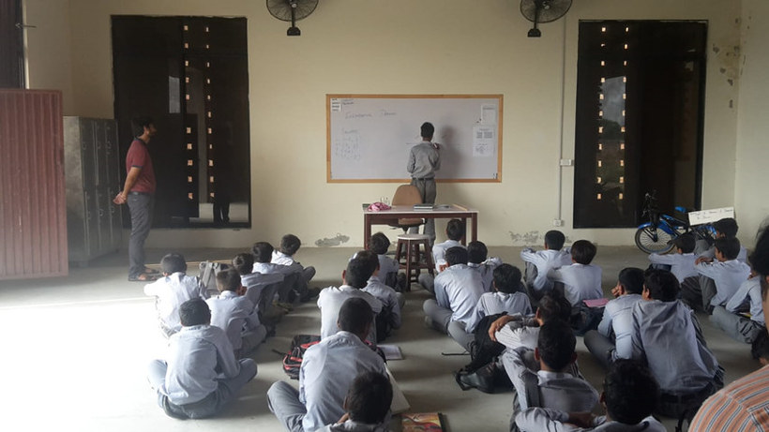
Photograph by Anne Goos (used with permission). Not CC licensed

Sample answer
This is what a German student noted down:
I see a teacher instructing a group of students, one student writing his answer on a whiteboard, books and notebooks near the students. This could be a scene from my own school days.
What is different is that the window shutters right and left from the board are closed may be to keep the sun out, students are sitting on floor, there are no tables, no computers and other equipment. I also observe that all learners are boys or young men and all seem to be wearing the same type of shirt and trousers. Maybe it is a school uniform.
The photograph does not provide any information as to what is being taught and we also do not know how exactly this is done but it does provide indications that formal teaching is a common way of imparting knowledge.

Task: Socialisation across cultures
This is Ernestina (name changed), who grew up in a village in West Africa and came to Germany about five years ago. She is now a trained day care mother and looks after three children. Do you think her upbringing in a village in West Africa and her training as a day care mother influences the way she looks after the children? Note down your thoughts in your learning journal.
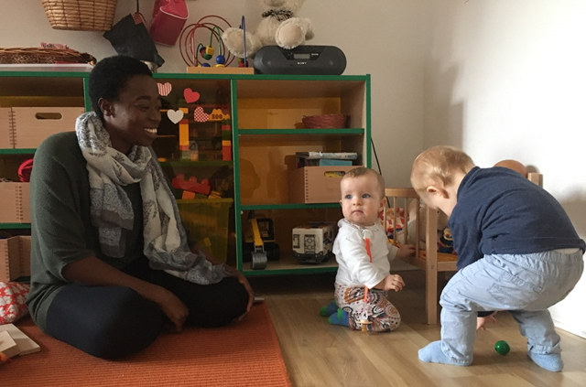
Photograph by Elena Busshoff (used with permission). Not CC licensed

Sample answer
When asked about whether she feels that she trains and educates the children differently, Ernestina said the following:
"In the village where I was born and raised, everybody was expected to look after the children of the village and felt responsible. This is also why all adults were allowed to reprimand children, no matter who the mother was. This is why I feel that all children I take care of here are like my own children, and when they are sick, I carry them around, I console them and feel sorrow. And when they leave I really feel an emotional pain. When I went for training as a day care mother we were told to keep an emotional distance to the children we are looking after. This was new to me and I feel that I cannot follow this advice, it would just not be me. But other than that I follow the script of what I learned during my training and cannot really see a difference between me and my fellow day care mothers."
This is what a mother says about Ernestina:
"I don’t know whether it is her upbringing in Africa or just her personality, she is very warm hearted and when I leave my child here, I know it is being taken care of and you can tell that she loves the children here. Ernestina passed her training and I know that she has all the necessary knowledge about hygiene, healthy food and how to train children."
But socialisation does not stop once we have completed our formal education and (possibly) graduated from college or university. It continues for example when we start working in a company. Here it usually takes place in a formal but also an informal way. The formal process may might involve an initial introduction and instruction regarding ‘the way we do things around here’, whereas the informal way will involve activities such as observing behavioural patterns, asking questions or by listening to stories. Socialisation is thus the process of internalising culture and represents the whole process of learning throughout the course of our lives. It has a major influence on our behaviour, beliefs, and actions both as children and as adults.
Cultural learning as a lifelong process is recognised by companies who appreciate and support a learning culture as part of their organisational culture. When this culture is ‘lived’ authentically by a company, it not only promotes the ongoing development of the employee by providing opportunities to acquire new knowledge, but also supports genuine collaboration among employees and beyond. The acknowledgement that the experiences and knowledge that people bring into the company are hugely valuable assets is a key principle for all learning at the company. This also involves enabling people to learn from their mistakes and actively seeking out challenges, thus enhancing creativity and innovation.
The fact that culture and thus behavioural patterns and knowledge are passed on reminds us that cultural repertoires are not created randomly and thus do not simply happen. This holds true for countries as much as for companies and other collectives. Just imagine you wish to work for a small family business. How much will the history of the company influence the way things are done?
Think about IKEA for example, a flat-pack furniture chain with around 360 stores in over 40 countries, which was founded by Ingvar Kamprad in 1943. It reflects his Swedish roots and his home town Småland in southern Sweden where nature, simplicity and limited resources play an important role in everyday life. This is where Ingvar Kamprad grew up and the values he was enculturated with such as togetherness, cost-awareness, respect and simplicity are still considered to be the guiding principles of the company today, despite the fact that IKEA was founded back in 1943 and its founder passed away in 2018.

Task: Socialisation at Disneyland
Read this short case study and note down the answers to the following questions / tasks in your learning journal:
- Characterise the collective of ride operators
- How were newcomers expected to learn?
- What were they expected to learn?
- What are the key factors that made learning effective?
Since 1955 Disneyland has been a major source of income for Walt Disney Enterprises. With operations in more than 40 countries, Walt Disney’s parks and resorts are among the leading attractions for family vacations and leisure experiences.
Potential candidates for ride operators or other hourly-paid theme park jobs are a fairly homogeneous group, mostly twenty-something tall white males and females with perfect skin who radiate good health. Facial hair, fancy jewellery and excessive make-up are not permitted.
Introductory seminars are held and inspirational films shown to explain Disney’s history, traditions and mission. This encourages the newcomer to feel part of the company and become integrated into the team. Moreover, new recruits go through a forty-hour apprenticeship programme to learn about regulations and procedures. One important aspect is language. Employees receive a vocabulary list with terms used in the company. Customers are called ‘guests’, rides are referred to as ‘attractions’, accidents are called ‘incidents’ and Disneyland is not an amusement centre but a ‘park’.
Introducing newcomers to basic values is another important aspect of the introductory sessions. They learn that ‘the customer is king’ or ‘everyone is a child at heart when at Disneyland’. Furthermore, recruits receive a lesson on how to act when guests misbehave, or how to respond when they face difficult questions. A training manual is handed out so that no one can forget what has been taught.
Apart from the formal socialisation processes, informal socialisation takes place as well. For example, newcomers who do not ‘fit in’ may be the subject of gossip and/or ostracism. They quickly learn that there are differences in how employees are esteemed. For example the type of job, the costume and the working area of the park determine the social status of the recruits. Highly skilled work and glamorous costumes signify higher status. Also, they will listen to stories attesting to the fact that employees are not infrequently fired for taking too long a break, not wearing part of the official uniform, or providing longer than usual rides.
Supervisors are there to help, but if recruits do not play the roles expected of them or do not perform well on-stage, their supervisor will know immediately, as it is their task to monitor and evaluate employees’ performance.
All in all, the socialisation processes at Disneyland are highly structured and effective. Indeed, it is surprising that employees appear to be willing to play the roles expected of them with a positive attitude and kind smiles while being constantly monitored, notoriously underpaid and under strict supervision.
Source: cf. Brown, Andrew (1995). ‘Organizational Culture’. London: Prentice Hall, p. 55; The Walt Disney Company https://thewaltdisneycompany.com/about/#global (accessed on 12.11.2020)

Sample answer
This is what Marie noted down:
Characterise the collective of the ride operators
One of the characteristics is that ride operators uses professional jargon provided to them as a kind of vocabulary list at the start of their service. They share professional values specific to Disneyland such as considering the customer as ‘king’ and are taught how to behave according to these values. Social stratification reigns in this collective, costumes and the working area are indicative of that. Subordination is another major principle which defines functioning of this collective.
How were newcomers expected to learn?
Newcomers were expected to learn from trainings through which they receive explicit knowledge, and from informal sources (e.g. communication with colleagues) – to get implicit knowledge.
What were they expected to learn?
Newcomers were expected to learn values, principles of behaviour and rules of hierarchical organization.
What are central factors which made the learning effective?
Among the central factors clearly was that the training was structured and embraced a whole range of aspects controlling the working process. One factor also likely to be was that the company made a great effort making employees feel proud to be part of the company. Perhaps another aspect to be mentioned here is the place itself, which for many people is associated with magic, childhood and fairy tales.

3.6 People as products and producers of culture
Culture can be perceived as acquired knowledge that people use to make sense of the world around them, to interpret experiences and generate social behaviour. The knowledge of one cultural group is distinct from the knowledge of another group and this enables group members to behave in a way that is meaningful to them. This means that we can think of culture as a cognitive map, frame of reference, or guidelines that informs us how we ought to behave and see the world. Such cognitive maps can be viewed as an aid to orientation and they help us to assess what is right or wrong. As such we are products of culture because we are socialised, shaped and influenced by the cultures we are part of.
However, having a map of orientation does not compel us to follow a particular course. It also does not mean that such maps cater for all circumstances and are unchangeable. We can, for example, deliberately depart from certain ideas or norms or even reject them altogether. A young woman, for example, who has been socialised into following the life path of her mother as a housewife who raises children and takes care of the household, may respond to educational programs that support women to carve out their own independent career. This means that culture can change, in this case as a result of knowledge acquisition.
And we are also producers of culture. In fact, we are constantly involved in cultural production, although in most cases unconsciously. For example, when we get a call from friends asking us to join them for dinner in the new 'cross-over' restaurant offering a fusion of cuisine from India, the Caribbean and China, we are involved in the production of new culture. Another example might be when we try the new ice-cream flavour containing a salty-liquorice taste. Whereas cultural production in the area of food, music and art is widespread and well known, we are also involved in producing culture on a much more conscious level.

Drinking water from the tap or from a bottle?
Think about daily routines and standardised activities which seem so natural to us that we hardly reflect on them or think about them much. For example, it may have become very natural to us to drink water from the tap. When we are in another countries we may realise that this is simply not done, and for very good reasons. Therefore we simply adapt and buy water in bottles. So, being exposed to a different context makes us change and adjust: Drinking water out of a bottle becomes a new routine.
Think about possible explanations for drinking water out of a bottle. Then click on the picture below to view some suggestions.

Sample answer
What could be possible explanations for drinking water out of a bottle?
- Hygiene norms
- Trusted quality of water manufacturer
- Bad experience from drinking polluted tab water
- A bottle is portable – you can drink water anywhere you want
- Water can be flavoured – lemon, strawberry, ginger
- You always know how much water you drink a day – 1 litre, 2 litres
Another example of cultural production in a German context would be the 'Urban gardening' trend which started to boom about 10 years ago and refers to the establishment of small gardens in urban areas to grow vegetables, flowers and plants either in repurposed or previously unused areas. Many of these new 'gardeners' are not skilled and started to garden because they appreciate and value growing their own fresh vegetables.
Our map of orientation is influenced by many factors. One influencing factor might be the experiences we have, which initiate a change. Another could be the result of a negotiation process among team members. When a group of people start working together, they are likely to attune their working routines to each other. This may be the result of a negotiation and adaptation process among team members, but it may also be enforced due to company regulations or contextual factors, as in the case of Covid-19.
In the context of the Covid-19 pandemic, people around the world were explicitly forced to change their behaviour in some countries and in others people changed voluntarily. This included people changing their ways of greeting, even in environments where it is common to hug and kiss each other. In cultures where people are used to standing very close to each other, this meant learning to maintain distance to other people and to many people around the world it was uncommon to cover their face and mouth.
Power, as the term already suggests, is a very forceful generator of change and may directly or indirectly influence our map of orientation. Of course there is formal power, which is the most obvious type, e.g. the power a superior has to influence the action of an intern. But in intercultural communication we are particularly concerned about the subtle aspects of power and how they impact interactions. For example, by excluding others, we exercise power. We also need to be aware that the norms and standards dominant within a culture are essentially the result of a power struggle. Over the course of time or through indirect and direct negotiations, certain people have made a particular set of behaviours the norm and standard.
People living now are the bearers of the culture they received from prior generations, but they are also the generators and carriers of culture into the future, as they adapt, develop and possibly reject particular aspects of it. Culture thus refers to a living system. We are the products of culture but at the same time producers of culture. This shows that culture is an ongoing process and underlies constant changes, some of which are hardly noticeable. Others are more profound.

Task: Culture scripts – giving a tip

Photograph by Adelheid Iken
This picture was taken in Spain and illustrates the act of giving a tip. We observed that in the restaurant it was common to ask for the bill and the waiter would then bring it to the table on a little tray, on which you would place the money. The waiter would then take it away and bring it back with the change and place it on the table. It was then up to you to decide whether to leave a tip and also how much you would leave. We also observed that it is common practice to leave the tip on the tray and walk away. Once or twice we tried to place money on the little plate enough for the bill and the tip we wanted to leave. We then told the waiter 'it is fine' and that there was no need to come back with the change, as would be common for example in Germany. But he took no notice and still brought back the change.
- What could be reasons for leaving the tip on the tray and walking away, as observed in Spain?
- What could be reasons behind a different system, whereby the tip is added to the total amount of the bill, and the waiter is told that (s)he can keep the change, as would be the case in Germany?
- Would we expect that the routines are the same in all Spanish restaurants?
- What could change the behaviour of the waiter?

Sample answer
What could be reasons for leaving the tip on the tray and walk away, as observed in Spain?
One possible reason could be that doing it this way means that the customer takes some more time to judge the level of the service, and the amount of tip that would reflect on this estimation. We also would not have to see the waiter's direct reaction to the tip, which would avoid any awkward social interaction if the tip was far below expectation.
What could be reasons for adding the tip to the amount of the bill and letting the waiter know that (s)he would not need to bring any change, as would be the case in Germany?
This way of tipping might save time for the customer, as he will not have to wait for the change if he considers it a tip anyway. It would also save time for the waiter, as he will not walk back to the table with the change if the customer does not need it. The Germans might not see the danger of a social awkwardness, and value the honesty in the direct interaction instead.
Would we expect that the routines are the same in all Spanish restaurants?
To find out if our observed behaviour is the same in all Spanish restaurants, it would be possible to asks locals about this tipping ritual. Of course, making the same observation in several restaurants might also give us the hint that this might be true. We might be able to learn that tipping could be generally more expected in higher than in lower priced restaurants.
What could change the behaviour of the waiter?
The answer to this question brings us back to our topic of people being the product as well as the producers of culture. If the waiter was used to the tipping behaviour we observed, what could make him change his cultural behaviour, and thus a producer of culture? The customer could explain to the waiter that unfortunately, he would not have much time today, and ask the waiter if he would be ok with simply keeping the change this time. The waiter might see this as unusual, but still acceptable behaviour, influenced by the circumstance. This would be a way to change the waiter’s behaviour in the short term. In the long term, an external factor like the pandemics in 2020 could influence this behaviour, as bringing back change also adds another step in human interaction that might need to be avoided to lower the possibility of spreading the disease.

3.7 Culture and its link to context
When we talk about context, we refer to a specific setting, environment and circumstances in which an event occurs or something is communicated. From a constructivist perspective, culture is constructed by the members of a collective and people can, depending on the circumstances activate elements from their map of orientation. This also means that people apply, adapt or reconsider their cultural repertoires depending on the specific situation and environment.
Hoffman and Verdooren (2019) refer to an incident in the 1990s when the Dalai Lama toured Europe, meeting leaders and heads of state including the Swedish King. The Dalai Lama approached him by folding his hands in front of his chest and bowing which is the typical ‘namaste’ greeting, while the Swedish king stretched out his hand for a customary handshake. This obviously produced confusion. When, some days later, the Dalai Lama visited Norway, he was welcomed by the Norwegian king with a ‘Namaste’ greeting. However, the Dalai Lama also had prepared to adjust his greetings and was ready to shake hands, which caused more confusion, but more importantly showed that people apply their cultural repertoire within a given context but also adapt their repertoire according to the context in which they communicate or interact. This adaptation at times takes place unconsciously and at times consciously.
A very good example in this context are expatriates or emigrants. A German manager who lived and worked in Portugal for many years, for example, will have adopted some of the cultural repertoire he experienced while working in the foreign company. This will become part of his 'cultural backpack'. Upon his return to Germany he may unconsciously apply his newly gained experiences and knowledge. This may become especially challenging because his colleagues and friends might expect him to still be the same, and show little understanding for behavioural changes from his side.

Task: Culture and context, the job interview
Imagine you are invited for a job interview. Would this context influence your choice of clothing? And if so, how? Note down your thoughts in your learning journal.

Sample answer
This is what Louis noted down:
I believe it would. I usually dress pretty casually, with a pair of jeans and T-Shirt in the summer. This is also influenced by the friends from my various multi-collectives that I am a part of. My family, the students around me and for example my friends from sport do the same. Depending on where my job interview was, I assume the expectation to dress up would be different. If I were to apply for a job in the local supermarket, I would probably not change my clothes, since I often see the people working there dressing as casually. However, if I were to apply work in a bank, I would definitely wear a business suit. The culture within a bank is much more formal. Since I do not go there as a customer but an applicant, it would be important for me to leave a good impression, and show that I could fit in. It would be then important for me to adapt to the culture of the bank, and dress very formal for my job interview.

3.8 Summary
Culture refers to groups of people, the boundaries of which are blurred. The members of the group share a certain amount of explicit and tacit knowledge and have developed a sense of familiarity through a system of shared codes and routines. In accordance with our understanding of multi-collectivity, a person’s identity is linked to his or her affiliation to multiple groups and thus collectives. From such a perspective, national identity can be seen as just one affiliation among others.
Culture is not something we are born with, but is learned. This socialisation process takes place within the family, but also at school, university and within a professional environment. Our primary socialisation process takes place within the family in which we grow up and our family therefore equips us with basic cultural knowledge. This makes us a product of culture. However, as we move through life and are exposed to different experiences and knowledge, our cultural orientation may change. As we interact and communicate with others, we are also producers of culture. Finally, there is a close link between culture and context, which means that we can choose from our cultural scripts and thus adapt our behaviour depending on circumstances and the environment.
When we are aware of our cultural orientation it is easier to understand the behaviour of others. Developing a thorough understanding of our personal behavioural preferences will therefore be the aim of the upcoming session.

3.9 Learning review
After working through this session, you should be able to explain the different characteristics of culture and apply them to your personal cultural context. The following tasks will help you assess your learning.
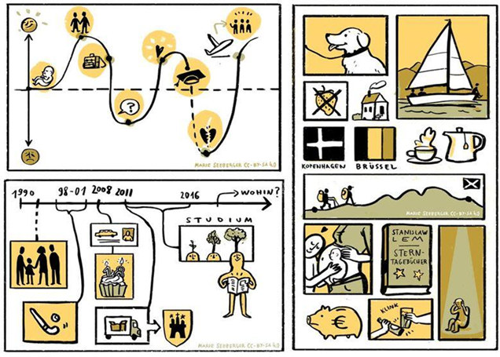
Illustration: Marie Seeberger (www.behance.net/marieseeberger) CC-BY-NC-SA 3.0 license

Task: Biographical reflections
Look back at the course of your life and sketch out important steps, phases or situations which you think have had a strong influence on your cultural orientation. Once this is done, carry out the following tasks:
- Note down at least three collectives of which you are a member and characterise them.
- Note down what you have learned in the course of your life that is beneficial to what you are doing today.
- Choose one example and indicate in which context you gained specific knowledge and how.
- Give two examples of explicit and implicit knowledge that you have acquired in the course of your life.

Sample answer
Name at least three collectives you are a member of and characterise them
My family (I have no brothers and sisters and growing up in a small family meant that I spent a lot of time with my parents. It was only when I went to the kindergarten that I came in close touch with other children and had to learn to share and be sociable. Another characteristic would be that we always shared a meal and talked a lot to each other. My father introduced me to the local football club and I started to appreciate playing football. What also characterises my family is that we still do many things together, even though I am a student now, we still go together on vacations, spend Christmas together and celebrate our birthdays)
My study group at the University (We are a group of three and started to learn together in term one and have grown quite close which means that we also talk about private issues, eat together and at time meet outside the university. Asked to characterise my study group I would say we are all pretty ambitious and are ready to share our knowledge and experiences. I would also say that we are all new in town and therefore enjoy exploring the city)
My friends from the kindergarten and primary school (Well, it is a long time since I went to the kindergarten and primary school in my home town. May be it is because I am single child that I still feel very attached to many of them. We try to meet during Christmas time and share the memory of our childhood but when I come to think about it, I think we also feel close because of the things we learned and the values which are important to us)
What have you learned in the course of your life that is beneficial to what you are doing today?
Apart from knowledge such as reading and writing, speaking different languages, math and many other subjects norms of behaviour are critical. For example the general etiquette like how to be polite, greet someone, behaving in the classroom is beneficial when studying. I also feel that having learned to concentrate and how to deal with texts are pretty important. May be also having a general knowledge of history, philosophy, technologies, law, economics is helping me but to bring it to the point I think it is very difficult to say what is beneficial.
Choose one example and indicate in which context you gained specific knowledge and how
I learned English at school but had the opportunity to spend three months in Australia as part of an exchange program. Learning the language in a country in which it is spoken made all the difference because instead of learning vocabulary I simply observed and learned by listening and watching. And I not only learned the language and some local vocabulary such as saying ‘How is it going mate’ but also customs and behavioural patterns which were new to me.
Give two examples of explicit and implicit knowledge you have acquired in the course of your life
- Explicit knowledge – grammar rules of the English language
- Implicit rules – how to articulate sounds and partially get rid of my Russian accent

3.10 Sources, further reading and web links

Sources
- Hansen, K. P. (2009). Kultur, Kollektiv, Nation. Passau: Karl Stutz.
- Hoffman, E., & Verdooren, A. (2019). Diversity competence. Cultures don’t meet, people do. Oxfordshire: CABI.

4. Social behaviour and culture or how do I want to engage with others?
Topics
4.1 Prelude 62
4.2 Introduction 62
4.3 The link between culture and social behaviour 62
Task: At the doctor 63
Task: The missing information 64
4.4 How do we want to engage with others? 66
Task: My fellow researchers 67
Task: Getting to know each other 67
Task: Working together? 68
Task: Hierarchical versus egalitarian orientation 69
Task: A cup of coffee with my professor 69
Task: What you think and what you say 70
Task: A team presentation 71
Task: Business deal 72
Task: Differences in time orientation 73
Task: Opening hours 73
Task: Getting to know myself and my cultural orientation 73
4.5 My cultural identity profile 74
Task: My cultural profile 74
4.6 Bridging cultural differences 76
Task: Comparing profiles 76
Task: How to bridge the differences 78
Task: Bridging cultural differences 79
4.7 Summary 79
4.8 Learning review 79
Task: Case "To cut a long story short..." 79
4.9 Sources, further reading and web links 81

Learning outcome
Based on your personal cultural identity profile you will critically evaluate your own behavioural preferences and those of others within a specific social and work context. In this way you will learn how behavioural differences can be leveraged.

Objectives
At the end of the session, you will be able to
- develop your understanding of the connection between culture and social behaviour
- discuss and apply key cultural frameworks
- evaluate a personal identity profile
- recognise and leverage behavioural differences

4.1 Prelude
In the previous session we analysed the central characteristics of culture and in doing so emphasised that we are multicultural and multi-collective people. The realisation that culture is learned served to remind us that parents and other socialising agents taught us what is considered appropriate and inappropriate behaviour. We also learned that we are a product but also producers of culture. Finally, focussing on the characteristics of culture helped us to understand better who we are and why we tend to behave in certain ways.
People we meet often behave similarly to us in some ways and differently in others. This can, but does not necessarily have to cause confusion and conflict. However, because we tend to take our own behavioural orientation for granted, it is important to become aware of our own cultural identity and behavioural patterns and then develop skills to leverage differences. To this end, the following session will not only explore the link between culture and behaviour, but invite you to explore your own cultural identity and find means by which we can leverage cultural differences.

Download: Learning journal for session 4
Learning journal (.docx) Learning journal (.odt) Learning journal (.rtf)

4.2 Introduction
People's attitude towards engaging with each other as well as their social behaviour can differ greatly. In the first session, for example, we examined the relationship between students and professors and how students approach superiors. The case study of a German businessman negotiating with his Chinese counterparts showed us how differences in the pace of negotiations can influence behaviour. When he openly accused his business partners of having a malevolent intention, this was clearly perceived as inappropriate.
In order to understand our own cultural self when we interact with others, we will develop our personal cultural profile and use this to understand behavioural differences. Through this we will analyse the expectations that people may have of us and the assumptions they make when they interact with us.
With this in mind, the aim of this session is to analyse key behavioural orientations. This will provide us with insights into how behaviour may differ and what our own behavioural orientation might be with regard to culture, context and the people involved. By developing our own cultural profile along several parameters we will be able to use it to detect potential differences as well as commonalities with cultural others.

4.3 The link between culture and social behaviour
When we talk about social behaviour, we refer to the way in which people within and between collectives interact and how they relate to each other. Social behaviour therefore describes the general conduct exhibited by individuals within a collective. When a child learns to ‘behave’ and act in a way which is considered appropriate by their environment, they acquire culture, a learning process which continues throughout life. Being socialised into a community or collective usually means having and sharing deep-rooted beliefs, values and assumptions, most of which are taken for granted and unconscious.
Let us consider eating habits for example. At some point in time, specific behavioural patterns started to be considered appropriate by most members of the collective and as such these became part of normative behaviour. This explains why members of societies in which food is commonly eaten with a knife and fork consider this to be normal and appropriate. As a consequence, they are likely to view other eating habits with disdain or even disgust and may for example consider belching as completely inappropriate. They do so because in their communities different eating habits are deemed appropriate and well-mannered. The way we behave and what we consider to be ‘good’ behaviour is thus not naturally given, but developed in response to both the environment and the available resources. These are passed on to the next generation as ‘proper behaviour’ and as part of our culture.
When interacting with others, there are, however, two other components which influence social behaviour. These are the characteristics and personality of the actor or actors and the situation or context which governs the interaction. This means that despite a person's propensity to behave in a certain way, their behaviour may change depending on circumstances. For example, we might have a preference for direct communication due to our cultural upbringing, preferring to clearly spell out what we want. However, in specific circumstances, for example when we want to ask somebody for a favour, we may deliberately or intuitively revert to a more indirect communication style.
Generally speaking, social behaviour is acquired and learned through observation and interaction. It can be viewed as a socially perceived routine and expected sequence of actions, or an understanding of how things should be done.
Let us start exploring the link between culture and social behaviour by analysing two case studies.

Task: At the doctor
Imagine you need to go to the doctor and are asked to wait in the waiting room to be called upon. In the waiting room, there are many chairs and there is only one other patient. Where would you choose to sit? Selecting from the list of available options below, which you will also find in your learning journal, tick the one or the ones you consider to be relevant and note down why you have chosen this particular seat.
- You choose to leave at least three chairs in between you and the other patient in order to avoid any infections
- You want to sit far enough away so that the likelihood that the other patient talks to you is minimised
- You want to sit close to the window and are not concerned about the other patient
- The other patient looks to you like a very empathic person and you choose to sit within ‘talking distance’
- You don’t want to sit at the other end of the room because the other patient may feel intimidated if you choose the furthest seat from her
- You want to sit next to the door so that you can quickly get up when called upon
- You want to sit very close to the other patient so that you can console her and have a good chat
- Another option...
Whatever seat you choose depends on a variety of factors which include person, culture and context (PCC). You may be a person who is very communicative and likes to get to know other people, i.e. your personality would be involved here. On the other hand, you may have learned that sitting next to a stranger in an otherwise empty room may be perceived as an intimidating and uncomfortable experience and inappropriate. This thought relates to culture. Last but not least, the context in which the interaction occurred plays a role. Your choice might have been different, for example, if you had been waiting at an embassy in order to obtain a visa for a country you would like to visit. In this case you would have hoped to gain some helpful information from the other person in the room. The context, therefore would have informed your decision.
We don’t usually spend time thinking about where to sit in a waiting room and even less so how culture influences our choice. However, this experiment serves to make us more aware of how the aspects of culture, person and situation govern our behaviour. And this, in turn, is an important stepping stone towards dealing with behavioural differences. So let us look at another example:

Task: The missing information
You are working on a project with four others and have been asked to prepare a presentation of your results. The deadline is tight and when you realise that you need information from your colleague Huan, one of the team members, you are not too sure what to do because Huan is out of the office for the afternoon and cannot be reached. However, you know that the file with the information must be on his desk. What do you do? In your learning journal, tick one of the three options.
- You know that the documents must be either on Huan's desk or in his filing cabinet, so you walk over to his desk and search for the information you need.
- You walk over to Huan's desk and see whether the file with the information is visible, but feel reluctant to actively search for it.
- You leave a note on Huan's answering machine and wait for his return to the office.
Regardless of the choice you make, you cannot be sure of Huan's reaction. Read through the different possibilities and think about explanations for any of his possible reactions:
- I can’t believe that my colleague actually went through my file and documents. I feel that my privacy has been truly invaded.
- I feel sorry that I couldn’t be reached and am glad that my colleague took the liberty to search for the missing information. I don’t mind my team members doing this, we are in this together.
- Well, I guess that my colleague was under pressure and didn’t really know what to do. But going through my filing cabinet and documents has left me with an unpleasant feeling of 'invasion of privacy'.
Again, when looking back at the situation and analysing it, we need to consider: Person, Culture, Context (PCC). On the cultural level, we can draw a distinction between people who have a strong feeling about what is private and what is public. In our case Huan may be a person who feels a strong sense of ownership regarding the information he holds and therefore perceives the act of searching through his documents as an invasion of privacy. Other people may be less concerned and feel that because they are a team, information should be shared without any fuss and if that means searching for it, then that is fine. So, how you generally perceive what is private and what is public is also related to culture and how you have been socialised.

The PCC model
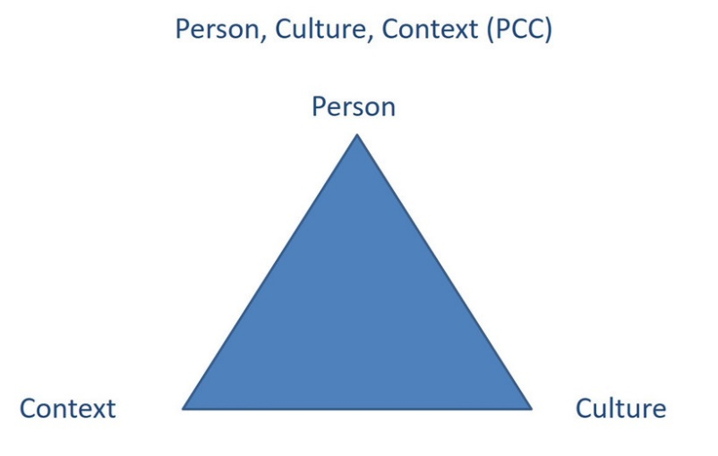
The PCC model reminds us that culture is not the only aspect which influences behaviour. As Barmeyer and Haupt (2007) argue (and the PCC model indicates,) other factors that require consideration are the characteristics of the actors involved and the context in which the situation is embedded. For example, when considering the person or persons involved, we need to think about their position and function, their personality, their way of communicating, their ability to adjust, their experience, and their openness to difference, to name but a few. The factor situation includes aspects such as the physical context, power relations, the organisational structure, the organisational processes, the competitive situation, and the project constellation.
As we have already mentioned, there is an immense variation in social behaviour in and across societies and collectives. Considerable research has been carried out to analyse and compare the different ways people interact and relate with each other. Probably the best known researchers in this field are Geert Hofstede et al. (2010 Cultures and Organizations: Software of the Mind, revised and expanded 3rd edition, New York: McGraw-Hill), Fons Trompenaars & Charles Hampden-Turner (1998 Riding the waves of culture; New York: McGraw-Hill) as well as Edward T. Hall (1959 The silent language; New York: Doubleday; 1966 The hidden dimension, New York: Doubleday).
What these researchers have in common is the search for features or dimensions which can help us to analyse a society and compare it with others. Their conceptualisation of differences centers on values, arguing that a society socialises its members into distinct value priorities. Individuals are then driven by this value orientation to behave in a way which is compatible with the values they have internalised.
In doing so, Geert Hofstede, for example, scores countries on several value dimensions. However, many researchers have criticised his work because using country level scores assumes that the average values are broadly representative of the entire country, which is questionable. Another critique relates to the generalisation of cultural patterns regardless of the specific situation. Finally, Hofstede assumes that value orientations remain fairly stable at the micro- and macro-level. Yet, there is enough evidence showing drastic behavioural changes within societies, e.g. due to digitalisation and technological advances.
One way of acknowledging this critique and at the same time benefiting from their work is by considering individuals and their orientations, thereby using cultural dimensions as a general framework to understand in which ways people’s behaviour may differ and how we perceive our own general behavioural orientation. In this way we are not considering country and country level scores. The following dimensions have been chosen because they provide us with a good orientation of the different ways people may relate to each other in a work context. The six dimensions are:
- task versus relationship
- independent versus interdependent
- egalitarian versus status orientation
- direct versus indirect communication
- risk versus certainty
- monochronicity versus polychronicity
Following Lane et al. (2019) and the approach of mapping cultural and other differences between people who meet and want to work together, we will introduce and explain the six dimensions and use them as a basis for mapping and thus developing a personal cultural profile.

4.4 How do we want to engage with others?
An important element in mapping investigates the question of how we want to work together. Lane et al. (2019) introduce five cultural dimensions, developed in conjunction with GlobeSmart, which they consider to offer a good combination of validity and practical relevance. These are: Task versus relationship, independence versus interdependence, egalitarian versus status, directness versus indirectness and risk versus certainty. The dimension of time was added in this context because it plays such a vital role in a business context.
If we use these six dimensions to map our cultural profile, then we are encouraged to acknowledge individual orientations and also the image people have of us in a specific context. Mapping occurs by locating each individual between a high and low orientation on each scale. This, of course, can never provide a completely accurate reflection of a person’s behaviour. One reason for this is that when we place ourselves on a scale, we necessarily implement our own unique understanding of the particular concept. I may or may not share some of this understanding with others. Nevertheless, it does provide us with a basic orientation.
First, we will examine the cultural dimension task versus relationship. This dimension refers to the fact that people who work together must complete a particular task, while at the same time taking care of relationships with their team members. In any team there are likely to be people who primarily want to focus on the task and the production of results. Consequently, these people will place a lot of emphasis on goal setting and planning. There may be others, however, who consider it vital to establish good relations with their work colleagues before and while performing the task at hand. These team members will be focused on interactions and fostering positive relations as well as taking care of the well-being of their colleagues.

Task: My fellow researchers
Read the case study and find indicators which may suggest that Vadim is more relationship-oriented than his fellow post-graduates. What could be other reasons as to why Vadim’s colleagues are so reluctant to talk about private issues? When answering this question think about the context as well as personal issues. Where might Vadim be making assumptions? Note down the answers in your learning journal.

Vadim is a post graduate student of Mechanical Engineering. A couple of months ago, he joined a research group, and now shares an office with two local post-graduate students. Overall, he likes it very much, and his colleagues are very nice, but he finds it difficult to establish personal relationships with his local co-workers. Even after several months, nothing has changed. He has barely found out anything about their family lives, and when he asks them about their personal lives, the response is usually short and seems rather distant to him. His co-workers just don’t seem very interested in him. And even though he’s been a member of the group for a long time now, so far he has not received a single private invitation. Now he is wondering what he might be doing wrong and comes to the conclusion that apparently his fellow researchers are naturally cold.
Source: Translated and adapted from the research project "Mehrsprachigkeit und Multikulturalität im Studium" (Multilingualism and multiculturalism in studies / higher education, MuMis project, 2011)
Both relationship and task-focused people are usually committed to completing the task and get the work done. However, their way to achieve this goal may be quite different. Task-oriented people tend to get started with their work quickly and consider relationship-building to be something which may develop as work progresses. They are likely to be the ones who develop a step by step plan and concentrate on meeting deadlines and achieving milestones. They are interested in task efficiency. For relationship-oriented people it is important to familiarise themselves with the people they are working with, and this is likely to include getting to know them more personally. Building good relationships first not only shows them whether the person is trustworthy but also lays the groundwork for good communication. Socialising is therefore an important part of work, which might involve drinking tea or coffee or eating together. It may even mean that part of the task is completed outside the office and office hours, for example during dinner or over a drink. Relationship-oriented people are likely to view a good relationship with co-workers and a positive work atmosphere as vital to achieving the necessary results.

Task: Getting to know each other
Read the case study and in your learning journal note down the answers to the following questions:
- Which topics does Karen consider to be inappropriate?
- What could be reasons why Thao is asking these questions?
- Which topics would you consider to be inappropriate in this context?
At the beginning of a two day workshop at a German university, participants are asked to get to know each other. To this end, participants meet in pairs. Their task is to introduce each other and share personal information. Karen meets Thao, an international student from Vietnam. When she introduces herself, Karen touches on fairly general issues related to her studies, travel and hobbies. Thao, however, is interested in knowing more about her career and financial plans, and asks whether she is married and what her financial background is. Karen considers these questions to be very personal and decides to give only very vague answers. She is glad when this ‘getting to know each other’ activity is over and decides to keep her distance from Thao.
Source: Based on a critical incident from the MuMis-Project 2010, C05;
http://www.mumis-projekt.de/mumis/index.php/ci-datenbank/situationen-typen/c-kommunikation-in-arbeitsgruppen/c1-gruppenarbeit-im-rahmen-von-lehrveranstaltungen,
accessed on 19.11.2020
The second dimension, independent versus interdependent, refers to the preference of working on our own versus coordinating with and helping each other with tasks. Independent entails giving more emphasis to the pursuit of our own ideas and personal goals and staying in control of events. In contrast, interdependent people share an understanding that the task can only be accomplished through mutual reliance. These people are highly responsive to the needs and expectations of others as well as being ready to support the people you are working with. In order to achieve this, a positive working atmosphere is vital, as well as a sense of loyalty and duty towards others.
This shows that colleagues who value interdependence and independence are likely to approach working together very differently. Interdependently oriented colleagues, for example, are likely to require frequent interaction, assign roles as necessary and are quite flexible in their approach, whereas independently oriented colleagues are likely to be confident working on their own and subsequently reporting back to others when a scheduled task has been completed. For them it is important that roles, once assigned, remain constant and that rescheduling and flexibility is kept to a minimum.
Interactions are important for both independently and interdependently oriented people alike. However, the extent to which they value collective effort differs and this will influence their assumptions with regard to the best way to work together.

Task: Working together?
Read through the case study and indicate why Mihai and his fellow student may have different understandings of ‘carrying out a team task’. Note down the answer in your learning journal.
Mihai is expected to join two other students and carry out a team task. Together they are expected to work on a difficult text and use it as a basis for answering a couple of questions. Mihai is very quick in working through the text and answering the questions. In no time he is ready to share his results with the other team members. He is perplexed and upset when he realises that one of his fellow students is quite annoyed about his approach. All he wanted to do is help!
Source: Based on a critical incident from the MuMis-Project 2010, C03;
http://www.mumis-projekt.de/mumis/index.php/ci-datenbank/situationen-typen/c-kommunikation-in-arbeitsgruppen/c1-gruppenarbeit-im-rahmen-von-lehrveranstaltungen, accessed on 19.11.2020
The third dimension, egalitarianism versus status, refers to how power and responsibilities are allocated and distributed. An egalitarian-oriented colleague is one who believes that all are more or less equal and power and responsibilities should therefore be shared as evenly as possible. The assumption is then that issues should be discussed and decided upon together and that everyone is expected to contribute towards the task at hand. Organisations who have an egalitarian-orientation have flat hierarchies, which means that employees generally have a great deal of independence and are allowed to make high level decisions. The objective of this kind of environment is to maximise employee motivation and commitment, thereby bringing out the best in everyone.
In more hierarchy and status-oriented work environments, people tend to expect that decisions will be made by superiors. Subordinates show engagement inasmuch as they follow instructions and do not necessarily make suggestions or provide relevant information. Power and responsibility are distributed vertically rather than horizontally and subordinates often find it difficult to approach their superiors when problems arise.
Status and hierarchy-oriented people tend to value formal forms of address and titles when communicating. They also tend to emphasise protocol, such as where people sit at a meeting, in which order they speak and how a meeting is run. Highly status-oriented people are also likely to have privileges such as larger and better equipped offices, membership cards or reserved parking lots. In contrast, egalitarian-oriented people are more likely to use and expect first names, speak and interact with the boss in a similar way as one would with a peer. They would also assume that people should receive the same benefits. In this way of thinking, for example, parking spaces would be allocated randomly.

Task: Hierarchical versus egalitarian orientation
Bowing in Japan is part of a long-standing cultural tradition. Use the internet to search the for reasons why people bow, how people bow and when they do so. Note down in your learning journal those aspects which relate to status and hierarchical orientations.
The following short case illustrates the unease of an international student who is invited for a cup of coffee by her professor.

Task: A cup of coffee with my professor
Read the short case and think about how you would have felt as a student in that situation.
Today when I went to the cafeteria, I met my economics professor who was next in line. He greeted me in a very friendly manner and invited me to sit down with him and have a cup of coffee. He said he wanted to learn more about the economic system in my country and that he would really enjoy talking to me. I apologised and told him that I could not stay. But the truth is that I feel awkward about this situation, after all, he is my professor.
The excerpt from an internship report indicates how power distance can influence work processes and be perceived by someone who is not used to a hierarchical system.
"My boss tells me exactly how I have to do my work without allowing me to question or influence his decisions. It therefore sometimes seems to me like I am being controlled. For instance, I had to create an excel-sheet, whose formatting I had to revise approximately ten times before it was suitable. This is new and unfamiliar to me, owing to the fact that I have previously worked for superiors who wanted me to be self-reliant and work independently."
The fourth dimension, directness versus indirectness, relates to a team member’s communication style. Somebody who values a direct communication style has a preference for frank, concise and straightforward communication. The aim is to be as clear as possible, leaving very little room for interpretations and ambiguity, thus ensuring communication that saves time. This is also the case when addressing difficult or critical issues, e.g. when giving feedback or finding errors in work submitted. Direct communication is based on the understanding that the person and the message can be separated. This avoids embarrassing people and threatening their face. Short and precise messages are typical for this kind of communication style, as well as written minutes of meetings and detailed instructions, with little attention to non-verbal cues and reading between the lines.

Task: What you think and what you say
Imagine you are in a foreign country and are offered some food, which to you really looks disgusting. You certainly want to decline the offer, but what would you do or say? Choose an option from the list below in your learning journal.

- "This food really looks different and I am sorry, but I cannot eat it."
- "Thank you very much for your offer, I very much appreciate it. But I am very sorry to say that I won’t be able to stay."
- "This food looks disgusting, no way can I eat this!"
- "That is very kind of you, but I am afraid that I am not feeling well."
- "This food looks very interesting and I wish I could join you, but I am afraid I have a stomach disorder."
- Other: ...
People who have a preference for indirect speech use different ways to express the message and tend to communicate in a way that leaves room for interpretation. Pauses, silence, tone of voice, and body language are important parts of overall communication. When communicating the focus is on the receiver of the message and the understanding that other people may have different views of the subject. It acknowledges that everybody operates within a certain context and that reading between the lines might open up avenues for exploring common ground and points of view without pinpointing. In this way embarrassment is avoided.
The fifth dimension, risk versus certainty, relates to the amount od information that is needed before acting. Of course everybody plans his or her actions, but how many details do they require and how much room are they able to leave for unforeseeable and unpredictable circumstances. Risk-oriented team members value quick actions and are ready to go ahead on the basis of information that only provides them with a rough orientation. They trust that by being flexible and by monitoring the process and being flexible they will be able to make the necessary adjustments as they go along. They are therefore fairly tolerant to change and do not consider rules and regulations to be of paramount importance.
The following example illustrates how this difference may surface in behaviour:
Robert is an engineer who is due to hold a presentation for an international group of colleagues. He spends a lot of time and effort working on his presentation because he wants to give his colleagues all the technical details of the new software necessary for them to implement it. After about an hour into his presentation, Jenny raises her hand, and points out: "Richard, many thanks for your presentation, but it is possible that you could just tell us what time it is rather than explaining to us how the whole clock works?”
For certainty-oriented people, giving and receiving detailed information is crucial order to ensure that everyone is prepared for all possible scenarios. However, for risk-oriented people, this can seem much too detailed as they would prefer to simply learn from experience and make adjustments when necessary.
People who have a preference for avoiding uncertainty require a thorough and detailed stock of information as well as a detailed plan before they feel comfortable committing themselves. This might include an intensive and detailed analysis of the issues at stake considering different aspects and points of views in order to avoid possible risks and eventualities. During the implementation phase the focus then switches to staying on track and following the agreed plan rather than adjusting it ad hoc. Having a detailed and agreed plan is perceived as creating transparency for all stakeholders. Milestones are understood as anchors that help to visualise the progress of the project and rules and regulations make it clear which actions are expected from everyone involved.

Task: A team presentation
Read the case study and in your learning journal note down how Alice might explain to Ajul why she finds it difficult to follow his way of approaching the team task.
Alice is a member of a working group of three that is supposed to give a presentation in a few weeks as part of the course requirements. On the initiative of her fellow student, Ajul, they developed a detailed schedule and tasks were allocated to the different members of the group. At the following meeting it turned out that nobody apart from Ajul had followed the plan and schedule. In addition, the other students got lost in discussions about things that were not directly linked to the actual task. This really annoyed Ajul, who kept asking them to stick to the plan and even accused Alice and the other student of being undisciplined and lazy. Thinking back to the work group meeting, Allice realised that for her, it is good to have a plan but this does not mean that it has to be followed meticulously and that it would be helpful to reach an agreement as to how they want to approach their task.
The last dimension is the monochronic versus polychronic notion of time. This influence of this dimension on teamwork is often underestimated. Indeed, especially in the light of the increasing urgency and time pressure that organisations and societies feel, the fact that people may experience time differently has a crucial impact on the flow and coordination of work and how we can best work together.
The following quote from a learning journal indicates a rather time conscious and structured working style.
"It bothers me when I run out of time, that’s why I like to start immediately after getting the task. Especially when we started our teamwork, one of my major personal needs was to clarify which member is responsible for keeping our timetable and work efforts updated so that we all have a kind of a structure which displays our progress and helps us to reach the goal. My personal preference of getting things done immediately and in the best case, being ready at least a few days prior to handing in the task also effects my course of action."
Source: Learning journal, 2020
Within our relationship to time, an important differentiation can be made between monochronic and polychronic time orientations. This refers to whether we feel comfortable multi-tasking, i.e. juggling several things at once or whether we rather have a tendency to schedule our tasks sequentially, accomplishing one task after another. The following is a good illustration of the difference between a monochronic and polychronic working style.
The work of a hairdresser illustrates the polychronic orientation nicely. Especially in smaller salons, hairdressers need to maximise their time. This is why they are likely to attend to several clients at once. One might be having their hair coloured, while another sits under the dryer or is asked to go to the shampoo basin. In between, the hairdresser takes phone calls and makes appointments. A mail courier, on the other hand, needs to behave quite differently, completing one transaction before moving on the next one, since most of his tasks cannot be intermeshed.
Source: cf. Ballard, D. I., & Seibold, D. R. (2003). Communicating and organizing in time. Management Communication Quarterly, 16 (3), p. 387.
The quote also indicates that in addition to the cultural element of monochronic and polychronic time orientations, they can also simply apply to different work contexts.

Task: Business deal
Read through the following case study and in your learning journal note down how the concept of monochronicity and polychroncity can help us to understand Mr. Balto’s and Mr. Bau’s behavioural expectations.
Mr. Baus, an experienced businessman, was sent abroad to negotiate on behalf of his company with a potential sales partner. As agreed, Mr. Baus arrived punctually at his negotiation partner's office at 11:30 am. However, Mr. Balto does not appear until approximately 11:45. He greets Mr. Baus extremely cordially, but does not seem to consider it necessary to apologise for his tardiness. In addition, he seems to make no effort to ensure an undisturbed atmosphere for their discussion. Despite Mr. Baus's presence, he repeatedly makes brief telephone calls and allows himself to be interrupted by colleagues. After an hour, Mr. Balto invites him for lunch and Mr. Baus therefore thinks that now, finally he will have an opportunity to discuss business matters with him. However, even here, Mr. Balto becomes involved in countless conversations. He chats not only with business partners, who all make themselves comfortable at their table, but also with friends who he meets by coincidence. Full of enthusiasm, he introduces each one to Mr. Baus, who becomes increasingly impatient
Source: Based on Zaninelli, S. M. (2005). Six-Stage-Model of an intercultural "Integrative Training Programm", http://www.culture-contact.com/resources/2017-von-Ulrike-Reisach-IKT-Six-stage-model_Culture-contact-Artikel.pdf, accessed on 30.11.2020

Another aspect of time could be seen as the notion of event versus clock time. The 'event time orientation' views time as cyclical and a continuous flow, where tasks are planned relative to other tasks and activities take place in succession from the past to the present and into the future. This means that you ‘call it a day’ not at a specific time but when the work you felt needed to be completed is actually finished. Clock time in contrast works according to precise schedules and activities anchored to time slots. This also means that days, for example, might be compartmentalised into when they begin, what happens after breakfast at a certain time etc., as the picture below indicates.
Photograph by Adelheid Iken

Closely linked to time orientation is the question of flexibility with regard to work schedules as well as our understanding of punctuality and deadlines. This is highlighted by the following case study.

Task: Differences in time orientation
The following short case illustrates different time orientations. Read the case study and in your learning journal note down two positive aspects relating to clock time and two positive aspects about with regard to flow time.
Mr. Miller was the chairman at an international meeting and had asked the group to reconvene at 2.00 pm precisely, since they had a tight agenda for the afternoon.
At 1.50 p.m. most participants had returned to the meeting room and were chatting. At 2.10 pm Mr. Miller started to become restless and impatient, waiting for the last participants to return. Two participants were still in the corridor making telephone calls. They came in at 2.20 p.m., which encouraged Mr. Miller to say in a somewhat irritated voice: "Now, ladies and gentlemen, can we finally start the meeting.” When he said this and looked around, Mr. Miller noticed that some of the participants looked a puzzled and dismayed by the tone of his voice.

Task: Opening hours
Look at the photograph below and consider what time you think the shop will reopen. What would somebody who is used to clearly defined opening hours think about the shop owner?

Photograph by Adelheid Iken
Using cultural dimensions as a framework can support our understanding of possible behavioural differences. They can also help us to understand which type of behaviour we display and expect when working with others, and this insight promotes self-awareness. It also helps us to see differences in behaviour from other perspectives.

Task: Getting to know myself and my cultural orientation
Knowing yourself is a crucial stepping stone in the direction of behaving effectively in an intercultural setting. The dimensions discussed here can be helpful in achieving this self-insight. Read the questions and, assuming a work context, use the scales in your learning journal to position yourself between one and five.
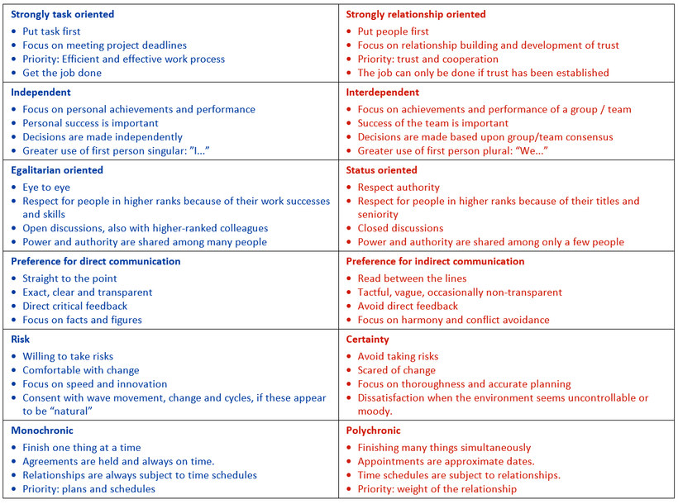
Click on the image for a larger view

4.5 My cultural identity profile
We have already reflected upon ourselves as cultural people. In previous units, for example, we considered our socialisation processes as well as the collectives to which we belong. Subsequently, we examined the typical behavioural patterns that are likely to follow, using cultural dimensions as a framework. In this session we will continue thinking about ourselves and our identity by starting to develop a cultural identity profile. Following Lane et al (2019) we will refer to this exercise as 'mapping'. This way of viewing the process seems appropriate since maps have different levels of detail and are developed for a variety of purposes. The purpose we are aiming for here is the development of a ‘map’ that might serve as an orientation if you were to join a workshop preparing for work abroad.
Using cultural profiles as a basis for mapping and negotiating culture

Task: My cultural profile
Imagine you have been invited to join a workshop whose goal is to prepare you to work abroad. You are expecting to meet new and disparate people who are all interested in preparing themselves to work outside of their home country. In the invitation you have been asked to develop a cultural profile and bring it along to the workshop to enable others to get toi know you. In order to help with this task, you have received a template with some questions that might guide you, but of course you are free to add any information you think might help seminar participants to get to know you better. Please fill out the four different quadrants of your cultural profile in your learning journal.

Your identity profile has four squares and covers issues such as:
- Who am I?
- What can I contribute?
- What have I experienced?
- What is important to me when working with others?
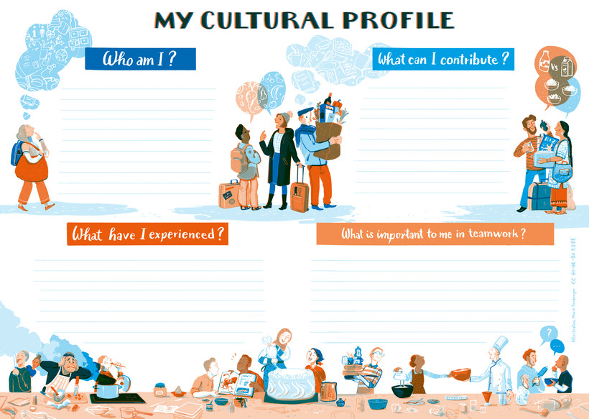
Illustration: Marie Seeberger (www.behance.net/marieseeberger) CC-BY-NC-SA 3.0 license
Click on the image for a larger view.
Who am I?
The answers should provide other workshop participants with personal information (that you are ready to share), which will help them to get to know you better in a work context.
- What is my educational and professional background?
- How old am I?
- What are the main collectives that I belong to? (e.g. professional, leisure time)
- Which collectives still have a strong influence on me when working with others? (e.g. your university, your family, sports club)
What can I contribute?
This quadrant includes information about experiences and competencies you have and which could be helpful when travelling abroad. Questions which may help you to identify these are the following:
- Which languages do I speak and at what level?
- Which competencies and skills can I contribute? These could include previous experiences abroad, openness, interest in other countries and cultures, readiness to listen or exploring and dealing with the unknown.
What have I experienced?
This quadrant involves evaluating past experiences in intercultural settings.
- What motivates me when meeting others?
- What irritates me when interacting with others?
- What drives me crazy?
- What are my trigger points?
- With which groups of people do I find it easy to establish a relationship?
What is important to me when working with others?
- What are my expectations?
- How would I like others to behave when working with me? When answering this question consider the cultural dimensions you dealt with earlier on, i.e. Independence versus interdependence, task versus relationship, egalitarianism versus status, direct versus indirect, risk versus certainty and monochronicity versus polychroncity?
- How is my self-image related to these dimensions?

4.6 Bridging cultural differences
Now that you have developed your cultural identity profile, you are ready to join the workshop and are looking forward meeting other people. One of the participants is Natalia, who is happy to share her profile with you.

Task: Comparing profiles
Compare your profile with Natalia’s profile and, keeping in mind that you wish to work together with her, identify differences and commonalities which you consider to be important. Note these down in your learning journal.
This is Natalia's profile:
Who am I?
I am 30 and I am an experienced female professional in the sphere of languages. My core value is communication. I already have two degrees and am now pursuing a new program to extend my hard skills and develop my soft skills. Currently I am living alone in a foreign country, where I moved last year. Every day since my arrival I face linguistic and intercultural challenges both privately and publicly. My newly acquired intercultural competences have helped me a lot, especially in not forgetting who I am and where I am from.
Everyone belongs to a different set of collectives and I am not an exception. The collectives I would attribute myself to include: my family in Russia, students, students of my university, friends who live in Russia, friends who live in Germany, foreigners from Russia in Germany, women, women aged 30, linguists, Fulda residents.
My family had the most profound impact on me during my upbringing, as well as my school and my friends.
I believe that during my upbringing I was strongly influenced by my school community, since at this school English was taught from the first year onwards and this ended up shaping my professional choice. This school community still exerts a strong influence on both my job choices and my working style. It was there that I first started speaking in public and I have become really passionate about it.

What do I contribute?
My cultural backpack includes my Russian origin, and my knowledge of English and German. I have been to 17 countries and have always worked in intercultural teams. Recently I have begun to work on virtual team projects. From this I have understood that working on remote projects is much more difficult because it requires a higher degree of commitment and stricter self-management. I guess this is not too hard for me because I believe that I am a very responsible team-member who always adheres to rules and shows a high degree of responsibility. When I work in a team I believe I contribute knowledge of the subject, commitment, responsiveness, MS Office skills and intercultural competencies.
What have I experienced?
The feeling of togetherness in a team motivates me to work with others, especially when I understand that there is something important that unites us. Miscommunication irritates me when working with others as do people who are reluctant to speak out. When I understand that I have results to achieve and I also enjoy the goal of the project, I want to get things moving. What motivates me is the nature of the project, because I can’t do something I have no interest in. I feel excluded when people don’t share information and their knowledge. I am a very easy-going and friendly person, and I have noticed that I feel comfortable around people who are open-minded.
What is important to me when working?
One of the most important aspects is to be tolerant and understand each other’s differences and uniqueness. Always being able to listen to each other and really trying to understand the people I am with is key.
On the level of dimensions, I would describe myself as follows:
- Interdependence – Although this sometimes takes longer, I think we can achieve more together than simply working on our own.
- Task versus relationship – I am task-oriented and want to get work done and I like to be focused, but I also believe that knowing the people I work with and socialising with them is very important. I like to strike a balance between task and relationships.
- Status – I respect people who have a higher status, but when working together I think hierarchy should not be an issue.
- Direct – I like to be direct but also don’t want to hurt anybody and feel that being polite is very important, so maybe it is a question of juggling between the two poles when working with others.
- Certainty – Risk is always unavoidable, but being more certainty-oriented can bring more stability. For this reason I like to make plans and have a schedule.
- Monochronicity – I am certainly a monochronic person because deadlines and plans help me to achieve goals and lead to better results.
Detecting commonalities here can help you to find common ground. For example, you might realise that in a work situation you both feel that being clear and direct helps to avoid misunderstandings. At the same time, you might also feel committed to being polite and respectful in your communication and agree on what this means in terms of expression.
However, it is likely that there are also areas in working together that require some significant bridging. Let us look at one possible example.
Imagine that in the context of working together you tend to be a very polychronic person who feels strongly that creating a positive working atmosphere by getting to know each other is crucial, and that developing detailed plans and schedules is not only time consuming but also hampers your ability to be flexible and adjust as circumstances change. Since you now know that Natalia tends towards the opposite style of working, this leaves you with the challenging task of how to bridge this difference.
The PCC-model helps us to put the situation into perspective:
Person(s): Natalia states that she is a very open and direct person, which is something we share. She also has a lot of experience in working with people from different cultures, which is a resource that I do not have.
Context: We are operating in a work context, which means that there is a deadline for the task to be completed. In addition to this, I have other projects to complete.
Culture: We differ with regard to our orientation towards time. Natalia is more monochronic in her orientation, whereas I tend to be the opposite.

Task: How to bridge the differences
Based on these findings, think about how bridging these differences could work. What might working together look like in the future from your perspective?
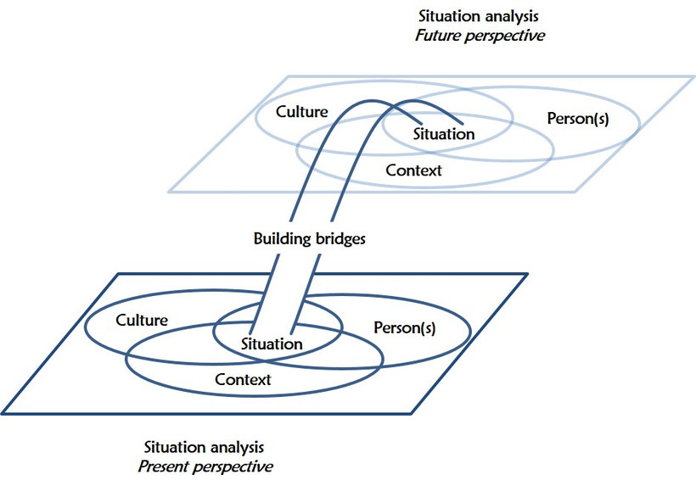
Source: Barmeyer, Christoph & Ulrike Haupt (n.d), reproduced and translated

Building bridges
Lin considers this case. This is how a possible solution might manifest itself from Lin's perspective:
Being an open minded person I would talk to Natalia directly and discuss the differences that were highlighted through the comparison of our cultural profiles. I would then exchange points of view with her on the benefits and drawbacks of approaching work from a polychronic and monochronic perspective. This may already help us to find an avenue to deal with our differences. What I envisage is a compromise, which might entail developing a work schedule and defining milestones, but without this being as detailed as Natalia is normally accustomed to. This would give us room to make adjustments and at the same time have a solid time framework. Additionally, we may want to agree to spend time together on something we both enjoy, which would fulfil my need to build a relationship and establish trust with my colleague. Given the deadline we are facing, I could also envisage giving in to Natalia's approach to a certain degree.

Task: Bridging cultural differences
Comparing your cultural profile and that of Natalia's, choose two areas where you detect differences. Using the PCC-model, carry out a situation analysis, and based on this make suggestions as to how the differences might be bridged. Note down the results of your analysis and your suggestions in your learning journal.

4.7 Summary
When we work together, we are likely to experience behavioural differences. These might at times surprise us, irritate us or pose a problem because they appear to be incompatible with our expectations. In all of these cases it is helpful to consider that culture and behaviour are linked, and that learning which behaviour is perceived to be appropriate or inappropriate is part of our lifelong socialisation process. Developing an awareness of our own cultural orientation and how this influences our behaviour is therefore a good starting point when we are confronted with different behavioural patterns. At the same time, we need to acknowledge that our behaviour as well as the behaviour of others is not only influenced by cultures, but also by personality and context.
Personal cultural identity profiles are helpful when we meet others for the first time as they provide indications of commonalities and differences. They are like maps with varying degrees of detail, which not only raise awareness but can also be used for bridging and thus developing common ground.

4.8 Learning review

Task: Case "To cut a long story short..."
Read the case study and carry out the tasks below as outlined.
Situation:
Mike coordinates the Sales and the PR department of an electronics company doing international business. His two direct subordinates are Jeremy and Miguel. He considers both highly efficient, but for some reason Jeremy appears to work somehow faster. Observing them at work, Mike can’t really notice any significant difference. One day, he asks them to file their yearly reports and have them delivered to his secretary. Both deliver the reports two days later, Jeremy in the morning, Miguel in the early afternoon. Accompanying their reports are these notes:

Jeremy's note:

Miguel's note:
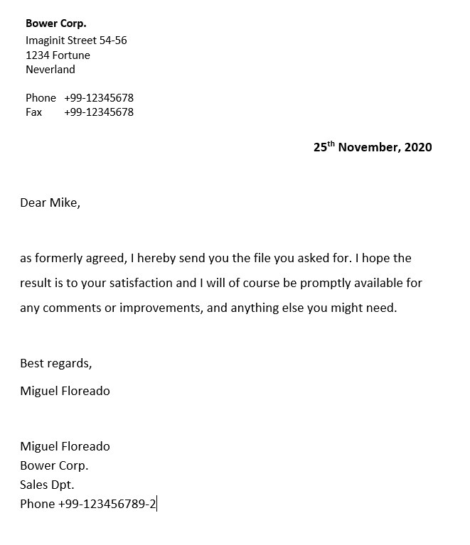
In your learning journal note down the answers to the following questions:
- What are obvious differences you detect?
- Why do you think could be reasons for them to adopt such different styles? Consider culture, person and situation. What might this say about the way they see hierarchy and status?
- We may conclude that Miguel probably takes a bit longer in his tasks because he worries about formalities. Or do we? They both delivered their files within a few hours. - Do you think this allows for an evaluation of his efficiency, given the task they had to execute?
- Do you think his formality necessarily makes Miguel less productive? Can you imagine situations where his formality may be an advantage in a professional context?
- Mike would rather that Miguel wasn’t so formal; not because he is too slow, but because Mike wants him to feel at ease. He considers that it doesn’t matter if Miguel takes a bit longer now and then. What does the fact that he wants to speak to Miguel say about Mike and his cultural orientation? How does Mike interpret formality and informality in terms of efficiency and productivity, and in terms of work ambience? What does Mike consider to be the most desirably work method and why?
- In your own work context, what people and factors influence and determine the way of doing things?
- Who depicts your own cultural orientation best: Mike, Miguel or Jeremy?
This exercise has been developed as part of the European project 'Intercultural competence for professional mobility', ICOPROMO 20070918_B3E (ecml.at) 22.11.2020

4.9 Sources, further reading and web links

Sources
- Barmeyer, C., & Haupt, U. (n.d.). Der Brückenschlag. Zielorientierte Situationsanalyse aus drei Perspektiven. https://www.ulrikehaupt.de/app/download/10055472/Brückenschlag.pdf (accessed on 30.11.2020)
- Hoffmann, E., & Verdooren, A. (2019). Diversity competence. Oxfordshire: CABI.
- Lane, H. W., Maznevski, M. L., & DiStefano, J. J. (2019). International Management Behavior - Global and Sustainable Leadership. Cambridge: Cambridge University Press.
- MuMis. (n.d.). MuMis – Mehrsprachigkeit und Multikulturalität im Studium (Research project on Mulitilingualism and multiculturality in higher education)
- Toronto Region Immigrant Employment Council (TRIEC). (n.d.). TRIEC learning:
https://trieclearning.ca (accessed on 30.11.2020)

Weblinks
- Lifeswap (https://www.youtube.com/lifeswap – Goethe-Institut Neuseeland) is a series of short animated Skype conversations between two young men, Jörg, 27, from Münster, Germany and Duncan, 27, from Wellington, New Zealand. The monthly episodes illustrate their adventures and misadventures during this cultural experiment of swapping their places of living
Unit 10, unit 6, unit 4 and unit 2 have a close reference to the issues discussed as part of this session.

5. Communication and the communication process
Topics

5.1 Prelude 83
5.2 Introduction 83
5.3 Communication, the attempt of a definition 83
5.4 The elements of the communication process 85
Task: My personal distance zone 90
Task: Accents 91
Task: At a hotel reception 91
Task: Counting on your fingers 92
Task: How miscommunication happens 95
5.5 The transactional model of communication 95
Task: The internal audit 97
5.6 Summary 98
5.7 Learning review 98
Task: The meeting 98
5.8 Sources, further reading and web links 99

Learning outcome
You will apply the transactional model of communication to analyse communication situations whilst identifying the influence of the various elements of the communication process on the co-creation of meaning.

Objectives
At the end of the session, you will be able to
- define interpersonal communication
- assess the influence of various components on the communication process and thus the co-creation of meaning
- explain the transactional model of communication
- analyse communication situations based on the transactional model of communication
- argue why it is important to view communication as an ongoing process

5.1 Prelude
In the previous sessions you dealt with various aspects of culture including the concept of culture, the understanding of multicollectivity, your personal cultural embeddedness and the influence that culture has on social behaviour. In this context, communication was referred to as a tool to create and pass on culture and thus as a precondition and basis for social interaction and the development of social relations.
Against this background, this session aims at providing an understanding of communication as a complex, mutual and ongoing process that moves us towards the co-creation of meaning in the sense of developing an understanding of each other’s perspectives. To this end, the following session will introduce and discuss the transactional model of communication and show how it can be used to analyse the influence of context, message, media usage, response, and noise on the co-creation of meaning.

Download: Learning journal for session 5
Learning journal (.docx) Learning journal (.odt) Learning journal (.rtf)

5.2 Introduction
Have you ever thought about what your life would be like without the ability to share your thoughts and feelings with close friends, exchange texts, argue about what you want to have for dinner, discuss your project with colleagues or ask for a pay rise? And have you ever thought of what is involved in order that we might be able to understand each other?
A lot of our communication occurs, in fact, below the level of our consciousness. It “just happens”. However, it is only when we realise that for some reason, we simply cannot understand each other, or when we unwillingly hurt someone’s feelings, for example, that we start to become conscious and ask ourselves what went wrong. In the light of this phenomenon, the aim of this session is to further our awareness of the communication process and enhance our understanding of those elements that influence the mutual construction of meaning such as context, noise and choice of media. In order to clarify our understanding, we will introduce the transactional model of communication, which we will use to analyse the impact of different elements on the communication process and their respective outcomes.
In addition, this session will provide a backdrop for a more detailed discussion of the connection between culture and communication as part of the 6th session.

5.3 Communication, the attempt of a definition
Communication is a term that is as difficult to define as culture because it is used in different academic contexts. It is derived from the Latin word communicare and relates to the words “common”, “commune”, and “community”, which can be interpreted as the activity of ‘bringing together’ or ‘sharing meaning’ and a common understanding. From such a perspective, communication can be understood as a process among people that aims at developing a shared understanding of something and thus developing a shared reality. (cf. Cobley, J. 2008)
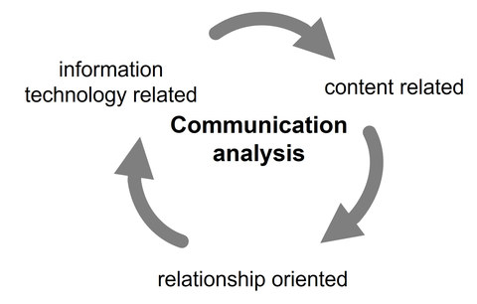
Perspectives from which communication processes can be analysed
Source: Bolten, 2015, p. 12, adapted and translated
Following Bolten (2015, p. 12), communication can be analysed by considering the technical, content and the relational level. On the technical level, communication is referred to as the actual process of transmission and thus the quality and quantity of the information transfer. This is the basis of the well-known communication model by Shannon and Weaver which was first published in 1948. Its value lies in the understanding that information can get lost or distorted in the process of transmission. As today most of our communication scenarios are media-based and wireless, it reminds us to pay attention to technological disruptions such as signal impairment, radio black spots, server, or bandwidth issues along with the asynchronous communication that these problems cause. Asynchronous communication relates to communication that is sent at irregular intervals, such as an email or chat message, and is stored until the recipient chooses to or can access it.
However, reducing communication to a purely technical level would only tell us about the means of transporting information and possible sources of technical disruption, but not about the content of communication nor about what actually happens in the course of the communication process.
If we examine the content level of communication, we see that not only words but also gestures, sounds and other forms of signs and symbols can have a content mediating function. For example, when dusk falls, it is a clear sign that night is approaching. This is therefore a sign based on context. Equally, waving one’s hand is often used as a sign of farewell or a greeting. The important thing when using signs and other symbols is to acknowledge that their meaning is socially conventionalised and not necessarily shared. The content level of a message thus refers to “what” is expected to be understood. In this regard we need to keep in mind that contents are not ’delivered’ from person A to person B but emerge through negotiation in a mutual process of communication. Interpersonal communication is interactive in the sense that it refers to a sequence of communicative moves between two or more people with the goal of reaching a common understanding.
We view communication as interaction because communication is more than simply sharing information, passing on knowledge, exchanging feelings, and points of views. From an interactional point of view, communication also negotiates the relationship people have or establish during communication. The relational level thus refers to the question of “how” communication takes place between people and ’what for’.
Bolten (2015, p. 11 ff.) argues that the medial, content, and relational level are linked and need to be seen as interconnected and dependent on a framework. The framework relates to the context in which the communication process develops, which in turn is co-created by the communicators.
In an overview, this could be depicted as follows:
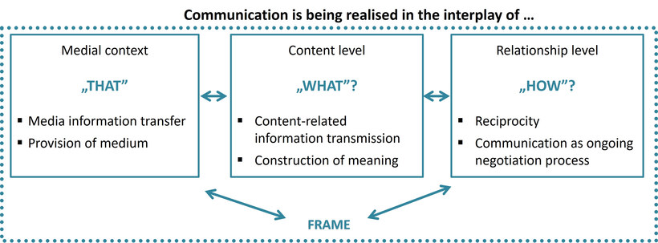
Interplay between medial, content and relationship level via the hermeneutic framework of communicative processes
Source: Based on Bolten, 2015, p. 20, translated
Image by Marie Seeberger (www.behance.net/marieseeberger) CC-BY-NC-SA 4.0 license
As illustrated above, it can be argued that there is an interplay between the medial, content as well as relational level. This supports the understanding of communication as an ongoing process of interaction through a mutual and simultaneous exchange of signs and symbols to create and sustain shared meaning and achieve sense-making in the relationship within a specific context. Communication viewed from such a perspective means that the co-creation of meaning is the basis for achieving our objectives of action.

5.4 The elements of the communication process
The quotes below are taken from emails that were part of an exchange between customers and a supplier of spare parts. Imagine that you oversee customer satisfaction at this company’s logistics department. You arrive at the office on Monday morning to find the following emails from clients in your inbox:
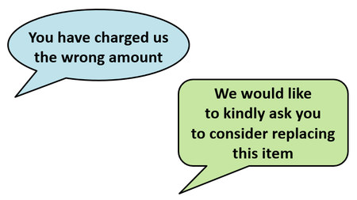

Think about:
- What is the actual content of the two notes?
- What feelings are evoked in you when you read them?
- If the content were part of a telephone conversation, how might the intonation alter your interpretation and how you perceive the words?
- When you read the emails, does the relationship you have with the customer make a difference to the way you interpret the messages?
- Does the number of prior email exchanges influence your interpretation of the content?
- Does the knowledge that your customer is a native English speaker influence how you "read" the messages?
Consideration of these questions can show us how multi-faceted and complex communication is. They highlight how much meaning might be contained in simple messages such as those above. This in turn underlines the relevance of analysing communication situations carefully.
In this session, we will achieve this by discussing the various components of the communication process. At the same time, we are aware that examining them separately has its limitations and serves only for the purpose of analysis, since ultimately, they are all intertwined elements of the communication process.
In essence, we can delineate eight elements of the communication process:
- the communicators or people involved
- the forms of communication
- the encoding and decoding process
- the medium used
- the type and amount of noise
- the context of action
- the response of the communicators and their interpretation
- the co-creation of meaning and outcome of the communication
The following example shows the different elements in a communication situation:
A client and a supplier (communicators) have recently started to develop a business relationship and the supplier has just delivered to his new client for the first time (context of action). Having noticed that one item that was ordered did not correspond to the specifications, the client wants the item to be replaced. As he has been waiting for the shipment for a long time and urgently needs the item, he is quite upset and decides to phone his supplier (medium) and talk (form of communication) to him. During the phone call there are disturbances on the phone line which constantly interrupt the conversation (noise). Both communicators react in an irritated manner (response) and decide to continue their communication via email to ensure that they develop a common understanding of what went wrong (co-creation of meaning) and what needs to be done differently in the future (outcome).
Before integrating these elements into a model of communication, let us look at each of them in more detail.

The communicators
The people involved in interpersonal communication are the communicators. Viewing them as communicators takes cognisance of the fact that they both create and receive messages, and that giving and receiving is not only a reciprocal act, but one that takes place simultaneously. Think about a situation in which someone asks their supervisor for a pay rise. Even while presenting the argument, the person doing so will carefully prepare, anticipate, and design
his or her utterances, whilst observing the supervisor’s reaction. The supervisor may signal concern or surprise and may, at a later point in time, respond verbally to the request. So, while speaking, both continuously shape their speech acts and orient themselves towards the other. This also means that there is an interdependence between the communicators.

The forms of communication
Communication is a process during which people interact while using different forms of communication to create meaning. A basic distinction can be made between oral and written communication. Within these categories, a further distinction can be made between verbal, non-verbal, paraverbal and extraverbal forms of communicating as the following chart shows.
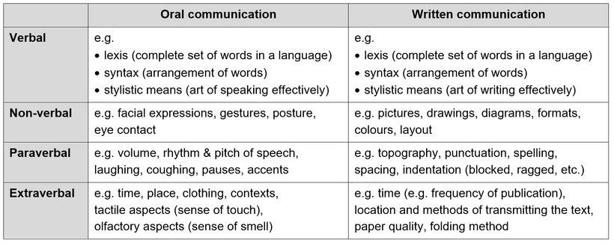
Different realisations of the four communication components
Source: Bolten, 2015, p. 23, amended and translated
Generally speaking, we communicate using signs and symbols that stand for something. Verbal signs and symbols, no matter whether they are spoken or written, refer to the words of a language but also to aspects such as the manner of speaking, the way words are arranged, and the style and ordering of sentences. In contrast non-verbal signs and symbols relate to the language of the body, including gestures, facial expressions, and body posture when engaged in oral communication. In written communication we can also observe non-verbal communication. In this case it is represented by pictures, drawings, and diagrams, for example. Paraverbal communication or paralinguistics include aspects such as loudness, accents, volume, and silence. As the term suggests, extraverbal communication relates to the time and place a communication takes place, but also includes our sense of touch and smell when communicating face to face. In written communication, extraverbal communication refers to time, for example the time of publication, but also to where the text is transmitted and other aspects such as the folding of the paper, for example.
Although meaning and affect is created through the interaction of verbal, non-verbal, paraverbal and extraverbal signs in oral and written communication settings, for analytical purposes they are will be dealt with separately in the following.
Verbal forms of communication
When thinking about verbal forms of communication, language is usually the first aspect that comes to mind. Language can be defined as a system of signs. The signs of a language are known as words, which stand for and represent things. For example, the three letters “d o g” constitute a word because at some point in time people agreed that this word should stand for a domestic animal. But because shared meaning depends on all people involved, the meaning and connotation of what a dog is, may vary. Some people may know a dog as a pet or even a family member. Others may view a dog as a working animal used to round up sheep and cattle. Yet others may simply see dogs as dangerous animals. This knowledge, which is transmitted and backed up by evaluations from our social group, influences our perception fundamentally.
Words are combined in a systematic way and following specific rules and social conventions. Social conventions tell us which signs, in this case words, we should use and how we should combine them to form sentences and communicate in a meaningful way. When we combine words to form a sentence, we apply the linguistic and grammatical rules that we are accustomed to. These practices have developed over the course of time and continue to change and develop further.
For example, among the German speech community it has become customary to use the word “Handy” for a mobile telephone or cell phone, although in most European and some other languages the word “mobile”, or “smartphone”, is common. Among the English-speaking community, the word “handy” commonly means “convenient to use”. What this example shows is that meaning is linked to the social conventions that are known and accepted by its users.
The use of the words “yes” and “no” is another case in point that is frequently mentioned as a source of misunderstanding. Apart from the meaning of “yes” as an affirmation, Hoffman and Verdooren (2019, p. 160) refer to other possible meanings of the word. They argue that it can also mean “Maybe”, or “I’ll think about it”, or “I hear what you are saying” or “Go on with your story”. The latter meaning of “yes” is called a verbal backchannel, where the person receiving the message intends to convey politeness and attention. An explanation for the variety of meanings of “yes” and “no” is that the answer in such cases is strongly linked to the relationship the communicators have rather than the content level (Hoffman and Verdooren 2019, pp. 160f.). For example, a person might be asked by his or her boss who has a preference for direct speech “Would it be possible for you to come in on Saturday for an hour or two?”. Instead of responding “I am sorry, but I will not be able to make it”, thus following their boss’s preferred communication style, may say “Yes,…” while in effect being unable to fulfil the request. The person may say “Yes” because he or she does not want to disappoint his / her boss and may use the “Yes” in the sense of “I will try but most likely I will not be able to make it”.
However, words may not just have different meanings, they can also stand for different social conventions, as the following example from two work colleagues highlights:
A: Well, I’m afraid I’ve gotta go now. Why don’t we have lunch together some time?
B: Ok great, when? Do you have time on Friday at noon?
A: I am afraid not. I’ll talk to you later.
The lexical or literal meaning of the sentence “Why don’t we have lunch together?” is easy to understand. However, the social convention behind the sentence could be that it is just a polite way of saying “I need to leave now and I want to say something that conveys connection and smooths my departure”. Considering the response, it probably meant that they might eventually have lunch together in the foreseeable or non-foreseeable future. The same may be the case for the sentence “I’ll talk to you later” with later meaning “some other time” rather than later during the day or the week. The social convention behind this is likely to be that of a polite marker in order not to disappoint the conversation partner and smooth the social interaction.

Non-verbal forms of communication
Apart from communicating using language, we can equally communicate non-verbally. Whereas verbal signs refer to spoken and written words, nonverbal signs are cues or signals that are transmitted without the use of vocabulary. When speaking, we choose words to convey meaning and these are accompanied by our bodily movements, facial expressions, and hand gestures. These non-verbal signs influence the meaning we assign to the words used. Non-verbal signs can supplement a verbal message, underline it or at times contradict it. For example, we might meet a friend and ask her: "How are you doing?", upon which she might reply: "I'm fine, thanks", even though her sunken face tells you otherwise.
Even for those who place considerable emphasis on verbal communication, the fact that non-verbal cues play a significant role in communication is inescapable. In contexts in which verbal transmission is impeded, non-verbal communicative codes based on gestures, facial expressions, body postures and distances, as well as paralinguistics become increasingly important. In fact, it is commonly argued that non-verbal communication ultimately has a greater impact on the message conveyed. It is therefore understood to be a language that is as crucial to meaning as it is difficult to steer.
For example, expressing one’s feelings in a non-verbal way is very common and there are many ways of doing so. Some people may openly, expressively, and directly show their happiness, surprise, or anger. In an attempt to emphasise a point, express dissatisfaction etc. the entire range of human emotions might be displayed. On the other hand, some people may be much more restrained in expressing their emotions or even try to abstain from showing them openly at all. The way we express our feelings and intentions in a specific setting is strongly influenced by social conventions but also our personality.
Facial expressions may be interpreted quite differently by individual communicators. A smile could be perceived as a sign of joy or affinity when meeting somebody or as self-confidence. However, it may also be interpreted as an expression of doubt or even hostility and interpreted as a malicious grin. Equally, people may confuse others if they smile after having made a mistake. Observers may not connect the smile to the social practice of saving face, which prevents people from letting emotions govern the situation.
The following images show examples of facial expressions. Look at the images and think about which emotional state they may display.

Facial expressions for different emotions: fear, contempt, sadness, happiness, surprise, anger, disgust
Photographs by Elena Martou
Another example is eye-contact. Eye contact can be perceived as a sign of attention, respect or sincerity and honesty. If this is so, people who look away or lower their head to avoid eye contact when talking or being addressed may accordingly be perceived as disinterested, disrespectful, or inattentive. However, the intention may be very different. For example, a young adult lowering his head and avoiding direct eye contact in front of his boss may behave this way to show respect to a superior. It is therefore important to develop an awareness of one’s own and of other people's perception of different facial expressions.
A further aspect of body language is the spatial distance between people, also known as spatial zone or personal distance zone. There are social conventions and expectations linked to this concept. In particular, our unconscious expectations become very obvious when our spatial zone is perceived to have been violated. If, for example, our personal distance zone is set to 40 to 50 cm, and this does not correspond with our communication partner’s spatial expectations, then our behaviour may be perceived to be intrusive, impolite or even intimidating. Negotiating a comfortable, mutually accepted personal distance with our communication partner is therefore vital.
The personal distance zone is closely linked to contact behaviour and touch. People who like to stand apart may also be confused by a physical touch such as patting on the shoulder, the arm or the hand. Greeting each other by shaking hands is also a touching gesture and is perceived very differently depending on the expectations of the receiver.

Task: My personal distance zone
Choose a specific context, for example when queuing up at a shop or waiting at the bus stop, and reflect on your preferred personal distance zone by gradually moving towards the person waiting with you. When do you start to feel uncomfortable? Do you think that the corona pandemic, but also such factors as the gender and body height of the person you are interacting with influence your preferred distance zone? How about the preferred personal distance zone of the other person: Is it similar to or different from yours? How can you tell?
Note down your thoughts in your learning journal.

Para-verbal forms of communication
Apart from verbal and non-verbal communication, we need to add paraverbal communication or paralanguage to our repertoire of communication. Paraverbal communication refers to those qualities which accompany speech and include, for example, our voice’s pitch, rhythm, and tempo, as well as pauses, articulation and resonance. It also includes vocalisation such as laughing, crying, yelling and throat clearing. Some researchers also include vocalisations such as um, ah, ooh, and uh in the repertoire of paralanguage, whereas others refer to it as verbal behaviour. Being sensitive to paralanguage and how it can influence communication can help to improve our common understanding.
Social practices influence the use and interpretation of paralanguage. For example, speaking loudly during an ordinary conversation may be perceived by some as showing strength and sincerity, by others it might signify authority, arrogance, or impoliteness. People who use vocalisations such as um, ah, ooh, and uh may be perceived as showing interest, attention, acceptance, or confirmation. and support. Others, on the other hand, may simply perceive this usage as a sign of uncertainty or weakness.
Given the increasing use of English as a lingua franca, the impact of pronunciation and accent as part of para-verbal communication have become increasingly important. These are very distinct markers of belongingness to social groups. Therefore, not only do they play an important role in how we are understood, but they also affect how we are perceived and judged in a social context. There is, for example, ample evidence to support the phenomenon that people whose accent is evaluated negatively are disadvantaged and that an accent which is perceived positively can lead to positive discrimination.

Task: Accents
Watch the short YouTube video on accents and think about whether you have been in a situation in which your accent has been perceived positively or negatively.
Source: The Leadership Conference: "Accents" (Fair Housing PSA, sport produced by the Ad Council, HUD, and the Leadership Conference on Civil Rights Education Fund), 2008, URL: https://www.youtube.com/watch?v=84k2iM30vbY

Extra-verbal forms of communication
The last level of communication to consider is extra-verbal communication. Extra-verbal communication refers to what can be seen and observed, touched and even smelled. It also incorporates the place, participants’ clothing, and the context in which communication takes place. Some professions, roles or companies require either explicitly or implicitly a specific style of dress from their employees. These could be, for example, priests, police officers or businesspeople. Although there are some overlaps in extra-verbal and non-verbal communication, one could argue that extra-verbal communication emphasises messages that are intentionally sent such as drawings, graphic design, illustrations, and other visual elements. In contrast, non-verbal communication is commonly unintentional.
During the actual communication process, the different forms of communication intertwine and cannot always be separated precisely. They appear simultaneously in communicative acts, where they influence each other and ultimately come together to construct meaning.

Task: At a hotel reception
You are going to watch a YouTube video in which a customer talks to a hotel receptionist in two sequences. First, we would like you to simply listen to the conversation without watching the clip (we recommend minimizing the browser window, switching to another browser tab or switching off the display). Evaluate whether and to what extent there is common understanding between the speakers. In your learning journal, note down three examples of sequences where communication was successful or unsuccessful and argue why you chose them.
In a second step, watch the video clip and assess the non-verbal aspects of the communication you observe in the video. Identify three examples of this non-verbal communication that might hinder the creation of a common understanding between the customer and the receptionist. Note these down in your learning journal as well.
Also note down two examples to show your understanding of the para-verbal and extra-verbal levels of communication.
Video: Negative nonverbal communication
Source: TheServiceChannel: Negative nonverbal communication, 2013,
URL: https://www.youtube.com/watch?v=N7lGqmZprx0

The encoding and decoding process
For communication to take place, thoughts and ideas need to be first encoded and subsequently decoded. Encoding refers to the process of turning thoughts and ideas into non-verbal or verbal codes so that they can be passed on. When we encode, we select and arrange verbal and non-verbal signs, following the social conventions we are familiar with and what is considered appropriate and applicable in a specific situation.
Imagine student June, who walks across the campus and sees a fellow student with whom she has become very friendly. She sees him smiling at her. This is likely to be a conventionalised sign and social practice from his language community that expresses a friendly greeting. In contrast, other social conventions and practices may include calling out “Hello!” across the campus or putting our hands in front of our chest and bowing.
Decoding refers to the process by which a communicator converts or translates the codes received into meaning. In a similar way to the encoding process, the interpretation and thus the meaning that the receiver attaches to the codes received depends on a variety of factors. These factors include the common conventions of the collectives that the receiver is a member of. The example with June highlights this. She may, for example, perceive the smile as inappropriate and feel intimidated by this non-verbal behaviour.

My internship abroad
Patita's experience as an intern is another case illustrating the encoding and decoding process. On one of the first days in her new environment, she sets off to do some grocery shopping. Not being able to speak the local language, she decides to point at the products she needs. She also wants to buy two eggs and indicates this using her fingers. To her surprise the shop keeper attaches a different meaning to her showing two fingers and in the end Patita ends up buying eight eggs. In this case the intern and the shopkeeper were not able to encode and decode their message in a way that resulted in the same meaning for both parties. Many weeks later that Patita learned that there are multiple systems for counting with your fingers.

Task: Counting on your fingers
How do you count to 10 using your fingers? Do you start with your thumb or your index finger? Do you start with the right or left hand? Do you start with your hand closed or open? Now watch the BBC video and acquaint yourself with one system which allows you to count to 20.
Video: Counting on your fingers
Source: BBC Reel: How the way you count reveals where you're from, 2021,
URL: https://www.youtube.com/watch?embed=no&v=g9S6qD_Wylw

The medium used
The medium can be seen as the vehicle through which the information travels between communicators. It is therefore the means of transmission. Verbal and non-verbal signs such as words, symbols and sounds are such vehicles. We observe people’s facial expressions and we read text. We use our five senses, such as our eyes to observe, mouths to speak, hands to write and skin to feel, ears to listen and nose to smell. It is essential that we acknowledge that in face-to-face communication all of these senses are active, and our verbal communication is accompanied by facial expressions, gestures, vocalisation, clothes and many more aspects when we exchange messages. It also means that in a communication different media are active. From a technical point of view, communication media include digital tools that support communication such as “rich media”, which refers to video and audio conferencing for example, as well as “lean media”, which includes emails, instant messages and letters. When communicating through lean media we lack para-verbal signs and cues and cannot immediately perceive the full reaction of the recipient to our message.
The type and amount of noise
Noise refers to any interference that impedes our ability to communicate well. It distracts the communication process and can emanate from internal or external sources. Types of noise discussed here include environmental or physical noise, physiological noise, psychological and semantic noise.
Physical noise relates to environmental obstacles that can easily impede the communication process. For example, a passing car, the baby crying next door, the noise of the incoming underground train, the sound of heavy rain or loud music might all interfere with our telephone conversation. Even an annoying whisper or the noise of paper sliding to the ground might disturb us in a focussed exchange.
Physiological noise relates to the physical condition of the communicators. For example, a strong headache can act as a barrier to communication. Sneezing or coughing can equally distort a conversation, or you may not have eaten all day and your empty stomach distracts you.
Psychological noise is an internal noise in your head which keeps you from listening well. Such noise may relate to thoughts about something else that occupies you, or a personal bias you may hold against the communicator. Another example might be when you feel that you are not being given the chance to speak because somebody keeps talking and you are desperately looking for an opportunity to interrupt.
Semantic noise refers to disturbance in the transmission of a message due to complex and complicated language such as technical terminology, pronunciation differences, ambiguous words or different meanings of words. All these issues make it difficult for the receiver to grasp the meaning of what is being said. The communication between a patient and their doctor could suffer from semantic noise if the doctor uses medical vocabulary that the patient finds difficult to understand.
The context of the communication
Communication does not take place in a void since people always communicate in a specific setting or overall context, which we call the context of action. Context is a crucial factor that influences the communication process since the way we communicate is situational. What occurs in communication is bound up with such factors as time, space and physical surroundings, as well as the roles, status, and the relationship between the communicators.
Consider the following sentence: "You look great" being said in the following situation:
- by a woman saying this to a man at a party
- by a doctor meeting his patient after a lengthy period of recovery
- by a woman meeting her friend after having been to the hairdresser
The words remain the same but each of the three situations creates a different sense of meaning due to the context.

The communicator's response and interpretation
Response is the information we constantly receive and send as a reaction to what has been said or written. We could call this “feedback” or the feeding back of information to the initiator. This is a constant stream of information, allowing our counterpart to judge and interpret the communication while it is taking place. The response to a message, and its interpretation, are therefore important components of the communication process because they allow people to monitor their performance. For example, we may smile at our boss as she expresses her satisfaction with our work or shrug our shoulders when we are being criticised. As such, feedback can be positive or negative and we can use all our senses to receive and send out feedback. The recipient’s response exerts an influence on the sender as it gives the communication sequence its dynamic nature. It is also how we negotiate, develop and exchange meaning.

The co-construction of meaning and outcome of communication
We have already encountered the notion of shared meaning in this course. In general, meaning refers to what a word, gesture or expression refers to or represents and how it should be interpreted. We usually take it for granted that our words and other signs that we use to pass on thoughts, feelings and attitudes are conveyed and understood in precisely the manner we intend. However, this is not necessarily the case.
We also argued that communication is contextual. This means that the context or the specific environment in which communication takes place has an influence on the choice of words as well as when and how you speak or write. When we enter our boss’s office and ask to go on sick leave we might say “Please accept my apologies, but I have a severe headache today”. However, when talking to our colleagues in the break room, we are more likely to say, “Oh damn, I feel awful…I have such a lousy headache today”. Apart from how the sender chooses the words he or she wishes to communicate, the environment or context also influences the interpretation of what is communicated. It can even add meaning to the message or discern what a particular word means. The following email is an example.
It reads:
She has arrived.
Rachel Hogan Murray
6 lbs 7 oz
1:06 am
You may be able to interpret it, guessing that somebody is announcing the birth of a child to be named Rachel, who weighs 6 lb 7 oz and was born at 1:06. We can do this because it is a social convention to add the weight and time of birth to such an announcement. Knowing more about the context, in this case that the mother was expecting twins and going through a difficult pregnancy gives the message additional meaning, which a friend expressed by responding:
“OMG! Congratulations. You were so very right when you wrote Happy Day.”
This means that in communication, meaning is not inherent in words alone, but is affected by a whole range of factors, including the situational context. We could also argue that there may be a gap between what the speaker wants to convey and what is received. And it is this gap between what is interpreted and what is meant that needs to be closed or at least narrowed for communication to be perceived as successful and satisfying. It is like a missing link that is a precondition for the action which follows.
We can see from the above that communication is interactive, or in other words it is an ongoing process of sharing, exchanging, developing and coordinating meanings. Both communicators are actively and continuously involved in the interaction process and thus mutually influence the communication and its outcome.
For example, you might enter your office and say “Good morning” to your colleague with a smile on your face. You might be smiling because you are remembering the positive outcome of a negotiation you were involved in together. Seeing the smile, the other person may raise their thumb to show agreement, which you interpret as confirmation. This could make you smile even more and encourage you to say “we really did a good job yesterday!”. This highlights the interactional aspect of communication, which involves a move and countermove by the communicators while they actively engage in the joint production of meaningful interaction. Here it is obvious that the verbal and non-verbal signs are understood in the same way and are congruent.
However, this is not always the case. For this reason, we need to be conscious of and enquire about meaning. Whenever there is a missing link, extra effort is required to co-create meaning. Co-creating is understood as the joint construction and development of meaning or of a shared conception of how a message should be understood. In other words, communicators are required to make sense of their interaction through a process of negotiation. The outcome of such a negotiation could be that:
- The verbal and non-verbal messages exchanged mean the same or very similar things to all parties involved in the communication process.
- Everyone understands how words are being used and how each party differs in the way they use them.
- The communicators have developed a common understanding, enabling them to understand each other’s perspective well enough to be able to accept it.
The goal of communication, i.e., to arrive at a shared set of meanings, may not always be achieved. If we feel misunderstood, we may simply walk away and grumble to ourselves and, as a response, refuse to cooperate. Here, where the co-creation of meaning fails, we might consider this to be “unfinished business” because we do not know whether or when the communication sequence might be continued.
Viewing communication from this perspective suggests that communicators are mutually responsible for the outcome of their communication while they both transmit information, create meaning and elicit responses. It also implies that participants must arrive at some mutual agreement about the meaning of their messages in order for communication to be perceived as effective and for their relationship to be considered satisfactory. The co-construction of meaning can therefore also be seen as the groundwork and pre-condition for any actions linked to the communication process. This might involve, for example, asking somebody to do something for us.

Task: How miscommunication happens
Watch the TED talk by Katherine Hampsten and in your learning journal, note down the practices mentioned that support the co-creation of meaning and reaching a common understanding together.
Video: How miscommunication happens
Source: Ted-Ed: How miscommunication happens (and how to avoid it) by Katherine Hampsten, 2016, URL: https://www.youtube.com/watch?v=gCfzeONu3Mo

5.5 The transactional model of communication
As stated earlier, we have isolated the various components of the communication process here for analytical purposes. In practice, of course, they occur almost simultaneously as the communication process evolves. In the next step we will observe how the different elements of the communication process relate and interact with each other on a graphic. Although pictures or communication models such as the one below offer a somewhat simplified perspective, they nevertheless help us to grasp the complexity of communication.
The transactional model was chosen here because it focuses on sharing, participating, and bringing people together with the goal of co-creating meaning, thus building a community through the communication process. It is the “we”-orientation that contributes to the creation of an atmosphere in which we feel understood, supported, and respected.
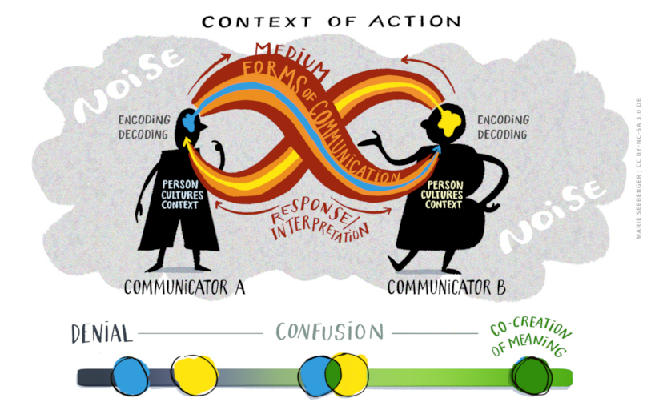
The transactional model of communication (part 1)
Source: Based on and inspired by Bosse, Elke (2011, p. 103)
Image by Marie Seeberger (www.behance.net/marieseeberger) CC-BY-NC-SA 4.0 license
The transactional model, originally developed by Dean Barnlund in the 1970s, takes the ideas of Shannon, Weaver and Schramm one step further by showing that the sender and receiver are simultaneously and reciprocally engaged in sending and receiving information. This is why in our model they are not referred to as sender and receiver but as communicator A and communicator B. We have depicted the reciprocity and simultaneity as a kind of Möbius strip that cannot be orientated and in which it is impossible to distinguish between clockwise from counterclockwise turns on its surface. The simultaneity and reciprocity also apply to the reactions, feedback, and interpretations of the communicators as well as the process of coding and decoding. This also indicates that both the form of communication and the medium are not fixed and can change during the communication process. The sources of interference are depicted here as a cloud, as they can be effective throughout the entire process. And, as already mentioned several times, it is important to consider the context of action, which influences the entire communication process.
The goal of communication is the co-construction of meaning, but, as the model also shows, this can never be fully achieved, and we can therefore only ever get as close to the goal as possible. This also has to do with the fact that we contribute and influence the communication with our person, our cultural imprints, and our very specific situation and thus the individual context from which we communicate. It is also possible that confusion, incomprehension, or irritation can arise in the communication process, which can be partially or completely resolved in the process or result in various forms of rejection. We will look at these reactions and how to deal with them in the communication process in the next learning unit.
The model also indirectly shows that communication has a relationship component and a content component. While the content refers to the information on the topic of the communication, the relationship component refers to how the communicators understand their relationship with each other and how it develops. So, we communicate to exchange messages and information, and at the same time we communicate to create and maintain relationships, form alliances, and engage in social interactions with others. Through this process, we contribute to the construction of social realities.
The transactional model was chosen here because it focuses on sharing, participating, and bringing people together with the aim of co-creating meaning and thus building community through the communication process. It is the ‘we’ orientation that helps to create an atmosphere in which we feel understood, supported, and respected.

Task: The internal audit
Analyse the communication situation below based on the transactional model. Using your results, argue to what extent Marino and the department manager were able to co-create meaning. Note down your answers in your learning journal.
The background:
Marino is an internal auditor. His current assignment is to audit a company’s travel department. The travel department is responsible for organising and paying for all the travel and accommodation arrangements as well as arranging visas for a staff of 35 international executives and sales representatives.
The communication situation:
Marino arrived at the travel department at the arranged time but was kept waiting in an auxiliary office for nearly 25 minutes. When he entered, he looked somewhat obviously at his watch. The department manager gave him a broad smile, saying: “Ah, we have plenty of time, have we not? Would you care for a coffee?” Marino politely refused.
The manager, having shaken hands with Marino, moved a bit closer, upon which Marino felt uncomfortable and backed away.
Marino’s discomfort was increased by the fact that the office seemed overcrowded, with desks occupied by people to whom he had not been introduced, while other people continuously came and went through a side door.
The conversation was interrupted several times by various people who asked the manager questions. The manager replied, while interspersing his replies with remarks directed at Marino, who began to feel increasingly confused.
After they had sat down and exchanged pleasantries, Marino began by raising the two problem areas that were highlighted in the preliminary audit report. One referred to complaints about late payment of travel expenses by expatriates working in the subsidiary. The other concerned numerous instances where rules had been infringed upon.
He suggested dealing with them in that order and the travel manager agreed, but then jumped straight to the rule infringement question.
“You know, some of those rules are really not practical”, he said. “They just make extra work for no reason. I take it you agree that your colleague found no instances of dishonesty or misappropriation of funds?”
Marino agreed – none had been found – but thought to himself: “Rules are rules, and they are there for a purpose.”
Source: Guirdham, M., & Guirdham, O., 2017, p. 145f., amended

5.6 Summary
Communication is a complex, interactive process. By introducing the transactional model and discussing the various constituents of the communication process, this session introduced a tool that can be used to analyse such processes. A further aim of this session was to sensitise the reader for the necessity of co-creating and negotiating meaning as a basis for any actions that follow. This also means that communicators need to acknowledge their responsibility in developing a common understanding of each other’s perspective.

5.7 Learning review

Task: The meeting
Use the transactional model and the example of Hadiko and Heiko to identify the different elements of the communication.
What might have helped to ensure the co-construction of meaning?
Note down the results in your learning journal.
Looking at her watch, the chairperson of a meeting realises that there are only five minutes left before she has to leave for a lunchtime appointment. She frowns because there are still two important items on the agenda. However, realising that it is too late to discuss these points, she says to those attending the meeting “Let’s call it a day” in a tone which sounded rather annoyed.
Upon saying this, some participants such as Hadiko, looked at her in a rather surprised manner, as it was common practice to only close a meeting after all the issues had been discussed. However, some participants could be observed smiling because for once the meeting had not run into the lunch hour. Most of them gathered their laptops and began to leave. Heiko, however, looked rather confused, as his mind was far away thinking about the quarrel, he had had with his wife the previous evening.
Source: Based on Steinberg, Sheila (1997, pp. 19f.)

5.8 Sources, further reading and web links

Sources
- Bolten, J. (2015). Einführung in die Interkulturelle Wirtschaftskommunikation. Göttingen: Vandenhoeck & Ruprecht.
- Broszinsky-Schwabe, E. (2017). Interkulturelle Kommunikation. Missverständnisse und Verständigung. Berlin: Springer VS.
- Cobley, P. (2008). Communication: definitions and concepts. In W. Donsbach (Ed.). International encyclopaedia of communication. John Wiley & Sons, Ltd. URL: https://doi.org/10.1002/9781405186407.wbiecc071 (accessed on 29.11.2022)
- Gamble, T. K., & Gamble, M. W. (2014). Interpersonal communication. Building connections together. London: Sage
- Guirdham, M., & Guirdham, O. (2017). Communicating across cultures at work. London: Palgrave
- Hoffman, E. & Verdooren, A. (2019). Diversity Competence – Cultures don’t meet, people do. Oxfordshire: CABI
- Liu, S., Volcic, Z. & Gallois, C. (2019). Introducing intercultural communication. Global cultures and contexts. London: Sage
- N.a. (n.d.). A primer on communication studies. https://2012books.lardbucket.org/books/a-primer-on-communication-studies/ (accessed on 29.11.2022)
- Steinberg, S. (2007). An introduction to communication studies. Cape Town: Juta.
- Warren, J. T., & Fassett, D. L. (2015). Communication – a critical / cultural introduction. London: Sage.

6. Intercultural communication and the co-creation of meaning

Topics
6.1 Prelude 101
6.2 Introduction 101
6.3 Culture, communication, and intercultural communication 101
Task: My speech communities 104
6.4 Expanding the transactional model of communication 104
Task: Exploring my communicative resources and preferences 106
6.5 Managing challenging communication situations 112
Task: Active listening 112
6.6 Conclusion 115
6.7 Learning review 115
Task: Case "Waiting for my colleague to be ready" 115
6.8 Sources, further reading and web links 115

Learning outcome
Based on the expanded transactional model of communication participants show means and ways of co-creating meaning and dealing with varying degrees of confusion in intercultural settings.

Objectives
At the end of the session, you will be able to
- explain the link between culture and communication
- define intercultural communication
- assess your personal communication practices and resources
- explain the expanded transactional model of communication
- apply the expanded transactional model in intercultural settings
- show means and ways of co-creating meaning and dealing with confusion and misunderstandings

6.1 Prelude
In the previous session we introduced the transactional model of communication in order to illustrate the complexity of the communication process and examine the multitude of factors that influence it. Now we will turn to the communicators themselves, the communication process in intercultural settings and how meaning can be co-created.

Download: Learning journal for session 6
Learning journal (.docx) Learning journal (.odt) Learning journal (.rtf)

6.2 Introduction
The connection between culture and communication is two-fold. We all acquire the specific social practices of the cultures we belong to, including a set of communication patterns unique to each culture. Simultaneously, it's through communication that we construct culture and imbue meaning when engaging with others. This highlights the intrinsic interplay between culture as social practice and communication, since culture is both shaped by communication but also, in turn, shapes communication.
In this session, we will delve deeper into the relationship between culture and communication. Utilizing the expanded communication model, we will examine the dynamics that can arise in intercultural communication scenarios. We will illustrate various courses of action and reactions that may occur in such contexts. Lastly, we will discuss interventions aimed at fostering the co-creation of meaning and fostering constructive dialogue in intercultural settings.

6.3 Culture, communication, and intercultural communication
We have argued that to grasp the complexity of culture, it's essential to move beyond categories like shared passport identity. For instance, we should consider factors such as age, gender, locality, lifestyle, language, education, and profession as potential markers of both difference and similarity in social life. In essence, if our aim is to discover common ground, it is more advantageous to focus on multi-collectivity rather than nationality, emphasizing a "zoom in" approach over "zooming out." This same principle applies to communicative practices.
As members of numerous distinct collectives, we are accustomed to a variety of linguistic and communicative routines present within these groups. This encompasses what to say, how to express ideas, and when to communicate them. Furthermore, we can argue that we construct collectives through communication. Simultaneously, the utilization of a specific language or communicative practices can serve as an indication of membership in a speech community.
To illustrate this concept, let's look at Mongolia, an East Asian country. According to Robert I. Binnick (2022), Mongolian languages belong to the Altaic language group and are spoken not only within Mongolia but also in neighbouring regions of east-central Asia. A widely accepted, though not universally undisputed, classification distinguishes between the western language groups, which include the closely related Oirat spoken in Mongolia and the Xinjiang region of China, as well as Kalmyk in southwestern Russia, and the eastern group, comprising the closely related Buryat (Russia) and Mongol (Mongolia and China) languages.
This example illustrates that there isn't necessarily linguistic conformity within a country, even regarding the official language(s) spoken. Communities that share the same language can exist both inside and outside a country's borders.
One distinctive aspect of Mongolia is its script, which is written in vertical lines, top-down and left to right across the page, as depicted in the image below.

Figure: Verse written in the Mongolian script, author unknown
Today, alphabets based on this unique classical vertical script are still in use, although the Russian Cyrillic script has become more prevalent in Mongolia. Regarding spoken languages, Russian is the most commonly used foreign language, followed by English, which is gradually gaining in popularity. Additionally, due to the significant number of Mongolians working in South Korea, Korean has also seen an increase in usage (cf. Mongolian script - Wikipedia, January 16, 2023).
Examining the scripts, languages, and dialects spoken within Mongolia showcases the linguistic richness present in the country. The fact that many individuals can converse in multiple languages highlights the presence of various, sometimes overlapping, speech communities. This diversity is further enriched by young people in Mongolia who seamlessly blend and mix languages in their daily interactions, both online and offline. In this context, Dovchin (2016; p.1) even refers to a generational gap in modern Mongolian communication. One of her interviewees, Bolor, supports this observation, noting that at times, she must explain her way of speaking to her parents and grandparents because they struggle to understand what she considers a completely normal form of communication.
A common practice, for instance, involves combining Mongolian suffixes with English stem words. An example of this is the question "cocktaildehuu?" which means "Shall we drink cocktails?" In this instance, the English stem "cocktail" is appended to the Mongolian question suffix "-dehuu?" ("Shall we do something?"). As Dovchin (2016; p.7) asserts, creating new words in this manner is an everyday occurrence.
Another method of incorporating English into the Mongolian language involves using English expressions like "wow," "Hey," "oh," and "ouch" in conversations. Dovchin (2016; p.8) points out that there are hundreds, if not thousands, of Anglicized Mongolian linguistic expressions in youth language. Additionally, it's common to include English verbs in Mongolian, such as saying "chatlah" meaning "to chat," "emaildeh" meaning "to email," or "showday" in the sense of "to go out" (Dovchin (2016; p.8). However, English-oriented resources are not the only ones integrated into everyday communication, as illustrated by the following Facebook entry:
The following figure refers to a Facebook post from an exchange between Altai and Undraa.
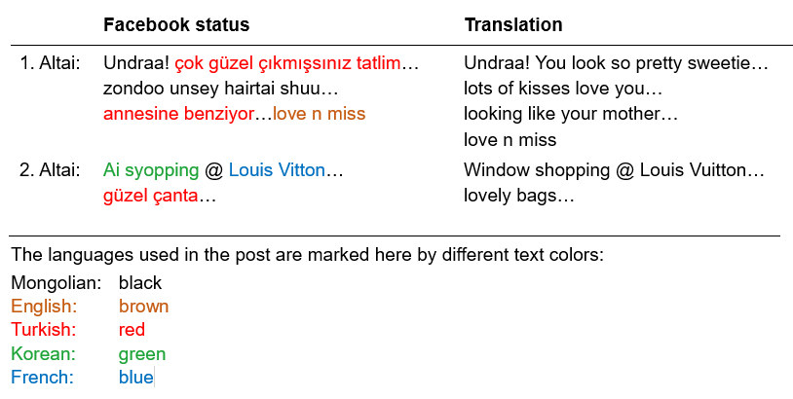
Source: Dovchin, Sender (2017, p. 152), modified
In the first line of the exchange, Altai uploads a photo of her friend, Undraa, and comments by blending Turkish and Mongolian language phrases using the Roman script. She also includes the phrase "love n miss," which, according to Dovchin et al. (2018; p. 4), is a popular transnational online expression. The term "Ai Syopping" ("Eye shopping") is a phrase borrowed from Korean English, meaning "I am window shopping," and "Louis Vitton" refers to the well-known French brand, Louis Vuitton. The use of Turkish comes into play because Altai attended a Turkish high school after moving to the capital of Mongolia, Ulaanbaatar (Dovchin 2018; p.4-5). This serves as a typical example of young people amalgamating cultural and linguistic resources available to them, fashioning them into a communication pattern specific to the members of their collective.
These examples highlight that we all belong to speech communities, which can represent larger collectives. Additionally, we are members of smaller collectives that exhibit distinct ways of corresponding and communicating, as exemplified by Altai and Undraa. The written exchange between them also illustrates how deeply social conventions for interaction are intertwined with language and how they are transmitted through language, evolving and changing over time.
Our affiliation with collectives influences the languages we use and how we employ our linguistic resources. Simultaneously, membership in these collectives entails specific social conventions and, consequently, communicative practices that we learn, adapt to, influence, modify, and internalize. These communicative practices typically operate beyond conscious recognition. It is when we engage with individuals unfamiliar with these practices that sharing and understanding meaning can become perplexing and challenging.
Interculturality is understood as a departure from normality, plausibility, and routine actions during an encounter because interlocutors employ different linguistic and behavioural patterns. Consequently, intercultural communication transpires when individuals lack the familiar norms, plausibility, and routines in their mode of communication and, consequently, their communicative acts. Various factors contributing to this can include distinct forms of communication, communication styles, and the use of different communicative practices. These differences can lead to incongruent expectations, misunderstandings, and may result in surprises or negative reactions.
Intercultural communication is thus defined as an interaction during which one or both communicators employ communicative practices that are perceived as distinctive by either party due to their unfamiliarity. This leads to diverse conclusions, assumptions, and interpretations, necessitating the negotiation of meaning and the development of a shared frame of reference.

Task: My speech communities
Identify the language collectives or speech communities to which you belong, and select one of them to showcase linguistic idiosyncrasies that might cause surprises, confusion, or misunderstandings when interacting with people who are not members of your collective. These idiosyncrasies could relate to terminology, specialised vocabulary, a dialect, or specific expressions used within your ingroup conversations.
Note down the results of your analysis in your learning journal.

6.4 Expanding the transactional model of communication
So far, in session 5, we have delved into the communication process and its various components, employing the basic transactional model of communication depicted below.
The transactional model of communication (part 1)
Source: Based on and inspired by Bosse, Elke (2011, p. 103)
Image by Marie Seeberger (www.behance.net/marieseeberger) CC-BY-NC-SA 4.0 license
We have also gained insight into the roles played by communicators during their interactions. However, it's essential to further explore communicators as active participants in the co-creation of meaning. The next step involves enhancing our understanding of the process by integrating the communicators' cultural and personal backgrounds into our considerations, as well as their situational context, all of which profoundly shape the overall communication process.
Crucially, we must address how to navigate towards the co-creation of meaning when misunderstandings or irritations arise. In this regard, the model illustrates a spectrum of possible reactions. It is worth noting that achieving shared understanding in an intercultural context requires considerable effort. We may also witness varying degrees of confusion within the communication process, as indicated by the continuum spanning from denial to the co-creation of meaning.
Let's initiate our exploration by focusing on the two communicators themselves. Their individual personalities, cultural orientations, and the specific context or situation in which they find themselves all exert significant influence on how they communicate. These factors, in turn, directly impact the outcome of the communication process.
One communicator, for example, may possess a highly inquisitive or adventurous personality, and this aspect of their character significantly influences their preferred communication style. For instance, an inquisitive individual may favour face-to-face communication and engage in asking numerous questions. In contrast, a person with a more cautious personality might lean towards active listening and adopt a more formal approach when responding, as another example. Furthermore, a person's communicative repertoire and established communication patterns are shaped by their individual experiences, background, and education.
In addition, we must consider the individual context or situation in which the communicators find themselves. Here, we draw a distinction between the overarching context of action, e.g., whether it occurs in an office, at a party, or elsewhere (as discussed in Session 5), and the individual context or situation. When we refer to the individual context, we are alluding to the communicator's mood, emotional state, needs, desires, and perceptions of the situation. We are also considering the interpersonal history, the type and depth of relationship the communicators wish to establish, and their feelings towards each other. This is sometimes referred to as the field of experience. Essentially, apart from their cultural orientation, communicators bring with them their personal experiences and history with the other person. When communicators have known each other for an extended period, sharing a long relationship and history, it implies that they have developed a shared experience and may have already established a common communication pattern, familiar with certain reactions and counteractions. This also means that our field of experience has much more overlap when conversing with a close friend than with a new colleague because with a friend, we have already developed a repertoire of common communicative conventions.
Lastly, we must pay attention to cultural orientation, as it influences the communication patterns commonly expected and considered normal, regardless of personal relationships. Every individual possesses a repertoire of communicative practices, which are understood as communication habits developed through membership in various collectives. Members of a collective share a common stock of ideas, signs, symbols, and meanings that are often taken for granted. When communicating, individuals choose from this shared repertoire. Consequently, this shared repertoire influences whether and to what extent communicators perceive themselves to be in an intercultural situation.
For instance, if you've been socialised to view direct eye contact as impolite, you're likely to avoid it yourself, consider it intrusive, and expect the same from your communication partner. However, if your communication partner regards eye contact as a sign of trustworthiness and respect, differences in non-verbal behaviour may lead to confusion and the potential for misunderstandings and misinterpretations. Likewise, attaching different meanings to the same verbal symbols or discrepancies in pronunciation, punctuation, and spelling can significantly impact the communication process. Recognizing one's own communicative repertoire is thus a fundamental step in acknowledging and developing an awareness of potential differences and commonalities. The following test can help you explore this further.

Task: Exploring my communicative resources and preferences
Despite the fact that we adapt our communication style depending on, for example, the context of action we are in, we nonetheless have general preferences with regard to the communication style and we have a specific repertoire of communicative resources. The self-assessment you are asked to do here will provide you with a general idea considering your communicative preferences and resources.
Using the scales provided in your learning journal, please create (a) your personal communication profile and (b) your profile with regard to communicative preferences
Now that you have provided a profile of your communicative style and resources, let us compare it with Luis's profile below, identifying differences and commonalities. In a second step, let's note how these differences and commonalities may affect your communication with others. For instance, if you tend to openly express your emotions while Luis is more restrained, we can explore how this might manifest itself in your communication.
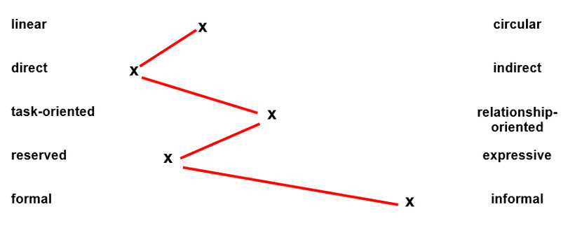
We have the ability to adapt our communication style and approach, often doing so based on the context of the situation. By conducting self-assessments like the one above, we can raise awareness of our own communication preferences as well as those of others, allowing us to identify commonalities and differences. These insights, in turn, can serve as a foundation for the development and discussion of a common understanding.

The expanded transactional model of communication
Being aware of one's own communication repertoire and preferences proves invaluable when encountering individuals with differing communication styles. Such self-awareness significantly influences the reactions triggered in these situations. For instance, how do you react when someone makes direct eye contact and employs expressive gestures while speaking? Or how do you respond when someone uses prompts to convey urgency, like saying, "Claude, I need the report ASAP!"
When communication does not align with your expectations, it can elicit feelings of surprise, confusion, or irritation. There may have been instances where a communication breakdown resulted in denial and a refusal to continue the conversation. How did you handle such situations? Were you able to analyse the communication context and consider multiple perspectives before reacting? Were you capable of stepping back, assessing the situation, and seeking a path to co-create meaning, even if it required mending the miscommunication? We will explore these questions by applying the transactional model of communication in its entity.
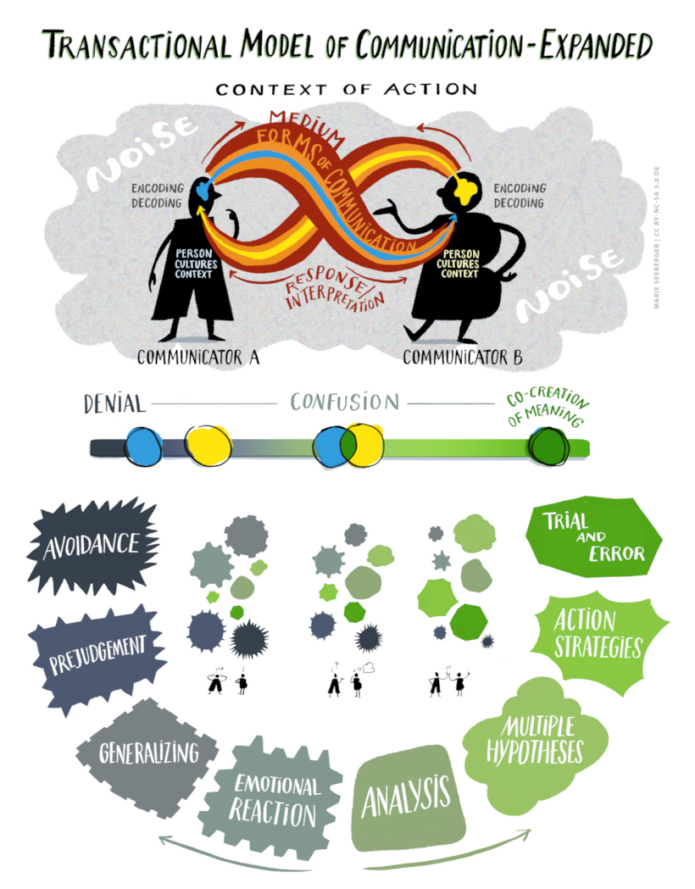
The expanded transactional model of communication
Source: Based on and inspired by Bosse, Elke (2011, p. 103)
Image by Marie Seeberger (www.behance.net/marieseeberger) CC-BY-NC-SA 4.0 license
In essence, we view the co-creation of meaning as the outcome of a dynamic process between communicators, emphasizing that communication is inherently interactive. Throughout this process, communicators continually monitor, assess, and respond to each other as the communication unfolds.
However, it's not always clear whether our communication goals have been met or met effectively. This uncertainty can lead to varying degrees of confusion, as illustrated in the model above. In such circumstances, particularly when co-creating meaning appears to have faltered, one communicator might react emotionally, generalize about a collective to which they belong, or choose to avoid further interaction with the other person. Conversely, another individual may embark on a methodical analysis, generating multiple hypotheses and formulating an action strategy to repair the communication and re-establish a co-created understanding illustrated by the bottom part of the model.
As the model depicts it would be incorrect to assume that reactions to communication irritations follow a strict step-by-step process, where one step invariably leads to the next. For instance, a person might become annoyed simply because the other communicator fails to grasp their intended message. While this could potentially result in generalisations or pre-judgments, it's not an automatic progression. In such a situation, one might opt to take a deep breath and then shift towards analysing the ongoing communication process with the goal of finding a solution. Conversely, an individual might have initially developed action strategies and tried them out but subsequently realised that these strategies didn't contribute to the co-creation of meaning. In this case, they may switch to avoidance and decide not to continue the communication.
Now let us delve into a case study to illustrate the possible courses of action and choices following a communication breakdown. Here is the case:
Just a formality?
A female controller has forwarded the half-year figures of the French subsidiary to her colleague at the German parent company. These figures are crucial for the preparation of the group's overall balance sheet.
A few days later, she receives an email from her male colleague in Germany, composed in German:
Sehr geehrte Frau Dupont,
vielen Dank für die Zusendung der Eckdaten. Leider sind die Zahlen, die Sie mir geschickt haben, falsch. Bitte überprüfen Sie diese noch einmal.
Mit freundlichen Grüßen,
Manfred Müller
In English, this translates as:
Dear Ms. Dupont,
thank you very much for sending me the key figures. Unfortunately, the numbers you sent are incorrect. Please review them again.
Yours sincerely,
Manfred Müller
The controller in France feels confused and somewhat irked. Firstly, she has meticulously reviewed the figures and is rather certain that they are indeed correct. Secondly, the tone of the message from her German colleague strikes her as exceedingly impolite. Consequently, she decides to withhold her response, effectively ignoring her counterpart in Germany. Time passes, and still, there is no response from France. Nevertheless, the imperative task of preparing the consolidated balance sheet remains.
Source: Grosskopf, Sina & Christoph Barmeyer (2021, p. 188), slightly amended
Let us begin our analysis by considering two possible approaches when encountering an intercultural situation, such as the one described above. One path often involves an initial emotional reaction, which may then lead to generalisations, and in some cases, even rejection and avoidance. This route is frequently taken when individuals feel misunderstood, experience anger, frustration, or believe their needs are being overlooked. In our case study, this is precisely the scenario that unfolded. Notably, the controller in our case study took it a step further by choosing not to respond, a decision that can be seen as a form of denial. These possible steps are shown in the bottom part of our expanded transactional model below.
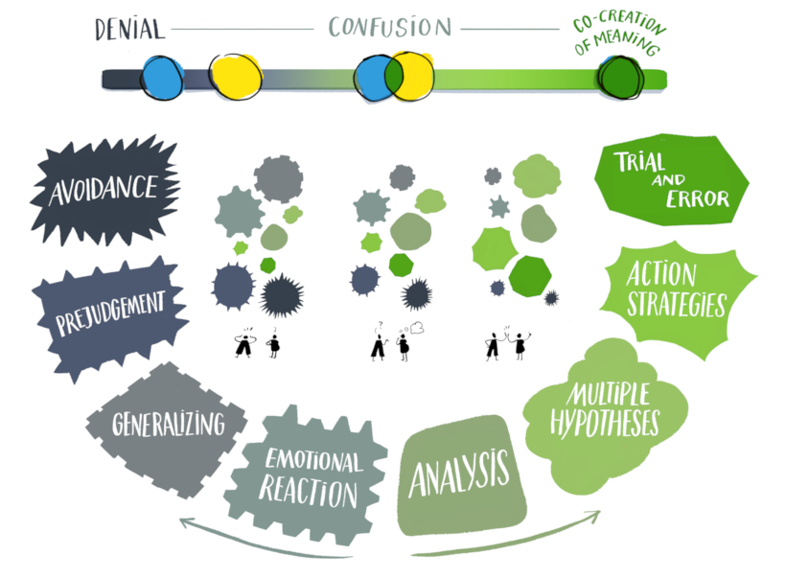
The transactional model of communication (part 2)
Source: Based on and inspired by Bosse, Elke (2011, p. 103)
Image by Marie Seeberger (www.behance.net/marieseeberger) CC-BY-NC-SA 4.0 license
On the other hand, there is an alternative pathway, one that has the potential to foster dialogue and the co-creation of meaning. To tread this path, it is essential to analyse the communication process as a foundation for developing multiple hypotheses and action strategies. An initial step towards achieving this outcome involves stepping back and utilizing the communication model as a guide to delve deeper into potential reasons for the confusion.

A brief analysis
When performing the analysis, we consider the communication process as an entity and thus look at the entire transactional model of communication (Weblink).
In our scenario, we have two communicators who are expected to collaborate closely, with one situated in the subsidiary and the other at the parent company. This context of action is firmly rooted in the realm of business. Their primary mode of communication is through email, a written form of correspondence. It's worth noting that the language used is German, even though it may not be the lingua franca within the company. The extent of the person in France's understanding of written German is unknown. The urgency of obtaining the figures adds an element of psychological pressure for the person in Germany.
Expanding our model, we recognize that both individual personality traits and cultural backgrounds play a pivotal role. Regrettably, the information available does not provide a comprehensive view of the communicators' personalities. Nevertheless, it's plausible to assume that the individual at the parent company values clarity and directness. Given his cultural background, he likely belongs to the German or English-speaking community. He appears to be male and accustomed to formal modes of addressing colleagues. Specific details about his current situation or nationality are not disclosed.
Comparatively less information is available about the colleague in France, although her reaction hints at familiarity with a different communication style. She is female and shares membership of an English-speaking community with her counterpart. It is possible that English may not be their first language. Both are employed by the same company but occupy different levels and functions. Whether she is a French national remains uncertain.
Turning to the encoding and decoding processes, it's essential to remember that this case study offers a mere snapshot of a broader communication process. Details such as the length of their working relationship and prior discussions regarding requests for information are absent. Additionally, the use of email simplifies communication by excluding non-verbal, paraverbal, and extraverbal elements.
In the context of the encoding process, we can consider the following questions:
- What are the communicators' intentions?
- What are their expectations?
- How do they convey their messages?
In our case, the person in Germany needs to compose a consolidated report and requires the figures to align with his particular specifications. He communicates this by sending a formal email request.
Regarding the controller's response in France, her silence likely signifies dissatisfaction with the way she was addressed. It may also serve as a demonstration of her objection and a desire for an apology, conveyed through her simple act of not responding.
In the decoding process, the following questions come into play:
- How do the communicators perceive the responses or lack thereof?
- How might they interpret the communication?
- What are their expectations?
For the person in Germany, decoding the "silence" is challenging. Silence, as a form of communication without words, is intricate to analyse. He may perceive this lack of response as confusion or an inconvenience, or he may perceive it as non-cooperation.
As for the controller in France, she clearly views the response as disrespectful and probably interprets it as rudeness. Her specific expectations remain unclear.

Developing hypotheses
The answers derived from the analysis can help us to develop hypotheses, i.e. potential explanations for what may have gone wrong. Let's begin by examining the perspective of the individual in Germany who required the figures. One hypothesis is that he might have perceived the controller in France as being unproductive or uninterested in reviewing the figures. Another hypothesis could assume that she was too occupied to respond, possibly due to being out of the office or encountering technical issues. When the employee in Germany reflects on how his email might have been received, he might also consider that she could have been irritated by his choice to communicate in German. Upon re-evaluating his email, he may even realise that his request to "Please check them again" could have come across as an order rather than a friendly request. Additionally, he may contemplate whether his message conveyed a sense of dominance or an attempt to assert authority over the subsidiary. Another hypothesis could be that she simply reviewed the figures diligently and is confident that they are correct, leading her to feel unjustly accused. She may have perceived the email's tone as impolite, accusatory, and intimidating. Alternatively, she might have anticipated constructive verbal feedback rather than criticism or may feel her efforts have gone unnoticed.
Shifting our focus to the controller in France, and assuming she begins to reflect on her decision to remain silent, several hypotheses may arise. For instance, she might consider the possibility that the controller in Germany was rushing to complete tasks before leaving the office and inadvertently forgot that he was composing the email to his French colleague in German. Alternatively, he might have been running late for an appointment but wanted to address the request promptly. The pressure from superiors might have contributed to the tone of his message. Considering his personality and cultural background, she might also acknowledge that he probably prefers direct and fact-oriented communication, which might explain his approach.

Action strategies
The hypotheses we develop here serve as the foundation for considering various action strategies, which we can then implement on a trial-and-error basis. This approach acknowledges the inherent uncertainty in our reflections and the corresponding action strategies. It underscores the need to remain open-minded about others' behaviour and the importance of our willingness to adjust and reflect.
Since the person in the German office is the one who requires the figures, he is likely to take the initiative. If he suspects that the controller in France may not have received the email or overlooked it, he may choose to resend it initially. If this does not yield the desired response, he may step back and contemplate a more comprehensive approach, which we could also call a strategy.
Effective action strategies often involve multiple interconnected activities and moves. Ideally, after contemplating the silence from the French office and developing various hypotheses, the individual in the German company may recognise the misunderstanding and its potential causes. One action strategy could involve initiating a phone call to express his supposition that his message may not have been interpreted as intended. This conversation could serve as a platform to inquire about the colleague's assessment of the figures, fostering a dialogue aimed at exchanging information and establishing common ground.
On the part of the controller in France, she may choose to set aside her negative feelings, review the figures, and resend them with a brief note. She might also consider that her counterpart at the headquarters is unlikely to have had ill intentions and opt to call him to discuss why the figures were deemed incorrect. Such a trial-and-error approach is helpful in situations where minimal repair work is needed or when relational aspects between individuals are not a primary concern.
Like other models, the expanded model of communication is not a perfect reflection of reality. It would be misleading to assume that, after the analysis, developing multiple hypotheses automatically and necessarily leads to the solution. Also, the action strategies chosen may not always be well-received by the other communicator.
Nevertheless, the model enables us to critically examine and reflect upon our own behaviour and the behaviour of others in complex communicative events that may appear confusing. It helps us to explore different interpretations and form a solid basis for addressing misunderstandings and actively co-creating meaning.

6.5 Managing challenging communication situations
But how do we put all this into practice? When dealing with communication confusion or unexpected intentions, one valuable technique is active listening. This technique can be applied at various stages of the communication process.
Active listening is as a powerful approach when one or both communicators perceive that their co-creation of meaning is unproductive. In these situations, we might experience confusion or irritation, be uncertain whether we have been understood, feel that our expectations are not being met or have been breached, or face outright misunderstanding.
Active listening encompasses a mindset characterized by full engagement and immersion in what the other person is saying, coupled with genuine respect. Its focus isn't on proving who is right or wrong but on listening to both the spoken and unspoken aspects of the conversation. The primary goal of active listening is to understand not only what the speaker is saying explicitly but also to discern underlying unspoken expectations, feelings, intentions, and needs. In essence, it revolves around making the other person feel heard, involving the use of all our senses.

Task: Active listening
Watch the first 3 minutes of Simon Sinek's YouTube video and note down in your learning journal the central elements of active listening and what you can expect to achieve by applying it.
URL: https://www.youtube.com/watch?v=qpnNsSyDw-g
Source: Simon Sinek: The Art of Listening, 2022,
Active listening is also a communication technique that can be learned. It involves temporarily putting aside our own opinions, expectations pre-judices and desires. It is only then that we have the ability to truly focus on the communication partner. It is an art which requires practice but brings the greatest gain in information, understanding and results, since it stimulates the thinking process of the communicators because one of the communicators is fully intent on understanding what the other means.
A statement or question from the listener can assist the speaker in elaborating on their thoughts further. It provides them with the opportunity to explain in greater detail what they've already conveyed or to contribute additional information. In intercultural situations, this frequently paves the way towards the co-creation of meaning. In other instances, it can also indicate that both parties comprehend each other's viewpoints, enabling them to gain valuable insights into each other's thoughts and objectives.
In order to initiate active listening, a response can be prompted, for example, for example, by saying:
- I am not sure whether I understand this correctly….
- Could you tell me more about…?
- From my perspective you sound as if….
- You seem to be…? Is that right?
- I would like to summarise what you have said in my own words if I may…?
- So then your idea would be...?
- Could it be that you have the feeling that...?
- I can imagine that it must be annoying that...?
- It almost seems as if you want to say... Is that right?
- You must have had the impression that ...?
- If I have understood you correctly...
In general, we can differentiate between four key abilities which support active listening: Paraphrasing, reflecting content, reflecting and interpreting emotions and reflecting needs (inspired by Cole, Kris, 1999; pp. 140-142.).
Paraphrasing means translating what has been said into one's own words in order to check understanding. Here is an example:
Chris: The situation I am in right now is very difficult. I am doing my best to finish the project and am even putting in a lot of extra hours of work. But I constantly have to remind my project partners of their contributions and that we have a deadline. I don’t mind the overtime, but I have to be able to rely on my team.
Paola: It sounds as if you feel that your team is letting you down and that you’re missing the support and understanding of your team.
Chris: Yes, that’s exactly how it is...
Paraphrasing involves the concept of "reflecting" or rephrasing what someone appears to have intended with their words, but using your own expressions.
Reflecting on content pertains to the skill of prompting for additional information in order to gain a more comprehensive understanding of a situation. Here is an example:
Bruno: Hey Maya, while you were on leave, so much happened here! Angela has taken on a new job and will be leaving our team. Berj has got the flu and is also out. Apart from that we had to hire someone to take over IT tasks and they actually managed to delete key corporate data, can you imagine that?! I'm so glad that you're back and can help me get things moving again.
Maya: Wow, it sounds like you've really been kept busy. But tell me, what exactly does Angela's new job consist of and when will she be leaving us? Also, when can we expect Berj to come back? And do you know exactly which data has been deleted?
Asking for details not only helps Maya to understand better what happened, it also helps Bruno to broaden his mind, which may already be a step towards the co-creation of meaning.
Reflecting and interpreting emotions refers to showing empathy when the communicator brings feelings to your attention. This could be, for example, when they appear to be upset, angry or excited.
Samy: How am I supposed to do my job when the financial plan is full of mistakes and inaccuracies? I spend most of my time checking the figures and ironing out other people’s mistakes, and that really isn’t my job!
Shaida: Wow, you sound annoyed and frustrated.
Samy: Yes, I really am. And the point is that I already have so much to do and these corrections are the last thing I need.

Here is another example:
Lisa: Well, we were arguing about what to do for our farewell party. And I had this fight with my fellow student about it. I'm still so angry because she wants a huge party and I know for sure that it’s not going to work out…and now she’s no longer speaking to me.
Jodie: Oh, that's tough. I can hear that you’re upset about the whole argument and that now you're not speaking because of it...
Reflecting emotions acknowledges that a message is always accompanied by feelings and emotions of different intensity. Acknowledging feelings not only heightens the communicator’s awareness of and ability to label their emotions but also transports empathy with the situation the other person is in.
Reflecting needs attempts to get behind the emotions of the speaker and discover what his or her real needs are in the particular situation.
Sara: The first thing that happened was a fundamental change in procedure that no one could have predicted. Then one of our best technicians quit… and on top of that the deadline was brought forward. So, one thing led to another
Mohammad: So there has been a whole pile of problems that have made this project particularly difficult...?
Sara: Yeah, you can say that again!
Mohammad: Let me think, where could I support you with this and what it would take to get the project back on track.
Reflecting needs allows the communicator to formulate what could be done in a particular situation and acknowledge that he/she has agency to change things.
Active listening can be implemented at any stage of the communication process and it can trigger a change in perspective and lead to ideas for change. Also, during the communication process we may realise that we simply do not share any common ground. At this point we should stop and implement active listening. This can open up communication and connect the speakers. After a while, we might then ask ourselves: At what point should we stop active listening? The answer here is usually that we stop active listening at the moment where we feel that the speaker has said everything, and that we have a fairly complete picture of the situation. Once this has been reached, the next step could be to attempt to resolve the misunderstanding or confusion. We might also describe the situation from our perspective and decide together what to do next. Real listening does not happen effortlessly and will always require a certain amount of self-discipline and commitment on the part of the listener.
With this in mind, let us return to our case study:
Imagine that, after some careful thought and analysis, the colleague in France decides to give her colleague in Germany a call and apply active listening, in which she reflects on both content and emotions. When she talks to him, she may, for example, recall that when she received the email she was in a stressful situation and it irritated her that the message to her was written in German (reflecting content and emotions). She may also say that she would like to hear more about how he calculated the figures as they both obviously have different results (reflecting content without judgment). Through this process, the colleague in German may introduce her to a calculation system that is unfamiliar to her, for example a system that includes wholly new financial positions. This open and judgment-free conversation may thus serve as a basis for the co-creation of meaning between the two of them.

6.6 Conclusion
In this session, we delved into the complexities of communication, shedding light on how communicators, influenced by their cultural backgrounds, personalities, and contextual situations, contribute to the co-creation of meaning. It became evident that these elements are inherently interconnected and should be woven into our comprehensive understanding of the communication process.
The extended model of communication that we introduced places significant emphasis on the dynamics of the process and the interactions involved. It underscores the idea that communicators collaboratively shape meaning during their exchanges, and that this meaning finds expression through language. Simultaneously, it recognizes that cultural disparities often lie concealed within linguistic expressions, showcasing how speakers possess a range of communication conventions and styles, which they deploy based on the circumstances and contexts at hand.
Furthermore, the expanded model outlines various pathways and offers insights into possible responses when one or both communicators recognize a misperception, confusion, irritation, or even an outright misunderstanding. Despite its inherent limitations, these options serve to illustrate how communication may swing towards avoidance but also how a systematic analysis, the formulation of multiple hypotheses, and the implementation of strategic actions can facilitate the repair of communication and the development of shared meaning.

6.7 Learning review

Task: Case "Waiting for my colleague to be ready"
An office worker relates the following episode:
Upon entering my colleague's office, I noticed that he was sitting down, engrossed in a phone call. It was apparent that he wanted to speak to me. However, he continued his conversation without instructing me to take a seat. Consequently, I found myself standing in front of his desk for what felt like an eternity, although it was probably just a couple of minutes. When he eventually concluded his telephone call, he turned towards me with a friendly smile and said, "Sorry to keep you waiting; that was an urgent call. Please, have a seat."
Employing the expanded transactional model of communication, analyse this scenario, formulate hypotheses, and consider potential responses from the perspective of the person recalling the situation, demonstrating how the co-creation of meaning could unfold. Note down your analysis in your learning journal.

6.8 Sources, further reading and web links

Sources
- Binnick, R. I. (2022). Mongolian languages. In: Encyclopedia Britannica, 5 Aug. 2022, https://www.britannica.com/topic/Mongolian-languages (accessed on 16.1.2023).
- Bosse, E. (2011). Qualifizierung für interkulturelle Kommunikation: Trainingskonzeption und -evaluation. Munich: Iudicium.
- Cole, K. (1999). Kommunikation klipp und klar – Besser verstehen und verstanden werden. Weinheim / Basel: Beltz
- Dovchin, S. (2017). The ordinariness of youth linguascapes in Mongolia. International Journal of Multilingualism, 14 (2), pp. 144-159.
- Dovchin, S., Sultana, S., & Pennycook, A. (2018). Popular culture, voice and linguistic diversity. Young adults on- and offline. Basingstoke: Palgrave MacMillan.
- Grosskopf, S. & Barmeyer, C. (2021). Learning from multi-pragmatic sensitivity in cross-cultural management? Empirical and theoretical considerations. International Journal of Cross Cultural Management, 21 (2), pp. 181-202.
- Hoffman, E. & Verdooren, A. (2019). Diversity competence. Cultures don’t meet, people do. Oxfordshire: CABI.
- Müller-Jacquier, B. (2003). Linguistic awareness of cultures. Principles of a training module. In P. Kistler & S. Konivuori (Eds). From International exchanges to intercultural communication. Combining theory and practice (pp. 50-90). Jyväskylä: University of Jyväskylä. https://www.academia.edu/45127794/LINGUISTIC_AWARENESS_OF_CULTURES_PRINCIPLES_OF_A_TRAINING_MODULE (accessed on 12.6.2024).

7. Pulling the strings together: Analysing interpersonal encounters by applying a culture-reflexive approach

Topics
7.1 Prelude 118
7.2 Introduction 118
7.3 Example 119
7.4 Background theories 121
7.5 Quasi-natural worldview 121
Example: An email to my colleague 122
7.6 Systemic-constructivist multiplied perspectives 123
Task: White Fragility 128
7.8 Synopsis: three meta-perspectives 128
7.9 Summary 130
7.10 Learning review 130
Task: Case "Wearing a headscarf at work" 130
7.11 Sources, further reading and web links 131

Learning outcome
You explore the complexity of interpersonal encounters applying a culture-reflexive approach and thus analyse a situation from three meta-perspectives

7.1 Prelude
Having completed the previous sessions, you already have a good understanding of the intercultural perspective how cultures may differ and how these differences influence behaviour. Also, you are now aware of the concept of multi-collectivity and how it can be useful when trying to understand the complexity and multifaceted nature of intercultural encounters.
In order to enlarge our repertoire of analytical tools, we are complementing this view by elaborating and by differentiating the multi-collectivity approach in 3 different ways. The first one relates to the fact that the moment we interpret we do so on the basis of assumptions and knowledge, and this means that we use (inter-)cultural meanings as a resource. The second aspect is to acknowledge that we cannot be sure whether any of our interpretations is right and therefore need to open up for not-knowing. This is the other side of the coin of the multi-collectivity theory from a systemic constructivist perspective. Finally, we are adding a critical perspective which pays particular attention to power relationships that go hand in hand with cultural resources. By elaborating and differentiating our approaches in such a way we improve our ability to grasp the complexity of intercultural encounters and find means and ways of managing them constructively.
The aim of this session is therefore to use different approaches to a situation, the multi-collective approach, the intercultural as well as the power reflexive approach while applying the concept of cultural reflexivity in its entity as a tool to analyse intercultural encounters in a variety of settings.
Our starting point will be to briefly examine the term "reflexivity". In practical terms, cultural reflexivity means questioning the assumptions and beliefs underlying social actions and the impact of these actions. These beliefs are strongly connected to what our pre-assumptions are and in what respect culture is relevant in encounters. In this context, our analysis of cross-cultural encounters needs to be carried out from a variety of perspectives with the premise that such a process has the potential to maintain or transform social relations and develop constructive cross-cultural dialogues. This unit is therefore an important step towards finding means and ways of managing various forms of cultural difference.

Download: Learning journal for session 7
Learning journal (.docx) Learning journal (.odt) Learning journal (.rtf)

7.2 Introduction
Nowadays, in any given encounter between two people or within a group or team at work, it is highly likely that differences in areas such as collective belonging, experiences, identities, value sets, expectations and action chains will become relevant. Intercultural case scenarios from the past decades have made this clear. We have realised, for example, that speakers of Hindi and British English as one of their mother tongues are likely to have different assumptions regarding procedures at work. Because of the dynamic quality of culture and the fact that we belong to many collectives (multi-collectivity), at the end of the day, however, we can never be sure to have grasped all the reasons why a misunderstanding came about.
Previous units of this module, especially the units 2, 3 and 6, have introduced you to the various sources of misunderstanding in intercultural interaction such as differing stocks of knowledge, different allocation of meaning and disparate communication styles, which stem from culturally divergent perspectives and practices. Adding to these insights, culture reflexivity is an approach that helps to reflect not only on misunderstandings but also on other influential collective factors that might hinder smooth interaction. Some approaches to intercultural communication indicate that it is also power structures and privileges that have a considerable impact on interactions and should therefore not be included.

7.3 Example
Imagine the following situation:
Recently, Mr. Sabia, a general practitioner, and his family, having taken refuge from the war in Syria, moved into a flat on the same floor as Mr. and Mrs. Smith, who have been living in this block in their home country for 25 years. Mr. Smith is the housing block's maintenance man. Three students, Ada, Ben and Clarissa, also live in the house but on a different floor. During a small talk exchange on the stairs, Mrs. Smith complains to them about the shoes in front of the door, the noise (some strange sounds) and the many visitors who their new neighbours entertain. In the light of these issues, she assumes that Muslim behaviour does not fit into the housing community...
Culture reflexivity approaches this situation by employing three types of assumptions and questions.
- Assuming that social actions are meaningful to the interacting participants, which factors could be culturally typical here (e.g. relating to a country or region)?
- The manifold cultural influences at play mean that there is a high level of complexity and interdependency. So, we could say that there is no single cause, and that possibilities for interpretation are limited. Nevertheless, we still need solutions for the situation: The question, therefore, becomes: 'What happens if we look for solutions without really knowing anything?'
- Which privileges are pre-distributed and which power structures and collective experiences are potentially active in this situation? Which actions could lead to more justice?
Imagine you are a student just like Ada, Ben or Clarissa and you are looking for an interculturally competent answer. The culture reflexive analysis would thus be as follows:
The approach symbolised by the first question is the most familiar one. We either think we know or inquire about the meaning, reasons and motives behind the phenomenon. Maybe the Sabias are simply used to the tradition of removing shoes before entering a home and see this as a common act of politeness. Also, receiving visitors from friends and family while communicating wholeheartedly might be an important component of everyday life for them.
Secondly, we are aware that there are many other collectives that are involved. The Sabias, for example, are not only a family from Syria but are also members of a local sports club (soccer), are Christians, and belong to several other collectives that might be important, but of which we are unaware.
The culture and organisation of the housing community is also crucial here. Are there obligations and house rules? What about the implicit, i.e. unmodified rules, such as: Do the neighbours rarely talk to each other or help each other? Or do they sometimes get together and socialise at parties? What could be the best way of finding a peaceful solution considering all parties' needs and customs? After all, The Smiths' needs do not seem to be met by the new behaviour in the house. And what about the Sabias' needs?
With the third question, the view of the situation differs. Cultural explanations are not completely satisfactory here. Viewing the scenario from this angle, agents in interactions have different resources of social capital, which are pre-distributed unequally and function as hidden influencing factors, giving strength or weakness to the respective parties. Factors such as gender, race, ability, education, language skills, marital status and many more give greater or lesser "weight" to the words of each of the interlocutors. There are asymmetries: The Smiths have a long tradition in the house and are living in their home country (with the respective passport privileges, rights, networks and probably language skills), whilst the Sabias had to leave their home country involuntarily due to war, which probably threw their life into complete disarray, and are now living in a foreign environment with a precarious residence permit status and many other hurdles to tackle.
These are thoughts from the culture reflexive approach that might go through the heads of Ada, Ben and Clarissa. Hence, which reaction and reply to the students might give to the Smith family's complaints is not obvious. For the sake of exemplification, Ada will react according to the first set of questions, Ben according to the second and Clarissa according to the third set of questions.
On the staircase, Ada shows empathy for the situation and then explains to the Smiths that the Sabias' habits could be of cultural origin. She hopes that there will be more understanding towards the behaviour when the Smiths understand the motives behind it. Ben mentions that the Sabias are Christians, just like the Smiths, and not Muslims. He reminds them that there are no house rules, or at least no one has ever insisted on strict rules. Until now, it has helped that the neighbours know each other's habits (who likes to sleep in, who goes to bed early, who likes to do DIY on the weekends etc.) and that they practice respect for the needs of the others in this way. He reminds the Smiths of these helpful practices and encourages them to invite the Sabias to talk to them about the situation and possible solutions at a suitable moment. He also offers to invite both families for tea to meet and maybe talk about living together in one house. It may well be, for example, that the Sabias have encountered irritations by others in the house as well.
Clarissa tells the Smiths she is happy that they have so much company in their new home since losing your home must be such a traumatic experience and she would not want to have their fate. She admits that she, too, is sometimes disturbed by the noise when she is trying to study for exams, but then she thinks of the kinds of noise they must have gone through: bombs, battles etc., and is relieved that the noise in this house is only conversation and laughter. This puts things into perspective for her and she decides to find her own solution by wearing ear plugs when studying.
The three students opted for different strategies based on different ideas which influenced the situation. The idea of a culture-reflexive approach is to multiply the perspectives on what we think is culture systematically, as shown in the example above. Ada goes for interpreting the situation from a cultural habit, a classical intercultural approach. Ben is aware that given so many collective belongings and the dynamic nature of cultures we cannot clearly know the reasons for actions which means we have to inquire, work with nescience or in other words with "not knowing” and jointly find solutions. Clarissa anticipates the power asymmetries in the situation. Compared to the new neighbours, those residents without a refugee background do have privileges i.e. knowing local rules, feeling safe or having a secure residence status. These meta-perspectives are accomplished by reflecting on and adopting all of these different possible perspectives in turn.

7.4 Background theories
The culture-reflexive approach can be considered a systematic way to deal with the knowledge we have or learn about culture, including our reflection on this knowledge. It works with different notions of culture with their respective theoretical traditions and combines them into 3 meta-perspectives that will be explained in the following sections:
- Quasi-natural worldview as intercultural perspective
- Systemic-constructivist co-construction based on the multi-collective approach
- Power-reflexive practice because we practice power and its reduction
There is no fixed order when using the meta-perspectives, meaning that you can start with any one of them and use them like a kaleidoscope – just turn the dial to gain a new perspective on the scene. What is important is that we view the scenario from all three perspectives and consider the importance of each party's identity in a given situation.

7.5 Quasi-natural worldview
The so-called "natural worldview" considers that when meeting others we usually take our knowledge and assumptions as facts in order to interpret behaviour. Knowing that there are different habits, values and meanings, we can use our existing knowledge, expand it by asking in order to get to enlarge it or as we at times do, assume that we know. Science also provides us with interpretations and frameworks when developing a cultural profile as part of unit 6. You may recall that we looked at independent versus interdependent patterns and indirect versus direct communication to name but a few. These are scientific constructions and second order categories that help us to ascribe meaning to an action. For example, an intercultural 'expert' might say: "He is more of an indirect type and uses high context communication in contrast to the other person who is a more direct type and uses lo context communication". This type of thinking is reflected by the many culture-contrastive 'critical incidents', which are supposed to exemplify a particular cultural behaviour. Due to the necessity of finding order in intercultural interactions, these categories have become and are often used as ways and means of interpreting a certain situation and giving meaning to it.

Source: Based on Rathje, Stefanie (2015). Multicollectivity – It changes everything. Key Note Speech at the SIETAR Europe Congress.
Figure by Julia Flitta (www.julia-flitta.com)
The main assumptive framework here is that there are particular cultural factors which influence the situation and from this perspective culture is seen as "ways of living and acting". This concept is mostly associated with national cultures, but also with any other idea of a closed group of people as members of a community, e.g. the "British family", "golfers", "all native speakers of Hindi". As you might have noticed, there is a reference here to the closed concept of culture that you came across in the first unit. Nonetheless our focus is on a dynamic understanding of cultures and the multi-collectivity approach. However, we need to be aware that if we use one or more cultural explanations and the moment we try to understand someone´s intentions, we automatically ascribe motives, meanings and find interpretations, which means we use closed notions of culture. That does not mean we cannot open up for other hypotheses as explanations what we should. Since intercultural communication from this perspective focusses on different meanings and expectations, misunderstandings could be said to be the logical consequence when people of different groups or communities meet. Whenever we use this meta-perspective of the ‘quasi world view’, we work with assumptions about the motives or intentions of others and ourselves, and we interpret and apply the knowledge we have. Hence, when dealing with strangeness, i.e. that which we do not know or that which is unfamiliar or 'abnormal' to us, we believe that a change of perspectives will help to foster understanding and support the development of intercultural competence.

Example: An email to my colleague
(Inspired by Ferres, R., Meyer-Belitz, F., Röhrs, B., & Thomas, A. (2005): Beruflich in Mexiko. Trainingsprogramm für Manager, Fach- und Führungskräfte.)
Emily works as a Customer Service Manager in the Netherlands. One of her team colleagues works in Mexico City. Emily has to report to her boss on a regular basis on customer development. Recently, he asked her to prepare an update on current client data. To this end, Emily writes to her colleague:
Dear Miranda,
Could you please send me our new client list?
Thank you and best regards,
Emily.
Miranda replies that she will send the data. However, nothing happens.
This is a critical incident where, in a culture assimilator training for example, participants learn to use the dimension 'relationship orientation' instead of assuming that Miranda is simply a lazy or impolite person or has a "mañana-mentality" according to the stereotype. Armed with the knowledge that trust and relationships can play a significant role in the local working context, we are more able to understand the situation and accordingly find means and ways to tackle the situation. From this perspective, Emily decreases the chances to get an answer as she does not attempt to try to build up a personal relationship and that this is likely to be the reason that Miranda sees no obligation to help her. In fact, she might consider the email as rude and impolite. For Miranda to feel an obligation or motivation to reply, Emily would consequently have needed to make some personal comments or engage in other types of relationship-building as a response is not triggered by the mere fact that they are team members.

Summary: The quasi-natural worldview meta-perspective
The intercultural approach has emerged because we can hardly interact without giving meaning to the actions of those involved when we experience misunderstandings. This is based on our knowing about possible other reasons for action, values as motives and habitual orientations in different cultures. Using this knowledge base leads to a closed notion of culture (e.g. nations, countries, regions, mentalities; "software of the mind") as hypotheses.
Characteristics of the quasi-natural world view and intercultural learning approach:
- considers people as primarily 'belonging' to (one or more) cultures
- anticipates the likelihood of culture clashes when people ('from different cultures') meet (culture as an independent variable)
- aims at understanding perspectives, e.g. values, motives, and meanings
- uses available knowledge or looks for routines in the respective cultures as a basis for interpretation
- aims at switching perspectives
- is oriented towards the Enlightenment: understanding and reasoning as key factor
Typical scholars of the culture contrastive approach are:
- Edward T. Hall (e.g. "The hidden dimension", 1976; "The dance of life", 1984)
- Geert Hofstede, Gert Jan Hofstede & Michael Minkov ("Cultures and organizations – Software of the mind: Intercultural cooperation and its importance for survival", 2010
- Michele Gelfand ("Rule makers, rule breakers: How tight and loose cultures wire our world", 2018)

7.6 Systemic-constructivist multiplied perspectives
One of the important contributions the study of intercultural communication has made is the identification of different styles, routines, orientations and guiding values for behaviour that can lead to misunderstandings. In unit 5 in particular you have learned a lot about different meanings of the supposed same symbol, word or action which may cause confusion and irritations. However, if we only think in a terms of binary categories, e.g. the British and the Mexicans, and ascribe traits or typical behaviour to them, then there is a danger of culturalism and our understanding of the situation will lack complexity. In reality, there are a large number of additional factors and influences to be taken into account.
To explain the multiplication of categories in the words of Amartya Sen:
"The same person can be, without any contradiction, an American citizen, of Caribbean origin, with African ancestry, a Christian, a liberal, a woman, a vegetarian, a long-distance runner, a historian, a schoolteacher, a novelist, a feminist, a heterosexual, a believer in gay and lesbian rights, a theater lover, an environmental activist, a tennis fan, a jazz musician, and someone who is deeply committed to the view that there are intelligent beings in outer space with whom it is extremely urgent to talk (preferably in English). Each of these collectivities, to all of which this person simultaneously belongs, gives her a particular identity. None of them can be taken to be the person´s only identity or singular membership category. Given our inescapable plural identities, we have to decide on the relative importance of our different associations and affiliations in any particular context."
Source: Sen, A. (2007, pp. XII-XIII)
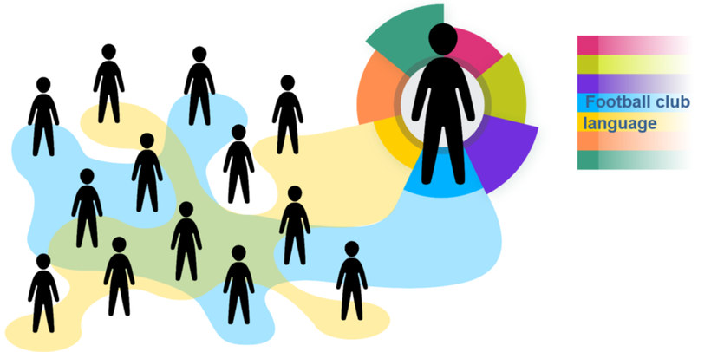
Source: Based on Rathje, S. (2015). Multicollectivity – It changes everything. Key Note Speech at the SIETAR Europe Congress (SIETAR_slides_Rathje.pptx (stefanie-rathje.de), accessed on 20.9.2024)
Figure by Julia Flitta (www.julia-flitta.com)
If we take this multi-collectivity of our identities and multiple influences into account, belonging to a community can change, we can enter new communities and leave some whereas some membership remain for example with regard to our mother tongue. Those who speak the same language or join the same football club have something in common. But what about many other group belongings we have? Considering multi-collectivity indicates that through a common membership we share certain things but we cannot know for sure why a person behaves the way he or she does. Even though we can, of course, look for causes and reasons (in accordance with the natural worldview perspective), every category is ultimately a construct, as are our assumptions of cultural belonging. In fact, we do not really know what is going on. There is always the option of a "missing link” as Rathje puts it (2011), that is, there is always the possibility that we misunderstand or do not understand something. If we think the multi-collectivity approach through to the end any encounter can be intercultural as the cultural resources of two individuals hardly match and we have to deal with not knowing and the possibility of misunderstandings. This is the systemic-constructivist perspective. It leads to dealing with nescience and co-constructing and negotiating transcultural connections.
When we refer to a systemic-constructivist perspective, we acknowledge that there is no one true reason, no objective truth or reality. Everything depends on the observing individuals and their perspectives. Systemic thinking describes and differentiates in terms of relations and interdependencies. There is no 'true identity' of persons or collectives since all categories that we use for collectives are simply a matter of perspective. Systems, their components and connections exist as long as we communicate through them. There is no definitive 'cause' of social actions. We can only build hypotheses and try them out. Individuals follow patterns and rules of the game in a system, and this makes sense to them including the local one. For example, in the apartment block (as in the scenario above), we also interact as neighbours, or visitors if we do not live there. In a football team the club, the rules of the game and the club culture are key factors influencing our behaviour. From this meta-perspective, elements that do not adhere to the self-preservation principles of the system will be considered 'strange'. In order to come up with genuinely new ideas and thus enlarge the repertoire of possible reasons for a perturbation (disturbance) of the system, it is helpful to work with nescience. This means that, i.e. we need to embrace not knowing, for example by asking open questions, negotiating a third space or culture, and embarking on the process without needing to define and know the outcome.
Example:
David has recently moved to a new town with his parents. He is a passionate football player and joins the local soccer club without hesitation. He is happy that he can make friends with the other team members while playing his favourite sport. At the club there is only one topic of conversation, i.e. football: Which team played is in great form, what is happening in the various leagues, and the professional football transfer news. After a while, David realises that he has joined a very heterogenous team. Two members are from his hometown where he had grown up. They too, felt homesick at the beginning. Three of his team members are expat kids from different Asian countries, and they sometimes talk to each other in Chinese. He likes to be with the other two Jewish team members even if they are not as religious as David´s family, and one kid has diabetes just like him, so they share the common experience of making sure they eat regularly and checking their blood sugar.
One of the important contributions the study of intercultural communication has made is the identification of different styles, routines, orientations and guiding values for behaviour that can lead to misunderstandings. We have learned a lot about typical differences with regard to different meanings of the supposed same symbol, word or action. However, if we just think in a terms of binary categories, e.g. the British and the Mexicans, and ascribe traits or typical behaviour to them, then there is a danger of culturalism and our understanding of the situation lacking complexity. In reality, there are a large number of factors and influences and we can never know the "true” motivation.

Summary: the systemic-constructivist meta-perspective
Characteristics of the systemic-constructivist perspective and intercultural learning approach:
- notion of culture: systemic-constructivist
- considers several collective orientations and self-identifications, and patterns
- looks for different sources of 'confusion'
- is aware that there is always a missing link as individuals never share the whole set of collectives and if so, use the cultural resources differently
- no cause-effect thinking but interdependency
- considers situational / organizational aspects
- requires self-perception and openness from communication partners
- works with the systemic 'constructive art of nescience'
- has the potential to create commonalities and common interests
- is creative and solution oriented
- limits the problem of culturalism
Typical scholars who either combine systems theory with intercultural communication or have a multi-collective approach are:
- Jennifer Plaister-Ten ("The cross-cultural coaching kaleidoscope. A systems approach to coaching amongst different cultural influences", 2016)
- Stefanie Rathje ("The cohesion approach of culture and its implications for the training of intercultural competence", 2011)
- Steven Vertovec ("Superdiversity and its implications", 2007)
- Wolfgang Welsch ("Transculturality – the puzzling form of cultures today", 1999)

7.7 Power-reflexive practice
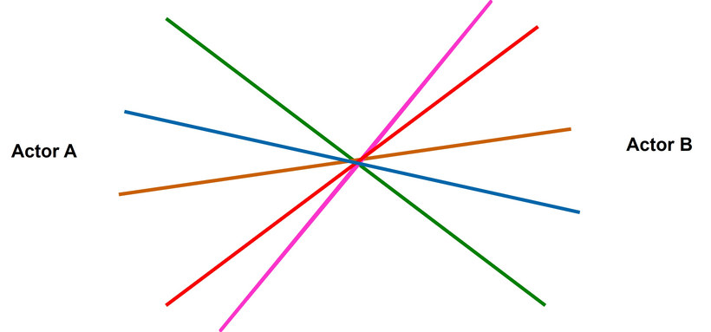
Source: Nazarkiewicz, K. (2016)
Figure created by Kirsten Nazarkiewicz for this course
Up to this point, we have treated cultural resources as if they were always considered as being of equal value. Scholars in the field of critical intercultural communication criticize a notion of culture that deals with habits and values and overlooks power asymmetries related to group memberships. They view the talk of culture as obscuring inequalities and injustice. In fact, from this meta-perspective, culture is seen to cover and hide the struggle for power. Power in this context is not necessarily meant in the sense of ‘I am using my power to influence the other’ but more as a hidden domination of the prevailing asymmetrical social structures.
If we consider the pre-existing conditions that underlie most situations, we can see that privileges are already distributed unequally. Consequently, everything we associate with intercultural communication in our natural worldview – from this meta-perspective – falls short and is ideology. The conception of particular cultural characteristics is used to define a person, which is often a form of orientalism, sexism or neo-colonialism. Holliday/Hyde/Kullmann (2004) call this "otherization". When there are misunderstandings, as they show using the example of French Tunisian lovers, a multiplicity of related background influences and all play a part (e.g. being European, Western, being of a particular age, having a certain level of education). Also, the particular culture in which the couple met, the fact that she is a tourist and the fact that he is a local worker living from tourism all influence their 'intercultural encounter'. Some scholars even think that the term cross-cultural communication is part of the world´s problems since we are too obsessed with talking about 'harmless' differences. Culture from this perspective is an arena where there is a battle for resources and belonging, and sometimes even for the very right to exist, if we consider the "Black Lives Matter" movement, for example.
This meta-perspective takes the global, macro influences on people's identities and their interaction into consideration and includes political dimensions. Due to circumstances for which we are not responsible, we have different resources e.g. whether we are a person who is of colour (PoC) or not, a male, female or diverse person, with or without handicap, gay or heterosexual, old or young, married or unmarried, has children or not, is well-educated or not etc. All these categories (some of them known as diversity categories), mostly pairs and poles, involve asymmetric relationships. With regard to people's opportunities to take part in economic success, asymmetrical positions are reproduced structurally as global positions. In any given context there is a mainstream, seen as 'normality'. Those who join the mainstream usually enjoy greater power, opportunities and resources. This approach is called power-reflexive practice because while speaking we re-construct or de-construct these power positions. Every practice of knowing, thinking, interpreting, and speaking relates to dominant patterns of discourse. The knowledge and words we use carry the asymmetries as hidden meanings and values and addressing them is delicate. This meta-perspective is called "practice" because we can find it in the discourse and speech acts, we are using. Hence, these power influences and daily practices may co-exist with equality laws or laws against discrimination.
Example:
In a study of the Johannes Kepler University Linz (Weichselbaumer 2016), around 1500 fictitious applications for a job were sent to the recruiting organisations. The precularity: Identical work experiences and CVs were combined with either a typical German name, a typical Turkish name (and the identical picture) or the same woman wearing a head scarf. The results show: The identical application with the German name had a positive resonance of 18.8%, with a Turkish name of 13.5% and wearing a head scarf of 4.2%. The conclusion: If you wear a head scarf you have to apply 4.5 times more often to achieve the same response.
Source: Weichselbaumer, D. (2020). Multiple discrimination against female immigrants wearing headscarves. Industrial and Labor Relations Review, 73 (3), pp. 600-627

Summary: the power-reflexive meta-perspective
Characteristics of the power-reflexive perspective and learning approach:
- notion of culture: cohesive, difference and diversity oriented, hence "culture" is an arena of power battles
- culture is considered as ideology (what is "normal"?)
- considers the inequality inherent in diversity factors (such as gender, race, age, physical abilities, sexual orientation) and other relevant influences like education, religion, immigration status, non-native/native, parental status etc.
- attempts to identify "power" and asymmetrical power relationships from global macro influences as (interfering) factors
- power differences are unnoticed prerequisites for interaction and identity
- has a political dimension: deconstructs discourses
- aims at equal opportunities for participation and justice
- reflects premises and aims at reducing domination when speaking and acting
Typical scholars of the critical intercultural communication theories are:
- Edwin Hoffman & Arjan Verdooren ("Diversity competence. Cultures don't meet, people do", 2019)
- Adrian Holliday, Martin Hyde & John Kullmann ("Intercultural communication an advanced resource book", 2004)
- Thomas K. Nakayama & Rona Tamiko Halualani (Editors of "The handbook of critical intercultural communication (Handbooks in communication and media)", 2010)
- Guido Rings & Sebastian Rasinger ("The Cambridge introduction to intercultural communication", 2023)
- Kathryn Sorrells ("Intercultural communication. Globalization and social justice", 2013)

Task: White Fragility
Write down the answers to the following questions in your learning journal.
- What is White Fragility?
- Why is it so difficult for white people, and hence also for people of colour, to talk about racism?
Before answering these questions, please watch an interview with each of the following two bestseller book authors:
- Robin DiAngelo, author of the book "White Fragility. Why it's so hard for white people to talk about racism" (2018)
- Reni Eddo-Lodge, who, in the UK, published the book "Why I'm no longer talking to white people about race" (2018)

Video suggestions:
Robin DiAngelo on White Fragility, Amanpour and Company [10 minutes]
URL: https://www.youtube.com/watch?v=6O27_yBQ8Qc
Reni Eddo-Lodge: Why I'm no longer talking to white people about race [12 minutes]
URL: https://www.youtube.com/watch?v=2vJZdeSqfFY

Sample answer
White Fragility is a term that goes back to Robin DiAngelo's experiences giving diversity training for business in the US and reflecting these in her academic research in sociology. It describes the defensive reactions and typical moves that are triggered by a minimum of racial stress when talking about race, in short: the "lack of racial stamina" (DiAngelo, 2011). DiAngelo concludes that this is a symptom for the white supremacy combined with the self-image as moral people. By practicing "White Fragility" there is a complicity denying structural systemic disadvantages, discrimination and exclusion of People of Color.
No wonder, the journalist Reni Eddo-Lodge writes about her despair and frustration to talk about race with white people in her book that got the British Book Award. White privilege is hard to bring up as a topic and addressing this difficulty in her blog in 2014 she got so much positive resonance (the blog was shared and linked many times) that she published a book later on. She writes about the desire to be white (which means to be able to take part and belong) and the color blindness of white people due to their advantages in a white dominated "normality" where exclusion and resentments are rare.
After publishing the hurdles to talk about race from these two authors the conversation between people of different races and with different social capital could be continued.

7.8 Synopsis: three meta-perspectives

Overview: three concepts for cultural reflexivity
The following table gives an overview of the differences we have seen in the meta-perspectives. There is not always a sharp distinction between the columns and aspects of one perspective can mingle with another. We can use the metaphor of a kaleidoscope: Once we turn it, the picture is a different one, and we discover different patterns.
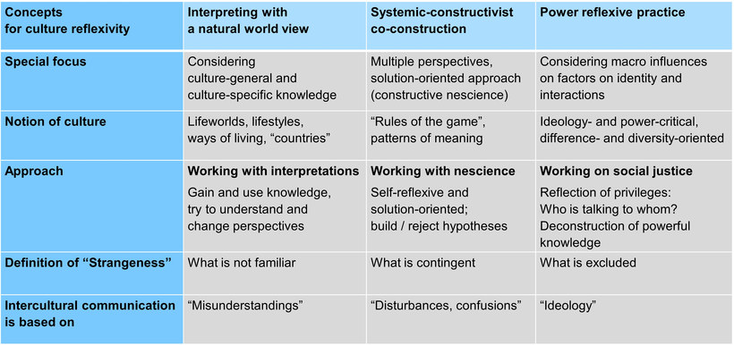
Three meta-perspectives, an overview
Source: Nazarkiewicz (2020)
Click on the image for a larger view

Transfer
If we approach situations and critical incidents with cultural reflexivity, we always keep in mind the three questions:
- Which cultural factors in terms of different perspectives and meanings could be at play?
- Which other collectives and systems, especially the situative organisation, could be influential? What do we not know and what do we even require a solution for?
- Which privileges and collective experiences are predistributed in the given interaction and need to be considered?
Hassan from Bangladesh was lucky to get a room in a newly furnished private dorm in Germany. He shares a kitchen and bathroom with his cohabitants. After a few weeks the employee in the university housing office receives a complaint from the landlord with some pictures attached. The brand-new kitchen is very dirty, especially the hot plates are covered with filth. It seems they can no longer be scrubbed clean. She talks to Hassan, who shrugs his shoulders.
Source: Inspired by Hiller, G. (2016). Eine Frage der Perspektive. Critical Incidents aus Studentenwerken und Hochschulverwaltung. Berlin: Deutsches Studentenwerk, p. 29.
URL: https://www.studentenwerke.de/de/content/eine-frage-der-perspektive-critical, accessed on 22.9.2024
In a culture-reflexive approach we do not primarily look for personality traits, e.g. that Hassan or his cohabitants might be ignorant or lazy. We scan the possible collective factors.
- Quasi-natural worldview: In those families in Bangladesh that have the privilege to study it is not unusual that a housekeeper takes care of the cleaning. Maybe Hassan is used to having help at home and has never done it on his own? Sometimes, international students don't even know how to handle cleaning equipment. It would be interesting to find out (if not known) how the inhabitants from different countries see the situation.
- Systemic-constructivist perspective: So many people use the kitchen, it is unclear who is 'guilty'. Maybe the responsibilities regarding the kitchen cleaning or the house rules are not sufficiently defined. Are there any? How many persons use the kitchen, what is the objective, and could there be a commitment for the future? Other cohabitants need to be involved.
- Power reflexive practice: Why was Hassan addressed? Is a cultural image, i.e. prejudice regarding foreigners, especially when they are Muslims with a dark skin, being used? Hassan is in a difficult situation, and it is very difficult for persons with "foreign" names who might not speak the local language fluently to find a flat or room with limited financial resources. The landlord and the housing office could take this into consideration as well.
All three meta-perspectives have their strengths and limitations. The search for cultural explanations in the natural worldview looks for different reasoning, however it might overestimate cultural factors linked to habits, etiquette or expectations. The power-reflexive practice is fundamentally oriented towards equality and reflects premises and presuppositions, focussing intensely on the prerequisites of the situation. However, the individual's influence on an interaction scenario is limited. Finally, the systemic-constructivist approach lacks cultural expertise and has no lens for power differences, solutions resulting from nescience in negotiations are rather uncommon and unexperienced in everyday practice.

7.9 Summary
Culture reflexivity that embraces three meta-perspectives recognises that:
- we all have cultural routines and practices which stem from the collectives that were or are meaningful for us, and switching perspectives is a challenge. Hence, knowledge about cultural differences might be helpful to interpret and decipher unusual behaviour
- all categories are temporary constructions. We belong to so many communities and collectives that we cannot know every influence on a situation and therefore have to inquire, ask open questions and negotiate in the given context. Also, every interaction takes place in a system or organisation with respective expectations and patterns of thinking and acting, and these also need to be considered in order to find a solution. The resources for solutions we find in the art of "not knowing" (nescience) what the best way is. Then, we are open enough to explore a way with our interlocutors.
- power asymmetries play an influential (subconscious) role in encounters and need to be anticipated. Equally, pre-distributed privileges need to be acknowledged and reduced. The challenge is to work against asymmetries in order to achieve more justice.

7.10 Learning review
The objective of this session was to enable you to explain the approach of cultural reflexivity as a concept that brings together previous learnings and to analyse intercultural encounters based on the three meta-perspectives of the culture-reflexive approach.
In order to test your knowledge, you are asked to apply the culture-reflexive approach to the following case study.

Task: Case "Wearing a headscarf at work"
Valerie is doing a vocational training in one of the biggest textile firms in Germany. Almost 70 per cent of roundabout two hundred employees are representatives of different minorities. Before the 'refugee crisis' in Germany, in this firm 99 per cent of the employees were women. But this started to change because many migrants from African countries and Syria had sewing skills and the company employed them. Some of the female employees do not like to have male colleagues, but they continue to work there. The headscarf is forbidden in the sewing hall, when operating the sewing machines. The women are wearing it during the breaks and take it off during the work.
One day, one of the Turkish employees has a conflict with the boss, and during the discussion she is told that if she does not like the working conditions she can quit. She cancels her contract and goes home. The others are told that she did not want to take off her headscarf at work because now there are male employees as well. She did not want to appear in front of the men without a headscarf.
Answer the following questions in your learning journal:
- Analyse the issues at stake using a culture reflexive approach and use the already introduced questions:
  - Which cultural factors regarding different perspectives and meanings of cultures could play a role?
  - What other collectives and systems, especially with regard to the situative organization, could play a role? What do we not know and need a solution for, anyway?
  - Which privileges and collective experiences are predistributed in the given interaction and need to be considered?
- What solutions with less conflict potential come to your mind? Find at least 3 variations of actions or steps.
- If you were Valerie: what would you do, personally, and why?

7.11 Sources, further reading and web links

Sources
- DiAngelo, R. (2018). White Fragility. Why it's so hard for white people to talk about racism. Boston: Beacon Press
- Eddo-Lodge, R. (2018). Why I'm no longer talking to white people about race. London / Oxford / New York / New Delhi / Sydney: Bloomsbury Publishing
- Nazarkiewicz, K. (2016). Kulturreflexive Perspektiven für Systemiker*innen. Talk at the 16th annual conference of the GGSF in Frankfurt. URL to the PowerPoint slides: https://www.consilia-cct.com/dokumente/Nazarkiewicz-Kulturreflexive-Perspektiven-fuer-Systemikerinnen.pdf (accessed on 13.1.2021)
- Sen, A. (2007). Identity and violence. The illusion of destiny. New York: Norton

Recommended reading
- Nazarkiewicz, K. (2016). Kulturreflexivität statt Interkulturalität? Re-thinking cross-cultural – a culture reflexive approach. In: Interculture Journal 15 (26),
URL to download this article as a PDF document: http://www.interculture-journal.com/
index.php/icj/article/download/278/362

Weblinks
- Nazarkiewicz, K. (2020). "Why culture reflexivity?", online lecture for the SIETAR series "moving online", URL: https://www.youtube.com/watch?v=6pwoz-cSelk

8. Creating a common ground of understanding and a space for interaction

Topics
8.1 Prelude 133
8.2 Introduction 133
8.3 Culture and interculturality, a quick review 133
8.4 Negotiating culture, the model 134
8.5 Negotiating culture, a step by step approach 137
Task: Case "Mario's team" 137
8.6 Intercultural competence, the concept 138
Task: My intercultural competence repertoire 139
8.7 Developing a common ground, a case study approach 140
Task: Case "Made in Germany (Or India?)" 140
8.8 Summary 142
8.9 Sources, further reading and web links 143

Learning outcome
Based on the theory of negotiating culture and the concept of intercultural competence, you make meaningful suggestions for developing a common ground of understanding and creating a space for interaction

Objectives
At the end of the session, you will be able to
- explain the model and approach of negotiating culture
- apply the step by step approach to a case study
- explain the concept of intercultural competence
- identify competencies needed for negotiating culture, and
- make meaningful suggestions for creating a common ground of understanding and a space for interaction

8.1 Prelude
In the previous sessions you acquainted yourself with various approaches and tools in order to analyse pitfalls and possible misunderstandings in intercultural encounters. A thorough analysis is a basic requirement for finding ways and means of dealing with such situations. This session takes you a step further by introducing a model of finding a common ground of understanding and a space which enables participants to interact in an adequate, appropriate and meaningful way.

Download: Learning journal for session 8
Learning journal (.docx) Learning journal (.odt) Learning journal (.rtf)

8.2 Introduction
You are about to conclude your professional and personal learning journey in intercultural communication. We developed this journey and its various paths with the aim of enabling you to analyse intercultural interactions and communication processes and use this analysis for developing a common ground of understanding. In other words, exploring the nature and effects of interculturality, use the potentials inherent in such encounters and be ready to cope with possible misunderstandings and confusions which may accrue from cultural differences. And this is the step, you are about to take in the course of this session. You are going to apply your learnings and use them as part of the process to outline how you can deal with misunderstandings and misperceptions through the process of negotiating culture.
You embarked on this learning journey to acquire knowledge, but by applying your knowledge and working on the various tasks you equally had the opportunity to develop useful skills. By introducing the conceptual framework of intercultural competence, the purpose of this session is also to provide you with a framework helping you to reflect on the knowledge and skills you have acquired.

8.3 Culture and interculturality, a quick review
If we wish to establish a common basis for understanding, then we need to be interested in the perspectives that various actors assume from their fields of experience. This involves being concerned with people and their cultural orientation. By considering an open perspective of culture, we acknowledge that culture exists within human collectives and is constituted through the interactive (re)production of patterns of shared meaning. With this understanding, culture can be created and changed by a group of people. The term culture as such refers to people’s membership of different kinds of groups that share commonalities. These could be, for example, a profession, a role, a department, a sport, a corporate organisation or a nation. Some of the collectives that actors feel affiliated with will become more relevant in particular contexts and at specific moments than others.
In a work environment, for example, diverse people meet for a specific purpose and may initially have different understandings of work processes due to their professional socialisation and membership of particular collectives. When they meet new colleagues they are likely to experience a feeling of unfamiliarity or even strangeness due to a different understanding of work and working together. Thus they find themselves in a situation in which ‘normality’ is missing. When we encounter such an absence of normality, i.e. a lack of shared understanding regarding established approaches and patterns of behaviour as well as a lack of plausibility and routinised action, this is what we call ‘interculturality’.
Interculturality can therefore be understood as a process of social interaction and communication during which people develop a common basis for understanding and modify and align cultural practices. This should be done in such a way that the people involved feel comfortable. In this case behavioural patterns are perceived as appropriate, with everybody behaving in a way that makes sense to others and in which routine actions are established which are understood and acceptable for all and therefore shared.

8.4 Negotiating culture, the model
When routine actions are accepted and shared by all, we can assume that the people involved have gone through a process of negotiation. A negotiated culture thus indicates a reciprocally and collectively formed culture that develops out of a communication process between all parties. It is linked to the interplay and process between action, reaction and adaptation, leading to the construction of reality. The experience of Marie and Jo may illustrate this:
When Marie and Jo started to work together, they realised that they had very different communication styles. Whereas Marie grew up learning that it is polite to wait until the other person finishes his or her sentence, Jo is a person who emphatically interrupts Marie. Getting passed her initial irritation with Jo's behaviour, she decides to talk to him about it. This is when they realise that Jo perceives his communication style as polite because by interrupting and being supportive of what Marie says, he wants to show his consent and appreciation. Understanding that interruptions distract Marie, especially when she wants to explain and talk about complex issues, Jo happily agrees to adapt. They agree that when Marie wants to explain something in more length and wants to be listened to without being interrupted, she simply says so. At times, however, Jo falls back into his habit, and whenever it is important to Marie she jokingly reminds him of their agreement.
For Yoko Brannen (1998, p. 12), the term 'negotiate' "is used as a verb to encourage us to think of organizational phenomena as individual actors navigating through their work experience and orienting themselves to their work settings. Focusing on culture as a negotiation includes examining the cognitions and actions of organizational members particularly in situations of conflict, because it is in such situations that assumptions get inspected." From such a perspective, negotiation can be identified as construction and reconstruction of divergent meanings and actions by the actors.
Such a negotiated culture requires different steps to be acknowledged, as the illustration below indicates. People meet and bring with them their cultural orientations, which reflect their individual social histories. They experience, therefore, a different set of meanings and have disparate behavioural routines. From these differences, issue domains that are perceived as confusing, difficult to deal with or incompatible can be delineated after a certain amount of time working together. These issue domains need to be acknowledged and respected so that they can be deliberately addressed and taken into consideration. If we recognise that culture is embedded in personal social histories, then it is clear that ensuring common meanings regarding the issues and goals at stake is vital. One step in this direction would be to acknowledge the collectives to which the actors belong when they are relevant to the task. Because the interaction takes place in a specific context, which can be influenced by relationships of hierarchy, power and dependence, these need to be taken into account and addressed.
Out of this interplay of shared sense-making, goal setting, identification of issue domains and contextual influences, the process of developing a culture that is appropriate to the circumstances, goals and group members’ cultural orientations can emerge. In the process of such a negotiation, common meanings as well as rules and behaviours which are acceptable to all should be established. In this way the parties involved create a common basis for communication, cooperation and collaborative working.
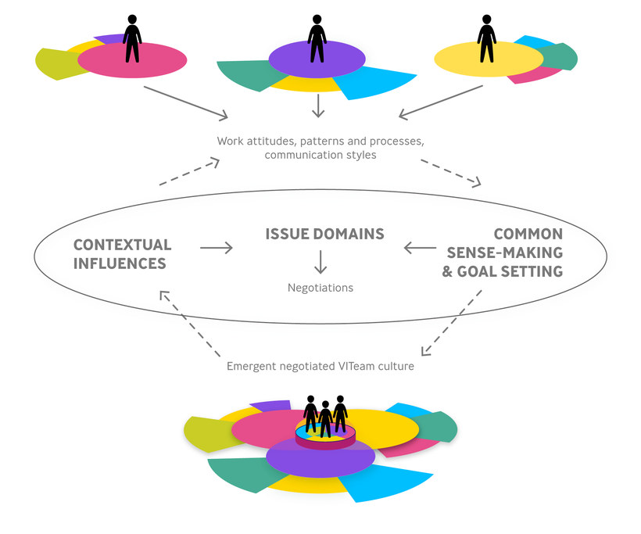
Source: Based on Brannen, Mary Yoko & Jane E. Salk (2000, p. 457)
Illustration by Julia Flitta (www.julia-flitta.com)
A negotiated culture is, as with any culture, fluid, which means that in the course of working together renegotiations may need to take place, followed by a refinement of the culture. A negotiated culture is therefore the outcome but also the beginning of a process.
Establishing a common basis for interaction and thus a common culture requires time, understanding, creativity, as well as the willingness and capacity to communicate and dialogue. People therefore need to possess the openness with regard to setting aside the time and energy needed for a culture to develop. During this process however, the level of unfamiliarity or strangeness experienced by the actors may differ. And finally, the way the negotiation process proceeds also depends on the complexity and relevance of the work domains that are involved and need to be addressed.
For example, in a work group in which all members are already experienced and confident in using English as a lingua franca, there is little need to debate which language to use. This is different when a newly established workgroup consists of some people who are not used to speaking English and others who are fluent and accustomed to its use. In such a constellation, language is an important issue domain. Here actors may come up with a negotiated solution whereby those who do not feel comfortable speaking English can discuss in their mother tongue. An alternative solution might be to agree to have somebody summarise important issues in a language other than English to make sure that all contributions are understood. Yet another option could be to ensure that important issues are translated or interpreted.
The outcome of such a negotiation process cannot be predicted but generally speaking several options are possible:
Complementing each other:
This refers to pooling resources such as knowledge and skills with the aim of achieving a better outcome through their combination.
For example, one person may have very good technical skills and another is good at writing reports. In this case they may simply decide that each of them simply contributes in the area of their competence.
Adaptation:
Adaptation is the ability and willingness to adjust one's own behaviour and accept different and new behavioural patterns or work approaches that might be more appropriate to the group’s situation and goals. One reason to choose such an approach could be that those who have greater access to particular resources can be more effective in this way.
An example is the case of Nick. He used to be a working student in an international company where he benefited greatly from the regular feedback he received. When he started his internship he was surprised that he never received any comments regarding the quality of his work. When he talked to his supervisor about this, he was told that his task was not a common one and that his boss did not have time to devote to it. As he was an intern, Nick felt he had no other choice than to accept this.
Finding a middle way or compromise:
In this process, the outcome of a negotiation emerges through all or some of the people involved ‘giving in’ to a certain degree, whilst integrating new practices. We might say they are 'meeting in the middle'.
Consider Lina who is concentrating on writing a report that needs to be completed today when she gets interrupted by Leo, the intern in their department. He asks a lot of questions and wants to be shown how to collate his Excel lists correctly. Because they talk about their different needs, they manage to come to a compromise whereby Lina spends time with Leo showing him Excel, while Leo helps Lina to format the report so that she does not lose time.
Novel ways of interacting or developing synergies:
This is a constructive approach whereby people search for new and innovative ways of working together. It is different from complementary approaches because it focuses on the added value of working together and the creation of something new through a process of combining attributes. Novel approaches can develop when social interaction among team members triggers the production of new ideas and products that the team members would not have been able to generate on their own.
The following is a quote from an internship report illustrating value creation:
"Another example where the international team added value was when we were all working together on one analysis. While I went into too much detail and was wasting a lot of time through my search for perfection, my colleague reminded me of all the tasks that were still pending. First, I thought this was not the way to go because we were not taking into account all of our information. However, in the end I learned that it was good to gain an overview of all the numbers. The way my colleagues worked was quite interesting because they defined the result they wanted to achieve and then found a way to get to that result, while I tried to do everything step by step, moving towards the best possible result. By using a mix of both approaches we produced a very meaningful analysis in the end and our boss was very happy with the result..."
What this quote highlights is the fact that time needs to be set aside for an open process of value creation.

8.5 Negotiating culture, a step by step approach
The steps identified to negotiate culture are:
- Acknowledging and appreciating differences as well as commonalities
- Establishing an understanding of domains to be negotiated
- Discussing and identifying contextual factors
- Developing a common meaning of issues and goals
- Negotiating and establishing a common basis for interaction
- Identifying the emergent elements of the negotiated culture

Task: Case "Mario's team"
The following is a short case taken from a book by Gehrke and Claes (2014; p. 130). Read the text and analyse it by providing answers to the following questions:
- Who is involved? Answer this question by simply listing the members of the workgroup
- Where can you detect differences and commonalities or, in other words, which typical cultural factors may be at play here? Answer this question by applying the knowledge you have about cultures and explanations which come into your mind.
- Which issue domains appear to be particularly relevant? In other words, where do you see areas which seem to cause confusion and need to be addressed?
- Which contextual issues might influence the effectiveness of the group and therefore require attention?
- What do you think the goals of the different members of the group might be?
- Where do you find language issues which require explanations? Here it is of particular importance to note down terms used which are linked to larger concepts and may require explanation.
- Where do you see potentials for negotiating cultures or, in other words, establishing common ground?
- What might a negotiated culture look like? What type of negotiation options make sense and why? Are there areas where new approaches may be found?
The case
Mario figures out very quickly that relationships between team members are far from ideal. His colleagues in Kazakhstan often had to be asked repeatedly to deliver results, sometimes even with the help of the corporate project manager.
Furthermore, those in the Milan team start to openly show their dissatisfaction. He himself sometimes feels frustrated, in particular with the confident manner of his English colleague Peter. Mario perceives Peter's direct criticism in front of everybody as a lack of trust in him as a leader. Peter tells him that he wants the task-related roles to be clearer. But Mario prefers to define roles in the team more fluidly, with people contributing to the work as and when they can. In this respect, he is fond of the Brazilians and Indians in the team who propose their ideas in a much more collegial tone, with phrases such as 'What do you think, should we re-analyse the high-pressure reservoir data?'.
Mario knows that, in order to succeed, the team has to work together in a highly interdependent way and this means everybody has to participate proactively in delivering results. He also understands that in order to improve the team's performance, he has to build on team members' differences. Mario asks himself the following question: How can he build a high level of trust and unity among his team? How should he organize the reporting lines and communication channels? How might he foster the creation of an interdependent knowledge base?
What this short case study and exercise illustrates is that negotiating culture requires specific knowledge and skills, which are generally referred to as intercultural competence.
Through working on this case study you will have activated a lot of the knowledge you have already gained by working on the various sessions. Our discussion on negotiating culture also shows that such a process requires an openness and willingness to reflect on one's own behaviour and adjust when the need arises. Many of the tools you have seen during this course will support you in achieving this.

8.6 Intercultural competence, the concept
There is no one single definition of intercultural competence. Equally, there is no one definitive term to describe it. In fact, the term may produce a wide range of associations such as intercultural communication, cross-cultural awareness, intercultural sensitivity, cultural intelligence, adaptation and possibly even global citizenship. In our conceptualisation of intercultural competence we acknowledge a dynamic understanding of culture and pursue a practical approach. Our understanding of competence therefore needs to be linked to the behaviour a person exhibits. This means our understanding of competence involves the development of a behavioural repertoire. This could be viewed as the cultivation of a range and variety of behaviours that are capable of achieving positive collaborative outcomes.
This kind of thinking is at its core similar to the definition of competence outlined by Kurz and Bartram (2002; p.230) who state that: "A competency is not the behaviour or performance itself but the repertoire of capabilities, activities, processes and responses available that enable a range of work demands to be met more effectively by some people than by others.” A competence can thus be understood as enabling us to do something. Kurz and Bartram use the example of a musician who has a repertoire of styles and skill areas which enable him or her to perform in a specific way. They call the performance "the choreographed stream of behaviour”. The musician’s competence refers to his or her ability to perform and transfer knowledge and skills from one job task, i.e. context to another.
If we apply this analogy to interculturality and thus situations which lack familiarity, plausibility and routine actions, then we can conclude that we need competencies that enable us to ‘create a sense of normality or familiarity that neutralizes the mechanisms that encourage stereotyping, inducement of anxiety, negative attribution and the creation of in and out-groups that the intercultural space may bring about’ (Verdooren, 2014, p. 19). In other words, interculturality requires competencies which have the potential to enable those involved to create connections and a common space which can then be used to further explore and negotiate differences. Intercultural competence can then be understood as enabling us to manage interactions in such a way that they are likely to produce an appropriate and effective outcome.
Although the understanding of intercultural competence varies in nuances, current theories and models commonly refer to intercultural competence as having three dimensions: knowledge, skills and attitude. Attitude refers to the willingness and openness to interact with a diversity of people and is thus a precondition for constructive cooperation. It can also be argued that awareness of culture as an influencing factor on people’s behaviour and communication style is closely linked to attitude. For example, we may have an open attitude but if we are not aware or sensitive towards issues that affect a given interaction sequence, then the attitude itself does not help very much in itself. Awareness includes aspects such as openness, empathy, curiosity and flexibility. The skills dimension refers to the ability to act. It includes observing, evaluating, changing perspectives, reflecting, and processing acquired knowledge. Knowledge can be knowledge with regard to social processes, knowledge regarding how other people see themselves as well as general geographical and culturally specific knowledge.
Although at times it is difficult to delineate the three dimensions and we could justifiably contest that all three are interconnected, conceptualizing intercultural competence in such a way is helpful because it can be used as a framework to evaluate what we have already achieved and define areas we want to develop further. Let us look at a very straightforward example. You might be very interested in completing an internship in Shanghai and therefore want to prepare for your journey. To do this you might well start reading about China. You then learn how to eat with chop sticks because these sources tell you that this is the common way of eating in China. By learning and exercising how to eat with chop sticks you develop the expertise and skills. In this way the knowledge part is linked to general country level information, whereas the skills part relates to the expertise and the attitude aspect to your willingness and openness to explore. And because you also reflect on your knowledge and know that this information should not be generalised or taken as absolute, you are only slightly surprised that when you are invited to eat with your new boss, you are given chop sticks, a spoon as well as a plastic serviette. On asking when to use the plastic serviette, you are told that you can use it to help eat the leg of duck using your hands.
The interdependence of the three components is equally illustrated by the following example: You may have learned that in many cultures, a meeting begins with a lengthy period of smalltalk. However, simply knowing this does not teach you how to deal with such situations if you are not familiar with them. Furthermore, you also need to have the willingness and openness to manage such situations well.
With this as well as the three dimensions in mind, let us explore your competence repertoire.

Task: My intercultural competence repertoire
Think back to the sessions you have already worked on, your life experiences and social history. Using keywords, note down what kind of cultural knowledge you have acquired and what kind of skills you have already developed. Since attitude and awareness are linked to motivation or inner disposition and are at the same time difficult to teach and learn, simply note down what you associate with these terms.
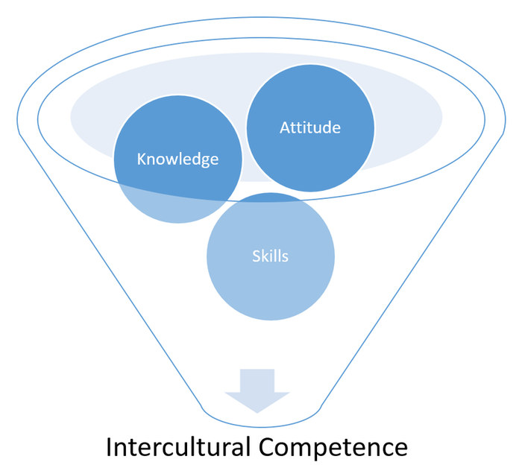
Linking these three dimensions provides the prerequisites required to develop a common basis for understanding and negotiate a common culture. This also means that intercultural competence supports the ability to develop and form an intercultural space.

8.7 Developing a common ground, a case study approach
The following is an authentic case study of a Northern German mid-sized engineering company that decided to locate production abroad with little consideration of any cultural issues. It was developed by Dr. Peter Witchalls (2015).

Task: Case "Made in Germany (Or India?)"
First of all, read the case study for comprehension. In a second step you will take on the role of cultural advisor. Your task is to analyse the case based on the following steps and questions:
- Who is involved? Answer this question by simply listing the persons involved in the case study.
- Where can you detect differences and commonalities or, in other words, which typical cultural factors may be at play here? Answer this question by applying the knowledge you have now gained about cultures. Use and reflect on any explanations that come into your mind and seem plausible.
- Which issue domains appear to be particularly relevant here? In other words, where do you see areas that seem to cause irritation & confusion and need to be addressed?
- Which contextual issues that might have an influence the outcome of the interaction do we need to take account of?
- What do you think are the goals of the German engineers and the Indian employees respectively?
- Where do you find language issues which require explanation? Here it is of particular importance to note down terms used which are linked to larger concepts.
- Where do you see potential for negotiation, i.e. establishing a common basis of understanding?
- What might a negotiated culture look like? Choose two areas or domains and evaluate the negotiation options. Can you also detect areas where a new approach might be found?
The case
A large German engineering company HENNES AG (name changed) manufactures high-performance customized filling and packaging systems for multinational companies such as Heineken, PepsiCo and Anheuser Busch. In this industry, precision, quality and punctual delivery are paramount.
As a global player, HENNES AG also provides a large amount of Indian companies with turnkey lines for the manufacture of beverage, food and non-food products. These companies are comprised of local manufacturers and producers under license from large food and drinks conglomerates (such as PepsiCo). Since the large multi-national players require high degrees of performance and precision in their production lines (some of them, for example, running 24 hours a day at a speed of 81,000 PET bph with a maximum permissible reject rate of 0.02%), the amount of original HENNES AG spare parts required to maintain these machines is considerably high, as is their price.
Contrary to expectations, a sales analysis revealed that HENNES’ spare parts’ sales in India were in no relation to the amount of HENNES AG machines operating there. In fact, the sales of spare parts were rapidly diminishing. On closer inspection, HENNES AG discovered that the Indian companies had been re-tooling and repairing their machines with generic, locally produced parts. In order to regain these lost sales, HENNES AG entered into a joint-venture with a large Indian producer and distributor of spare parts for production lines (Jaipur Machine Parts (JMP)). By combining JMP’s local expertise and their access to local distribution channels with the German concept of quality, HENNES AG was soon able to serve their Indian customers successfully with reasonably-priced, original parts.
The venture was so successful that two years later it became a HENNES AG subsidiary. And when a new Production Director was appointed to the HENNES AG Board of Directors (Vorstand), he decided to expand the JMP manufacturing facilities and move the production of one of their less complex products (labelling machines) from Germany to the Indian plant in order to lower production costs. The machines were to be sold both in India and in Europe, including Germany.
One of the consequences of this measure was that most of the workforce in the German division Labelling was laid off, apart from five (of the original ten) key engineers, who were kept on in order to train the Indian engineers how to manufacture the labelling machines in India. To this end, five Indian engineers visited HENNES AG for six months (and were booked into rooms in a local hotel) in order to learn the manufacturing techniques which they were to put into practice in India. They were to work closely with the German engineers and clearly part of the success of this venture would rely on good communication between them
However, the German engineers (Mr/Herr Sievekind, Mr/Herr Beeck, Mr/Herr Holler) often complained that their Indian colleagues (introduced as Ajay Singh, Dipak Chandra, Mandeep Bhakta) were difficult to understand and too familiar: they seemed to get very close to them when they were explaining the machine assembly, used first names and touched them on the arms at times. Furthermore, they wanted to talk about issues outside of work, and did not seem to want to go home when it came to leaving work at 3.30 p.m. (what the German engineers called Feierabend which could be translated as time off after work).
In addition, the Indian engineers often nodded enthusiastically when the construction of a machine part was explained to them (after a while the German engineers learned that an apparent shaking of the head could mean yes) but were then unable to put the parts together when asked.
The Hennes AG engineers at one plant explained the task repeatedly and became increasingly frustrated. In one case, Mandeep Bhakta was asked to weld two machine parts together but Herr Sievekind regarded the work as sloppy (too much welding material was used and the join did not form a neat line) although the parts adhered to strength requirements. The Indian welder Mandeep did not seem to understand the problem. In general, the engineers Ajay, Dipak and Mandeep were convinced that the engineers from Hennes AG did not like them, since they rarely smiled and did not appear to want to socialize with them after the 3.30 pm deadline.
Ajay, Dipak and Mandeep were, however, pleasantly surprised when one of the personal assistants, Sarah Fischer, who helped to coordinate their trip, smiled and joked with them, called them by their first names and was prepared to give them her mobile phone number. So, when Ajay realized that it was her birthday, he called her to congratulate her (it was her day off) but was surprised not to encounter an enthusiastic response from Sarah on the other end.
When Ajay, Dipak and Mandeep were finally sent back to JMP, they felt reasonably capable of performing the tasks that were required of them, but were puzzled and somewhat shocked by the reception they had been given and the way they had been taught and evaluated, since the phrase in Ordnung (which could be translated as ok or in order) seemed to be the most praise they had received.
When a particular part that was required by JMP did not appear to have been sent out by Hennes, one JMP employee wrote an e-mail to the Production Department and copied the mail to the Board of Directors (BOD), who were sitting in the headquarters in a different part of the country. According to the German employee who received the mail, it was felt to be "direct and accusatory”. According to the sender of the e-mail from JMP, sending such an e-mail and copying the BOD was seen to be normal procedure and was in no way meant to be offensive or disruptive. This was, in his interpretation, "the appropriate method to choose when voicing concerns about a logistics issue”.
When production began in the Indian plant, problems began to emerge, such as deadlines not being met, parts going missing and many machines being unsaleable on the German market (for both functional and aesthetical reasons).

8.8 Summary
Understanding why people behave in a certain way and what their intentions are very often helps us to come to terms with a confusing or even conflicting situation. However, if we are willing to take the time to move beyond initial conceptions, then a common culture can be negotiated and a common space for interaction can be created. In this way we harness the diversity present and actively benefit from it. Such a process requires implementing a sequence of steps. One such step is becoming aware of one's own cultural orientations. A further step is then to explore and identify central issue domains that need to be negotiated as well as analysing contextual influences. Subsequently we need to ensure that common meanings are developed and establish genuine agreement on common goals that all parties can identify with. This forms the basis for further negotiation of ways of communicating and working together and is a significant step towards developing a common culture. There may be areas where people are able to complement each other, adapt to each other or find a middle way. Over and above this, the process also sets the stage for novel ways of interacting and thus the development of synergies. Because a negotiated culture not only acknowledges diversity but values it and searches for means and ways of benefiting from it, it is an approach which has a high potential for constructive, effective and satisfying interactions. Negotiating culture requires awareness as well as knowledge, skills and an open attitude. All this together could be called 'intercultural competence'.

8.9 Sources, further reading and web links

Sources
- Barmeyer, C. (2018). Konstruktives Interkulturelles Management. Göttingen: Vandenhoek & Ruprecht.
- Brannen, M. Y., & Salk, J. E. (2000). Partnering across borders: negotiating organizational culture in a German-Japanese joint venture. Human Relations, 53 (4), pp. 451-487.
- Gehrke, B., & Claes, M.-T. (2014). Global leadership practices. New York: Palgrave.
- Hoffmann, E., & Verdooren, A. (2019). Diversity competence. Cultures don’t meet, people do. Oxfordshire: CABI.
- Kurz, R., & Bartram, D. (2002). Competency and individual performance: modelling the world of work. In: I. T. Robertson, M. Callinan, & D. Bartram (Eds.), Organizational effectiveness: the role of psychology (pp. 227-255). London: John Wiley & Sons.
- Spitzberg, B. H., & Chagnon, G. (2009). Conceptualizing intercultural competence. In D. K. Deardorff (Ed.), The SAGE handbook of intercultural competence (pp. 2-52). Thousand Oaks: SAGE.
- Verdooren, A. (2014). Taking multiplicity seriously: towards new approaches for intercultural practioners. Interculture journal, 13 (23), pp. 11-24.
- Witchalls, P. (2015). Teaching and learning intercultural business communication
through an authentic case study: an experience report. Interculture Journal, 14 (24), pp. 67-76. https://www.ssoar.info/ssoar/bitstream/handle/document/45013/ssoar-interculturej-2015-24-witchalls-Teaching_and_learning_intercultural_business.pdf
(accessed on 15.1.2021).

9. The journey continues

Topics
9.1 Prelude 145
9.2 Introduction 145
9.3 Developing intercultural competence 145
9.4 Key areas of intercultural competence and my personal achievements 147
Activity: Dealing with opposing views 149
Activity: Case "Not telling the truth" 151
Activity: Exploring the other's perspective and meaning 153
Activity: Case "How to tackle a difficult topic in a constructive way" 154
Activity: Interpreting non- and paraverbal behaviour 155
Activity: Finding explanations for irritating behaviour 157
Activity: The world upside down 158
Activity: Privileges and disadvantages 160
9.5 ... and the journey continues 160
9.6 Sources, further reading and web links 161

Learning outcome
You will reflect upon your learning achievements and foster the development of your intercultural competencies for the future.

Objectives
At the end of the session, you will be able to
- discuss aspects of intercultural competence development
- identify and evaluate your learnings
- outline areas for refining your intercultural competence

9.1 Prelude
You are about to conclude your professional and personal learning journey in intercultural communication and this is a good moment to look back in order to assess what you have achieved but also to look ahead into the future.
We developed this journey and its various paths with the aim of enabling you to analyse intercultural interactions and communication processes and use this analysis for developing a common ground of understanding. In other words, exploring the nature and effects of interculturality, use the potentials inherent in such encounters and be ready to cope with possible misunderstandings and confusions which may accrue from cultural differences.
So what has changed for you? Are you now better able to sense and explain irritations you may experience when coming across other cultural practices? Does the knowledge you acquired reduce the notion of unfamiliarity and strangeness you at times feel in intercultural encounters? And has this course helped you to develop skills to navigate intercultural interactions and communication processes well? These are questions we want to explore in this final session.

Download: Learning journal for session 9
Learning journal (.docx) Learning journal (.odt) Learning journal (.rtf)

9.2 Introduction
At the beginning of this module we argued that developing an understanding of cultural diversity and improving one’s capacity to deal with diversity and a multitude of cultural orientations in a constructive way is considered a key qualification in many business and private settings which supplements the expertise in specific fields. Now, after having explored the different facets of cultures, the possible challenges in intercultural communication and outlined approaches of negotiating culture and co-creation of meaning, it is time to reflect upon your learnings and the competencies you developed.
The aim of this session is thus to raise your awareness of the competencies you improved upon and reflect on how they are expressed in behaviour enabling you to pinpoint personal achievements and further study paths.

9.3 Developing intercultural competence
As Verdooren (2014, p. 19) rightly stated, we want to do more than talk about cultures and develop our sensitivity towards factors influencing interactions. We want to develop meaningful ideas and options as to how to interact in a multicultural world. This means that we need knowledge and skills which enable us to respond to those situations which may be confusing, perceived as strange if not incomprehensible or incompatible.
Understanding interculturality as a communicative interaction which is lacking familiarity, routine action and plausibility means we need competencies enabling us to ‘create a sense of normality or familiarity that neutralizes the anxiety, stereotyping, negative attributions and in-out group mechanism that the intercultural space may bring about’ (Verdooren, 2014, p. 19). In other words, interculturality requires competencies which have the potential to enable the involved persons to explore commonalities and to create a common space and connection from where differences can be explored and be dealt with.
When introducing the general concept of intercultural competence in session 08 it was stated that intercultural competence is commonly considered as having three dimensions, a knowledge, a skill and an attitude and awareness dimension. Whereas the knowledge dimension refers to knowledge for example of social processes, knowledge about how other people see themselves and general country and culture specific knowledge, the skills dimension refers to the ability to do something. It includes aspects such as observing, evaluating, changing perspectives, reflecting, and processing acquired knowledge. It was also argued that awareness and attitude are a precondition for a constructive cooperation. Whereas awareness relates to the cognizance, consciousness and sensitivity of recognizing where and how culture influences interactions, the attitude refers to the approach I am taking once I realize the influence of culture on behaviour.
What these elaborations show and you probably noticed when carrying out the tasks is that there is a relationship and interdependence between the three dimensions of intercultural competence. This is also why at times it is difficult if not impossible to place an item with only one of the three dimensions. Think about language for example, knowing the vocabulary and sentences structure of a language would clearly be placed with knowledge. But such a knowledge is surely not enough in order to communicate in an adequate and appropriate way. This would require skills to be sensitive to context, the ability to know when to say what in which way and include aspects such as politeness and communication strategies and styles. And it would require the readiness and motivation to explore when and how to communicate what.
In short it is necessary to develop an awareness and use one’s open attitude to generate knowledge. And such knowledge goes beyond facts as it includes a reflection of one’s own behaviour in order to establish a repertoire of skills needed for reflexive action applicable in a specific context. A competence of action is thus one which considers the process of interaction and does justice to the fact that the word competence according to the Online Etymological Dictionary comes from the Latin word competentia meaning “meeting together” and
in its earlier sense “fall together” or “come together” (https://www.etymonline.com/word/
competence, accessed on 31.12.2020) . A competence of action or intercultural competence for that matter can thus be defined as the ability to act in a way that supports the co-creation of shared spaces that are perceived as appropriate, inclusive and satisfying.
As you went along working on the various sessions, the case studies became more complex and you started to consider a variety of domains to be analyzed and finally worked on issues helping you to develop meaningful interventions. Going through these various activities reflects the process character of intercultural competence development. It is thus not unusual that with a growing complexity we also realize how big our knowledge gaps are and that not-knowing and dealing with this fact of not-knowing is part and parcel of intercultural competence.
There are countless definitions of intercultural competence highlighting specific knowledge, skills and behavioural dimensions and Deardorff (2020, p. 5) summarizes them by saying that:
"...intercultural competencies in essence are about improving human interactions across difference, whether within a society (differences due to age, gender, religion, socio-economic status, political affiliation, ethnicity, and so on) or across borders.” In the definition used in this module we want to go a step further and focus on the action orientation of intercultural competence by referring to competencies which support the co-creation of shared spaces that are perceived as appropriate, inclusive and satisfying by all actors involved."
The core competencies discussed in our context here are openness, communication and culture-reflexive knowledge and are therefore by no means exhaustive but have been chosen on the basis of relevance and for providing focus.

9.4 Key areas of intercultural competence and my personal achievements
In this session we want to bring core intercultural competencies closer to you which are being summarised under the key aspects of openness, communication and culture-reflexive knowledge. We want to do this by exploring their meanings, by giving examples of how they are being expressed in behaviour and work settings, and by offering activities which help you to assess your learnings.
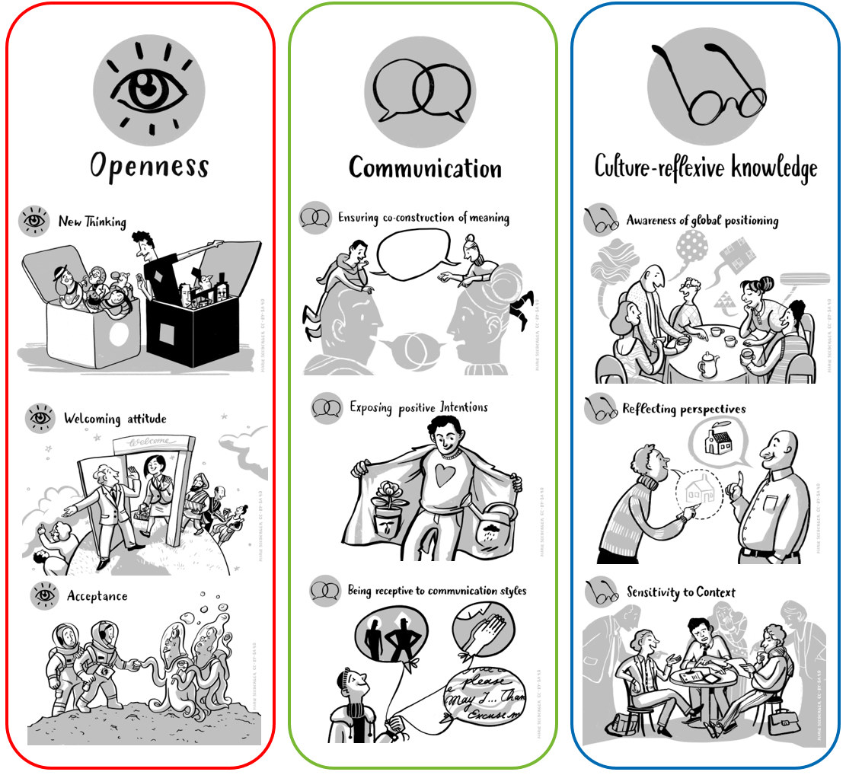
Key areas of intercultural competence
Illustrations by Marie Seeberger (www.behance.net/marieseeberger) CC-BY-NC-SA 4.0 license

***


Openness in the sense of being ready to explore new situations and feeling comfortable in unfamiliar and at times highly complex situations is surely a valuable trait to address intercultural encounters constructively. Openness encompasses new thinking and a welcoming attitude which can be understood as the readiness to initiate relationships with new people and those who may be very different for example with regard to their personal or cultural backgrounds, experiences and behaviours. If we want to develop a common ground it is also important to accept behaviour that may be very different from our own or even be in conflict with our own sense of best practices.
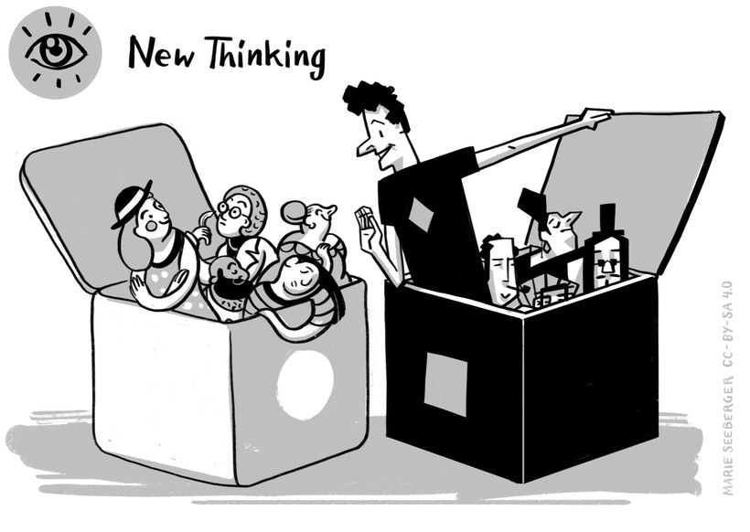

Meaning
People who have the competency of New Thinking feel passionate about following up with new ideas or developments. These are people who have a natural curiosity and like to venture into new and unfamiliar fields. They also like to view things from different perspectives, challenge established facts, and like to get "to the bottom" of things by learning more about the background and connecting the dots. Using their curiosity as well as their natural sense of creativity they like to find "out of the box" solutions for established challenges.

Example
Priscilla is working as an engineer, where she enjoys to stay ahead of new developments in her fields. When a global pandemic hits, everyone is restrained to work on a virtual level. Priscilla sees the challenge, but especially the opportunities this new situation brings. She enjoys the steep learning curve when it comes to using different platforms for collaboration, and the opportunity to quickly get the ideas and information from colleagues from the whole globe together. She enjoys the mutual learning that she can take from her colleagues of the 4 continents she is working with. Of course, she misses the face-to-face interaction with her colleagues sometimes, but finds new solutions for connecting to them on a virtual level, using a variety of different tools she finds available after active research.

Activity: Dealing with opposing views
Open a newspaper or a website that you usually would not read because the views displayed here do not depict your own. Pick an article, maybe a commentary, which you reckon to be quite different from what you believe and what your common understanding is. When you read the article, ask yourself how you can deal with opposing views or behaviour. Is there anything in the reading that enriches your worldview?
Choose two aspects from the article or commentary, describe them briefly in your learning journal and note down the new thinking which developed from your reflection.
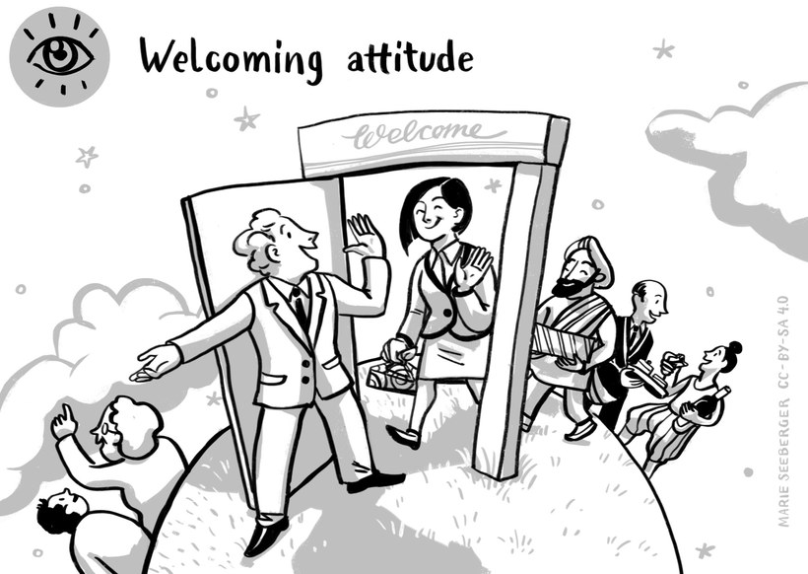

Meaning
People with a Welcoming Attitude like to meet and learn from individuals that might have different thoughts or backgrounds compared to their own. They find it interesting to exchange thoughts with people that have very different experiences. Besides, these people find it well within their comfort zones to take the initiative and approach people that might dress or behave differently than themselves, or also speak another language. They also find it fulfilling to help those who might come from other cultural backgrounds and look for orientation.

Example
Yaoting takes a semester abroad in India. She knows many students that come from the same country as she does, but she is much more interested in meeting with local Indian students, as she finds it fascinating to learn about their way of life and cultural backgrounds. As her fellow Indian students notice her genuine curiosity, they are happy to share more about their experiences and ways of thinking with her. At the end of the term, Yaoting has made many friends there, who feel sorry to see her leave.

Activity: Mastering an unknown situation
Remember a situation where you mastered an unknown situation well, for example when you got into contact with a former unfamiliar person or faced a behaviour you do not cherish at all. Do you also remember your inner hurdles and hesitations? What helped you to foster a welcoming attitude and embrace the moment?
Note down the story in your learning journal together with a short commentary as to what was helpful in dealing with the situation well. The strategy you used is a valuable resource to remember and to be used again. It follows the motto: "If you are not my friend, you are my coach".
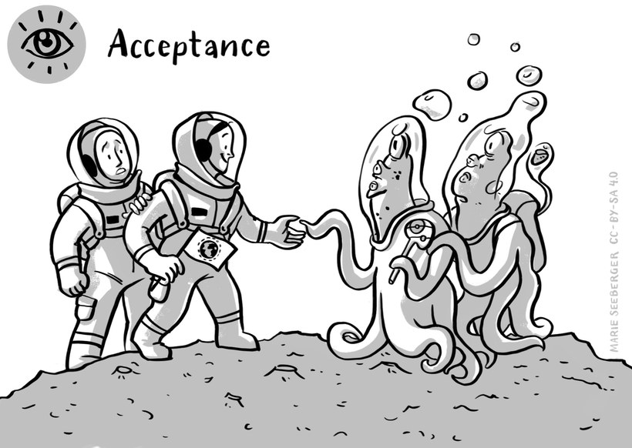

Meaning
In short, to have a high level of Acceptance means to avoid judgments about other people´s behaviours, especially if these do not conform to our expectations. Especially when we encounter behaviour that might be seen as disrespectful in our own cultural experience, we need to try to understand the background rather than to judge too quickly. Because a quick judgment can hinder us from understanding other possible reasons behind other people's behaviour, to be open-minded enables us to see the bigger picture. However, Acceptance is more than about tolerance and understanding our counterparts. It is also the awareness that other work practices can expand our own horizon and help us to grow.
It does not, however, mean that we need to like or copy any other behaviour from other people. All of us have limits to our level of acceptance, which are often deeply rooted in our value system. There are several ways to deal with these limits in an "accepting" way. As mentioned, we can see them as an opportunity to learn and grow from them. Another way may be to tolerate these differences. That means, if a behaviour or concept might be very difficult for us to accept, it could also be a viable strategy to try avoid the confrontation, and withhold our judgement. The prerequisite of acceptance is to respect an approach that differs from my own.

Example
When Florian is giving a presentation abroad, he notices that many people seem to be very busy with other things. While some members of his audience write something in their laptops, others are looking at their phones, or even closed their eyes for a nap. He can well imagine that many people with his cultural background would find this disrespectful. Florian however uses a different approach by asking questions and discussing his observations with some local friends. When they see that Florian is curious to understand the behaviour he is not familiar with and openly asks questions, his friends are happy to explain it to him. Florian feels if he had judged the behaviour of his audience as disrespectful right away, this would have left him with a strong feeling that his presentation was not being acknowledged and his work not appreciated which was not true.

Activity: Case "Not telling the truth"
Please read the following example, then answer the questions below in your learning journal.

Example
Marie started working recently as a nurse abroad in a small Ugandan town. One day, she sits with her co-worker, a young nurse called Nina. When Marie asks her if she has any children, she smiles and says "no". Some days later, Marie finds out that Nina was not honest about it. She actually has two little children at home.
- On a scale from 1 (= nearly no acceptance) to 10 (= full acceptance), how would you assess your ability to accept that behaviour? Note down a number.
- Imagine you wrote down 3 (or 5 or 8). Explain why it is not less than this number. What would help you to accept Nina's behaviour?
***

Another set of competencies is linked to communication and thus the ability to absorb, share and understand information considering the sender's perspective and respond in a way that is comprehensible from the receiver's point of view. In short, it is the ability to communicate in a way that minimizes the potential for misunderstandings. It is thus not surprising that ensuring the co-construction of meaning is an important aspect in this context. Being able to establish and maintain trust by exposing positive intentions is another valuable trait to support the development of a common ground. Knowing about different communication styles and interpretations and usage of non-verbal signals is the basis for the ability to be receptive to communication styles and non-verbal signs. Such an ability greatly supports understanding and the co-creation of meaning.
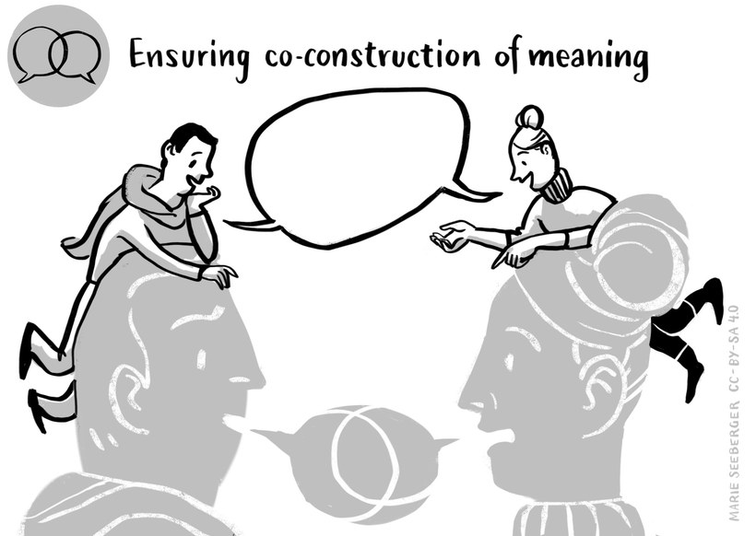

Meaning
Patterns of meaning and interpretations at times collide in intercultural situations. This is so because very often we use terms which mean different things to different people. A person who is confident in co-construction of meaning places emphasis on communicating and dialoguing with all people involved. Such a person makes sure that everyone involved has an understanding of how something are meant. The process behind this may or may not lead to the generation of a common meaning for a specific term or concept. Most important is that all people involved have a thorough understanding of how something is understood by a person.

Example
Lisa is an intern and during the first week of work, she is asked by a co-worker whether she would like to come along for a coffee. However, Lisa is very busy and declines the offer but remembers an article she read about 'the Italian coffee break'. Rereading the article makes her aware that the saying: 'Would you like to come along for a coffee' may actually have different meanings to different people. The next time she is asked to come along she takes the opportunity and in fact realises that this is true. When entering the café, her co-worker meets and greets colleagues from other departments, introduces Lisa to them and they chit-chat for a while, sharing information and opinions about issues before they are all returning to work. Lisa actually had expected that she would sit down with her colleague and they would have a face-to-face conversation about more personal issues. Realising this, Lisa initiates a conversation about the topic and she and her colleague exchange views of their understandings of 'having a coffee' and are quite amazed that such a little thing can have different meanings. This also makes them realise how important it is not to assume common meaning.

Activity: Exploring the other's perspective and meaning
Inquire into "different meaning and co-construction" in your surrounding. Next time you have a chat with a friend or colleague be curious about the meaning of words. If s/he says, for example, "this TV series I just watched was wonderful", ask him/her what s/he means by "wonderful". Use your curiosity and empathy for the person to inquire perspectives but don't be too insisting as otherwise you may irritate the person. Just be interested in the person's concepts.
What new perspective were you able to gain from this inquiry? Think about an example where inquiring into the meaning of something may be vital and co-construction of meaning essential.
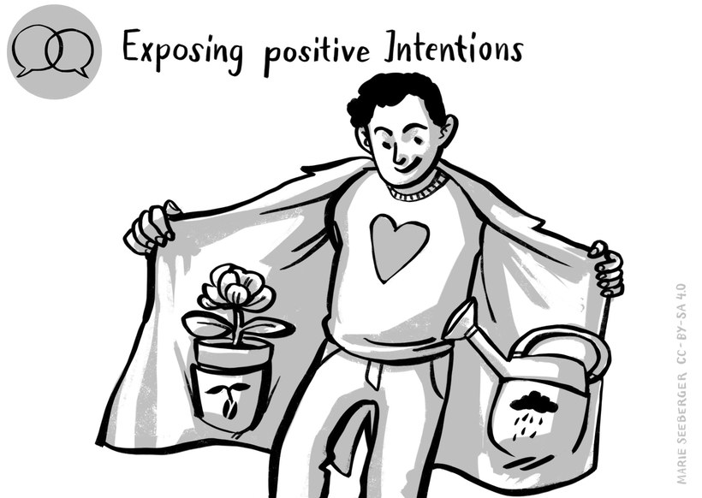

Meaning
Having an open mind when talking with people of other cultural backgrounds is not always enough. To know how to expose our positive intentions means that you are also able to deliver this attitude in a way that it is being understood. People with this competency know how to deliver their message in a clear and transparent context, but also consider the communicative needs of their counterparts. It especially means to be clear about your intentions, wishes and expectations, and that you are sure to display your position in a constructive and non-threatening way.

Example
Zamil has a new colleague who just joined his marketing team some weeks ago. Unfortunately, Zamil sees that his new colleague has not been meeting any of the set deadlines so far. Also, whenever she finally sends the information needed, Zamil sees that it is often not the data they agreed on to be delivered. The next time they meet, Zamil makes an extra effort to small-talk with her, using phatic expressions to ensure that a personal bridge is developing between them. He transparently highlights his needs but also emphasizes his offer for support and their common goals for the project.
His colleague is now clear about what Zamil needs from her and does not feel threatened by his feedback.

Activity: Case "How to tackle a difficult topic in a constructive way"
Write down the conversation between Zamil and his colleague (Zamil's part) in your learning journal. What could Zamil have said (quote!) to express his positive intentions? Note down the beginning of the conversation, and how he cultivates the relationship. Also write down how he approaches the touchy topic by showing his positive intentions.
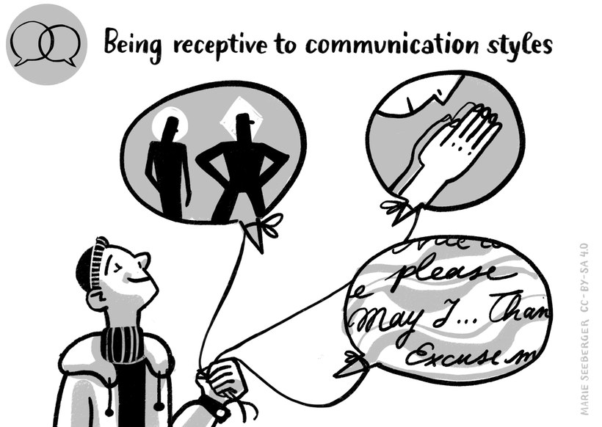

Meaning
Whereas Exposing positive intentions enables us to make ourselves understood in a way that displays our open-mindedness, being receptive means that we are also open to other people´s communication needs. It means we not only have an open mind but also know how to transport this attitude to our communication partners. We know which questions to ask to display that we do not seek to convince, but rather to understand our counterparts. We are sensitive to possible signs, for example, body language and mimics, and can correctly understand the intentions in high- or low-context messages.

Example
Elif is abroad and in price negotiations with a new customer. Even if her colleagues feel frustrated that their negotiation counterparts do not seem to "come to the point", Elif can quickly adapt to this communication pattern. She also finds out that there are some points their new business partners do not seem to be happy with, even though they do not voice it directly. Still, they seem to be relieved that Elif picks up their signals and suggests solutions for their concerns. At the end of a long negotiations, the new customer has developed a high level of trust towards Elif and her team, in large parts because of her attunement to the customer´s spoken and unspoken concerns.

Activity: Interpreting non- and paraverbal behaviour
The following video shows an interaction between a Chinese employee and his manager.
Source: IntercultureTV: Relationship boss – employee, 2017, URL: https://www.youtube.com/
watch?v=y4hyMujT_Ew
Please pay particular attention to the non- and para-verbal communication of the employee. If you were the supervisor, how would you react to accommodate the needs of your staff? How would you interpret his non- and para-verbal signs and show your understanding of the underlying needs here?
Put your answers in the learning journal.
***

The last set of competencies considered in this session relate to a culture-reflexive knowledge. It encompasses more than referring to knowledge such as 'this is how things are being done around here'. Reflexive knowledge is knowledge based on conscious reflection and reasoning. It follows the rules of rationality and the knowledge that there is more than one way of doing things right. Reflexivity is thus understood as the ability to step outside one's own frame of reference and knowledge by enhancing one's understanding of reality through the eyes of the communicators and thus in their own terms. Developing culture-reflective knowledge thus requires the ability to reflect perspectives which refers to the ability of viewing things from different points of views and to consider issues in their relations, interdependencies and relative importance.
Another important aspect of culture-reflexive knowledge refers to being sensitive to context. This entails to acknowledge that context has an important influence on an interaction. And that an interaction not only takes place in a specific physical context (e.g. at the doctor, an office, in a bar) and is thus influenced by environmental conditions but that the people themselves are enmeshed in a personal context (e.g. strict order from their superior, organizational culture, immediate social context) which guides their encounters.
The last aspect to be considered is the awareness of global positioning. This refers to given asymmetries in encounters as it is important to acknowledge that there is a limit to changing perspectives. This is so because there are experiences we cannot share, perspectives we cannot take. For example, a "White" person can hardly anticipate how a Person of Colour (PoC) experiences a world where whiteness is the privilege. A person able to walk will not have the same perspective on side-walks and footbridges as someone who is reliant on a wheelchair in a world of pedestrians with two healthy legs. We therefore are required to meet the continuous challenge of balancing different approaches to the world and to overcoming the dominance of selective perspectives.
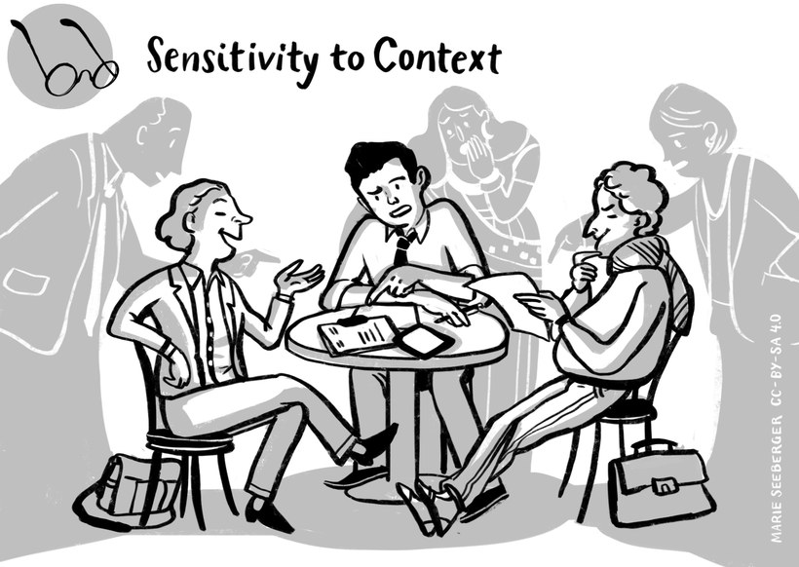

Meaning
We all have a tendency to overemphasize personal characteristics when judging a person´s behaviour and ignore situational factors. In social psychology this is called "fundamental attribution error". People who are sensitive to context place emphasis on inquiring, sensing and understanding the influence the context has on the interaction and the communication. The overall context relates to the environment, the setting and the location in which an interaction takes place or communication is practiced. Sensitivity to context also includes considering the immediate context of the people involved. This can include the organizational context they are in, social rules and mutual expectations that guide communication, interdependencies in relationships as well as aspects referring to the interpersonal history and type of relationship which exists between the people involved (so the counterpart is the basis for the reaction). Other contexts can be the emotional and mental well-being, a region, things that just happened shorty before the incident etc. People sensitive to contexts are able to sense possible expectations of language and behaviour related to the overall and personal context.
Trying to see this perspective here can also prevent us ourselves from becoming agitated, and thus start a negative communication circle. It also keeps us from feeling disrespected or frustrated based on the reasons of misunderstanding.

Example
Raoul has been working in the marketing department for five months and feels that he is slowly becoming a true member of the team when one day he opens his mailbox in the morning and reads: "Cleaning up the showroom is due on Tuesday, noon." He is perplexed if not shocked reading the message which he perceives as being very impolite and written in a tone he would not have expected as a member of the team and cleaning and tidying up the showroom is the last thing he wants to do. Thinking about the context in which the email was most likely written helps him to calm down. He remembers that Liane is currently working from home because her two children are ill and he can imagine that she was just trying to work off her to-do list. It may also be possible that she had not intended to send the mail off as is. Considering these context factors helped Raoul to calm down. He tidied up the showroom as requested. When a couple of days later, Liane thanked him for the job, he mentioned the email and it was only then that she realised what she had done. She apologised and Raoul was grateful that by considering the context he was able to place the message into perspective.

Activity: Finding explanations for irritating behaviour
Think of a behaviour of someone that you found disrespectful in some way. It might be someone who cut your way in traffic, someone whose communication style you find difficult to deal with or any other behaviour you find difficult to accept. If we assume a reason other than "wanting to be disrespectful", which context could explain this behaviour? How could it help you to find out more about different influential factors, and how could you do this?
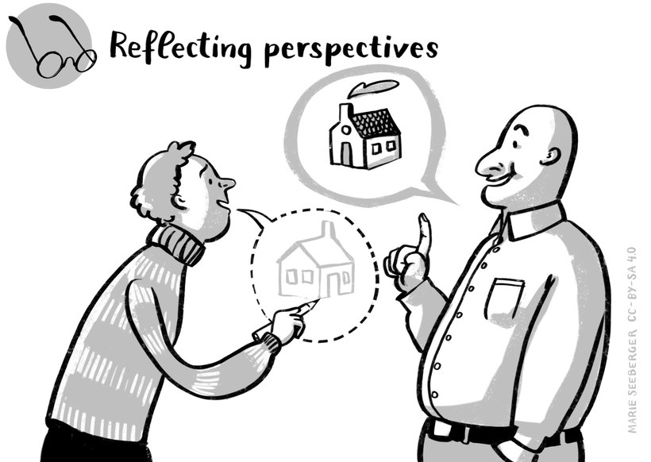

Meaning
Take any situation, we never have the whole picture, we only have one or some perspectives that we understand is the whole view. When we reflect our perspectives we keep in mind that there are more approaches than those that we might have in mind, that there are many "truths" and realities in their own respect. Reflecting perspectives means keeping in mind different cultural orientations and values but also numerous other perspectives that we cannot anticipate.

Example
Milena and Anna both have a child in elementary school and they are comparing their parenting styles. Christina loves rules, e.g. her son is not allowed to have an ice cream before dinner or watch TV after 8 PM. Milena finds that funny, she decides from situation to situation. Christine is astonished how Milena´s son will ever learn what to do. Milena answers: "with your approach he learns rules, with my approach he learns how to assess the situation and me. Both perspectives are helpful."

Activity: The world upside down
- Have a look at the map below. Search for the country you were born in. Was this more difficult for you than usual? Why is that? Describe the perspective that you see.
- What could you do to acquaint yourself with the unfamiliar view and make it a more familiar perspective? Note down three such strategies in your learning journal.
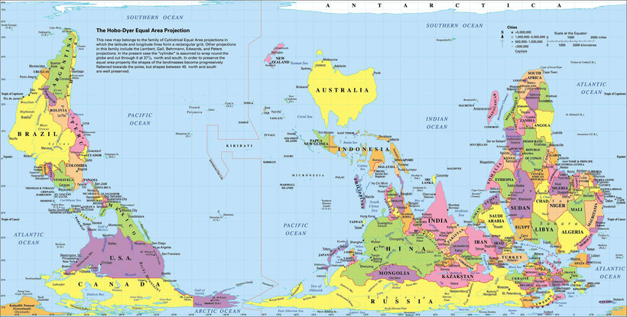
Image source: https://www.reddit.com/r/MapPorn/comments/94993a/
do_you_know_how_the_world_map_looks_in_australia/

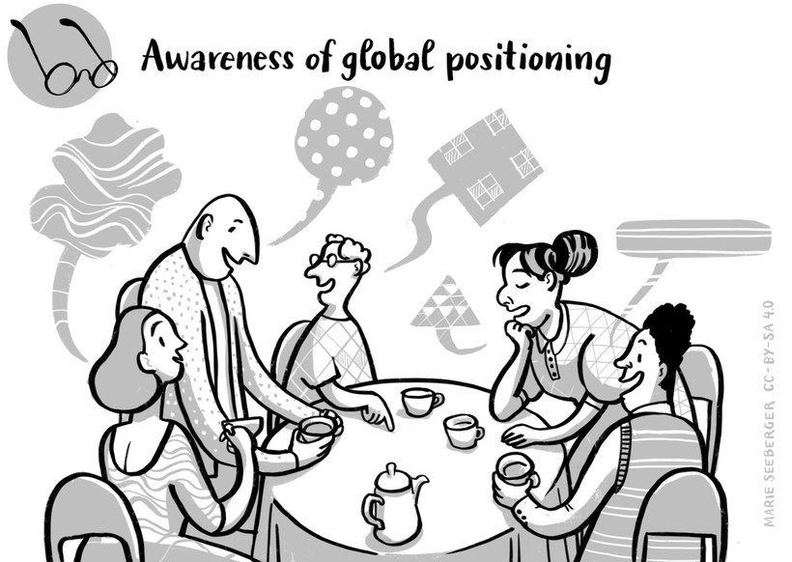

Meaning
Persons who are aware of global social positioning take macro influences of an encounter into consideration and incorporate pre-distributed privileges. Whenever people meet there is one thing we have in common: we are all human beings with own dignity, but there is diversity in the way that societies and cultures judge the value of attributes like gender, age, physical abilities, religion or spiritual beliefs or any worldview, wealth, educational background, sexual orientation, parental status, language skills and many more factors. These judgments have huge influences regarding our chances in life. Some differences are not only prejudged by most societies, also living conditions are oriented towards a specific normality that discriminate or excludes variances. Hence, pre-distributed privileges and chances for career and success in life are a result. Keeping this in mind, we might be easier able to accept a perspective we do not share and balance powerful differences. It is a practice to deconstruct power asymmetries acknowledge collective experiences like living in a diaspora.

Example
Ryan (US-Citizen, white male) studies International Management, a Master program where his fellow students come from many countries. One student, Natalia (a female Kyrgyzian citizen, scholar) is visually handicapped, and Ryan financed part of his studies being one of her scientific assistants. In the 3rd semester he decides to apply for permission to write a Master thesis together with her on diversity management as a topic. He is aware that it would be easier for him, faster and less risky to write the thesis on his own. However, he is confident that he will learn a lot more about diversity and his own approaches to diversity with the experience of writing the thesis with Natalia than he would learn from the content of pen and pencil research. Not least, he has a high motivation also supporting her.

Activity: Privileges and disadvantages
Have a look at the following checklist that lists 50 privileges. Go through the list and note down the number of the privileges you are aware of.
Checklist: 50 potential privileges in the workplace
(You can do a right click + "Save link as..." (or similar) to download the file.)
Download the checklist (.docx) Download the checklist (.odt) Download the checklist (.rtf)
Then write down the answers to the following questions in your learning journal:
- How many privileges do you have? How does it make you feel?
- Name one disadvantage you face yourself. How do you handle it? Give an example.
- How do you handle disadvantages of others? Give 2 specific examples.

9.5 ... and the journey continues
Conceptualising intercultural competence, it was argued that it has a knowledge, skills and awareness as well as attitude dimension. Following these distinctions, competencies related to openness would be strongly linked to the awareness and attitude dimension, whereas communication has a stronger skills orientation and culture-reflexive knowledge a knowledge orientation.
Although making these distinctions help us to capture the concept of intercultural competence, we need to be aware that the dimensions are interlinked and even build on each other. Knowing alone does not activate an appropriate response or change people's behaviour nor does it change their emotional engagement in a certain situation. Knowledge needs to be complemented with an awareness of where and how culture influences interactions as well as an awareness of our own common practices. And it needs to come along with an open and conducive attitude and thus readiness, desire to and empathy for understanding other people. Whereas our knowledge helps us to analyse a given situation and provides possible explanations, it is our attitude which motivates us to engage. And such an engagement requires skills helping us to do so and to manoeuvre a given situation well, investigate, discuss and negotiate a common ground of understanding. It also requires skills to manage our experiences of strangeness, in other words our feeling of uncertainty and thus our emotions.
What this discussion highlights is how closely interlinked the different dimensions are and that in fact, they also reinforce each other. The knowledge about culture in general as well as its influence on behaviour you acquired joining this course was meant to enhance your repertoire of relevant knowledge for intercultural encounters. And by increasing your knowledge it is expected that you also increased your awareness, cultural sensitivity and open-mindedness. With the knowledge at hand, an awareness and your communication skills, the aim of this module was thus to enhance your ability to negotiate culture together. This in turn has the potential to lead to more knowledge, a greater awareness and an enhancement of your communication skills. This is what the image with the spiral indicates.
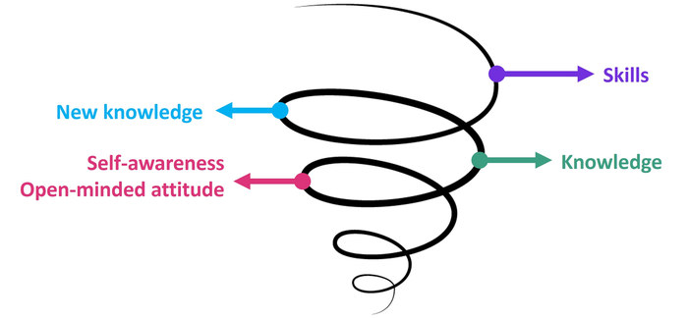
Figure: Development of intercultural competence
Diagram developed by Thu Phong Vuong for this course
Applying your intercultural competencies can in one instance, simply help you to better understand what is going on in a given encounter. In another instance it may support paving the way for a positive interaction and the development of a common ground of understanding. And yet in another instance intercultural competence can be put to use for the creation of normality and plausibility as well as routine actions. The more we know, the more experienced we are, the better are we able to understand and manage critical encounters in general and complex encounters in particular. Constantly seeking to expand our knowledge not only supports avoiding misunderstandings and misperceptions but also dealing with irritations and complex issues. This means that we persistently need to enhance our knowledge, be ready to question, reflect and explore with an open mind. Developing intercultural competence is thus best understood as an ongoing process and therefore often referred to as a lifetime learning opportunity. If we are ready to continue traveling it is a fascinating and personal enriching journey for all of us.

9.6 Sources, further reading and web links

Sources
- Arasaratnam, L. A. (2016). Intercultural competence. Oxford Research Encyclopedias: https://doi.org/10.1093/acrefore/9780190228613.013.68 (accessed on 25.1.2021).
- Bertelsmann Stiftung und Fondzione Cariplo (2008). Intercultural Competence – The key competence in the 21st century?
https://www.ngobg.info/bg/documents/49/726bertelsmanninterculturalcompetences.pdf (accessed on 25.1.2021).
- Deardorff, D. (2020). Manual for developing intercultural competence: story circles. (UNESCO, Ed.) Routledge: London.
https://unesdoc.unesco.org/ark:/48223/pf0000370336 (accessed on 25.1.2021).
- King, P. M., & Magolda, M. B. (2005). A developmental model of intercultural maturity. Journal of College Student Development, 46 (6), pp. 571-592. https://www.researchgate.
net/publication/236750691_A_Developmental_Model_of_Intercultural_Maturity (accessed on 25.1.2021).
- Kurz, R., & Bartram, D. (2002). Competency and Individual Performance: Modelling the World of Work. In I. T. Robertson, M. Callinan, & D. Bartram, Organizational effectiveness: the role of psychology (pp. 227-255). London: John Wiley & Sons.
- Spitzberg, B. H., & Chagnon, G. (2009). Conceptualizing intercultural competence. In D. K. Deardorff (Ed.), The SAGE handbook of intercultural competence (pp. 2-52). Thousand Oaks: SAGE.
- UNESCO (2013). Intercultural competence – conceptual and operational framework. Paris: UNESCO. https://en.unesco.org/interculturaldialogue/resources/132 (accessed on 25.1.2021).
- Verdooren, A. (2014). Taking multiplicity seriously: towards new approaches for intercultural practitioners. Interculture journal, 13 (23), pp. 11-24.

